Appendix: Implementation Evidence
Testnet Contract AddressContract Address (Sepolia):
0x6f822D85f54C1B8Ca5DE574fF335Cd94C1934B97
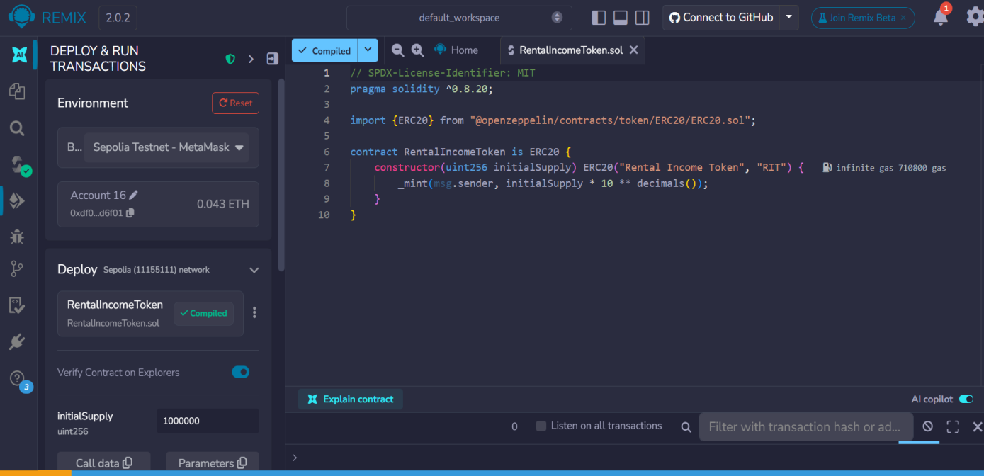
Figure1: Contract Deployment in Remix
The smart contract was successfully deployed on the Sepolia test network using Remix and MetaMask.

Figure2: Basic Contract Functions(name, symbol, totalSupply, balanceOf)

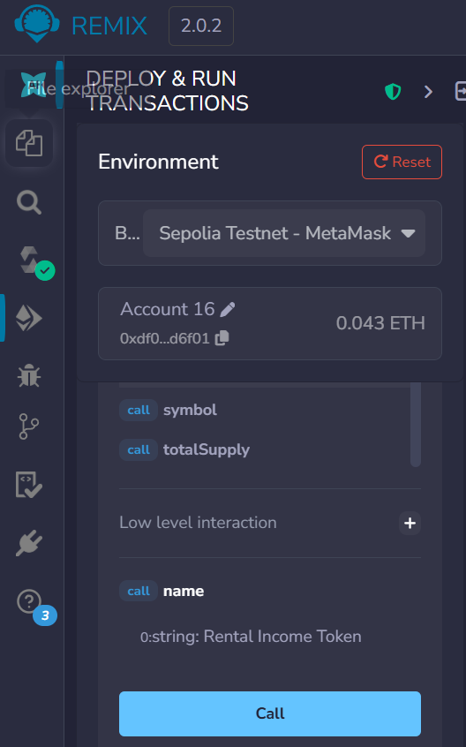
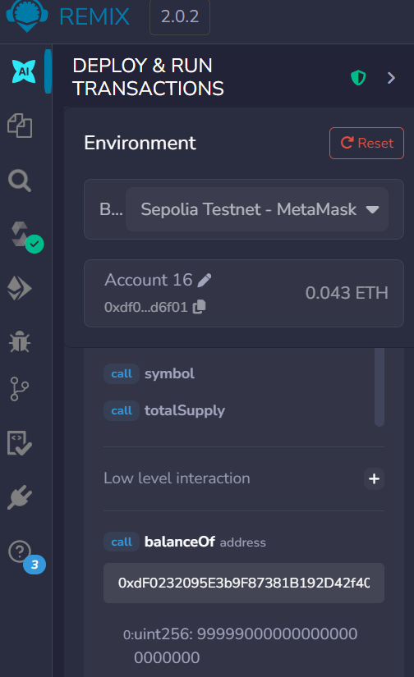

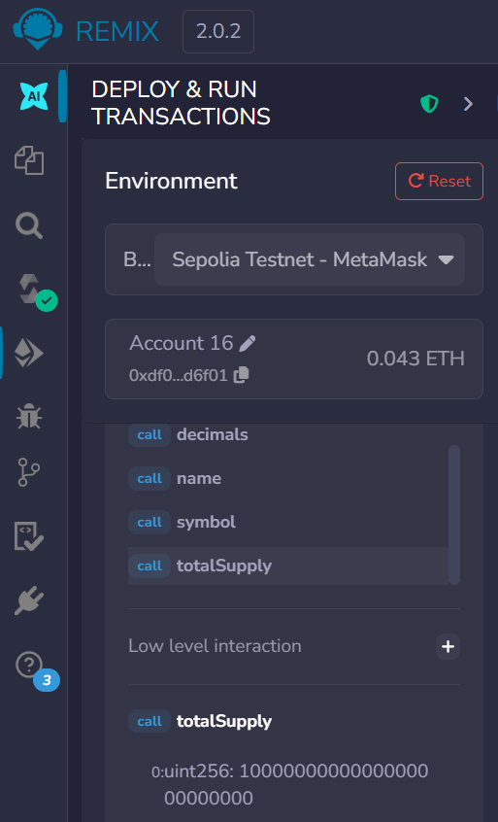
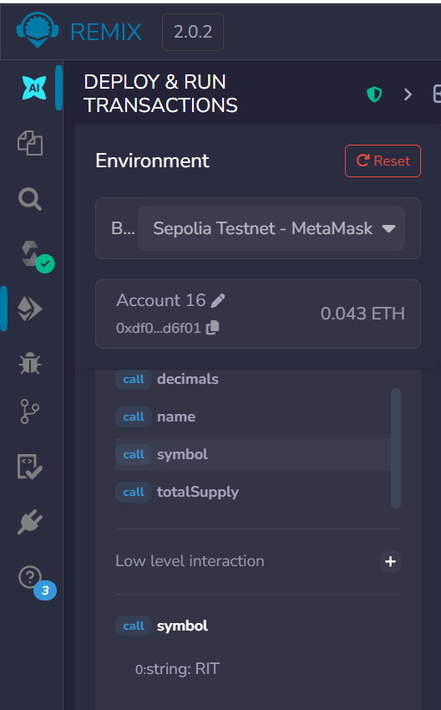

Figure3: Transfer Execution
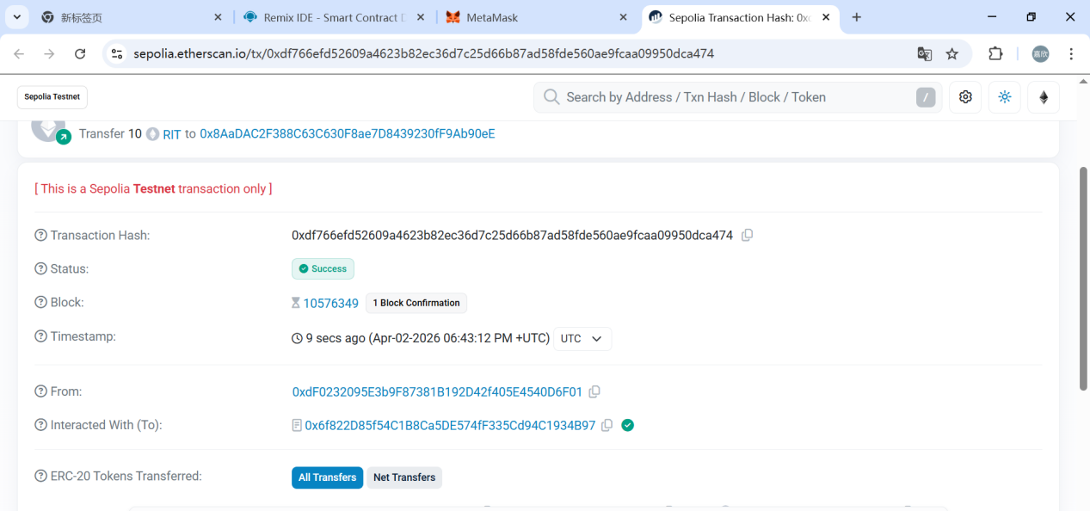
The transfer function was executed to send tokens to another address, demonstrating token transferability.

Figure 4: Transfer Result (Balance Verification)
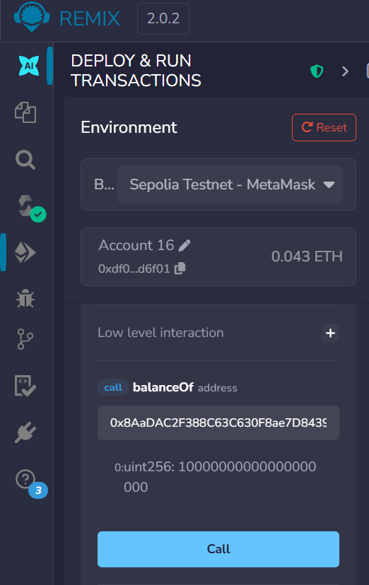

The balanceOf function confirms that the recipient received tokens, verifying successful transfer execution.

Figure5: Approve Execution
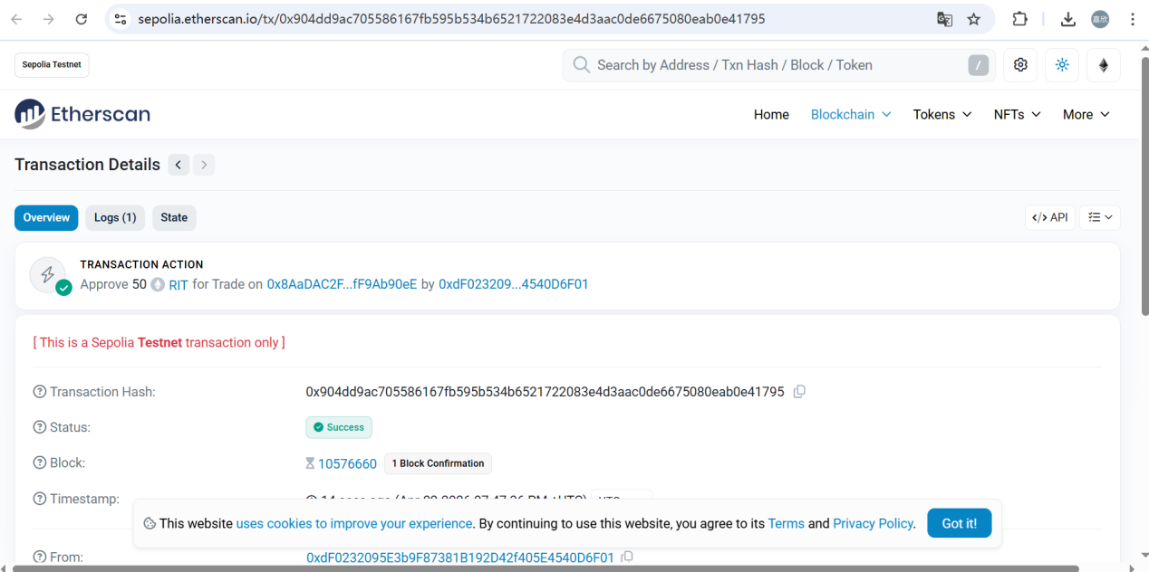
The approve function was executed to authorise another address to spend tokens on behalf of the token holder.
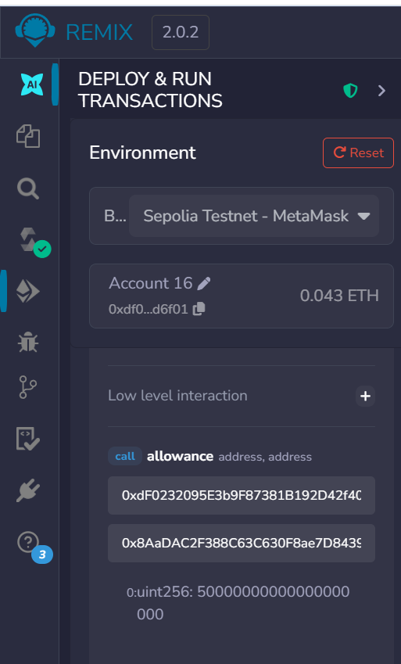
Figure6: Allowance Verification

The allowance function confirmed that the approved amount was correctly recorded on-chain.

