Design Documentation

- System design

The Blood Donation App is a MEAN Stack application. As figure above shows, the maind technologies to compose the Stack are Express, MongoDB, Angular 2 and Node.

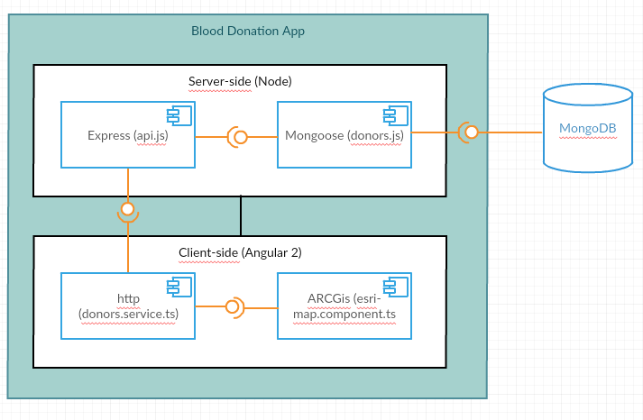

- Technologies, libraries and APIs

- Angular 2
- ARCGis 4.3.1
- Node 5.0.3
- Express 4.15.3
- MongoDB 3.4.4
NoSQL database with geolocation support.

- Mongoose 4.10.6
API to connect JavaScript application to MongoDB.

- Socket.io 2.0.3

- More details

- GIT Repository
The project is available in https://github.com/cindysoares/blood-donation at Github.

- MongoDB Database
Once you start the application, a database called blood-donation will be created at the running MongoDB instance at the address mongodb://localhost. Some dummy data will be created when the collection donors is empty. If you want to recreate the initial state, run the following commands at MongoDB Shell:

> use blood-donation
> db.donors.drop()

- Postman

