**Computational Astrophysics HW4**

R08244002 蔡欣蓉

* **Applied Gaussian filter with and , cell and respectively**

Run the file *convolution_2D_Gaussian.py*.

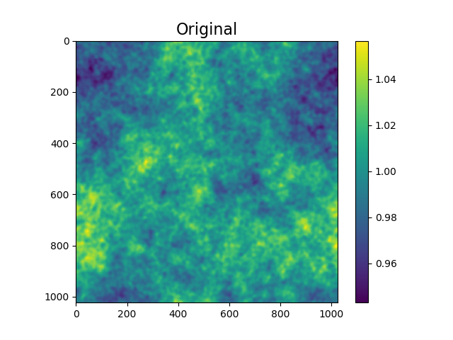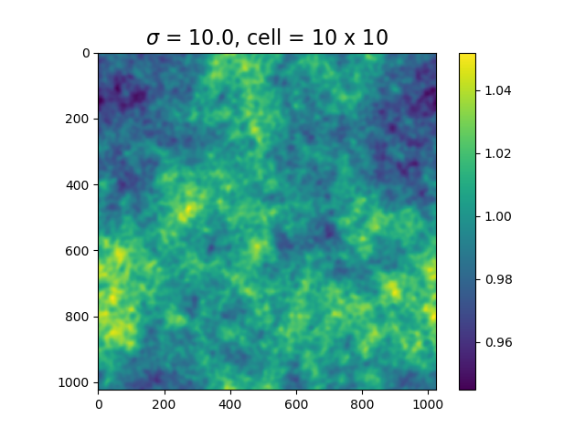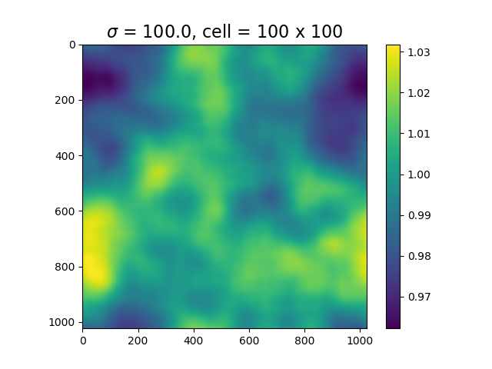

* **Power Spectrum**

Run file *convolution_2D_Gaussian.py.*

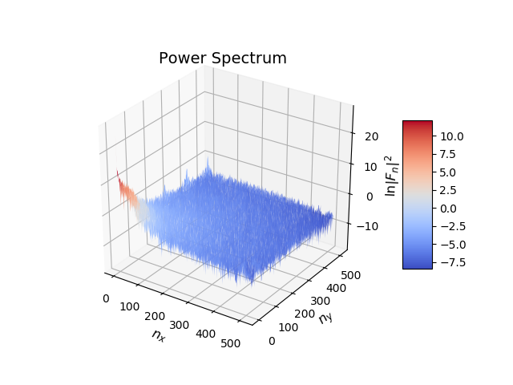For each and , we have a power spectrum, we can see that low and contributes a lot.

If we sum all the amplitude that have the same , than it gives,

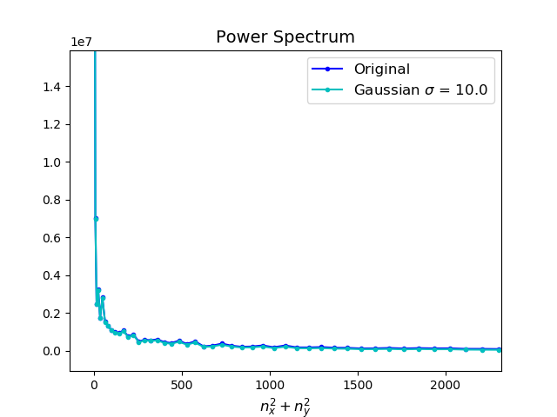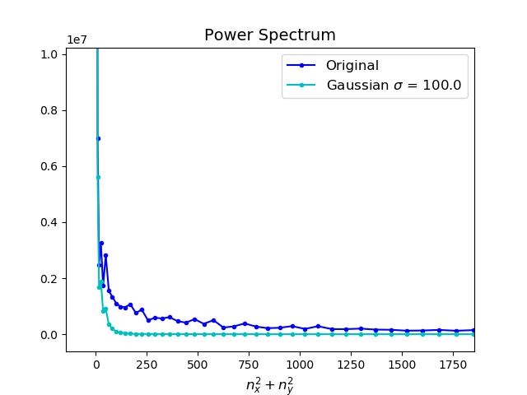

After applying Gaussian filter, if is large, which blends more cells together, will eliminate bigger frequencies range. While smaller still keeps the characteristics of the original one, but still, removes high frequencies nodes.

And their individual and spectrum is really interesting, even though I don’t know what cause it to be like this. They are bubble like.

