**Computational Astrophysics HW5**

R08244002 蔡欣蓉

* **Some test runs on the N-body simulation.**

In this section, I defined the error as:

1. Results

I’ve only show one of the simulation (KDK), since we can’t tell the differences in others.

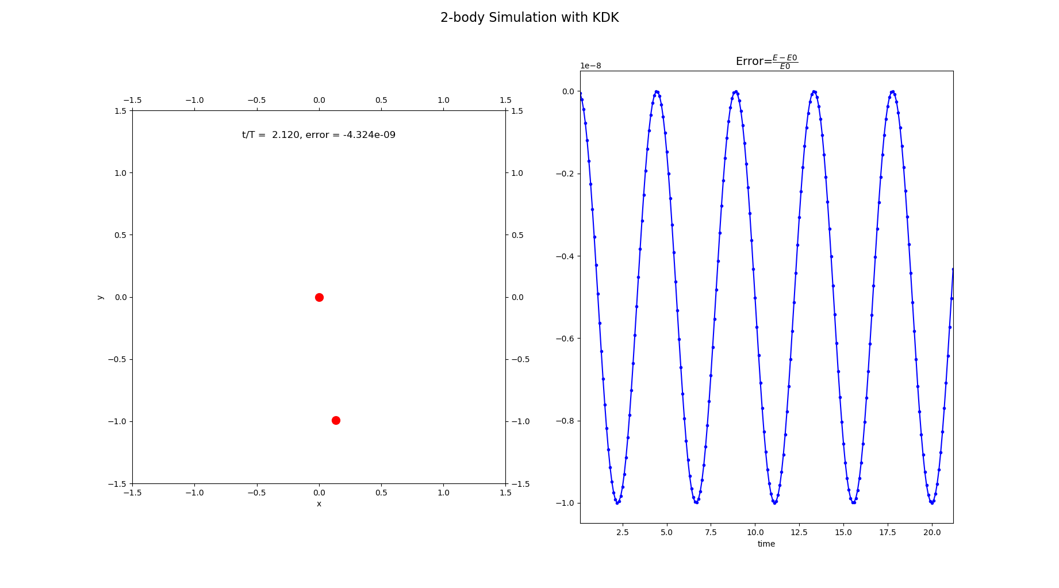2-body Simulation:

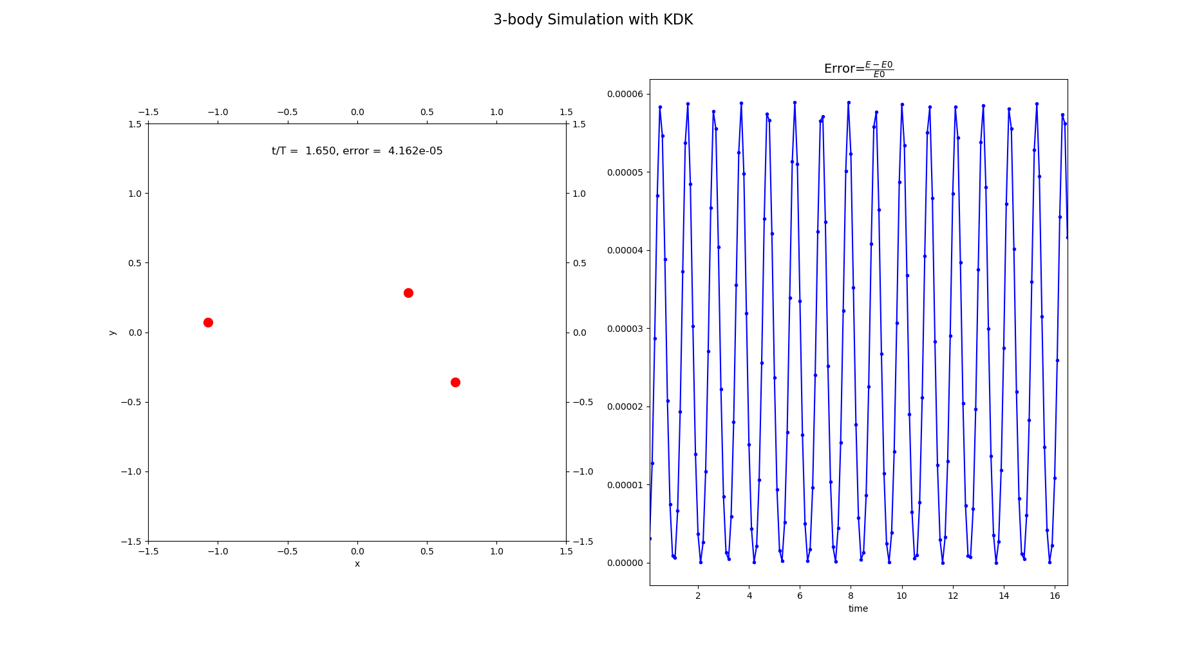3-body simulation:

1. Their errors and their time used in each simulation:

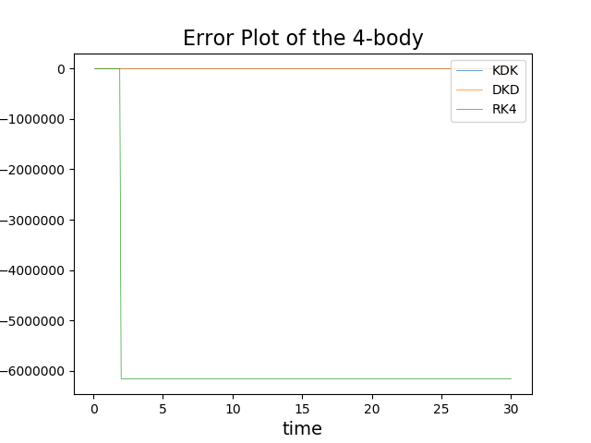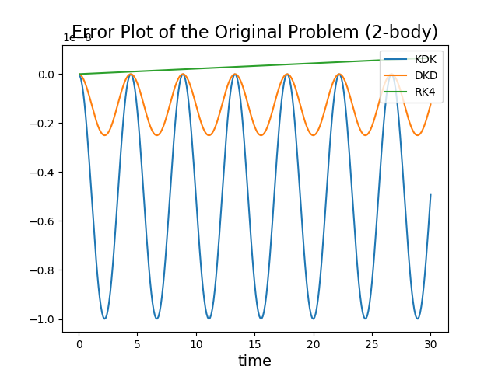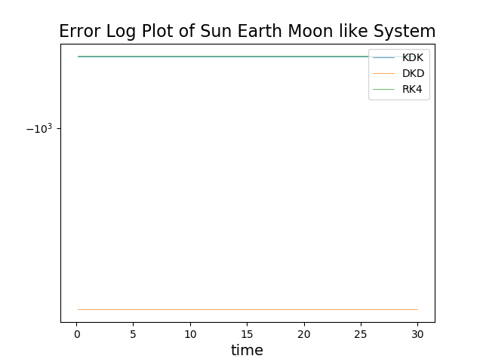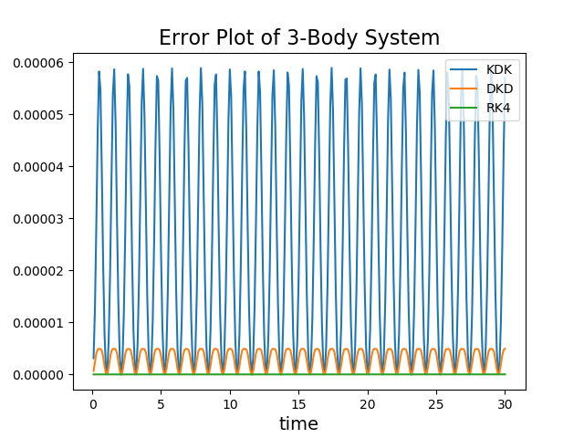

RK4 and KDK are sticked together.

DKD and KDK are sticked together.

|  |  |  |  |  |
| --- | --- | --- | --- | --- |
| **Time used (sec)** | |  |  |  |
| Original 2-body | KDK | 0.077 | 0.171 | 0.333 |
| DKD | 0.055 | 0.105 | 0.240 |
| RK4 | 0.239 | 0.467 | 1.010 |
| 3-body | KDK | 0.160 | 0.329 | 0.673 |
| DKD | 0.105 | 0.195 | 0.385 |
| RK4 | 0.435 | 0.752 | 1.666 |
| Sun Moon Earth Like | KDK | 0.161 | 0.336 | 0.674 |
| DKD | 0.101 | 0.193 | 0.401 |
| RK4 | 0.425 | 1.014 | 1.630 |
| 4-body | KDK | 0.259 | 0.530 | 1.061 |
| DKD | 0.153 | 0.298 | 0.574 |
| RK4 | 0.646 | 1.213 | 2.384 |

1. In the problem where distances difference in different particles are not that large (2-body and 3-body), the error of these algorithm falls in . In the Sun Earth Moon like system, since the distance between Earth and Moon are too small compared to 1AU and the mass of the Sun is too large, even though I used double precision, the round-off error still makes the error falls in . In the 4-body system, the errors are small until 4 particles start their own narrow and flat elliptic orbits, and they start to diverge. Again, due to round-off error, the errors fall in . It’s even worse that the acceleration by gravity is just a number near the double precision limit of accuracy, so the more it calculates the gravity in the algorithm, the larger the errors are.
2. All in all, to choose a proper algorithm to calculate N-body problem, we should consider if the particles will fly away in different directions, or all of them will stay together in a region. If it diverges, we should use DKD, since each step only calculates gravity for once. If they stay together in a region and the time scale is short, then use RK4. Otherwise, try out KDK and DKD to see which is better.
3. We can see that turns half, time used in three algorithms doubles.
4. And time used in 2-body is roughly a quarter/one-third of 4-body, is roughly , but not that accurate. Since most of the time 4-body is doing some near zero calculation.
5. The less we calculate the gravity, the faster the algorithm is. Time used by three of the algorithm follows:

* **Compare with an analytic solution**

1. Binary Star (2-Body Problem)

Initial condition:

|  |  |  |  |
| --- | --- | --- | --- |
|  | Mass | Position | Velocity |
| Particle 0 |  |  |  |
| Particle 1 |  |  |  |

Define error through position:

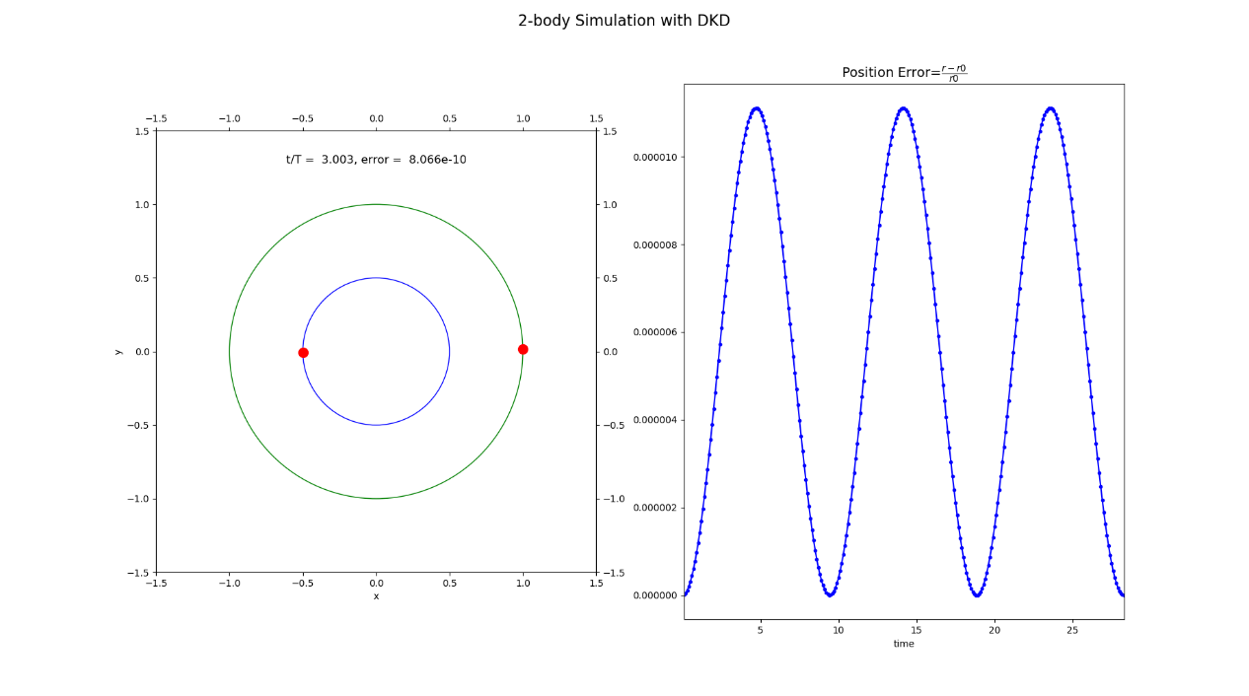Define error through energy:

1. Result

Errors in different algorithms:

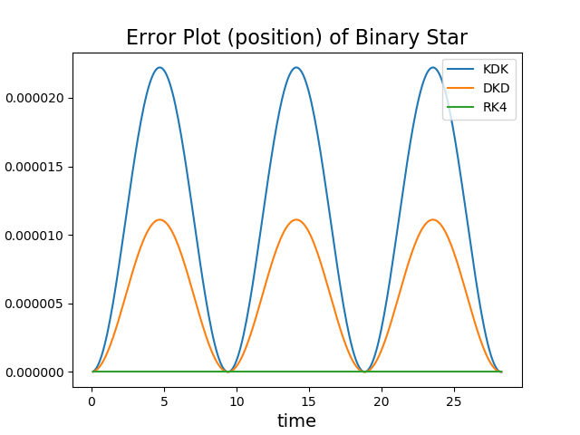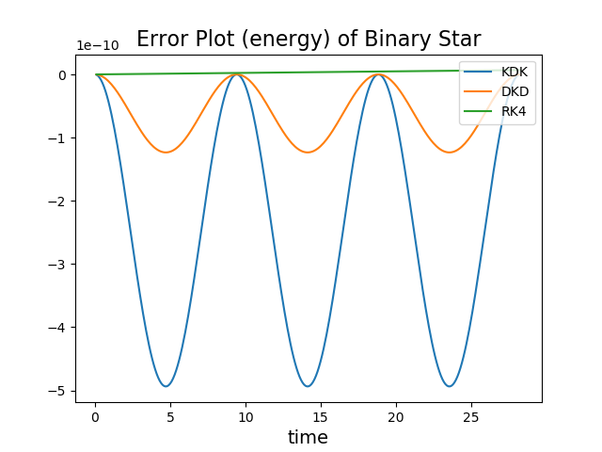

Time used in different algorithms and time steps:

|  |  |  |  |  |
| --- | --- | --- | --- | --- |
| **Time used (sec)** | |  |  |  |
| BinaryStar 2-body | KDK | 0.076 | 0.154 | 0.320 |
| DKD | 0.059 | 0.108 | 0.229 |
| RK4 | 0.223 | 0.434 | 0.893 |

Errors in KDK with different time steps:

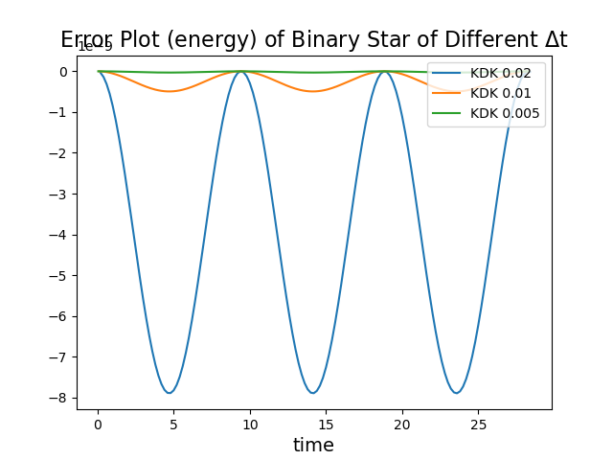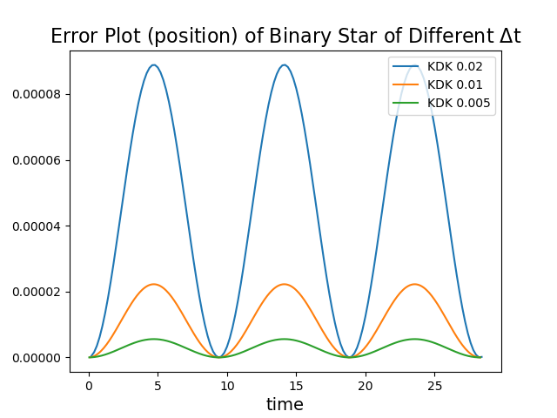

Errors in DKD with different time steps:

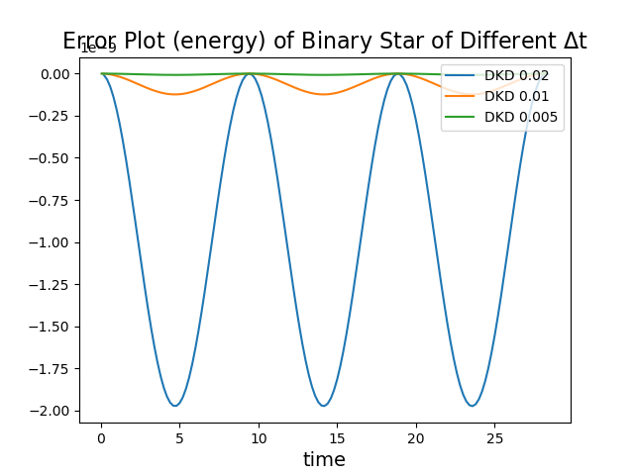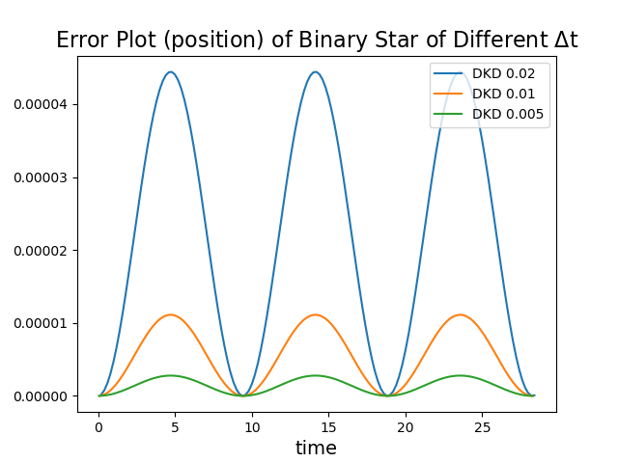

Errors in RK4 with different time steps:

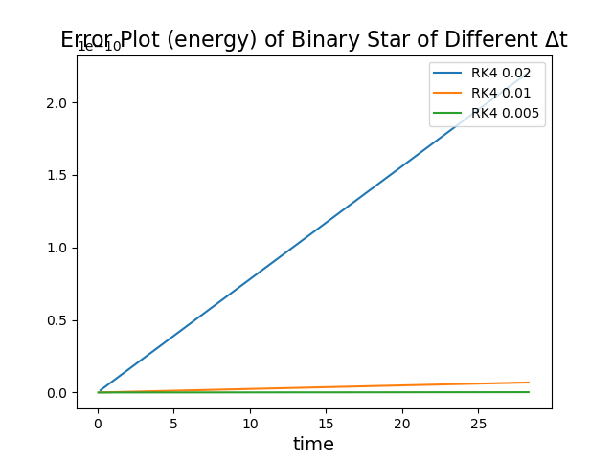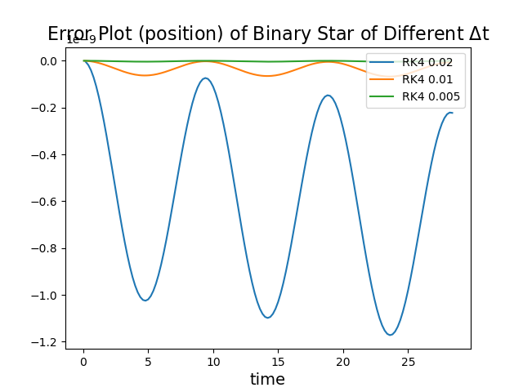

1. Discussion
2. Time used and error plot defined by energy match the discussion on the previous section.
3. It is not surprising that the absolute value of the error defined by position and energy increase and decrease together, since the velocity seldom changes and the potential energy is calculated by position.
4. Since the distance between the particles should never change and their velocity seldom changes, the energy error and position error grows with opposite signs.
5. We can clearly see that RK4’s error grows with time.
6. There is no specific relation between time steps and errors, since different definition of error will give different result.