1. Create a new folder named `data_project` on your local machine. Initialise it as a git repository and verify its status.

mkdir data_project

cd data_project

git init

2. Inside the `data_project` directory, create three Python files: `data_cleaning.py`, `data_analysis.py`, and `visualisation.py`. Add all these files to the staging area.

touch data_cleaning.py data_analysis.py visualisation.py

git add data_cleaning.py data_analysis.py visualisation.py

3. Commit the added Python files with the message "Initial commit with data processing scripts".

git commit -m "Initial commit with data processing scripts"

4. Display the commit history of your repository.

git log -- oneline

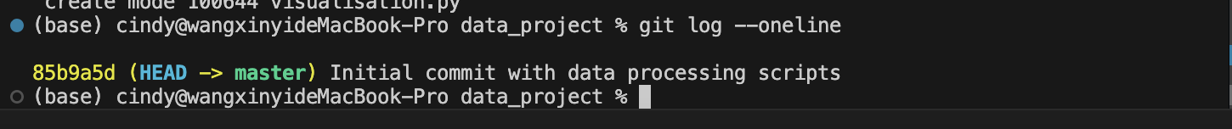

5. Add a new function `clean_data()` in `data_cleaning.py`. After modifying the file, stage and commit the changes with the message "Add clean_data function to data_cleaning.py".

6. Create a new branch named `feature-exploration` and switch to it.

git branch feature-exploration

git checkout feature-exploration

7. On the `feature-exploration` branch, add a new file `exploratory_analysis.py` and commit it with the message "Add exploratory_analysis.py for initial data exploration"

touch exploratory_analysis.py

git add exploratory_analysis.py

git commit -m "Add exploratory_analysis.py for initial data exploration"

8. Switch back to the `main` (or `master`) branch from `feature-exploration`.

git checkout main

9. Merge the `feature-exploration` branch into the `main` (or `master`) branch.

git merge feature-exploration

10. Commit the merge and list all the branches in your repository.

