Sub-diffraction linear spatial filtering with layered metamaterials
Anna Pastuszczak, Marcin Stolarek, Rafał Kasztelanic and Rafał Kotyński,
Faculty of Physics, University of Warsaw, Pasteura 7, 02-093 Warsaw, Poland
Tel: (4822) 5546888, Fax: (4822) 5546882, e-mail: rafalk@fuw.edu.pl
ABSTRACT
We describe layered metal-insulator metamaterials using the model of a linear-shift-invariant system. We present the modelling and optimisation strategy for engineering such metamaterials. A variety of point spread functions may be reached, either for superresolution, or for far-field image processing. The first group includes layered superlenses and effective media for directed refraction. As an example of the latter, we demonstrate a metamaterial consisting of highly reflecting cavities coupled to form a high-pass spatial filter. The proposed filter can be applied for phase visualisation.
Keywords: layered metamaterial; metal-dielectric multilayer; phase visualisation.

INTRODUCTION
Stratified photonic structures consisting of dielectric materials or of both dielectrics and metals have been used for a long time as interference filters. More recently, optical metamaterials consisting of metal-dielectric stacks brought significant attention. Perhaps the most successful of the latter structures are layered superlenses [1-6], which allow for imaging with sub-wavelength resolution. A common view on these two categories of one-dimensional photonic crystals may be reached if they are considered as linear filters. Their temporal or frequency response is important in the case of interference filters, while the spatial response or spatial frequency response is what decides on the resolution in the case of superlenses. Both, the spatial and temporal responses may be found using the transfer matrix approach.
In order to describe the resolution of an imaging system consisting of a multilayer in a systematic way, it is convenient to refer to the theory of linear shift invariant systems [7-9] (LSI, also termed as linear isoplanatic systems). We describe metal-dielectric multilayers (MDM) as LSI systems - a layered superlens is a one-dimensional spatial filter characterised with its point spread function (PSF). This approach facilitates the application of plasmonic elements to optical signal processing which is currently bringing increasing research interest.
Since the suggestion of using a silver slab for projecting evanescent waves at sub-wavelength distances, the experimental demonstration of an asymmetric superlens and the proposal of improving the performance of the structure by using a multilayer operating within the approximation of an effective medium, there exists an ongoing effort to design diffraction-free structures with low losses, a large total thickness, and sub-wavelength resolution [10-18]. Overcoming the diffraction limit in such structures may be attributed to the combined effect of effective anisotropy, of coupling SPP modes, and of supercollimation. In this paper we review the properties of diffraction-free layered metal-dielectric periodic stacks and look to their possible applications. In particular, we introduce a metamaterial consisting of highly reflecting cavities coupled to form a high-pass spatial filter.
In [19] it is shown that the framework of linear shift-invariant (LSI) systems, widely used in the past within Fourier optics, may be extended to construct a polarisation-dependent point spread function (in a matrix form), which enables to express the layered system in an easily tractable form. This formalism has been also used to propose and study a diffraction-free non-planar imaging device. Although it is convenient to treat a multilayer as an LSI, the analogy to classical imaging systems may be misleading in some respects. For instance, its point spread function (PSF) is not always similar to a Gaussian function and may include a strong phase modulation. In such a case the width of PSF can not be simply interpreted as a measure of resolution. Instead, the actual resolution depends on the feature size of the object and may be even better than the width of PSF [20]. Due to reflections, a near-field source and the LSI stack can not be regarded as completely independent systems. Nevertheless, in the two limiting cases of tight coupling (a hard source model) and no coupling (a soft source) the LSI model remains valid [7], and in practice it proves to be an efficient tool for the design of multilayers. In a recent work [11] we have optimised Ag-TiO₂, Ag-GaP and Ag-SrTiO₃ multilayers in terms of the resolution and transmission coefficient. Apparently, the optimised structures are dissimilar to those designed using the effective medium theory in terms of both the filling fraction and the internal distribution of the field. This is a strong argument for using numerical optimisation instead of simplified theoretical models when designing layered superlenses for practical applications. In the present paper, we analyse structures consisting of coupled cavities, optimised in terms of the off-axis transmission.

STRATIFIED STRUCTURES WITH ENGINEERED POINT SPREAD FUNCTION
In this section, we focus on metal-dielectric layered metamaterials whose elementary cell consist of cavities tuned for the Fabry-Perot condition for reflection. For the purpose of example we assume that the structure consists of silver and TiO₂ and the operating wavelength is equal to 500nm. Several cavities may be stacked together in order to increase the reflection coefficient at the normal direction of incidence. However, at an oblique angle of incidence, the transmission coefficient remains large. Therefore the transfer function takes a high-pass form. In signal processing, high-pass transfer functions are often used to reduce the DC component of the signal. In optics, high-pass spatial filtering is used for edge enhancement but also for phase contrast visualisation.
In Fig. 1 we show the high-pass transfer functions of a metamaterial consisting of 5 cavities operating at the Fabry-Perot resonant condition for reflection with different resonance order m. Only the far-field part of the spatial spectrum is presented. Notably, higher order FP conditions block a narrower band of low spatial frequencies. At the same time, the phase modulation of the transfer function becomes stronger with the increase of the resonance order m. This can be understood as the consequence of Fresnel diffraction which builds up with the increasing size of the cavity.
In Fig. 2 we compare the transfer functions with respective point spread functions. The metamaterial is optimised by tuning the resonance order of aech cavity in order to obtain the highest transmission for a broad range of spatial frequencies. When the number of cavities becomes sufficient for the first order FP maxima to become spatially separated and not to overlap at the centre, the point spread function takes a form with two maxima and a small value in the centre. The phase is shifted at the maxima with respect to its central value. Together with the small mean value of the PSF, which results from the small value of the transfer function for the normal direction of incidence, this assures that the filter corresponds to a differential operator. Such a filter may be used for edge enhancement or for phase visualisation.
In Fig. 3. we confirm that the metamaterial may be used for phase visualisation. This figure shows the dependence of the output intensity on the linear phase slope of a phase-only input image. This phase-to-intensity conversion characteristics is obtained with the filters whose point spread functions and transfer functions have been presented in Fig. 2ab.

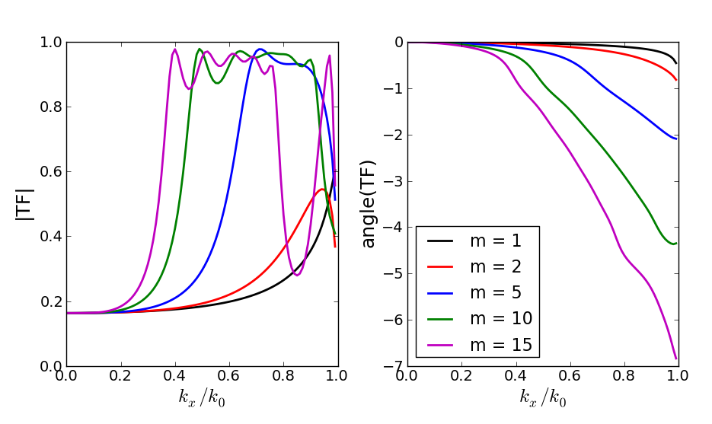
Figure 1. High-pass transfer functions of coupled-cavity layered metamaterials (amplitude on the left, and phase – on the right). Each structure consists of 5 TiO₂ cavities separated by 10nm-thick Ag reflector. Every cavity is tuned to the Fabry-Perot resonance for reflection. The resonance order m is varied in between 1 and 15. The wavelength is equal to 500nm.

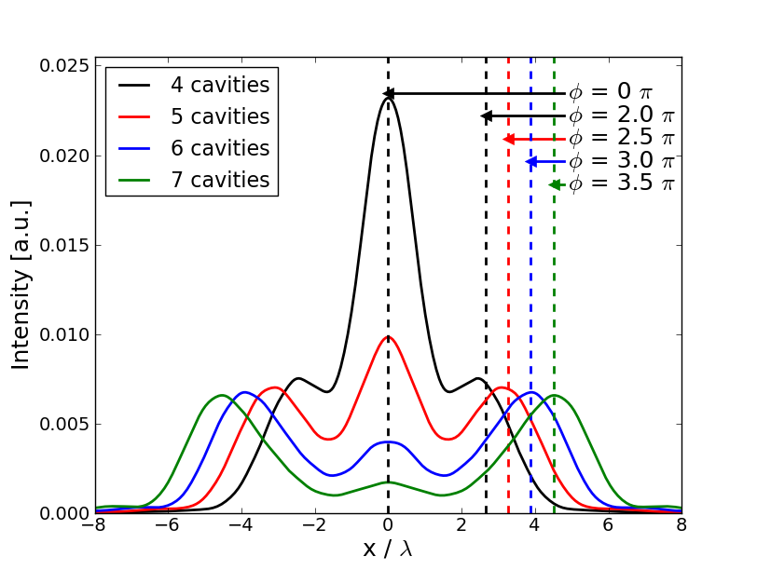  (a) | 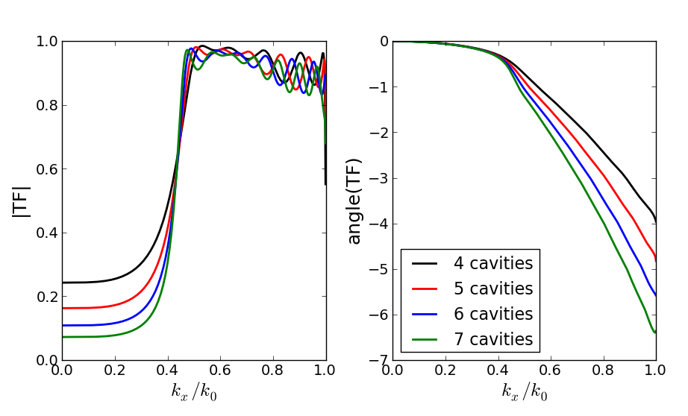 (b)
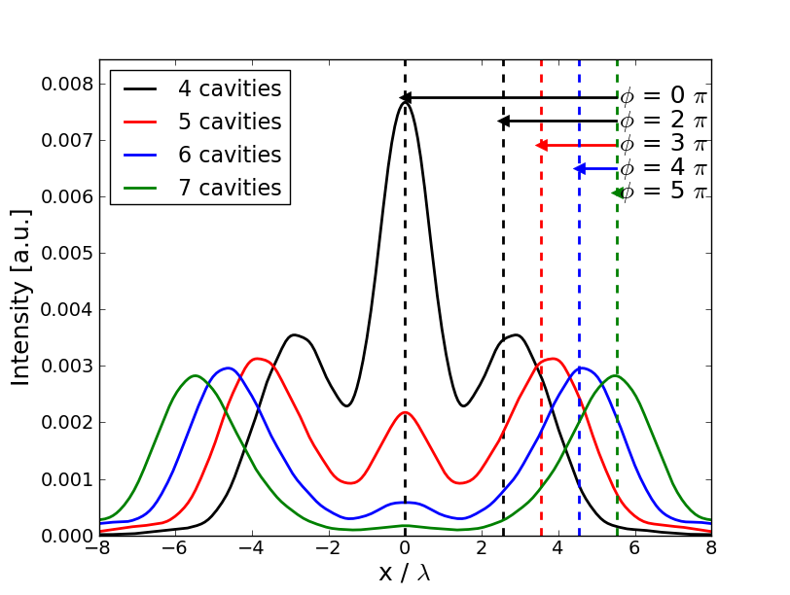  (c) | 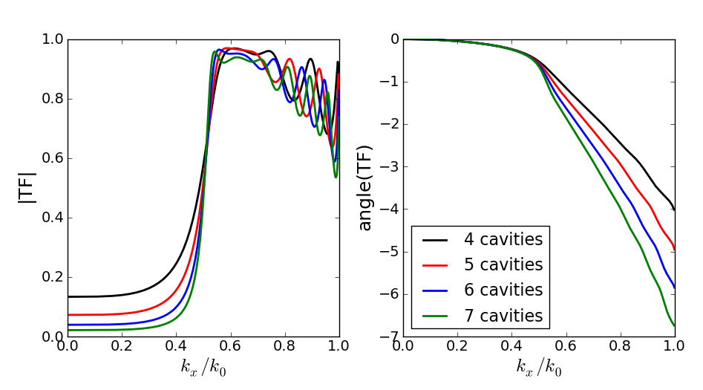  (d)
Figure 2: A comparison of the point spread functions (a,c) and corresponding transfer functions (b,d) of optimised coupled-cavity layered metamaterials. Each structure consists of 4-7 TiO₂ cavities separated by 10nm (a,b) or 15nm (cd) Ag reflectors. The wavelength is equal to 500nm. The phase shift between the 0th and 1st order maximum of PSF may is tuned for contrast change or for a phase contrast.

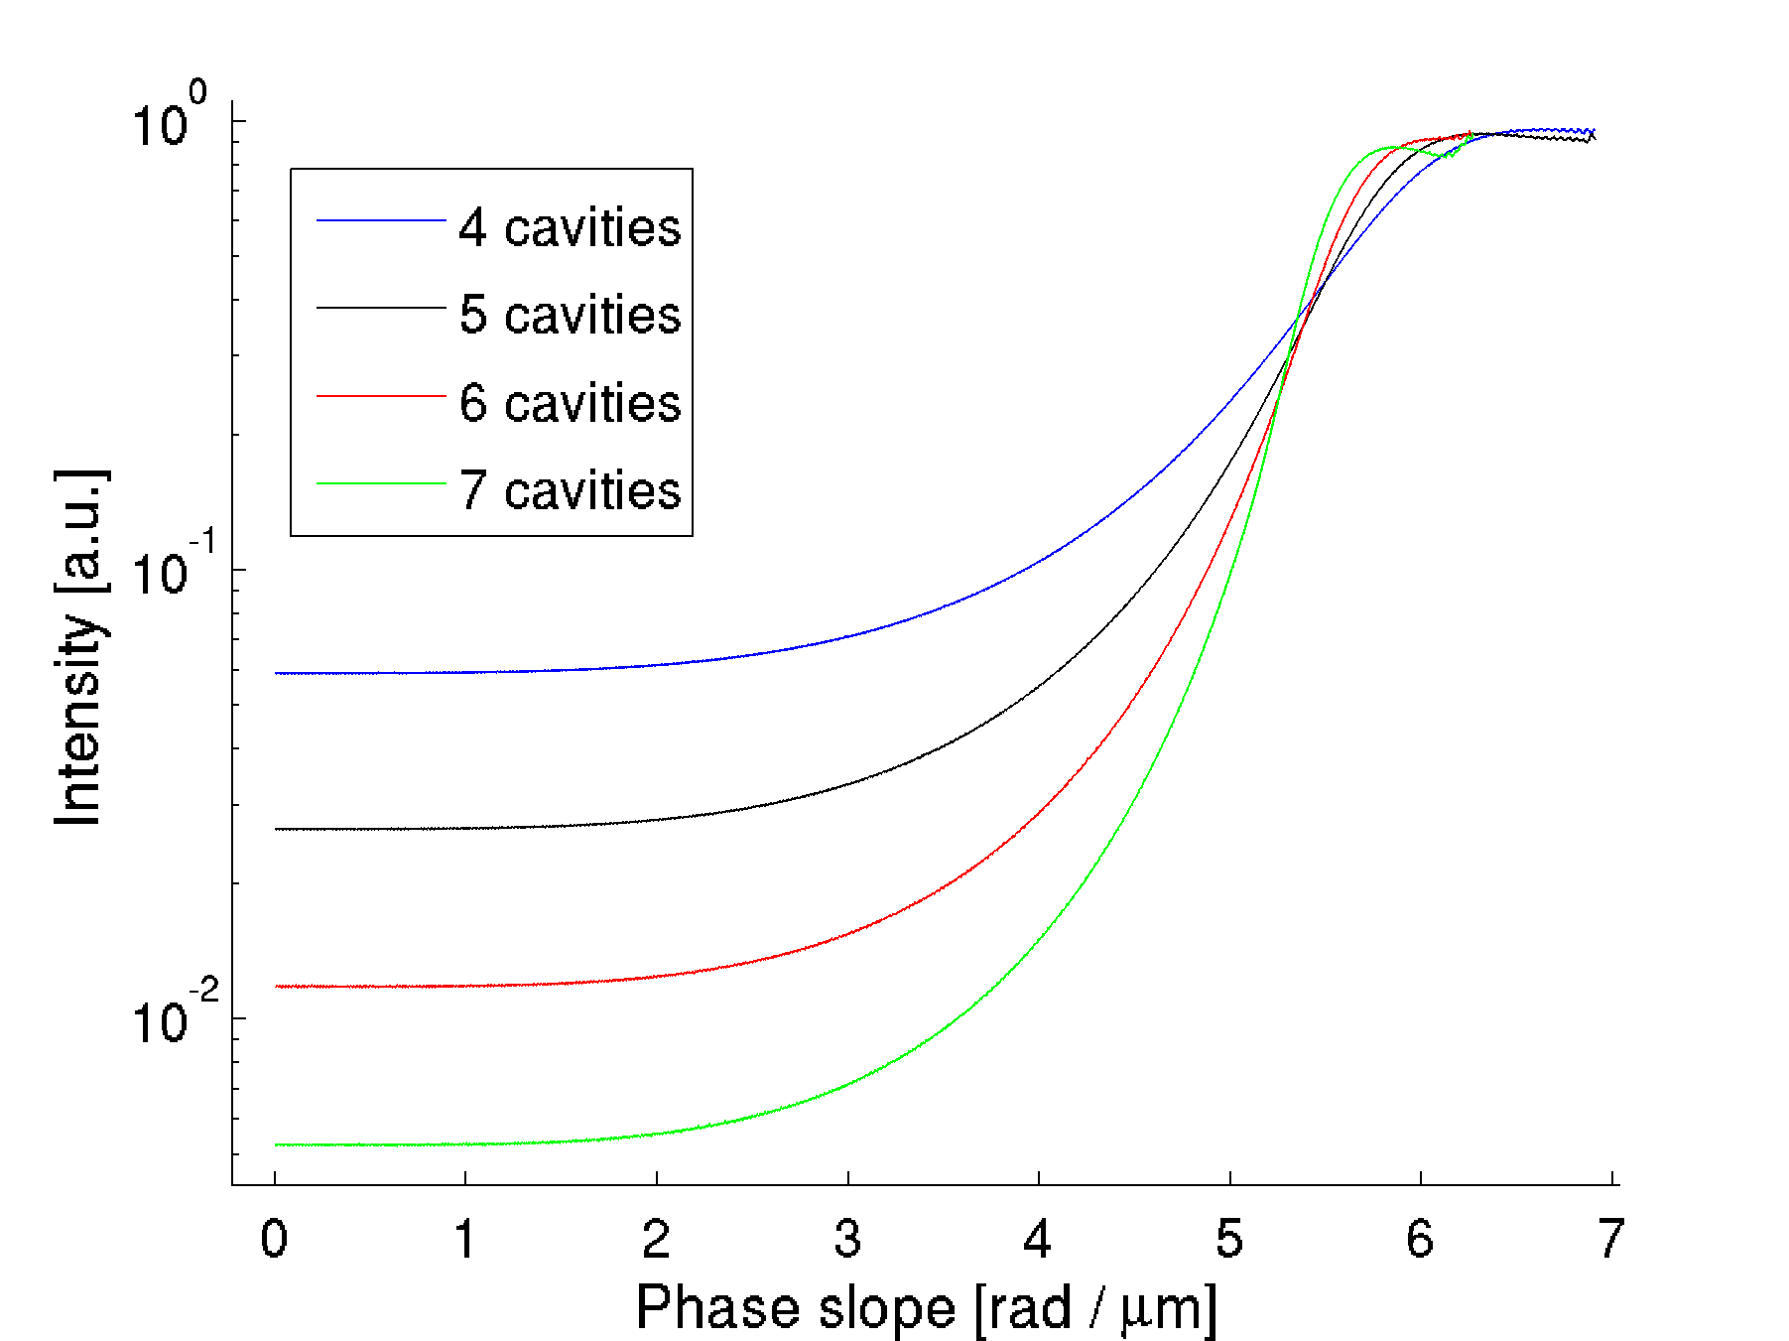
Figure 3: Phase contrast characteristics: output intensity vs. the slope of the phase at the input. The curves correspond to the filters whose point spread functions and transfer functions are presented in Fig. 2ab.

CONCLUSIONS
We use the framework of linear shift-invariant systems (LSI) to optimise and characterise layered metal-insulator metamaterials. In particular, we have demonstrated layered metamaterials with high-pass transfer functions. These structures may be used for far-field imaging. As an example, we show that they may find application as a novel phase visualisation photonic elements.
ACKNOWLEDGEMENTS
We acknowledge support from the Polish National Science Centre projects DEC-2011/01/B/ST3/02281, DEC-2011/01/M/ST3/05734, and from the National Centre for Research and Development project N R15 0018 06, DEC-2011/01/M/ST3/05734 and the framework of European Cooperation in Science and Technology - COST action MP0803.
REFERENCES
- J. B. Pendry: Negative refraction makes a perfect lens, Phys. Rev. Lett. vol. 85, pp. 3966-3969, 2000.
- Z. Liu, H. Lee, Y. Xiong, C. Sun, X. Zhang: Far-Field Optical Hyperlens Magnifying Sub-Diffraction-Limited Objects, Science Vol. 315, 1686, 2007.
- D. O. Melville and R. J. Blaikie: Super-resolution imaging through a planar silver layer, Opt. Express, vol. 13, pp. 2127–2134, 2005.
- B. Wood, J. B. Pendry, and D. P. Tsai: Directed subwavelength imaging using a layered metal-dielectric system, Phys. Rev. B, vol. 74, 115116, 2006.
- D. de Ceglia, M. A. Vincenti, M. G. Cappeddu, M. Centini, N. Akozbek, A. D'Orazio, J. W. Haus, M. J. Bloemer, and M. Scalora: Tailoring metallodielectric structures for superresolution and superguiding applications in the visible and near-ir ranges, Phys. Rev. A, vol. 77, 033848, 2008.
- P. A. Belov, C. Simovski, and P. Ikonen: Canalization of subwavelength images by electro-magnetic crystals, Phys. Rev. B, vol. 71, 193105, 2005.
- R. Kotyński: Fourier optics approach to imaging with sub-wavelength resolution through metal-dielectric multilayers, Opto-Electron. Rev., vol. 18, pp. 366-375, 2010.
- N. Mattiucci, D. Aguanno, M. Scalora, M. J. Bloemer, and C. Sibilia: Transmission function properties for multi-layered structures: Application to superresolution, Opt. Express, vol. 17, pp. 17517-17529, 2009.
- C. P. Moore and R. J. Blaikie, "Experimental characterization of the transfer function for a Silver-dielectric superlens," Optics Express, Vol. 20, Issue 6, pp. 6412-6420, 2012.
- M. Conforti, M. Guasoni, and C. De Angelis: Subwavelength diffraction management, Opt. Lett., vol. 33, pp. 2662-2664, 2008.
- A. Pastuszczak, R. Kotyński: Optimised low-loss multilayers for imaging with sub-wavelength resolution in the visible wavelength range, J. Appl. Phys., vol. 109, 084302, 2011.
- J. J. Miret; D. Pastor; C. J. Zapata-Rodríguez , "Subwavelength surface waves with zero diffraction," J. Nanophoton. 5, 051801, 2011
- R. Kotyński, T. Stefaniuk, and A. Pastuszczak: Sub-wavelength diffraction-free imaging with low-loss metal-dielectric multilayers, Applied Physics A, vol. 103, pp. 905-909, 2011.
- R. Kotyński, H. Baghdasaryan, T. Stefaniuk, A. Pastuszczak, M. Marciniak, A. Lavrinenko, K. Panajotov, T. Szoplik: Sensitivity of imaging properties of metal-dielectric layered flat lens to fabrication inaccuracies, Opto-Electron. Rev., vol. 18, pp. 446-457, 2010.
- P. Shi, K. Huang, and Y.-P. Li, "Enhance the resolution of photonic crystal negative refraction imaging by metal grating," Optics Letters, Vol. 37, Issue 3, pp. 359-361, 2012.
- J. Wang, H. Yuan Dong, K. Hung Fung, T. Jun Cui, and N. X. Fang, "Subwavelength image manipulation through an oblique layered system," Optics Express, Vol. 19, Issue 18, pp. 16809-16820, 2011.
- L. Hi, "Wave classification and resonant excitations in lossy metal-dielectric multilayers," Photonics and Nanostructures - Fundamentals and Applications 8 (3), 2010.
- Y. Jin, "Improving subwavelength resolution of multilayered structures containing negative-permittivity layers by flatting the transmission curves," Progress In Electromagnetics Research, Vol. 105, 347-364, 2010.
- R. Kotyński, T. J. Antosiewicz, K. Król, and K. Panajotov: Two-dimensional point spread matrix of layered metal–dielectric imaging elements, J. Opt. Soc. Am. A, vol 28, pp. 111-117, 2011.
- R. Kotyński, T. Stefaniuk: Multiscale analysis of subwavelength imaging with metal-dielectric multilayers, Opt. Lett. vol. 35, pp. 1133-1135, 2010.

