
OCT v1.0-stable

Creating Installers

Denis SAUNIER, Romain BOUTIN,
Thibaud LAMARCHE, William LE COROLER

Mars 09, 2015


Referring professor: Philippe MESEURE
Table des matières
Windows 3
Download link: 3
Requirements: 3
MAC OS X 9
Deployment for MAC OS X 9
Debian/Ubuntu 10
Download link: 10
Requirements: 10
Building: 10

Windows
To create an installer for Windows, we use the software Inno Setup Compiler. Inno Setup Compiler is a software program released under a free license. it works on several versions of Windows (from Windows 2000 to Windows 8) 32 and 64 bits. It manages the installation, uninstallation, and custom installations (Full Compact, Custom,...) and creates shortcuts and multilingual management.

Download link:
http://www.jrsoftware.org/isdl.php

Requirements:
You must compile OCT in release mode, retrieve the adequate dll for Qt and QtAV.

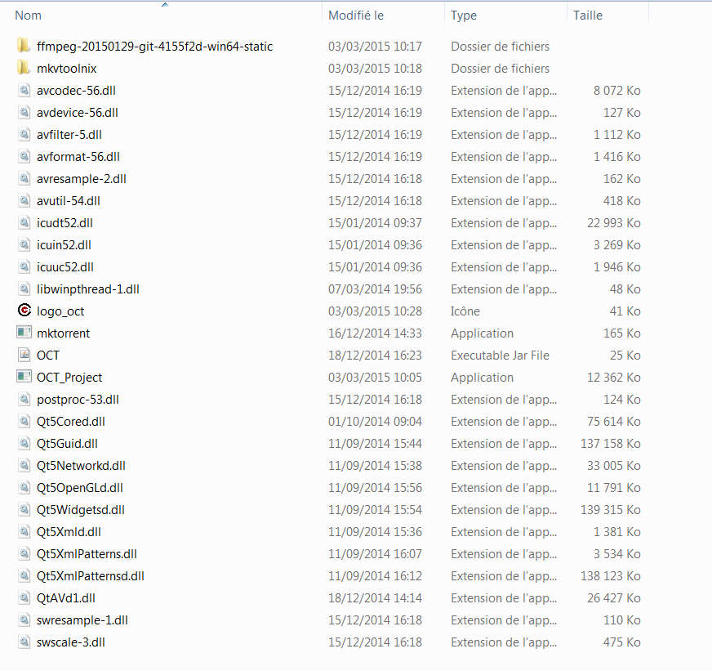

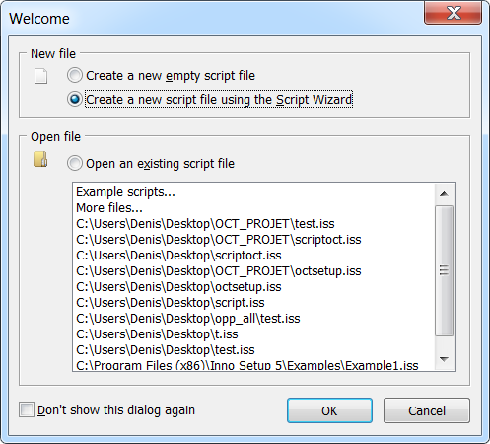
Your installation folder is ready, you can start “Inno Setup Compiler”. You must choose “Create a new script file using the Script Wizrad” and press OK then "NEXT".
In the following window, you can fill the application name, its version and the name of the organization. Then press "NEXT".
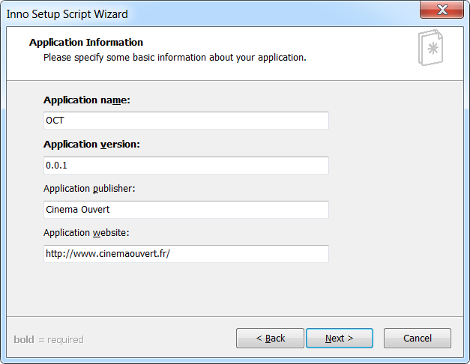
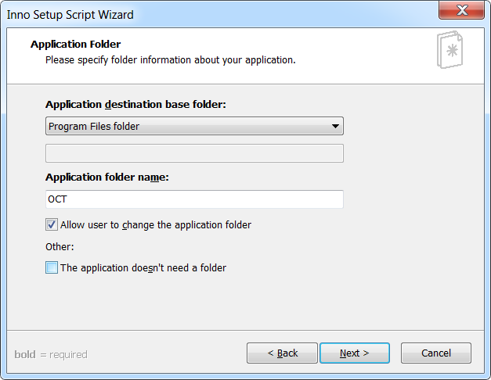
In the following window, you have to choose the installation folder of OCT (Default: Program Files). Then press "NEXT".
In the following window, choose the executable OCT then add the folder with Dlls that you have prepared. Then press "NEXT".
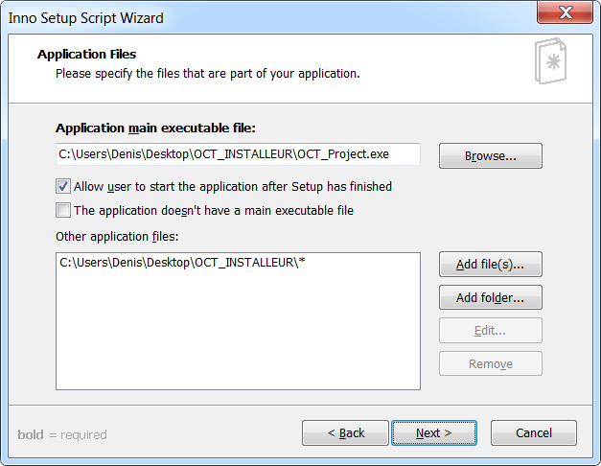
In the following window, you have to choose the name of the folder that will be created in the Start menu. Then you can create desktop shortcuts for the Uninstall. Then press "NEXT".
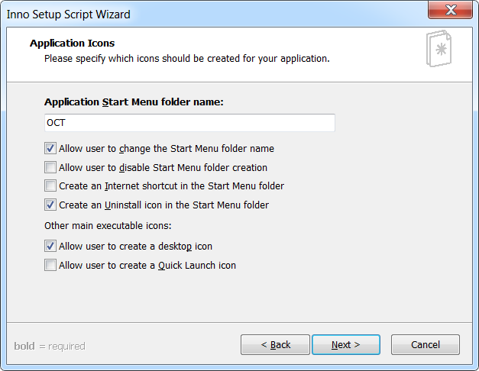

In the following window, you can add the license for OCT. Then press "NEXT".
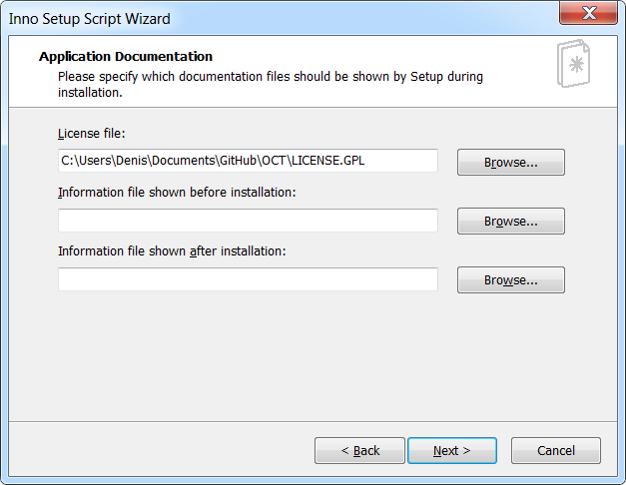
In the following window, you can add languages for installation of OCT. Then press "NEXT".
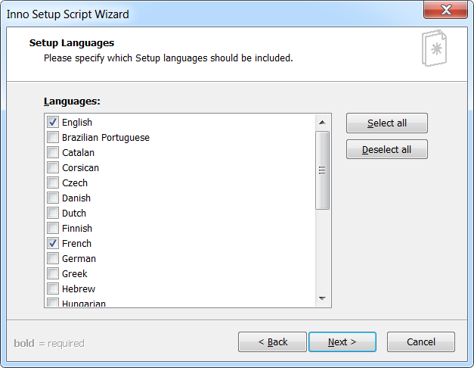

In the following window, you have to choose the name of the installer and then you can put an icon to it. Then press "NEXT".
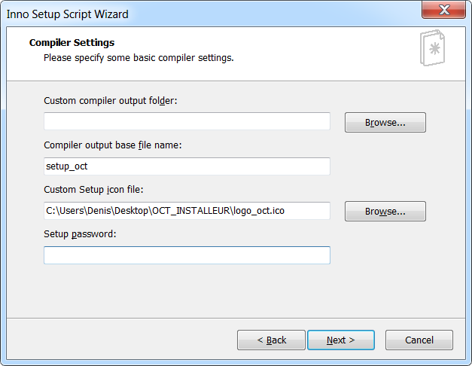
Finally, press “NEXT” then “FINISH”. The software asks you to compile, press “NO” if you want to add an icon for the software.
In the generated script, there is a tag [Icons] for each of the lines below, add at the end:
; IconFileName: "path to icon.ico"
Now you can compile the script, go to the “Build and Compile” menu. An “Output” folder will be created on your desktop with the installer.

MAC OS X

Deployment for MAC OS X

If you have to deploy oct on MAC OS X, you must first compile oct on MAC on release mode. You'll find in the output directory the bundle created by QT called "oct.app".

Then, you use "macdeployqt" which is the Qt tool which puts the Qt ".framework" directories into our bundle "Frameworks" directory. It puts the .dylib binary files from Qt into the "Plugins" directory and automates the change of dependencies path in the ".framework" directories executables and the Qt plugins. It's located in the "bin" folder from the Qt directory installed on your computer.

Note that to do this manually you have to copy all the concerned dependencies from the Qt folder in good directories of the "oct.app" bundle. Then you have to use "otool" in command line to display the id of the binaries files and the path of their dependencies (including the "oct" executable in "oct.app/Contents/MacOs/", the "oct.app/Frameworks" content and the "oct.app/Plugins" content). Finally you have to use "install_name_tool" in command line to change the identifiers and the dependencies paths into the several binary files.

Note that the qt code embedded into your software has to know where to search the Qt's ".framework" files and the Qt's plugins used. To do that we add the following lines into the "main" function in "main.cpp":

#if defined( Q_OS_MAC )
QStringList libPaths;
libPaths << a.applicationDirPath() + "/../PlugIns";
QApplication::setLibraryPaths( libPaths );
#endif

If we don't do this, the executable "oct" won't work on computers with the Qt librarie installed. The mac linker will load the Qt's dependencies from the oct bundle whereas the executable "oct" will load the Qt's dependencies from the Qt directory installed on the computer. The consequence will be that the oct couldn't be launch and there will be an error saying that we try to launch two time the same dynamic library.

Debian/Ubuntu
To create an installer for Debian or Ubuntu, download “Debreate package”, it is an open source software.

Download link:
http://debreate.sourceforge.net/?page=download

Requirements:
You must compile OPP in release mode to generate the adequate executable for the operating system.

Building:
Start “Debreate” and create a new project. It starts a window were you have to fill all the informations.
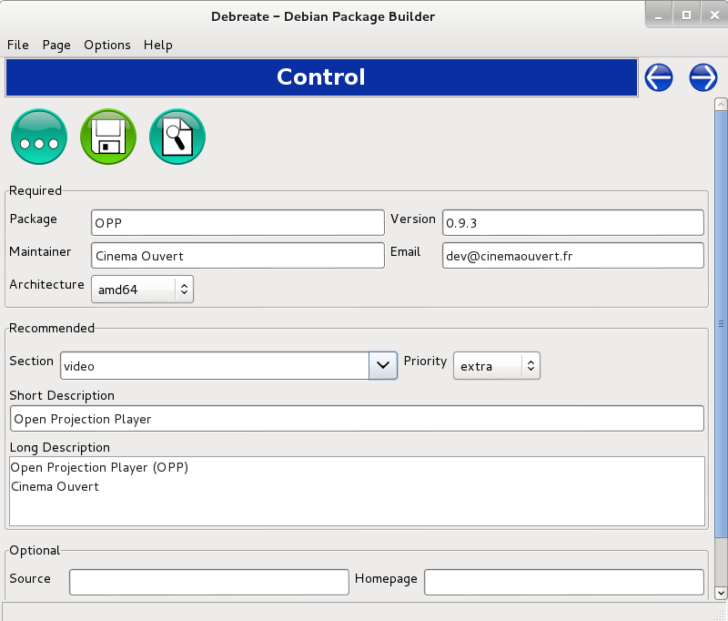

The following window shows the dependencies to install the package. In the window you need to add the necessary libraries
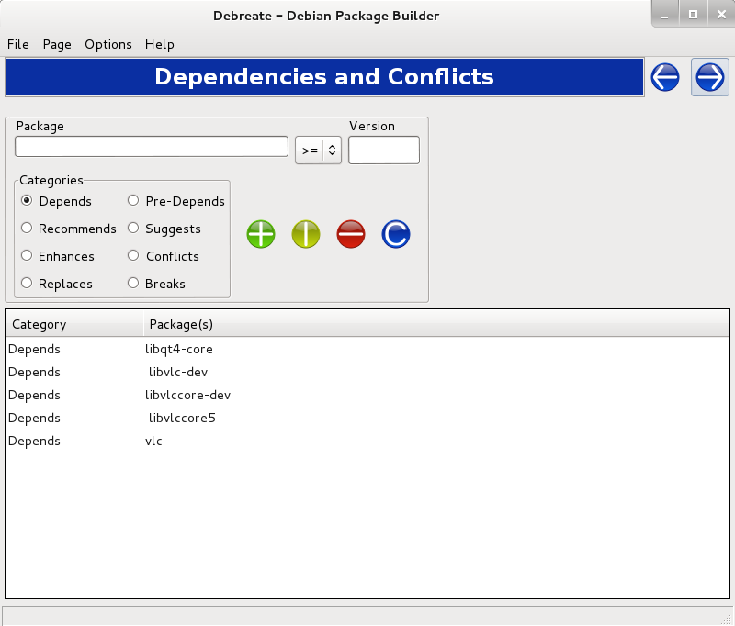

The following window shows the files required to install the package. Add executable, icon.
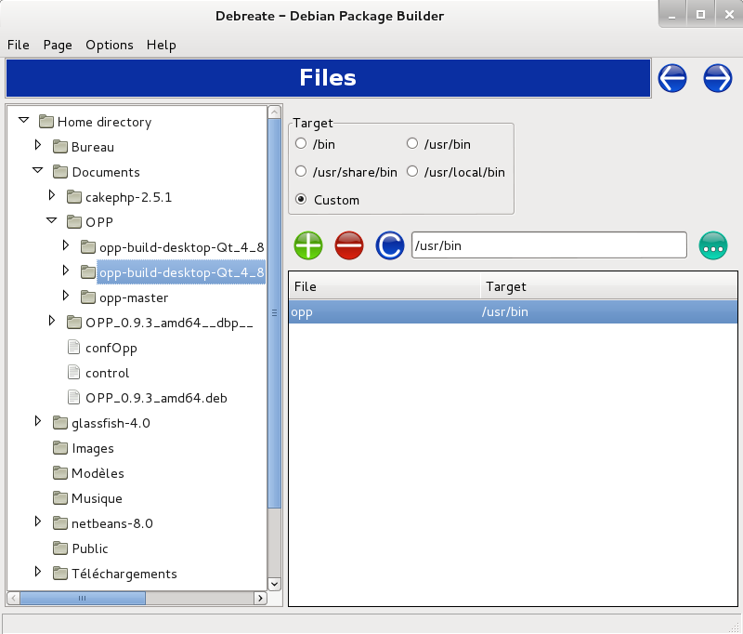

The following window shows logs for the package creation.
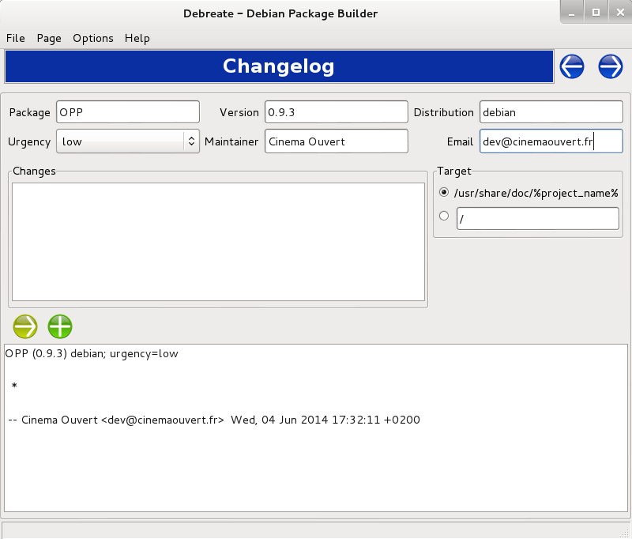
The following window shows the license of the software, copy the opp license in this window.
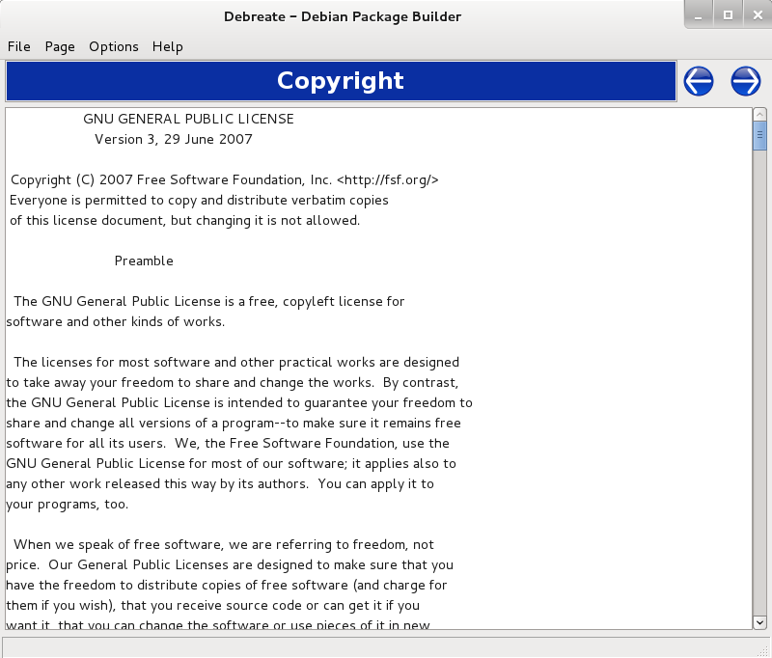
The following window shows the menu launcher, you need to add path to icon and category.
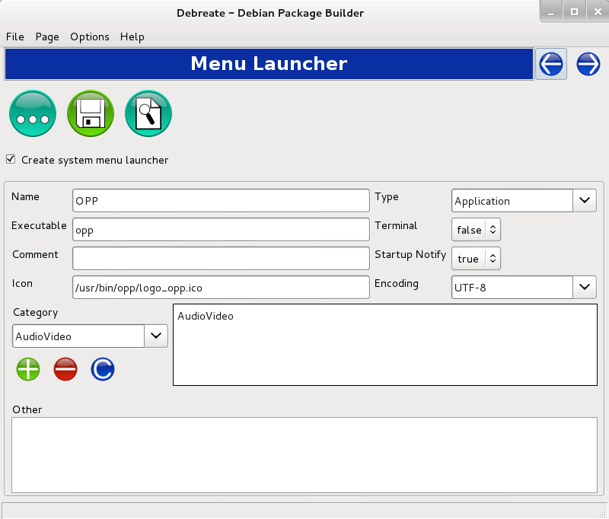
The following window shows the building step, choose create md5sums file and press build button.

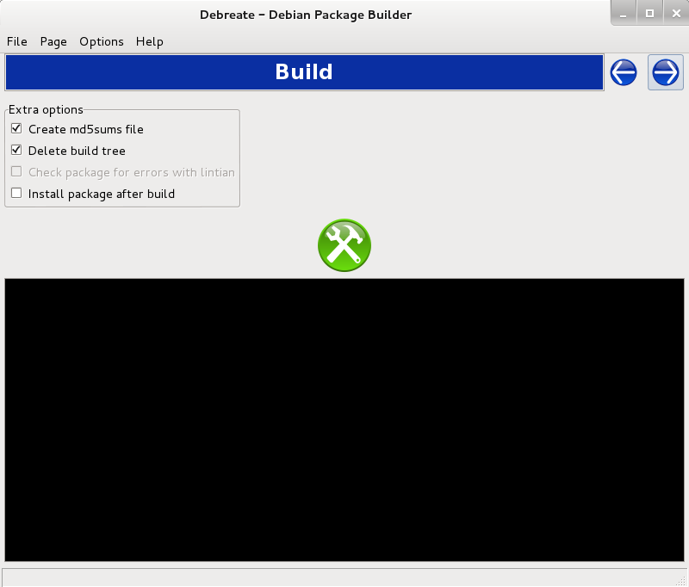

The deb file is generated with the name of the operating system with its version and his architecture.

