

OCT v1.0-stable

Maintenance Manual

Denis SAUNIER, Romain BOUTIN,
Thibaud LAMARCHE, William LE COROLER

Mars 09, 2015


Referring professor: Philippe MESEURE

Diffusion list

Version follow

Table des matières
OCT v1.0-stable 1
Maintenance Manual 1
1.Diffusion list 2
2.Version follow 2
3.Introduction 5
1Constraints 5
4.Analysis 5
1Use case diagram 5
2Class Diagram 1
5.Class description 2
1Model 2
Attachment 2
Audio 2
Database 2
File 3
OCPMValidation 3
Parameter 3
Project 4
Serializable 4
Stream 4
StreamWrapper 4
Subtitle 5
Video 5
2View 5
AudioPane 5
EncodePane 6
FilePane 6
InformationPane 6
MainWindow 7
MyDelegate 7
MyModel 7
ParametersDialogue 7
QueueListView 8
SubtitlePane 8
VideoPane 8
VideoPlayer 8
3Controller 9
Exporter 9
LoggerSingleton 9
Merger 9
OCTDispatcher 9
Transcoder 10
TreatmentThread 10
Updater 10
Utils 10
6.Maintenance 11
1Dependencies 11
2Compilation 11
3Change version number of OCT 11
4Update 11
5Creating installers 12
6Licence 12
7.Deployment 13
1Translation 13
2Installers 13
3Generate the Doxygen 13

Introduction

Constraints

This project contains some constraints :
- in order to evolve (with the community help), the software must be released under a free license (GNU GPL License).
- the software must deal with multiple platforms such as Linux, Mac OS and Windows, in this specific order because Linux is aimed at the programmers community to allow further development, Mac OS because it is used by a large portion of projectionists and finally Windows to ensure that the software is available for a larger group of people.

Analysis

Use case diagram

In this software the user must be able to do several actions, this use case diagram is there to represent it :
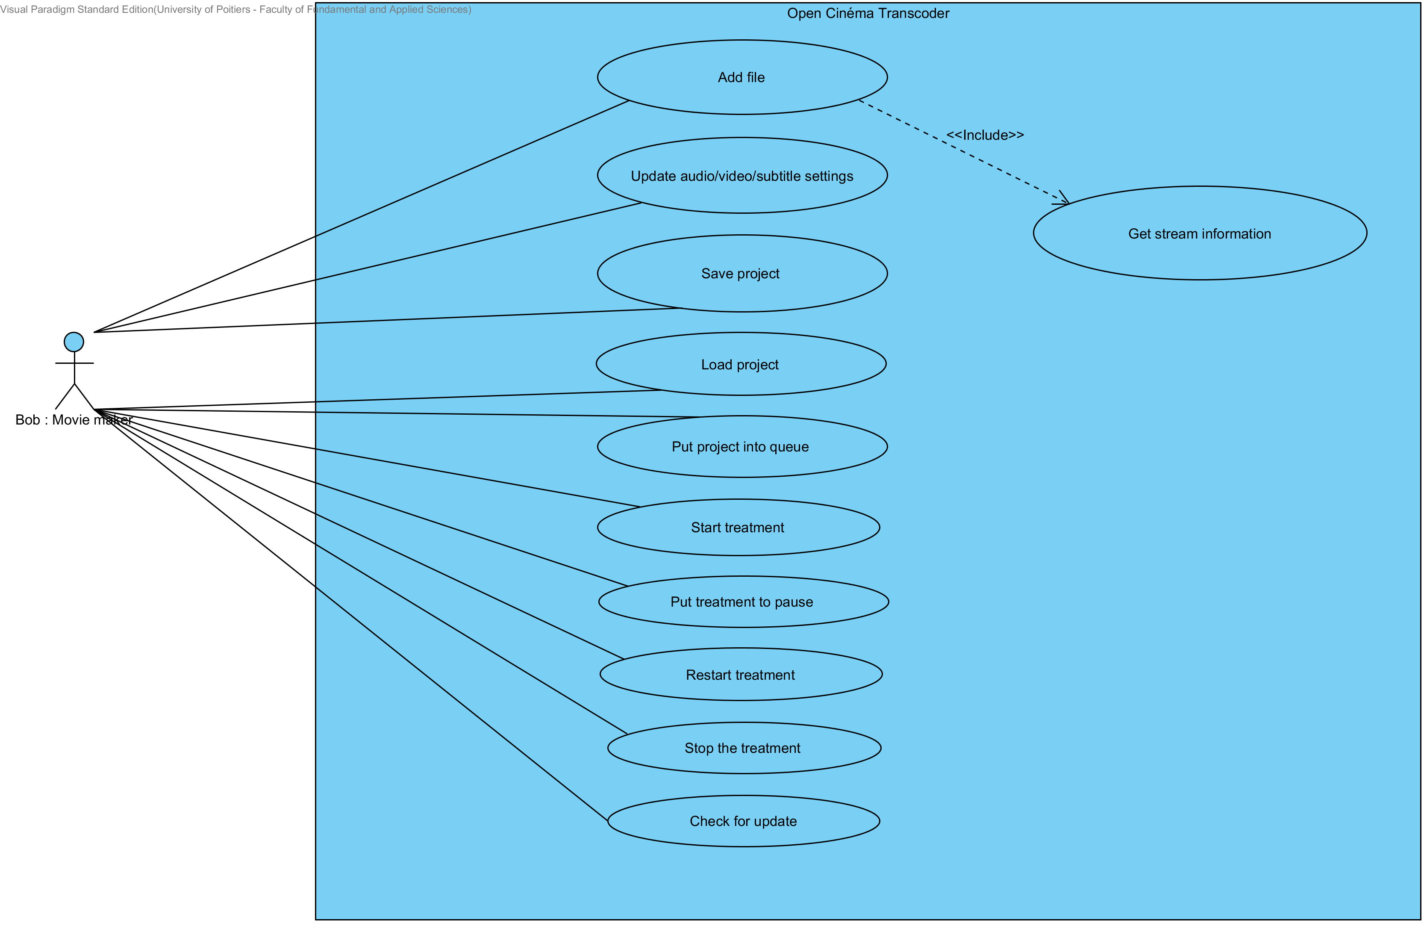

Class Diagram

The software is following the MVC pattern.
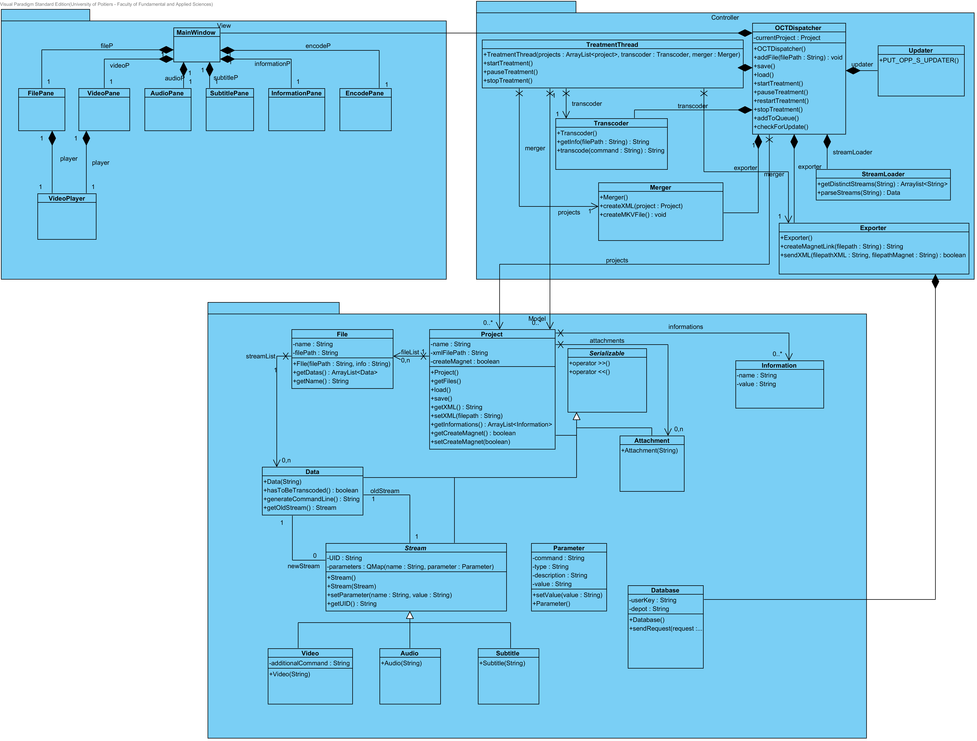
Here you can see the architecture of the software.

Class description

Model

Attachment
Name | Attachment.cpp / Attachment.h
Description | Attachment is used to manage attachment file information.  Attachment file is all except video, audio and subtitle file.
Interaction | Project, OCTDispatcher, FilePane, InformationPane,
Critical aspect

Audio
Name | Audio.cpp / Audio.h
Description | Audio class inherits of Stream  Audio is used to manage audio file information and parameters.  It create an Audio object from an XML producted by ffprobe.
Interaction | File, OCPMValidation, Project, StreamWrapper, OCTDispatcher, AudioPane, FilePane, MainWindow
Critical aspect | Constructor is based on XML producted by ffprobe.

Database
Name | Database.cpp / Database.h
Description | Database class is used to manage web service CODB-Depot. It send and get information in JSON from this web service
Interaction | Export
Critical aspect | Require the Internet connection

File
Name | File.cpp / File.h
Description | File is used to manage all input File except Attachment.  Constructor determine number and type of sreams contained in the file.
Interaction | Project, OCTDispatcher, TreatmentThread, AudioPane, FilePane, MainWindow, SubtitlePane, VideoPane
Critical aspect | identification of streams type is based on XML producted by ffprobe.

OCPMValidation
Name | OCPMValidation.cpp / OCPMValidation.h
Description | OCPMValidation is used to load / check validation  it also uses to load preconfiguration
Interaction | OCTDispatcher, AudioPane, FilePane, InformationPane, SubtitlePane, VideoPane
Critical aspect | load file from XML formated as OCPT recommendation

Parameter
Name | Parameter.cpp / Parameter.h
Description | Parameter is used to manage streams parameters.  it contains commande line used to transcode a stream.
Interaction | Audio, File, OCPMValidation, Stream, Subtitle, Video, OCTDispatcher, AudioPane, FilePane, SubtitlePane, VideoPane
Critical aspect

Project
Name | Project.cpp / Project.h
Description | Project is used to manage the global project.  it create commande line for the transcoder and the merger
Interaction | Exporter, Merger, OCTDispatcher, TreatmentThread, and all classes form View
Critical aspect

Serializable
Name | Serializable.cpp / Serializable.h
Description | Init serializable values for all the model
Interaction | Used by the OCTDispatcher in the constructor
Critical aspect

Stream
Name | Stream.cpp / Stream.h
Description | superclass of Audio, Subtitle and VIdeo
Interaction | same as Audio, Subtitle and Video
Critical aspect

StreamWrapper
Name | StreamWrapper.cpp / StreamWrapper.h
Description | StreamWrapper is used to manage a stream.  it contains two stream, the original and one with the modification to apply
Interaction | same as Audio, Subtitle and Video
Critical aspect

Subtitle
Name | Subtitle.cpp / Subtitle.h
Description | Subtitle class inherits of Stream  Subtitle is used to manage subtitle file information and parameters.  It create an Subtitle object from an XML producted by ffprobe.
Interaction | File, OCPMValidation, Project, StreamWrapper, OCTDispatcher, FilePane, MainWindow, SubtitlePane
Critical aspect | Constructor is based on XML producted by ffprobe.

Video
Name | Video.cpp / Video.h
Description | Video class inherits of Stream  Video is used to manage audio file information and parameters.  It create an Video object from an XML producted by ffprobe.
Interaction | File, OCPMValidation, Project, StreamWrapper, OCTDispatcher, FilePane, MainWindow, VideoPane
Critical aspect | Constructor is based on XML producted by ffprobe.

View

AudioPane
Name | AudioPane.cpp / AudioPane.h
Description | AudioPane is used to manage audiopane.ui  it shows informations about audio input file and allow operation on them
Interaction | MainWindow
Critical aspect

EncodePane
Name | EncodePane.cpp / EncodePane.h
Description | EncodePane is used to manage EncodePane.ui  it shows informations about the project and allow operation on them
Interaction | MainWindow
Critical aspect

FilePane
Name | FilePane.cpp / FilePane.h
Description | FilePane is used to manage FilePane.ui  it shows informations about files and streams contained in the project.  it allows add / remove file from the project.  it also shows if file is valide about OCPM .
Interaction | MainWindow
Critical aspect | refresh method particulary fat!

InformationPane
Name | InformationPane.cpp / InformationPane.h
Description | InformationPane is used to manage InformationPane.ui  it allows to fill in OCPM information field
Interaction | MainWindow
Critical aspect

MainWindow
Name | MainWindow.cpp / MainWindow.h
Description | MainWindow is used to manage MainWindow.ui  it is used to create all pane of the window according to the file contained on the project
Interaction
Critical aspect

MyDelegate
Name | MyDelegate.cpp / MyDelegate.h
Description | MyDelegate is used to manage the QListView on EncodePane
Interaction | EncodePane, FilePane
Critical aspect

MyModel
Name | MyModel.cpp / MyModel.h
Description | MyModel is used to manage the QTableView on FilePane
Interaction | FilePane
Critical aspect

ParametersDialogue
Name | ParametersDialogue.cpp / ParametersDialogue.h
Description | Class used to display the parameters window used to manage settings
Interaction | Opened by the MainWindow
Critical aspect

QueueListView
Name | QueueListView.cpp / QueueListView.h
Description | This class extends the QListView to manage the project list displayed in the encode pane
Interaction | Used in the encode pane
Critical aspect

SubtitlePane
Name | SubtitlePane.cpp / SubtitlePane.h
Description | SubtitlePane is used to manage SubtitlePane.ui  it shows informations about Subtitle input file and allow operation on them
Interaction | MainWindow
Critical aspect

VideoPane
Name | VideoPane.cpp / VideoPane.h
Description | VideoPane is used to manage VideoPane.ui  it shows informations about Video input file and allow operation on them
Interaction | MainWindow
Critical aspect

VideoPlayer
Name | VideoPlayer.cpp / VideoPlayer.h
Description | Used to display the video streams
Interaction | Used in video and subtitle panes
Critical aspect

Controller

Exporter
Name | Exporter.cpp / Exporter.h
Description | Exporter is used to interact with the database, it also used to create magnet Link and Torrent.
Interaction | OCTDispatcher, TreatmentThread
Critical aspect | Require mkTorrent, OCT.jar, and a the Internet connection

LoggerSingleton
Name | LoggerSingleton.cpp / LoggerSingleton.h
Description | This loggerSingleton to display the log in the interface and in a log file
Interaction | used by the qApp to redirect qDebug qWarning …
Critical aspect

Merger
Name | Merger.cpp/ Merger.h
Description | Merge is used to merge files on a MKV via MKVmerge.
Interaction | OCTDispatcher
Critical aspect

OCTDispatcher
Name | OCTDispatcher.cpp / OCTDispatcher.h
Description | OCTDispatcher is used to manage all the program. It’s the “main” class
Interaction | All
Critical aspect

Transcoder
Name | Transcoder.cpp / Transcoder.h
Description | Transcoder is used to transcode stream / file via ffmpeg. It also used to get informations from file via ffprobe.
Interaction | OCTDispatcher
Critical aspect

TreatmentThread
Name | TreatmentThread.cpp / TreatmentThread.h
Description | TreatmentThread is used to execute Operation like merge or transcode on a thread.
Interaction | OCTDispatcher
Critical aspect

Updater
Name | Updater.cpp / Updater.h
Description | Updater is used to manage and update the version of the program
Interaction | Used in the MainWindow
Critical aspect

Utils
Name | Utils.cpp / Utils.h
Description | Utils is a class with static methods like convertion methods, md5, sha-1
Interaction
Critical aspect

Maintenance

Dependencies

The software uses these libraries:
- MKVtoolnix (used to merge file on MKV)
- ffmpeg (used to get information from file and transcode)
- QtAV (used for the videoplayer on the HCI)
- MKTorrent: (used to create the torrent file)
- CODB-Depot: (database needed to share mkv and know the actual OCPM recommendation)
- QtNetwork to manage the conenction to the BDD
- QtXml & XMLPattern to manage the ffmpeg informations

Compilation

The compilation can be done on Windows, Linux and MacOs with QtCreator.
For more explanation, take a look at this link:
How to compile

Change version number of OCT

The version number of the software program is shown in the configOCT.h file. To modify the version, you must change the value of the variable “VERSION”.

//va.b.c
// a = number for the release
// b = number for the minor version
// c = number for the small changement
const QString VERSION = "v0.0.1";

Update

To upgrade OCT, the software checks the version number from the release on the http://cinemaouvert.fr/ website.
The web tree is http://cinemaouvert.fr/update/OCT/ “NAME OF OS” / latest /
In the folder “latest”, you can find the installer and a file “version.txt” with the version number inside.

If you want to update the name of the installers, take a look at the file configOCT.h.

Creating installers

We have created an installer for several operating system. For Windows, we generate an installer with “Inno Setup Compiler”, for Ubuntu/Debian a .deb with “Debreate” and for Mac OS a .pkg with “packageManager”.

Licence

The software is delivered under the version 3 of the GNU GPL license. For all details about GPL license, refer to the following page http://www.gnu.org/licenses/gpl.html

Deployment

Translation
The software use a translation system. The default language is English, the other languages can be integrated from translation files.
How to How to translate

Installers
We have created an installer for several operating system. For Windows, we generate an installer with “Inno Setup Compiler”, for Ubuntu/Debian a .deb with “Debreate” and for Mac OS a .pkg with “packageManager”.
How to create an installer

Generate the Doxygen
To generate the Doxygen documentation, you can download Doxywizard and install Doxywizard with Graphviz.
Download link: http://www.stack.nl/~dimitri/doxygen/manual/doxywizard_usage.html
Then, you must get doxyFile on your local repository of OCT and run Doxywizard with the doxyFile.

