

OPP v0.5-dev

Maintenance Manual

Denis SAUNIER, Geoffrey BERGE,
Thibaud LAMARCHE, Thomas BERTHOME

June 04, 2014


Referring professor: Agnès ARNOULD

Diffusion list

Version follow

Summary
Diffusion list 2
Version follow 2
Introduction 4
Project background 4
Constraints 4
Analysis 5
First analysis 5
Current analysis 7
Class diagram 7
Core 7
User interface 8
Class description 9
MainWindow 9
Maintenance 10
Translation 10
Compilation 10
Installers 10
Plug-in 10
Update 10
Add a media setting (clamp to the media and saved) 10
Change the version number 10
Generate the Doxygen 10

Introduction

Project background
We were asked to take over the realization of a movie management software for the non profit organization “Catalogue Ouvert du Cinéma” (COC). The main goal of this organization is to promote independent cinema such as : movies under free license, movies moved to public domain or even short films. This project is based on the fact that, cinema associations are often making projections without necessary tools. They usually end up using a simple personal laptop with VLC on it to project the films, which usually creates some problems such as : the projectionist desktop showing on the screen or difficulties to set the good audio balance between movies.
The main goal of this project is then to carry on with the software development, to correct, and finalize an existing software in order to allow a projectionist to manage a play-list of movies which will be displayed on a screen. The projectionist would have a little sample of the running movies on his screen in order to have a feedback of the projection. He should be able to manage the sequence of the projection, the programming and the specific audio balance for each movie.

Constraints
This project contains some constraints :
- in order to evolve (with the community help), the software must be released under a free license (GNU GPL License).
- the software must deal with multiple platforms such as Linux, Mac OS and Windows, in this specific order because Linux is aimed at the programmers community to allow further development, Mac OS because it is used by a large portion of projectionists and finally Windows to ensure that the software is available for a larger group of people.
- The taking over of the existing project started by last year's group with all the difficulties thus generated.

Analysis
A year ago a group of students of the university of Poitiers started this project. This is their analysis of the project.

First analysis

Quote:
Authors : Baptiste Roziere, Cyril Naud, Florian Mhun, Hamza Haddar
The figure below represents our use case diagram, which illustrates the different use cases and main functions of our system. Also, it represents the main ways to use the software.
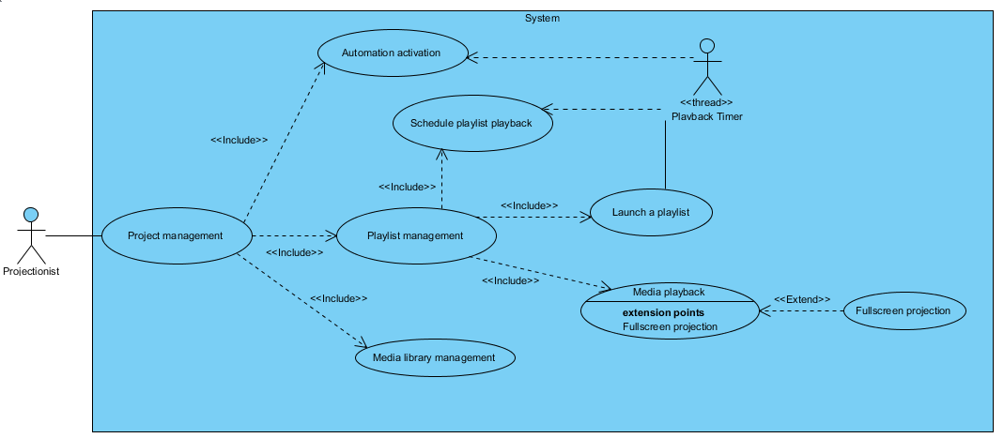
Project management, playlist management, schedule playlist playback, automation... represent the different use cases (functions) of our system. We can see that there are relationships between them. For example, the relationship “include” between Playlist management and Media playback means that, to achieve the objective Playlist management, we use the objective (use case) Media playback. And as we can see, we have chosen to represent the timer that triggers the playing of playlist as an actor.

Class diagram

Quote:
Authors : Baptiste Roziere, Cyril Naud, Florian Mhun, Hamza Haddar
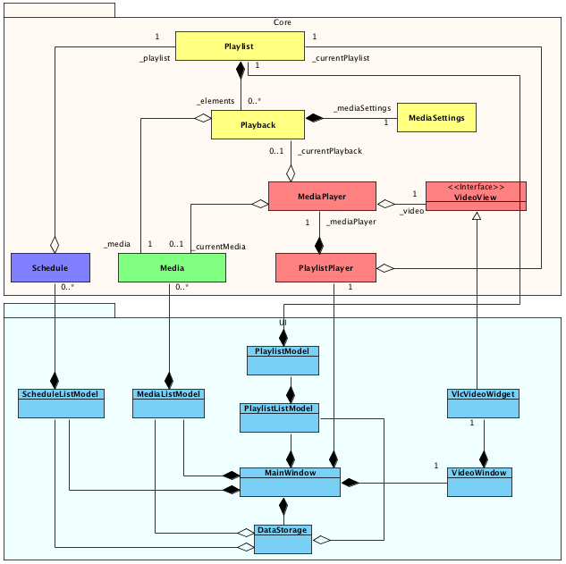

Model View using Qt

Quote:
Authors : Baptiste Roziere, Cyril Naud, Florian Mhun, Hamza Haddar
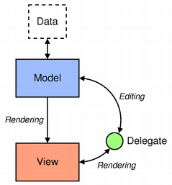
The Qt model view is designed as follow :

This concept is mainly used to render lists with Qt. There are three entities, the model, the view and, optionally, a delegate. Technically, we implement the model/view by subclassing abstract Qt classes and overloading methods.
The model is bound to a data source. In our case, data were media list, schedule list, playlist (list of playback). We have not yet implemented the model/view for playlist list but we are working on it.
The model provides methods that change data state like insert, remove, modify and sort items.
When the data changes, the model automatically applies the rendering into the view.
The view is just responsible of rendering data into a Qt component. We used only QTableView to display data in a table but other components exists, like QTreeView which can render data with a hierarchical structure.
The delegate is not required to deal with model/view programming. In fact, sometimes you need to handle behavior between the model’s data state and the view rendering. The delegate acts as a “proxy” object between the model and the view.
For example, when the user double clicks onto an item, the delegate can turn the item label text into a combobox and let the user edit the entry. Then when the user submits a change, the delegate is responsible to modify item’s data through the model.

Current analysis
As you can see in the first analysis the software is separated in two parts, the core and the user interface.

Class diagram

Core
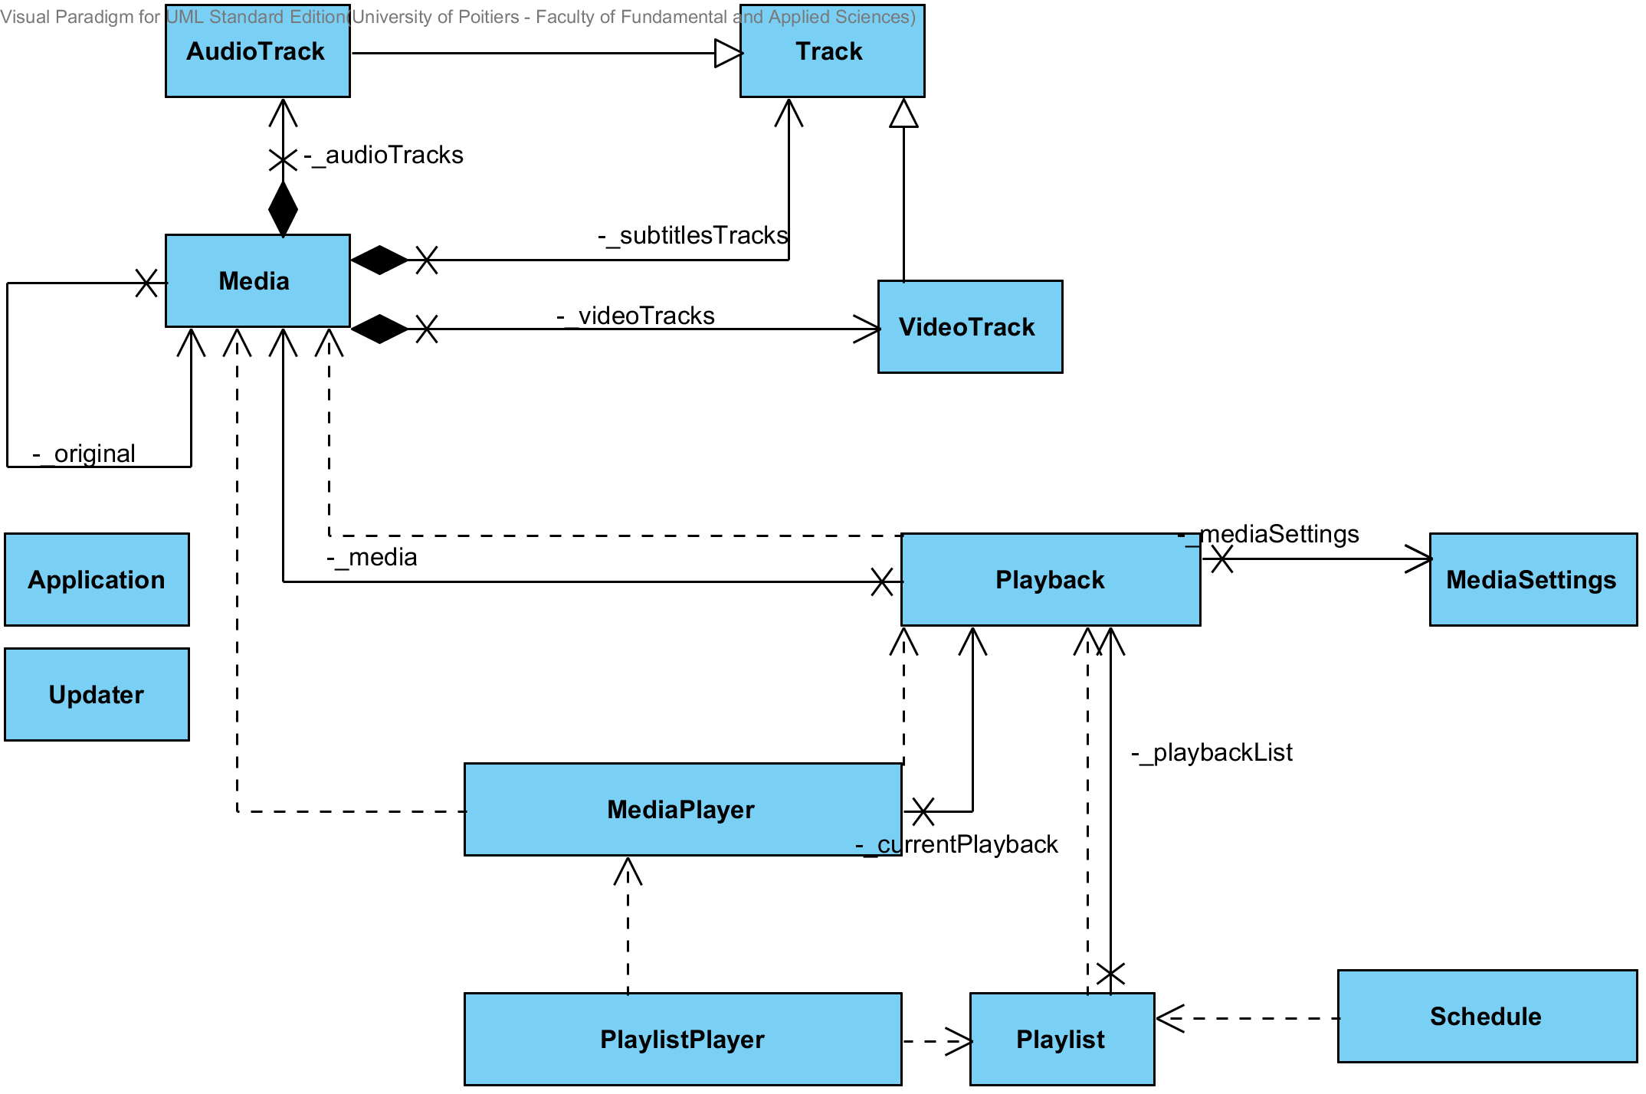

User interface
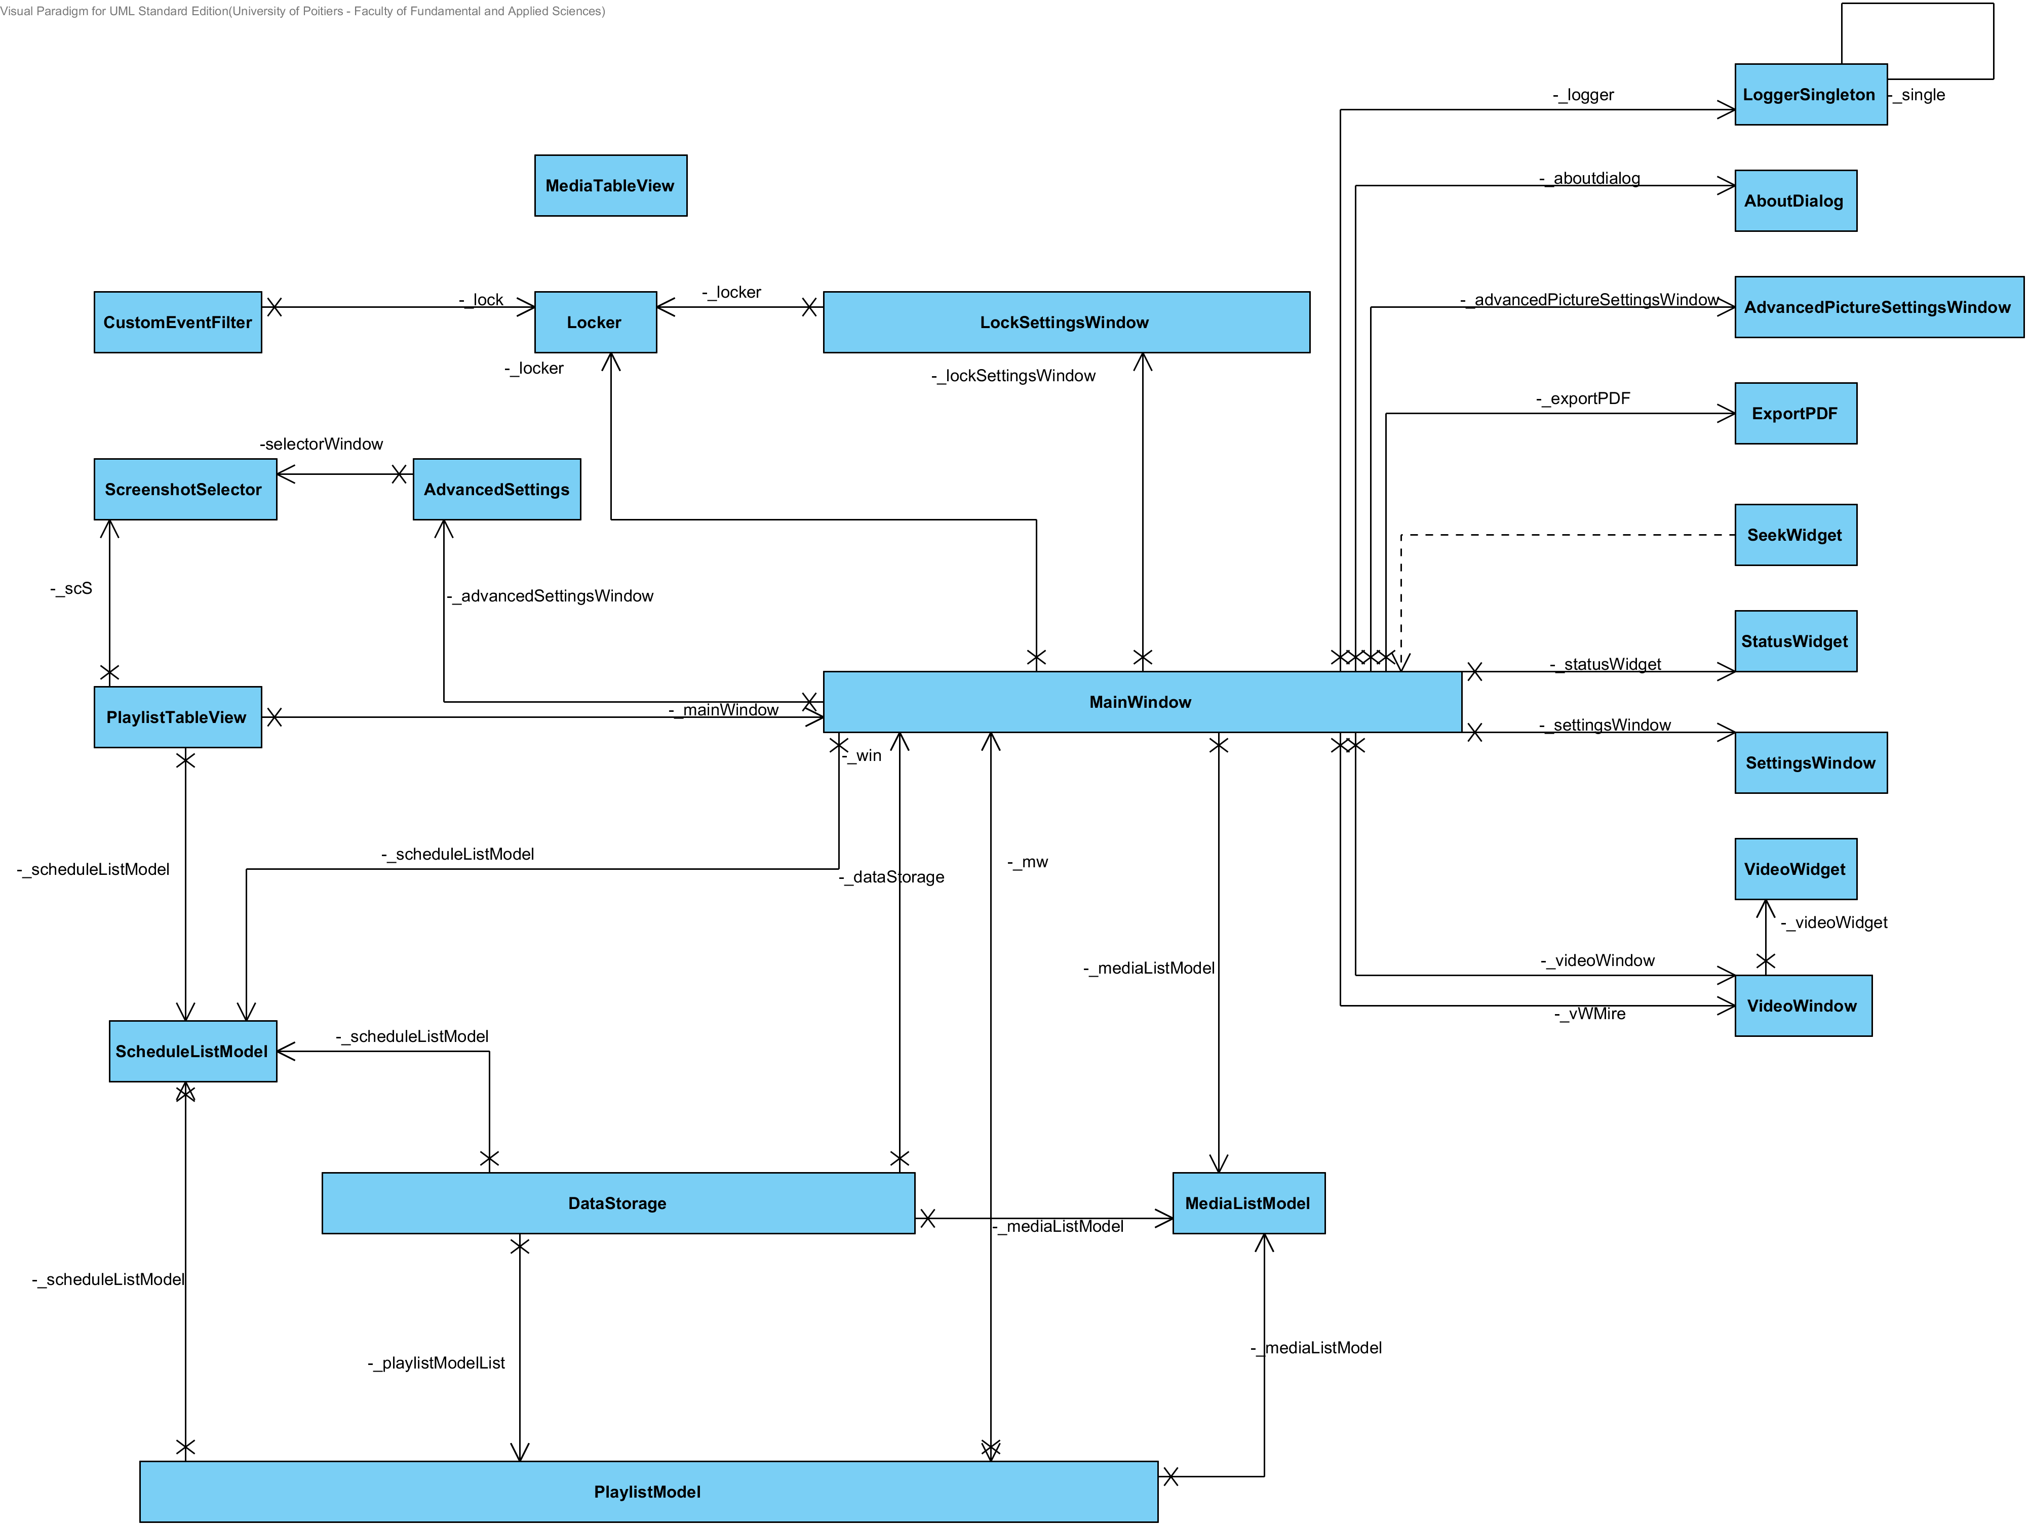

Class description

VideoWindow

VideoWidget

Utils

StatusWidget

SettingsWindow

SeekWidget

ScreenshotSelector

ScheduleListModel

PlaylistTableView

PlaylistModel

MediaTableView

MediaListModel

Maintenance

Dependencies
This software uses the vlc library, it was tested with several libvlc versions (from 2.0.8 to 2.1.4). Then, it uses QtNetwork, to upgrade OPP, QtWebkit, to export the schedule to PDF, and QtXml, to save.

Compilation
The compilation can be done on Windows, Linux and MacOs with QtCreator.
For more explanation, take a look at this link:
How to compile

Plug-in
To create a plug-in, you must use the OPP library. Then, you must create a new project with a class that implements a plug-in interface declared in OPP.
For more explanation, take a look at this link:
How to create a plug-in

Change the version number
The version number of the software program is shown in the config.h file. To modify the version, you must change the value of the variable “VERSION”.

Update
To upgrade OPP, the software checks the version number from the release on the http://cinemaouvert.fr/ website.
The web tree is http://cinemaouvert.fr/update/ “NAME OF OS” / latest /
In the folder “latest”, you can find the installer and a file “version.txt” with the version number inside.

Add a media setting (clamp to the media and saved)
To add a media setting like “gamma”, you must create a getter and a setter for the setting in MediaSetting class. Then, a signal for the setting like “gammaChanged(gamma)”.

In the MediaPlayer class, you must create a setter:
setCurrentGamma(float)

In this setter, you must call a libvlc method (the one you want to apply).
libvlc_video_set_adjust_float(_vlcMediaPlayer, libvlc_adjust_Gamma, gamma)

Then, you must connect the setting in the “open()” method:
connect(_currentPlayback->mediaSettings(), SIGNAL(gammaChanged(float)), this, SLOT(setCurrentGamma(float)));

In the “close()” method, you must disconnect the setting:
disconnect(playback->mediaSettings(), SIGNAL(gammaChanged(float)), this, SLOT(setCurrentGamma(float)));

Finally, you must add the setter in the “applyCurrentPlaybackSettings()” method.

To save the setting, you must add this line in the Datastorage class in a save method:
playback.setAttribute("gamma", playbackElement->mediaSettings()->gamma());

And to load the setting, you must add it in the “load()” method:
settings->setGamma( playbackAttributes.namedItem("gamma").nodeValue().toFloat());

License
The software is delivered under the version 3 of the GNU GPL license. For all details about GPL
license, refer to the following page http://www.gnu.org/licenses/gpl.html

Deployment

Translation
The software use a translation system. The default language is English, the other languages can be integrated from translation files.
How to translate

Installers
We have created an installer for several operating system. For Windows, we generate an installer with “Inno Setup Compiler”, for Ubuntu/Debian a .deb with “Debreate” and for Mac OS a .pkg with “packageManager”.
How to create an installer

Generate the Doxygen
To generate the Doxygen documentation, you can download Doxywizard and install Doxywizard with Graphviz.
Download link: http://www.stack.nl/~dimitri/doxygen/manual/doxywizard_usage.html
Then, you must get doxyFile on your local repository of OPP and run Doxywizard with the doxyFile.

Users documentation
In order to properly launch the users documentation you need to place it into the folder « help »
and name it « usersDocumentation.pdf ».

