|  |
| --- |
| FONTYS |
| Light Camp |
| Project Agenda week 1 to 14 |
|  |
| **Constantine Indjov** |
| **6/11/2013** |

Week 1

1. Name

The name we picked is Light Camp since the event that we are going to organize will be focused on a lot of light effects and there will be parties during the night.

2. Logo

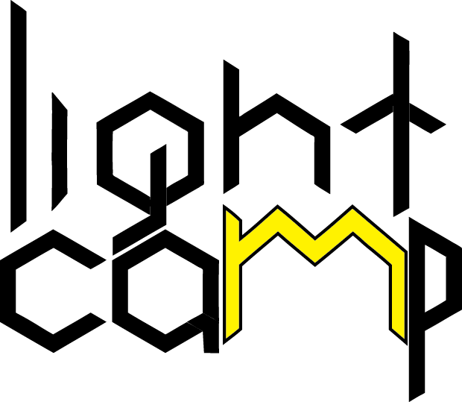

The logo is suited with the idea of the camp and the “M” can be referenced as a tent with the yellow colour symbolizing the light.

3. Project plan (beginning)

* Roles

The first thing before planning the work is distributing the roles and deciding how to split the work.

|  |  |
| --- | --- |
| Nikolai | Secretary / Programming |
| Konstantin | Presenter / Databases / Websites |
| Zhen | Programming / Websites |
| Vladimir | Databases / Programming |

These roles are not permanent and according to the work we need to do, we might change them.

* Database

We start creating the ERD design.

If we finish it early enough, we will start working on the Relational model.

**Tools : Oracle Data Modeler**

* Programming

Start planning and designing UML Class Diagrams

**Tools : Microsoft Visual Studio 2010**

**4. Questions**

**Programming**

What information should be given with the application “for the organization to inspect the status of the event”?

**General**

Is it our concern the relations between the manager of the event and the employees, musicians etc (for salaries, work shifts )

# Week 2

## 1. Expected time & Role distribution

Expected time - around 2h.

Actual time taken : 1h 20 mins

For this week all the group members worked together.

## 2. Functionality

• Application for entrance of event

- Checking if the person has valid registration (using confirmation number)

- Assign the money account to the entrant, once he goes in. (In case the person who bought ticket and put money in the account doesn’t come - the money amount in his payment account are refunded. Entrance fee isn’t)

• Application for entrance of camping

- Check if the entrant has valid reservation (using his confirmation number)

• Application for the shops

- List of beverages that are available (menu)

- Make GUI for the bar, so that the employee can use it to create the order.

- Transfer the money amount out of the visitor’s account, according to the beverage he bought.

• Application for stands where you can loan materials

- List of materials we have available for renting.

- Keep track of quantities

- Assign the material to the visitor, who uses it

- Renting fee (taken after usage, depending if the rented material is returned in the same condition as when it was rented) – uses the interface for payment.

• Application to be used when a visitor leaves the event

- Check his current account balance. Refund, if there’s any amount available.

- Close his account and mark the he left the event (used for status app)

## 4. Questions

- What is the “status of the visitor” concerning the status application?

- Do we need to create functionality for charging your account?

- How is the registration done? Should we create GUI for the entrance, where the confirmation number of the visitor is checked ?

- Once we have clear functionality is it good to start with the UML diagrams?

- Website design – We don’t have a lot of web design skills yet, so maybe we’ll delay with 1 or 2 weeks doing the design of the site, until we study some more things.

# WEEK 3

## 1. Role distribution

For this week all the group members worked together.

## 2. Functional requirements

1. Entrance

1.1. Check validation number

1.2. Change status of the visitor

1.3. Update status of the event (current visitors)

1.4. Check reservation number

2. Food bar

2.1. Get lists of different product categories

2.2. Make order list

2.3. Clear order list

2.4. Place & Pay Order

3. Loan stand

3.1. Get lists of different materials (available ones)

3.2. Start renting material – changes the status of the material, assigns it to the visitor who uses it

3.3. Return & Pay – changes the status of the material back to available, calculates total price + possible damage costs

4. Checkout

4.1. Change status of the visitor

4.2. Transfer back remaining money from his event account

4.3. Change status of the event (current visitors)

4.4. Check for not-returned materials from the stand

5. Status application

5.1. Get number of current visitors

5.2. Get number of all who visited the event

5.3. Get ratio between males & females

5.4. Search for visitor

3. Application design

According to the functional requirements, applications are being designed to deliver that functionality.

# WEEK 4

Nikolay & Leo – work on website version 1

Konstantin & Vladimir – Continuing work on application design and ERD (+Leo).

# WEEK 5 & 6

Leo & Nikolai – working on ERD, according to the functional and non-functional requirements

Konstantin & Vladimir – finalizing general application design and start creating classes, covering the needed information and functionality for C#.

# WEEK 7

Group work on making entrance app and creating all the general classes. Continuous work on databases, synchronizing the fields with the C# applications and preparing for future connection between c# and our databse.

# WEEK 9 & 10

Making a database & C# connection.

Leo Chen – Working on Snack bar & Material App

Nikolai – continuous work on the site, starts PHP part.

Vladimir & Konstantin – using the database connection finish the methods, which need to be filled with code used for entrance app & registering new client functionality.

# WEEK 11 & 12

Group work, discussing the progress of the applications and continuous work on finishing the C# applications and connections.

Website – connection to the database and making working php forms.

# WEEK 13

Group work on finalizing all connections (both php-db & c#-db) and working functionality. Testing and organizing final document work.