<https://github.com/cinnamonbreakfast/flcd/tree/main/lab3final>

**Lab Final Documentation**

|  |  |  |  |
| --- | --- | --- | --- |
| Function | Pre-condition | Post-condition | Observations |
| Detect(program) | <program>: string – valid name for an input source file | <program>_PIF.out : contains PIF data  <program>_ST.out : contains ST data | Using Regex to fetch the program, then send the tokens through filters |
| is_ident_const(cod) | cod : token | Boolean | Function checks if the current token is an identifier or constant |
| is_reserved(cod) | cod : token | Boolean | Checks if the current token is a reserved work or token. |

Both ST and PIF are built on HashTable. The Analyzer is build using Functional Programming, using the functions documented above.

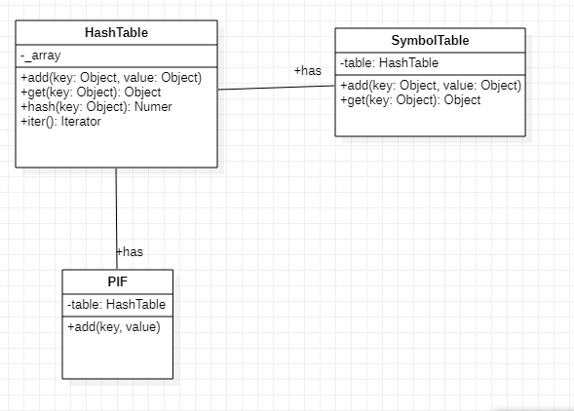

**Run Example:**

Code:

p1.in

entry {  
 int number;  
  
 number = 0;  
  
 if(number < 5) {  
 WRITE("RANDOMSTRING");  
 }  
}

p1_ST.out

Using HashTable for data representation  
  
[]  
[['5', 0]]  
[]  
[['number', 0], ['0', 0], ['"RANDOMSTRING"', 0]]

P1_PIF.out

('entry', 0)  
('{', 0)  
('int', 0)  
('number', [3, 0])  
(';', 0)  
('=', 0)  
('0', [3, 1])  
(';', 0)  
('if', 0)  
('(', 0)  
('<', 0)  
('5', [1, 0])  
(')', 0)  
('{', 0)  
('WRITE', 0)  
('(', 0)  
('"RANDOMSTRING"', [3, 2])  
(')', 0)  
(';', 0)  
('}', 0)  
('}', 0)

**Error handling:**

We’ll take P1 and add some errors:

entry {  
 int number;  
  
 +number = -0;  
  
 if(number < 5) {  
 WRITE("RANDOMSTRING);  
 }  
}

Console:

Lexical error for +number at line 4

Lexical error for -0 at line 4

Lexical error for "RANDOMSTRING at line 7

ST:

Using HashTable for data representation  
  
[]  
[['number', 0]]  
[['5', 0]]  
[]

PIF:

('entry', 0)  
('{', 0)  
('int', 0)  
('number', [1, 0])  
(';', 0)  
('=', 0)  
(';', 0)  
('if', 0)  
('(', 0)  
('<', 0)  
('5', [2, 0])  
(')', 0)  
('{', 0)  
('WRITE', 0)  
('(', 0)  
(')', 0)  
(';', 0)  
('}', 0)  
('}', 0)