Strategic Buyer Outreach Platform
Consolidated Business Analyst Specification — v2.0
Velocity Capital
Prepared for: Jeremy Pak
Date: 25 May 2026
Status: Specification consolidated post inputs deep dive. Ready for build.

1. Executive Summary
This document specifies the requirements for a reusable, multi-mandate strategic buyer outreach platform for Velocity Capital. The platform automates the enrichment, sequenced email outreach, NDA execution, and pipeline tracking of strategic and financial buyers across sell-side M&A processes. The advisor retains full control through Human-in-the-Loop (HITL) checkpoints at every email send and at all client-facing decisions.
This version (v2.0) supersedes v1.0 and incorporates all decisions from the inputs deep dive completed on 25 May 2026 — including the simplified mandate setup (deal strategy, buyer scope, and client sign-off are intentionally kept outside the platform), the up-to-6 contact model, the geographic-aware persona waterfall, and the three NDA execution paths.
1.1 Goal
Deliver a Java + Embabel platform that ingests advisor-curated seed lists from comparables.ai, enriches buyer contacts through a vendor waterfall, runs templated four-touch email sequences with multi-recipient staggering, executes NDAs through DocuSign with two-party countersignature, and provides a unified multi-mandate dashboard.
1.2 Volume Profile
Dimension | Volume
Mandates per year | 10–20
Buyers per mandate | 5–50
Contacts per buyer (max) | 6 — up to 5 from comparables.ai + 1 agent-discovered
Emails per contact | Up to 4 (Day 0 / Day 3 / Day 7 / Day 14)
Max emails per mandate | ~1,200 sends (50 × 6 × 4)
Maximum sequence tail (no replies) | ~24 days per buyer

1.3 Success Metrics
- Email response rate per mandate.
- NDAs signed per mandate (buyer-signed and fully countersigned).
- Sequence completion rate — proportion of contacts reaching a terminal state.
1.4 Pain Points Addressed
Today's pain point | Platform resolution
Time loss on contact identification and copy-paste | Automated enrichment waterfall + LinkedIn discovery. Estimated 70–80% time recovery per mandate.
Forgotten follow-ups (replies buried in inbox) | Auto reply detection + sequence pause + dashboard review queue.
Forgotten NDAs (1–2 day lag from yes to send) | One-click NDA send from review queue + stale-NDA alerts + DocuSign reminders.
No unified multi-mandate tool | Single platform for enrichment, sequencing, NDA execution, and pipeline tracking.

1.5 Out of Scope
- Buyer identification and shortlisting — Rogo and comparables.ai remain manual upstream tools.
- Target company details, deal strategy, and buyer scope criteria — kept outside the platform.
- Client sign-off on buyer list and exclusion list — done outside the platform.
- LinkedIn scraping — manual Sales Navigator + RocketReach profile workflow only.
- Per-buyer customisation of Flyer or NDA documents — generic only.
- LLM-generated personalisation of outbound emails — templates with merge fields only.
- Auto-reply to inbound buyer emails — agent triages and recommends; advisor replies.
- Mandate handoff beyond meeting-confirmed terminal state.
- Client-facing portal access.

2. System Architecture
The platform is a Java application built on the Embabel agent framework with Spring Boot service layer and PostgreSQL state store. The agent orchestrates multi-step workflows but defers to the advisor at every outbound send and at specified enrichment gates. LLM use is limited to deterministic tasks — reply classification and NDA diff detection. Outbound email content is fully template-driven with no generative content.
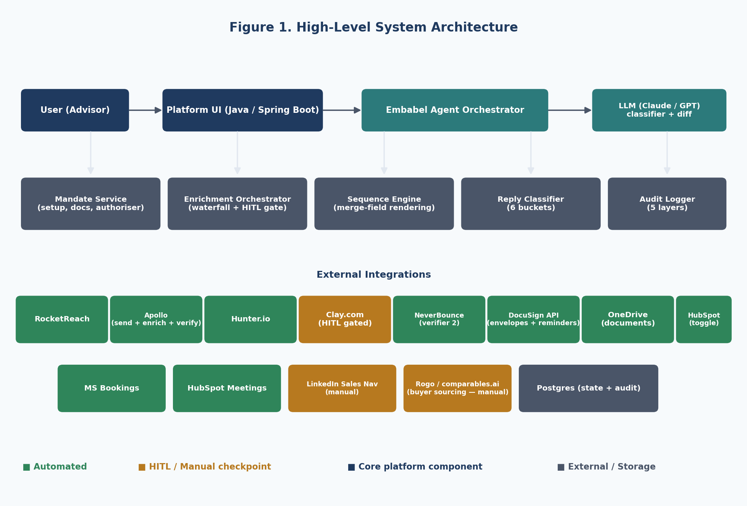
Figure 1. High-level system architecture.
2.1 Technology Stack
Layer | Technology | Notes
Agent framework | Embabel (greenfield) | Hard requirement; no version constraint
Language / runtime | Java 21 | LTS
Service framework | Spring Boot 3.x | REST APIs, scheduling
LLM (primary) | Claude Sonnet (latest) | Reply classification + NDA diff
LLM (fallback) | OpenAI GPT-class | Resilience on outage
Database | PostgreSQL 16 | State + JSONB audit payloads
Hosting | Cloud-agnostic | No residency constraint; AWS ap-southeast-2 recommended
Frontend | React + TypeScript | Single-page UI

2.2 External Integrations
Integration | Purpose | Auth model
RocketReach API | Enrichment 1 (auto) | API key
Apollo API | Enrichment 2 + sending + verifier 1 | API key + domain auth
Hunter.io API | Enrichment 3 + verifier 3 | API key
Clay.com | Optional enrichment behind HITL gate | API key / webhook
NeverBounce API | Verifier 2 | API key
DocuSign eSignature REST API | NDA envelopes + reminders + countersign routing | OAuth (JWT grant)
Microsoft OneDrive (Graph API) | Source folder for documents | OAuth (delegated)
Microsoft Bookings (Graph API) | Meeting scheduler — option A | OAuth (delegated)
HubSpot API | CRM logging + Meetings scheduler (togglable) | OAuth
Google Search API | LinkedIn URL discovery (fuzzy match) | API key
LinkedIn Sales Navigator | Manual workflow only (no API integration) | n/a

3. Mandate Setup
Mandate setup captures only what the platform needs to execute outreach. Deal strategy, buyer scope, target company details, and client sign-off all remain outside the platform by design — they belong in the advisor's upstream workflow and client relationship.
3.1 Mandate Setup Form Fields
Field | Requirement | Notes
Mandate name | Mandatory | Single field doubles as project code; used in dashboards
Mandate status | Auto | Draft / Active / On Hold / Closed
Lead advisor | Mandatory | Defaults to logged-in user
Sender mailbox | Mandatory | Defaults to outreach@velocitycapital.co.nz; manual override field
Sender display name | Mandatory | Defaults to lead advisor
Sender signature | Mandatory | Rich-text; per-mandate override
Sequence template | Mandatory | Selected from library; copied for per-mandate editing
Flyer PDF | Mandatory | File upload preferred; OneDrive path as alternative
NDA PDF (signable) | Mandatory | Generic; buyer fills entity at signing OR pre-fill at send
NDA Word doc (redline fallback) | Mandatory | Includes {{buyer_entity_name}} token if pre-fill mode is to be supported
NDA Authoriser — name + email | Mandatory | Per-mandate, per-buyer override allowed
Meeting scheduler | Mandatory toggle | MS Bookings or HubSpot Meetings
Default meeting length | Mandatory | Single default per mandate
HubSpot integration | Optional toggle | Off by default until HubSpot stood up
Exclusion list (XLSX) | Optional | Cross-referenced against buyer list at import
Compliance footer | Toggle | On in spec; may be turned off at build time

3.2 What Is Intentionally Outside the Platform
- Conversation with the seller-client about strategic buyers.
- Buyer research and shortlisting work in Rogo and comparables.ai.
- Target company name, sector, revenue, EBITDA, deal thesis.
- Buyer-type mix, geographic scope, size band criteria.
- Client sign-off documentation and approval workflow.
- Wet-ink NDA chasing prior to platform upload.

4. Buyer and Contact Ingestion
The advisor uploads two files exported from comparables.ai — a Companies file and a Contacts file — plus an optional Exclusion List. The platform fuzzy-joins these and produces buyer and contact records, runs exclusion checks, and prepares for enrichment.
4.1 Source Files (per mandate)
File | Source | Required columns
Companies XLSX | comparables.ai company export | company_name (legal entity), country, website
Contacts XLSX | comparables.ai contacts export | company_name (entity reference), contact_name, contact_role
Exclusion list XLSX (optional) | Advisor-curated | company_name, optional website_domain

4.2 Cross-Reference and Join Logic
- Companies and Contacts files are joined on entity name with fuzzy matching (corporate suffixes normalised — Ltd, Limited, Pty, Inc, Holdings, etc.).
- Each buyer ingests with up to 5 contacts from the Contacts file.
- If a row in the Contacts file has no matching company row, it is flagged for user review.
- If a company row has no matching contact rows, the buyer is created with zero seed contacts and routed to agent-discovery (Section 5.2).
4.3 Validation Rules
- Reject rows without a buyer company name or without at least one priority contact name (post-join).
- Treat "n.a", "N/A", "NA", "-", and empty string as null on all fields.
- Soft-warn on duplicate buyers within the same upload — ask user to merge or treat as distinct.
- Hard-block on buyer already present in the current mandate — refuse re-import.
- Soft-warn on buyer present in another active mandate — show which mandate, ask to proceed.
- Soft-warn on buyer matching prior opted-out in this mandate.
4.4 Exclusion List Cross-Reference
- Match on company name AND website domain (fuzzy logic on name, exact on domain).
- If match found: hard warning to user with side-by-side comparison; user must explicitly confirm override to proceed; otherwise the buyer is blocked from outreach for this mandate.
- Audit log records every exclusion match decision (override or block).
4.5 Domain Resolution
- If the supplied website domain redirects (e.g., parent-company website), the platform follows the redirect and uses the resolved domain for enrichment.
- If the domain resolves to a parking page or domain squatter, the agent flags as suspicious; user confirms or corrects before enrichment.
4.6 Incremental Additions
The seed list is append-only after kickoff. New buyers can be added to an in-flight mandate by uploading a delta XLSX. Existing buyers cannot be deleted once enrichment or outreach has commenced — they can only be marked Opted Out or On Hold.
5. Contact Enrichment
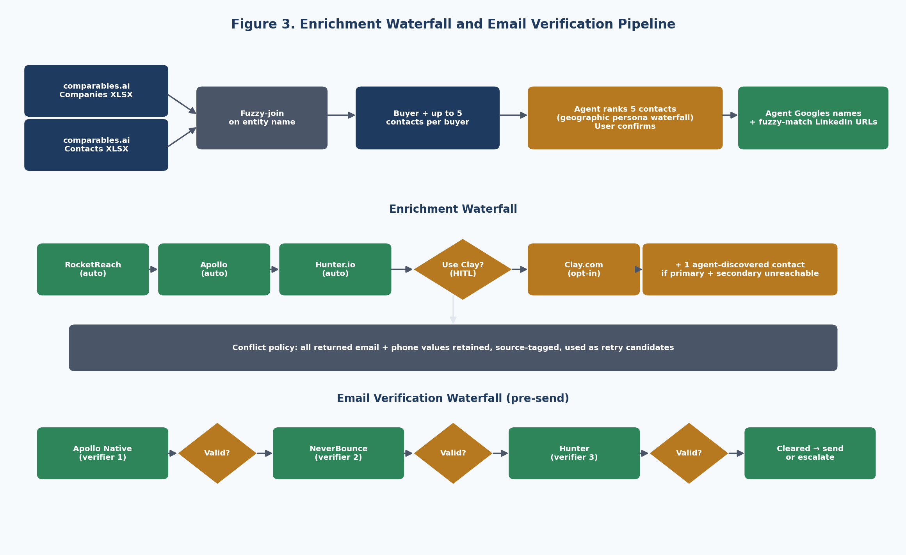
Figure 3. Enrichment waterfall and email verification pipeline.
5.1 Contact Stack Per Buyer
Source | Count | Notes
comparables.ai contacts file | Up to 5 | Imported as seed (name + role)
Agent-discovered (Google + LinkedIn fuzzy match) | 1 additional | Activated when primary + secondary cannot be reached
Maximum per buyer | 6 | Hard cap

5.2 Persona Waterfall (geographic-aware)
Used by the agent to rank the seed contacts (primary → quinary) and to drive tertiary-contact discovery when primary + secondary are unreachable.
Buyer country group | Recommended persona order
AU / NZ buyers | CEO → Chairman → Managing Director → Owner → CFO → COO → BU Head → Corp Dev / M&A
All other countries (default) | Corp Dev / M&A → CEO → CFO → COO → Managing Director → Owner → BU Head

The agent applies the appropriate waterfall based on the buyer's country, scores each seed contact's title against it, recommends a ranking (1=primary, 5=quinary), and surfaces for the advisor to confirm or override before enrichment runs.
5.3 LinkedIn URL Discovery
- Agent Googles each of the 5 input contacts plus the buyer company name.
- Fuzzy matches the top result to the contact and stores the LinkedIn URL when identifiable.
- When LinkedIn URL cannot be confidently identified, the contact proceeds without it; enrichment vendors will attempt their own lookup.
5.4 Enrichment Waterfall
- RocketReach runs first, automatically, on every contact.
- Apollo runs next, automatically, filling gaps.
- Hunter.io runs next, automatically, filling remaining gaps.
- Clay.com is gated behind a HITL checkpoint — agent pauses, shows completeness summary + projected credit cost, advisor chooses Use Clay or Skip.
5.5 Conflict Handling
Conflicts are defined narrowly: two or more enrichment sources returning non-null, non-matching values for the same field, limited to email addresses and phone numbers. All conflicting values are retained with full source attribution. They are not collapsed to a winner. On send error, the platform retries using the next conflicting value (priority order: RocketReach → Apollo → Clay → Hunter) before escalating to the next ranked contact.
5.6 Quality Gates
- Seniority floor: configurable user-editable keyword block list (defaults: Intern, Junior, Assistant, Coordinator).
- New-hire contacts (tenure < 3 months): send anyway.
- Job-change detected during enrichment: pause this buyer's enrichment, surface HITL alert with three options — find replacement at same buyer / follow them to new company / drop them. Other buyers continue enriching in parallel.
5.7 Tertiary Discovery (the 6th contact)
Triggered when both primary and secondary contacts at a buyer fail enrichment (no valid email from any verifier) OR when primary + secondary remain unresponsive through Day 14 of their respective cadences.
Agent searches RocketReach and Apollo for verified contacts at the buyer matching the applicable persona waterfall. Top 3 candidates surfaced; user picks one (or rejects all) before the discovered contact enters the sequence.

6. Email Verification
Verification runs after enrichment and before any send, in a three-tier waterfall.
- Verifier 1 — Apollo native verification (fast, included with Apollo subscription).
- Verifier 2 — NeverBounce (invoked only if Apollo returns risky / unknown / catch-all).
- Verifier 3 — Hunter verifier (invoked only if NeverBounce returns inconclusive).
- Pass criterion: at least one verifier returns valid / deliverable.
- Fail action: escalate the contact to the next ranked recipient in the buyer's stack.
- Bounce-rate target: under 2% per mandate (industry-standard for cold outbound).
7. Email Sequence Engine
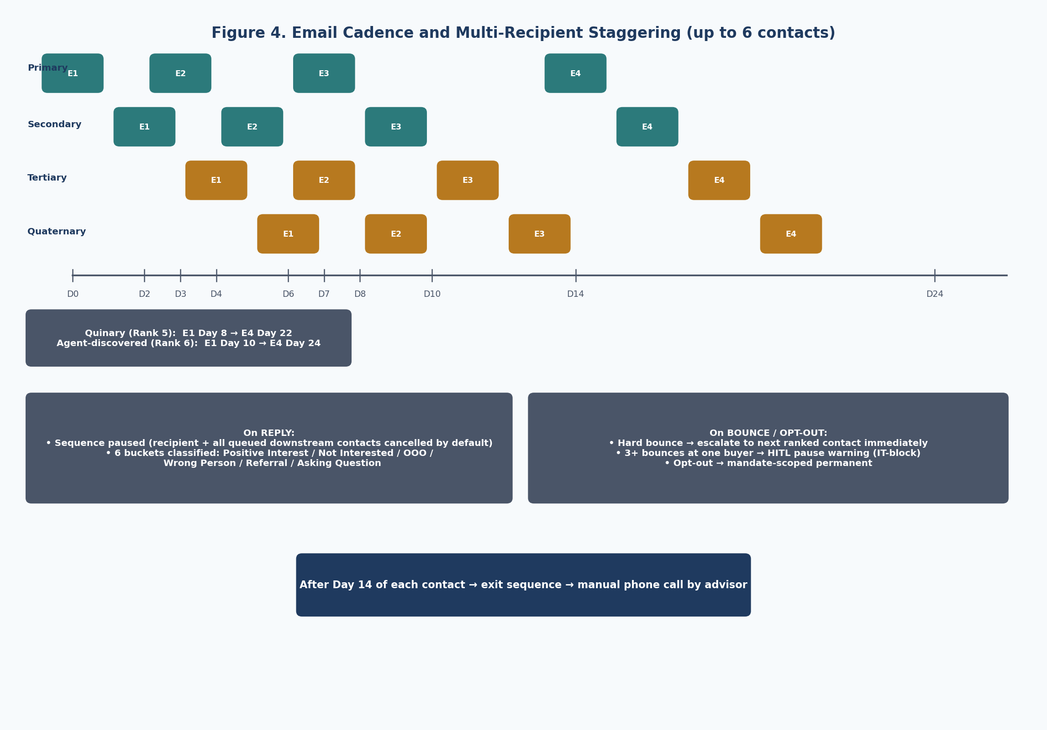
Figure 4. Email cadence and multi-recipient staggering across up to 6 contacts.
7.1 Templates
- Authored within the platform — library of reusable templates plus per-mandate copies that can be edited freely without affecting the library.
- User supplies subject line and body for each of E1–E4 per mandate.
- Personalisation is strictly mail-merge — no LLM-generated content.
- Every rendered email queued for advisor review and edit before send.
7.2 Merge Fields
Field | Source
{first_name} | Contact
{last_name} | Contact
{title} | Contact (enriched)
{buyer_company} | Buyer
{buyer_country} | Buyer
{buyer_website} | Buyer
{mandate_name} | Mandate
{sender_first_name} | Sender
{sender_signature} | Mandate config
{compliance_footer} | System (togglable)

Null merge field handling: safe fallback substitutions ('there' for missing first name, 'your team' for missing title, etc.). Rendered email is queued for advisor review where the fallback can be edited.
7.3 Cadence
Step | Day | Purpose | Content
E1 — Initial Teaser | Day 0 | Introduce opportunity and establish contact | Text-only invitation. NO tracked links. NO attachments. Asks if recipient would like to receive the Information Flyer and NDA.
E2 — First Follow-Up | Day 3 | Gently remind, restate value proposition | Text-only follow-up.
E3 — Second Follow-Up | Day 7 | New angle, prompt for response | Text-only with additional context.
E4 — Third Follow-Up | Day 14 | Final invitation, confirm interested parties exist | Text-only final touch.
Exit | Day 14+ | Hand off to manual phone outreach | Sequence ends; advisor calls using phone numbers on file.

7.4 Send Time
- Sends scheduled in the recipient's local time zone.
- Timezone fallback order: buyer HQ country → enrichment data → mandate default.
- Permitted send window: Tuesday–Thursday 09:00–16:00 recipient-local (configurable).
7.5 Multi-Recipient Staggering
- Primary (rank 1) receives E1 at Day 0.
- Secondary (rank 2) starts +2 days after primary, if no response to primary's E1.
- Tertiary (rank 3) starts +2 days after secondary, if no response to secondary's E1.
- Quaternary (rank 4), Quinary (rank 5), Agent-discovered (rank 6) follow the same +2-day cascade.
- Each recipient runs their own independent 4-touch cadence from their start date.
- Maximum tail per buyer if no responses: ~24 days from Day 0 to last recipient's E4.
7.6 Reply Handling
- Any reply detected on a sequence thread (regardless of sender match) auto-pauses that recipient's sequence immediately.
- Queued sends to downstream contacts at the same buyer are cancelled by default. User can re-enable with one click.
- Reply classified into one of 6 buckets — Positive Interest, Not Interested, Out-of-Office, Wrong Person, Referral, Asking a Question — with confidence score. User confirms or overrides.
- Returning to sequence offers three options: Send now / Resume on original cadence / Custom date.
- Out-of-Office auto-resumes on stated return date + 1 business day.
- Wrong Person prompts user to add the referred contact as a new recipient.
- Asking a Question routes to user for manual reply; agent never auto-replies.
7.7 Bounce Handling
- Hard bounce — escalate to next ranked contact immediately. No retry on the failing address.
- Soft bounce — retry once after 24 hours, then escalate.
- IT-block auto-pause — 3 or more hard bounces at the same buyer triggers HITL pause warning across all contacts at that buyer.
7.8 Opt-Out Handling
- Opt-out is permanent within the current mandate only. Not propagated globally.
- Multiple cancel points exist — explicit opt-out link in any email, manual flag in reply triage, dashboard Mark as Opted Out action.
- All contacts at the opted-out buyer are removed from this mandate's future sequencing.

8. NDA Workflow
The NDA workflow supports three buyer signing paths: electronic via DocuSign, wet-ink scan upload, and Word-document redline. All paths converge at the diff-check stage; any text-level change versus the original template flags for legal review.
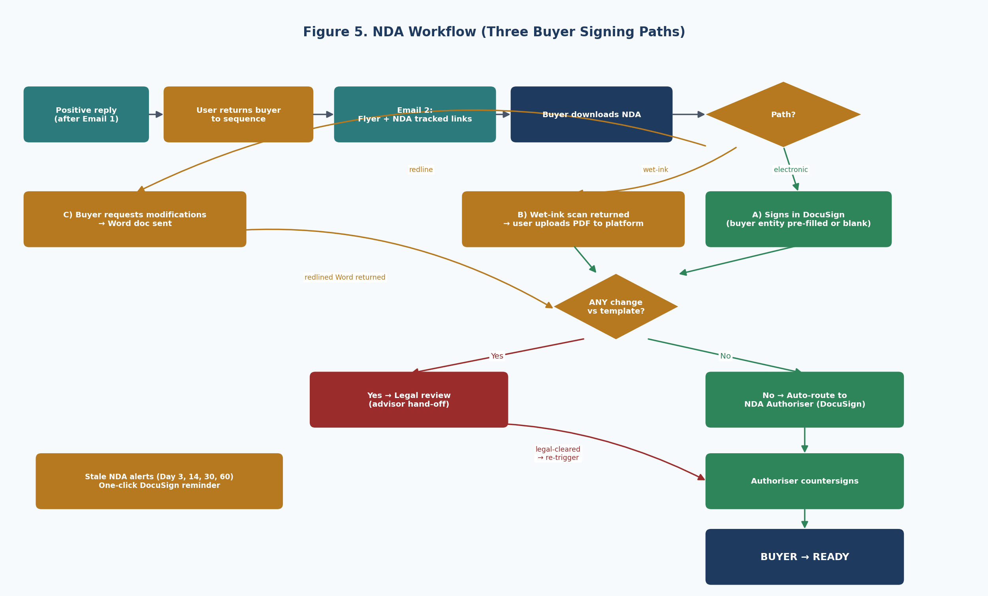
Figure 5. NDA workflow with three buyer signing paths.
8.1 NDA Send (post positive reply)
- On positive reply, advisor returns the contact to sequence; Email 2 sends with tracked links to the Flyer PDF and NDA PDF.
- When buyer signals readiness to sign, advisor triggers NDA send from the dashboard with one click.
- NDA send supports two modes: (a) send blank — buyer fills entity at signing; (b) pre-fill — user enters buyer entity name at send; platform substitutes {{buyer_entity_name}} token in the Word/PDF before envelope creation.
8.2 Path A — Electronic (DocuSign)
- Buyer signs in DocuSign.
- Platform diffs the returned PDF against the original template.
- If clean → auto-route DocuSign envelope to per-mandate NDA Authoriser for countersign.
- If any change → legal review hand-off.
8.3 Path B — Wet-Ink
- Buyer signs wet-ink and returns a scanned PDF.
- Advisor uploads the signed PDF to the buyer record in the platform.
- Platform diffs the uploaded PDF against the original template (OCR-assisted).
- If clean → platform creates a DocuSign envelope directly to the NDA Authoriser (buyer-side already complete).
- If any change detected → legal review hand-off.
8.4 Path C — Word Redline (~30% of corporate buyers)
- Buyer explicitly requests modifications.
- Platform sends the NDA Word document.
- Buyer returns redlined Word doc; advisor uploads to platform.
- Platform diffs vs original template; ANY change flags for legal review (advisor hand-off).
- After legal review, advisor can re-trigger DocuSign with agreed final version.
8.5 Diff Detection
Diff is performed at the text-level between the returned document and the original template stored in OneDrive. Any non-zero text delta — outside the explicitly tokenised entity-fill field — flags as material and routes for legal review. The diff output is presented as a side-by-side view in the dashboard for the advisor's reference.
8.6 Countersign Routing
- Per-mandate NDA Authoriser: name and email captured at mandate setup.
- Per-buyer override available — useful when the standard authoriser is unavailable or has left the client.
- Once authoriser countersigns, buyer transitions to Ready state automatically.
8.7 NDA Chase
- Passive dashboard alerts at Day 3 / Day 14 / Day 30 / Day 60 of inactivity on an outstanding envelope.
- One-click DocuSign API reminder action available from the alert (uses DocuSign's native reminder mechanism — no off-DocuSign chase emails).
8.8 Document Management (OneDrive)
- Flyer PDF, NDA PDF, and NDA Word document referenced from a mandate-specific OneDrive folder.
- Documents may change mid-mandate. New versions apply only to contacts who have not yet received that document.
- Contacts who already received an earlier version are not re-sent.
- Dashboard displays the version sent to each contact.
9. Direct-NDA Pathway
A shortcut entry path for buyers who already have an established relationship with the advisor and do not need the four-touch outreach sequence. Buyer skips Emails 1–4 entirely and goes straight to NDA execution.
9.1 Trigger Locations
- Per-mandate dashboard — add an ad-hoc buyer to this mandate and send NDA immediately.
- Standalone tool — send NDA without binding to a specific mandate (for cases outside any active mandate).
9.2 Minimum Data
- Contact full name (required).
- Verified email (required, runs through verification waterfall).
- Buyer entity name (optional; can be typed in by user if known).
9.3 Dashboard Treatment
- Buyer appears in the mandate dashboard with a visual marker indicating direct-NDA entry.
- Full NDA workflow applies as per Section 8 — three paths (electronic / wet-ink / Word), diff detection, countersign routing, stale alerts.

10. Buyer Lifecycle
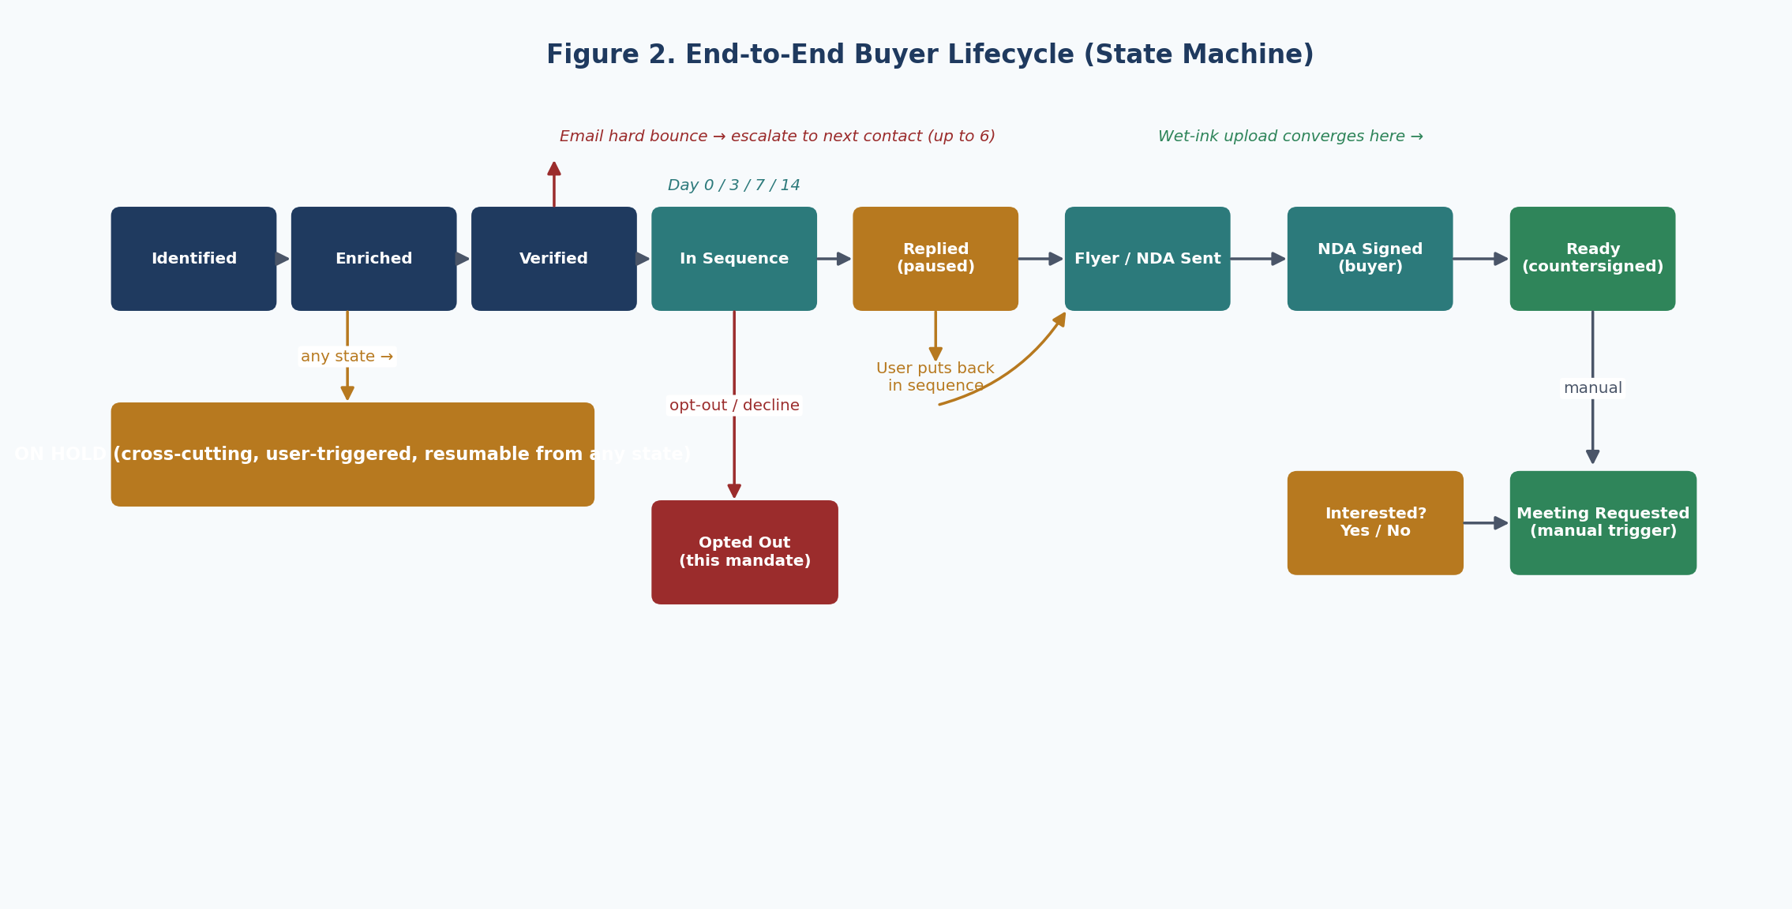
Figure 2. End-to-end buyer lifecycle state machine.
State | Entry trigger | Exit trigger
Identified | Seed list ingested + cross-referenced | Enrichment waterfall begins
Enriched | Waterfall complete (incl. optional Clay) | Email verifier runs
Verified | At least one email passes verification waterfall | First send queued
In Sequence | E1 sent | Reply / bounce / opt-out / cadence exhausted
Replied (paused) | Reply detected on sequence thread | Advisor returns to sequence or marks terminal
Flyer / NDA Sent | Email 2 with tracked links delivered | Buyer signs (or requests Word, or sends wet-ink)
NDA Signed (buyer) | DocuSign or wet-ink upload completed | Auto-route to NDA Authoriser
Ready | Authoriser countersigns | Manual meeting request trigger
Meeting Requested | Advisor manually sends meeting email | Buyer books or sequence ends
Interested? Y/N | Buyer responds (or doesn't) to meeting outreach | Terminal — sortable in dashboard
On Hold | User-triggered, any state, no reason required | User-triggered resume
Opted Out (this mandate) | Buyer declines / unsubscribes / asks to stop | Terminal for this mandate

11. Post-Ready Meeting Request
- Manual trigger only — advisor initiates from the dashboard once a buyer is Ready.
- Email content is templated and pre-filled with buyer-specific personalisation that the advisor can edit before send.
- Embeds scheduling link from either Microsoft Bookings or HubSpot Meetings, per mandate config.
- After the meeting is booked, advisor flags the buyer as Interested = Yes or No.
- Dashboard auto-sorts buyers by Interested = Yes at the top of each mandate.
12. Dashboard and Reporting
12.1 Per-Mandate Dashboard
- One row per buyer with drill-down to contact-level detail.
- Visible state per contact, colour-coded by lifecycle stage.
- Auto-sorted by Interested = Yes at the top.
- Filterable by state, recipient rank, last activity date, document version received.
- Aggregate metrics — response rate, NDA conversion rate, bounce rate, opt-out rate, sequence completion rate.
12.2 Buyer Drill-Down
- Full enrichment record with source attribution and conflict flags.
- Email history per contact with draft + final versions side-by-side.
- NDA status, DocuSign envelope link, diff output if applicable.
- Call notes log (free-text, timestamped, attributed).
- Per-buyer Opt Out and On Hold toggles.
- Per-buyer NDA Authoriser override.
12.3 Multi-Mandate Overview
- Single view across all active mandates with summary metrics.
- Cross-mandate buyer-overlap warnings (soft warn).
- Drill-down per mandate.
12.4 Client Reporting Export
Per-mandate close-out report, generated as a PDF and accompanying JSON, containing:
- Cover Page — mandate name, dates, advisor.
- Status Table — buyers by current state, with key milestones (first send, reply, NDA signed, meeting booked).
- Metrics — response rate, NDA conversion, bounce rate, time-to-NDA, time-to-meeting.
- Audit Summary — high-level audit trail suitable for client transparency (full audit log available on request).

13. Non-Functional Requirements
13.1 Human-in-the-Loop Checkpoints
Checkpoint | What the advisor sees | Why
Mandate setup | Setup form, NDA authoriser, scheduler toggle | Per-mandate configuration
Exclusion match | Side-by-side comparison + manual confirm | Prevents accidental contact of excluded buyers
Persona ranking | Agent's recommended rank 1–5 + override | Advisor judgement on relationship priority
Job-change detection | Notification for affected buyer; three options | Tone, accuracy, follow-through
Clay enrichment gate | Completeness summary + projected credit cost | Cost control on premium enrichment
Email send (every email) | Drafted email in review queue; edit + approve | Quality gate on every outbound
Reply triage | Classified bucket + recommendation; advisor confirms | Tone, judgement, relationship preserved
Resume from pause | Three resume options (now / cadence / custom) | Advisor controls timing
NDA send | Pre-fill or blank mode; one-click | Trust but verify
NDA diff review | Side-by-side; legal review hand-off if change | Risk control
Wet-ink upload | Manual PDF upload triggers envelope creation | Buyer's preferred mechanism preserved
Meeting request send | Pre-filled email; manual trigger only | High-stakes touch stays human
Interested Y/N flag | Set by advisor on dashboard | Subjective; only advisor can judge
On Hold toggle | Per-buyer, any state, no reason required | Discretionary advisor control

13.2 Retry and Resilience
- Email send errors trigger retry against the next conflicting email value on file.
- If all email values fail verification or send, escalate to next ranked recipient.
- Phone outreach is manual; alternate phone numbers surfaced in priority order.
- LLM outages fall back from primary (Claude) to secondary (GPT-class) automatically.
- DocuSign envelope failures retried with exponential backoff (3 attempts) before alerting.
- Apollo sending outages: sends queued; dashboard alert; auto-resume on API health.
13.3 Audit Trail (5 layers)
Layer | What is logged | Retention
Mandate-level | Mandate setup, template versions, authoriser changes, document versions | 7 years
Buyer-level | Enrichment sources queried, raw responses, conflict values, contact selections | 7 years
Contact-level | Every email draft (pre + post edit), send timestamp, delivery, opens, clicks, replies, call notes | 7 years
Document-level | NDA versions sent + returned, diff outputs, DocuSign envelope IDs, signed PDF hashes | Permanent
Agent action | Every tool call, inputs, outputs, HITL decision points, advisor edits | 2 years rolling

13.4 User Model
- Built multi-user from day one; deployed initially as single-user (Jeremy).
- Roles in code — Admin (full control), Operator (draft + queue, no send), Viewer (read-only).
- No client-facing access.
13.5 Compliance Footer
Minimal compliant footer (sender identification + one-line unsubscribe) included in spec, consistent with NZ Unsolicited Electronic Messages Act 2007. Per advisor's legal advice, the footer may be removed at build time. Advisor accepts residual regulatory risk on the basis that outreach is one-time, to known individuals, with no subscription model.

14. Data Model
Core entities: Mandate, Buyer, Contact, Document, EmailSequence, EmailMessage, NDARecord, AuditEvent. All entities use UUID primary keys. Conflict-prone fields (emails, phones) are modelled as arrays of (value, source, verified) tuples preserving full enrichment provenance.
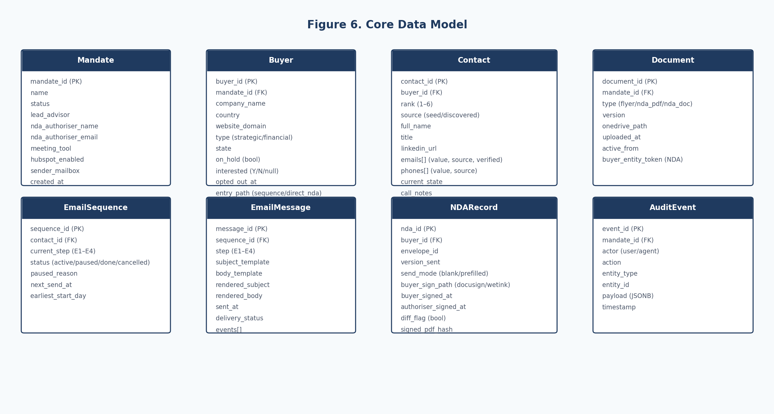
Figure 6. Core data model — entity relationships.
14.1 Key Design Decisions
- Contact.emails[] and Contact.phones[] are arrays with source attribution rather than scalar fields, preserving conflicting enrichment data.
- Contact.rank is 1–6, with source ∈ {seed, discovered} distinguishing comparables.ai vs agent-discovered contacts.
- EmailSequence is contact-scoped (not buyer-scoped) so each recipient runs independently.
- NDARecord is buyer-scoped (signed by the legal entity, not the individual); send_mode captures blank vs pre-filled; buyer_sign_path captures docusign vs wetink.
- Document.active_from supports mid-mandate document version changes without retroactively altering what previous contacts received.
- Buyer.entry_path distinguishes standard sequence buyers from direct-NDA buyers.
- AuditEvent.payload is JSONB to accommodate variable event shapes across the five layers.
15. Current vs Future State
Stage-by-stage map of the manual workflow today versus the platform-supported workflow. Drawn from the current-state walkthrough captured during the inputs deep dive.
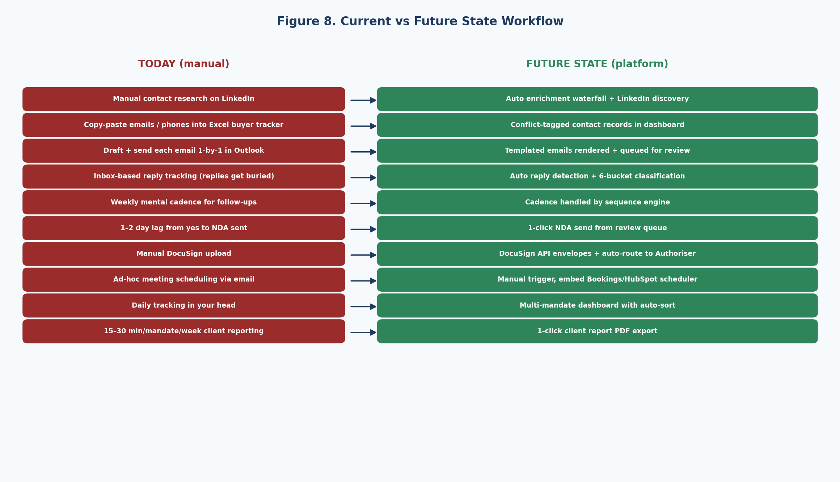
Figure 8. Current vs future state side-by-side.
15.1 Stage-by-Stage Map
# | Stage | Today | Future | Who acts
1 | Buyer identification | Conversation + Rogo + comparables.ai | Unchanged — outside platform | Human
2 | Client sign-off | Email + Teams meetings (1–2 weeks) | Unchanged — outside platform | Human
3 | Mandate setup | Files scattered, no central tool | Single setup form (~10 min) | Human
4 | Buyer + contact import | Manual buyer tracker Excel | Two comparables.ai XLSX files + exclusion list; fuzzy-joined | Human upload, agent processes
5 | Exclusion validation | Visual check | Hard warning + manual override; company + domain match | Agent flags, human confirms
6 | Contact ranking | Mental | Agent applies geographic waterfall, recommends | Agent + human confirm
7 | LinkedIn URL discovery | Manual search | Agent Googles + fuzzy match | Agent
8 | Enrichment | RocketReach plugin + copy-paste | Auto waterfall; conflicts retained | Agent
9 | Clay decision | n/a | HITL gate | Human decides
10 | Email verification | None | 3-tier waterfall (Apollo → NB → Hunter) | Agent
11 | Job-change detection | Discover only on bounce | Pre-send flag with HITL pause for that buyer | Agent flags
12–14 | E1, follow-ups, multi-recipient | 1-by-1 in Outlook, weekly mental cadence | Templated, queued, auto-staggered | Agent draft, human approve
15 | Bounce handling | Manual reconcile | Hard bounce auto-escalates; 3+ at buyer = pause | Agent
16 | Reply detection | Manual inbox scan | Auto-pause + 6-bucket classification | Agent
17 | Reply triage | Read + decide | Recommendation, advisor confirms | Agent + human
18 | NDA send | 1–2 day lag, manual upload | One-click; blank or pre-filled | Human triggers, agent executes
19 | NDA chase | None | Dashboard alerts + DocuSign reminders | Agent surfaces
20 | Wet-ink path | Manual forward to client | Upload PDF → envelope to authoriser | Human upload, agent routes
21 | NDA redline (~30%) | Email back and forth | Diff vs original → legal review hand-off on ANY change | Agent surfaces, human reviews
22 | Counter-sign | Manual forward | Auto-route to Authoriser | Agent
23 | Ready transition | Mental | Auto state change | Agent
24 | Meeting request | Ad-hoc calendar emails | Manual trigger + Bookings/HubSpot link | Human + agent
25 | Interested Y/N | Mental | Dashboard flag, auto-sort | Human
26 | Pipeline tracking | In Jeremy's head | Multi-mandate dashboard with drill-down | Agent surfaces
27 | Client reporting | 15–30 min/mandate/week | PDF export with cover/status/metrics/audit | Agent + human review
28 | Call notes | Memory / Excel | Free-text field per contact, timestamped | Human enters

16. Edge Case Catalogue
Edge cases identified during the inputs deep dive, grouped by category. Each defines the trigger condition and the platform's response.
16.1 Data and Enrichment
# | Edge case | Platform behavior
1 | Buyer with thin online presence (no usable website / weak LinkedIn) | After all enrichment tools return no valid email, surface Manual Enrichment Required; user inputs manually; verification still runs.
2 | Contact has departed the buyer (job change confirmed via LinkedIn) | Pause this buyer's enrichment; HITL alert with three options — replace at same buyer / follow to new company / drop.
3 | Same individual appears at two different buyers (exec moved) | Soft warn on second import; user confirms whether to engage them; first-buyer record marked historical.
4 | Comparables.ai contact has malformed role field | Agent extracts most recent role using parsing; flags for user review if confidence low.
5 | Buyer's domain redirects to parent or unrelated site | Use the redirected domain for enrichment. If domain resolves to a parking page or squatter, flag as suspicious; user confirms or corrects.

16.2 Reply and Engagement
# | Edge case | Platform behavior
6 | Reply arrives from a different email (personal Gmail, EA, forwarded thread) | Sequence auto-pauses for the original recipient (always pause on threaded reply, regardless of sender match); agent attempts to match sender to known contact; if no match, Reply from unrecognised sender alert.
7 | Auto-reply from EA ("contact my assistant Sarah at...") | Classified as Wrong Person; agent prompts user to add Sarah as new contact; original sender's sequence stays paused.
8 | Multi-language reply | LLM classifier handles common languages; if confidence below 60%, defaults to Asking a Question and routes to user with literal translation.
9 | Buyer replies positively then goes dark after E2 | After 7 days of silence post-Email 2, sequence does NOT auto-resume; Stalled after positive reply alert; user decides next action.
10 | Out-of-office return date passes without further reply | Sequence auto-resumes on stated return date + 1 business day; treated as no-reply continuation.
11 | Two contacts at same buyer reply at the same time with conflicting messages | Positive reply wins; sequence cancels for the negative responder; user notified of conflict.

16.3 NDA Execution
# | Edge case | Platform behavior
12 | Buyer signs wet-ink AND modifies the document | User uploads PDF; platform diffs vs original; ANY change → legal review hand-off; after approval, user re-triggers DocuSign with agreed version.
13 | NDA Authoriser unavailable or has left the client organisation | User updates per-buyer Authoriser override; envelope re-routes to new authoriser.
14 | NDA goes stale (60+ days, no countersign) | Dashboard alerts at Day 3, 14, 30, 60; one-click DocuSign reminder action throughout.
15 | Buyer signs NDA but never engages further | Stays in Ready state with no meeting; Ready, no engagement indicator in dashboard; user discretion on meeting trigger.
16 | Buyer being acquired themselves mid-process (or any reason to pause) | User flags buyer On Hold; sequence pauses for all contacts at that buyer; resumable manually. No reason required.

16.4 Operational
# | Edge case | Platform behavior
17 | DocuSign outage during NDA send | Retry 3× with exponential backoff; if all fail, dashboard alert; user retries manually or downloads Word for fallback send via Outlook.
18 | Apollo / sending mailbox outage | Queued sends held; dashboard alert; auto-resume when API healthy.
19 | LLM outage during reply classification | Reply surfaced with Classification unavailable tag; user classifies manually; fallback LLM tried first if available.
20 | Mandate cancelled mid-flight (deal pulled) | One-click Cancel mandate cancels all queued sends; preserves audit trail; buyers transition to Mandate Cancelled terminal state.

17. Build Phasing
Three-phase build sequenced to deliver functional value early. Option A confirmed — Zoho skipped entirely; HubSpot is togglable and switched on once HubSpot is stood up at Velocity Capital.
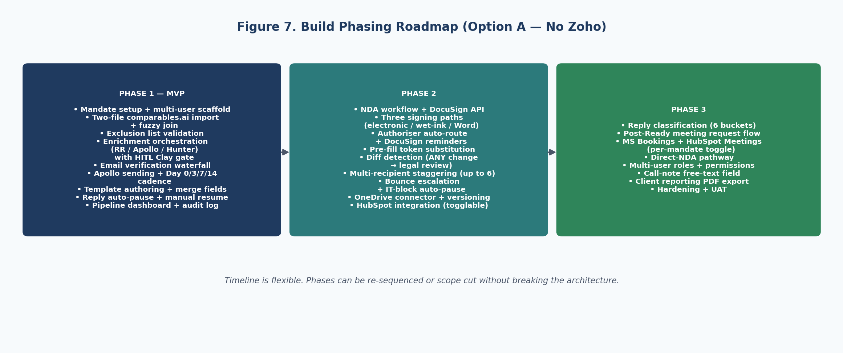
Figure 7. Build phasing roadmap.
17.1 Phase Scope and Indicative Cost
Phase | Scope
Phase 1 — MVP | Mandate setup, multi-user scaffold, two-file comparables.ai import + fuzzy join, exclusion list validation, enrichment waterfall (RocketReach / Apollo / Hunter) with HITL Clay gate, email verification waterfall, Apollo sending and Day 0/3/7/14 cadence, template authoring + merge fields, reply auto-pause + manual resume, pipeline dashboard, full audit log.
Phase 2 | NDA workflow with three signing paths (electronic / wet-ink / Word), DocuSign API + reminders, Authoriser auto-routing + per-buyer override, pre-fill token substitution, diff detection (ANY change → legal review), multi-recipient staggering (up to 6), bounce escalation + IT-block auto-pause, OneDrive connector, document version management, togglable HubSpot integration.
Phase 3 | Reply classification (6 buckets), post-Ready meeting request flow, MS Bookings + HubSpot Meetings (per-mandate toggle), Direct-NDA pathway, multi-user roles + permissions, call-note free-text field, client reporting PDF export, hardening, UAT.

18. Open Items
18.1 All Specification Decisions Locked
Every decision from Sections 1–6 of the inputs deep dive (25 May 2026) is reflected in this document. No specification-level questions remain open.
18.2 Deferred to Future Phases
- Client portal for in-platform buyer-list visibility — deferred to v2.
- Direct integration with Rogo and comparables.ai for automated buyer sourcing — deferred.
- Active news monitoring for buyer M&A events — deferred (manual On Hold flag used in v1).
- Reply auto-classification fine-tuning using mandate-specific historical data — deferred.
- Mandate handoff into a downstream deal pipeline (HubSpot deal stages) — out of scope for v1.
- Per-row sequence template overrides — deferred to v2.
- Active LLM personalisation of outbound emails — explicitly removed from scope.
18.3 Build Activities (not specification items)
- Embabel implementation patterns and prompt scaffolding.
- DocuSign Connect / webhook configuration for envelope state callbacks.
- Apollo domain warm-up status and IP reputation monitoring.
- OneDrive Graph API permission scoping at Velocity Capital tenant level.
- Production deployment, monitoring, and on-call runbook.
19. Document Control
Version | Date | Author | Notes
1.0 | 25 May 2026 | Felix (BA), reviewed by Jeremy Pak | Initial locked specification post four-round scoping conversation.
2.0 | 25 May 2026 | Felix (BA), reviewed by Jeremy Pak | Consolidated post six-section inputs deep dive. Adds two-file comparables.ai import, up-to-6 contact model, geographic-aware persona waterfall, three-path NDA workflow (electronic / wet-ink / Word), Direct-NDA pathway, On Hold state, 6-bucket reply classification, current vs future state map, 20 edge cases. Removes LLM-generated outbound personalisation.

