**Scrims and Ladders**

**By: Antoinette Cioffi, Jesse Curtin, Catherine Davis, Kenny Zajesky**

**JACK, LLC**

**CSC434**

**May, 2019**

**Table of Contents**

**Project Drivers**

1. The Purpose of the Project

2. The Client

3. Users of the Product

**Project Constraints**

4. Mandated Constraints

5. Definitions

6. Assumptions

**Functional Requirements**

7. The Scope of the Work

8. The Scope of the Product

9. Functional and Data Requirements

**Nonfunctional Requirements**

10. Look and Feel Requirements

11. Usability and Humanity Requirements

12. Performance Requirements

13. Maintainability and Support Requirements

14. Security Requirements

**Project Issues**

13. Open Issues

14. Risks

15. User Documentation

16. Waiting Room

**1. The Purpose of the Project**

**1a. The User Business or Background of the Project**

Scrims and Ladders will allow players to sign up and list/rate

characteristics, skills, and things of that nature. The service will be able to create teams of

similar skill level and balance out teams for the game League of Legends, and could

possibly be spread to other games in the future. Users would be able to build effective

teams to enhance gameplay.

**1b. Goals of the Project**

The goal of this project is to create a system that allows coaches and e-sports managers to create teams and leagues for players of similar skill levels alongside creating an environment that allows the mentoring of lower skill players by higher skill players.

**2. The Client**

The client for this web application is Dr. Kimberly Cornell, on behalf of the College of Saint Rose.

**3. Users of the Product**

* Regular Users (Players):
  + Role: These are the players signing up and the most common user. They will be able to sign up and communicate with coaches that have shown interest in the player, and when placed on a team, will be able to communicate with other players on their team. Players can also customize their preferences and input fields whenever they would like.
  + Subject matter experience: can be a beginner, intermediate, or professional player.
  + Technological matter experience: can be a beginner, intermediate, or professional user.
  + Anybody with an internet connection can sign up and participate.
  + It is assumed a user knows how to use a computer, an internet browser, and know how to navigate a website.
* Administrative User (Coach/Manager):
  + Role: Coaches and managers will how the power to create leagues for teams to participate in. They will also be able to create teams of players, by viewing players profiles and selecting them. Admin users can communicate with other admins and also message players before they are on a team, and after if the coach or manager adds them to their roster.
  + Subject matter experience: should have intermediate or professional knowledge of the game.
  + Technological matter experience: should have basic knowledge of using a database and a website.

**4. Mandated Constraints**

**4a. Solution Constraints**

Description: Scrims and Ladders will implement PostGres database. Rationale: The database system will run on server.

Fit Criterion: User account information, and characteristics will be stored in the database to be referenced.

Description: Visual Studio

Rationale: Web deployment application that can merge tools into one singular product.

Fit Criterion: Visual Studio will be used to populate our product onto the

web for users access.

Description: HTML/CSS/Javascript will be used for front end design.

Rationale: This offers a straightforward design to our product.

Fit Criterion: Each browser will be tested to ensure accuracy.

Description: Scrims and Ladders will implement Java as part of our webpage.  
 Rationale: Java is a secure cross platform language.  
 Fit Criterion: Java functions will be tested on all browsers.

**4b. Partner or Collaborative Applications**

Scrims and Ladders will work mainly with League of Legends, and

potentially other game providers.

**4c. Schedule Constraints**

Scrims and Ladders will be completed before May 8, 2019.

**5. Definitions**

League of Legends (LoL) - A 5v5 MOBA video game that places two opposing teams against each other.

SaL - Shorthand for Scrims and Ladders.

MOBA - stands for multiplayer online battle arena, a gaming genre that drops players into a map or arena where they fight until a victor is crowned.

Player - a person who plays games.

Scout - Someone who spectates players in attempt to find talented players for more higher level play.

Coach - a user that is looking to form a team of players in order to help them improve and stand at a position of leadership.

Manager - similar to a coach, a manager is a user who looks to put together a team, but rather wants to put together the strongest team and not help with in game tips. Also takes care of the out of game part of players.

Scrim - short for scrimmage, a scrim is a team practice between two teams in a less formal manner.

**6. Assumptions**

* Since this software is a web-based application all users must have some form of an internet connection.
* The software will be compatible with multiple web browsers and operating systems.
* Anyone with an internet connection will be able to create a player or spectator account, while managers, coaches, and scouts will need to request special account access.
* Many users will have basic proficiency in game specific terms.

**7. The Scope of the Work**

**7a. The Current Situation**

At the moment, a vast majority of League of Legends players don’t have the opportunity to play in a more “professional” environment and are stuck learning the game and improving themselves as players on their own. For game as in depth as League of Legends, it can be frustrating to be on your own while trying to play the game and may even dissuade one from playing all together.

Coming from long standing members of the League of Legends community, it would be a major step forward for players, both new and old, if they had a platform that could group players of similar skill level together so they could learn together and get a more optimal way of learning the game instead of drowning on their own. This also gives higher skilled players the opportunity to give back to the community by sharing their knowledge with newer players and those who are looking to improve.

**7b. The Context of the Work**

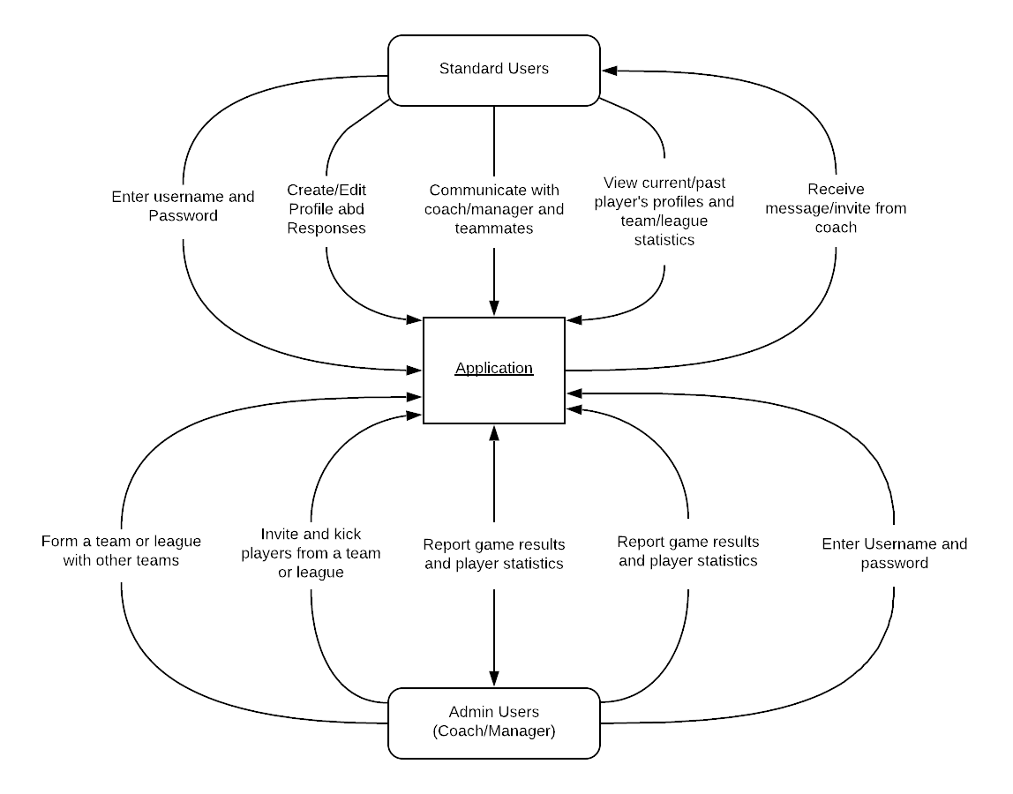

**7c. Work Partitioning**

* + - 1. Event Name: Admin or user logs in.

Input: Admin or user logs into the application using their username and password.

Output: Application confirms the login credentials and allows aaaaaaaaaaaa user to enter the site.

Summary: An admin or regular user enters their login info, the aaaaaaaaaaa application confirms what they entered and opens aaaaaaaaaaa access.

2. Event Name: Admin User creates a team

Input: Application receives an update request to team _________________database.

Output: Application creates a new team entry and adds it to _________________the database.

Summary: Administrative user creates a new team instance and _________________adds it to a database

3. Event Name: Admin User invites another user to a team.

Input: Admin sends an invite request to the application.

Output: Application sends invite request to the specified user.

Summary: Administrator sends an invite message to another ________________user.

4. Event Name: An admin or user sends a message to another user.

Input: Admin or user sends a message request to the _________________application.

Output: Application sends the recipient the message sent _________________from the original user.

Summary: An admin or user sends a direct message to another _________________admin or user.

5. Event Name: Admin reports the results of a game and players’ _________________statistics.

Input: An admin sends in a statistics page to the application.

Output: Application goes through the statistics and adds them _________________to a database and updates previous statistics.

Summary: Admin user submits a game’s statistics and then a _________________statistics database is updated.

6. Event Name: An admin or user views another profile.

Input: Either an admin or user requests to view another _________________profile.

Output: The application allows access to the profile.

Summary: An administrative user or regular user goes and looks _________________at another user’s profile and statistics.

7. Event Name: A user adds information or updates already inputted _________________information.

Input: A user submits an information change form to the _________________application.

Output: The application takes the form and either adds or _________________updates information in the player database.

Summary: A user updates or adds information to their profile _________________page.

**8. The Scope of the Product**

Allow group members to communicate privately through direct messaging.

**8a. Product Boundary**

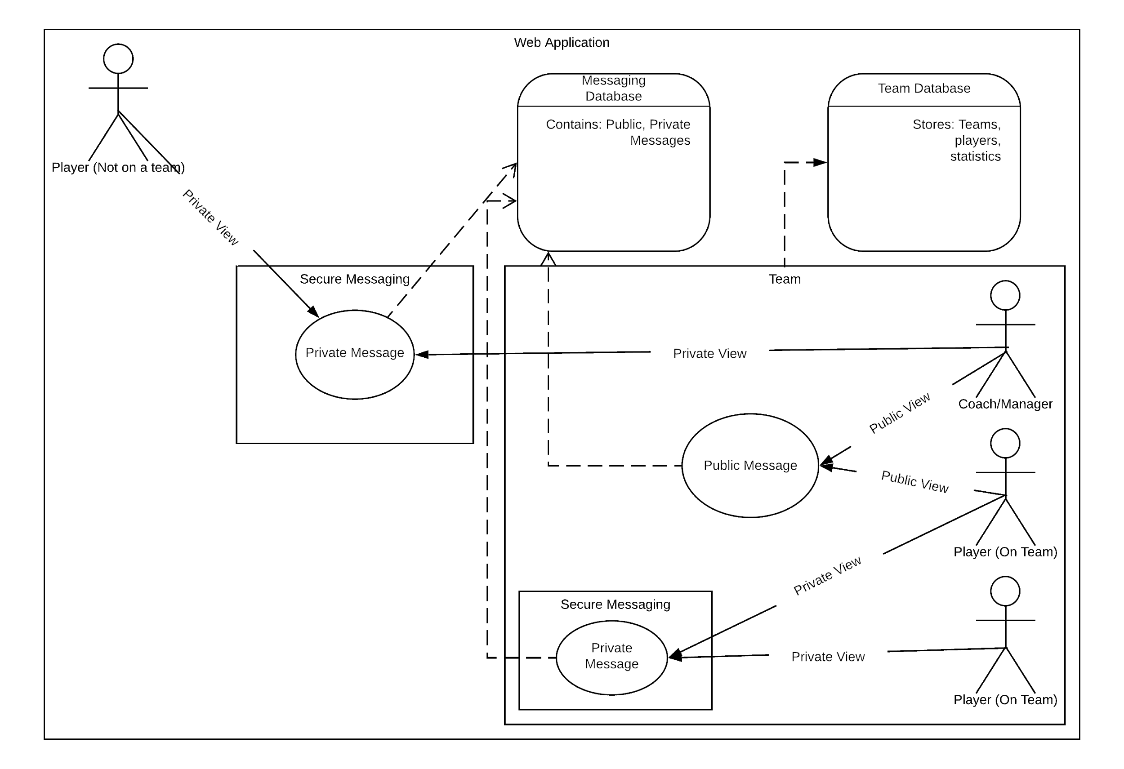

**8b. Product Use Case List**

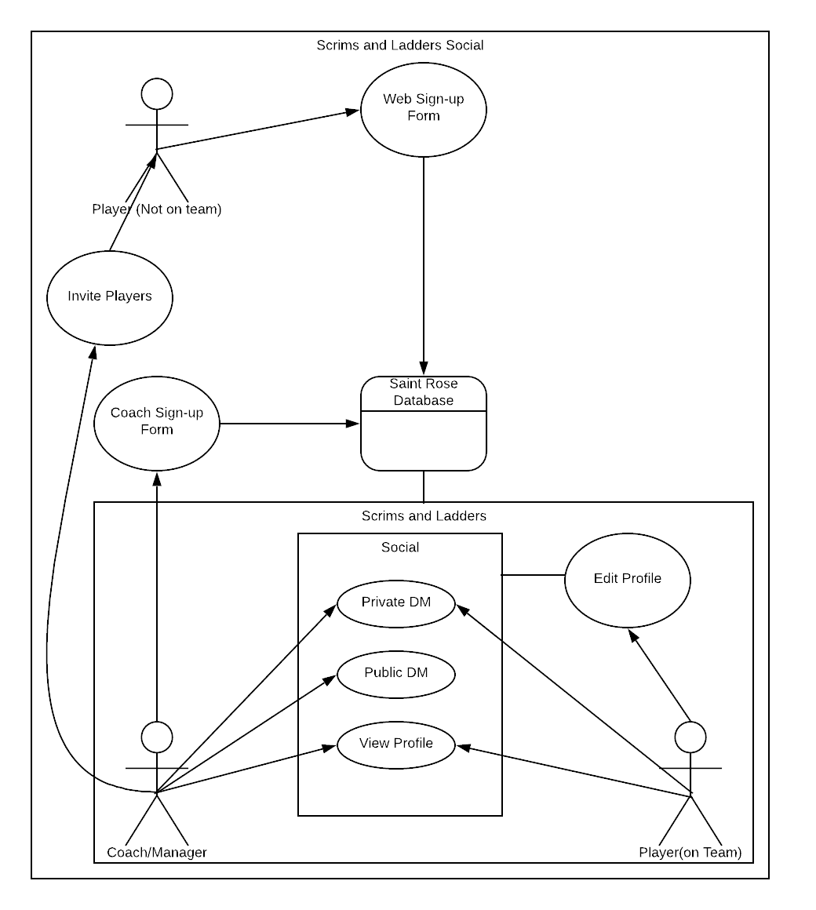

**8c. Individual Product Use Cases**

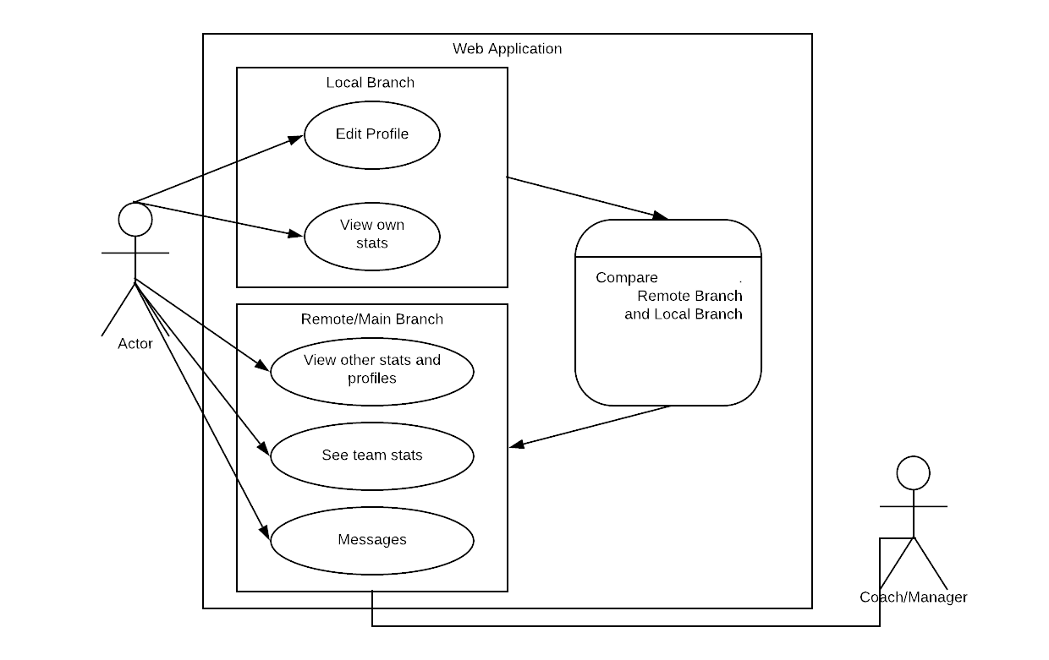

**9. Functional and Data Requirements  
 9a. Functional Requirements**  Requirement 1

Use Cases: Web Registration Form  
 Description: Players will need to create an account recording their username and

stats through a web-based form. They would need to create a username,

password, and select their skill levels for different characteristics in the game to

be compared and contrasted with other players in the system.  
 Rationale: This is the main input method to record and store unique users and

their stats. It is important for there to be a unique identifiable record for each user

for Scrims and Ladders to build teams.  
 Fit Criterion: Account registration is valid when the username (used as the

unique identifier) is unique in the system of stored users and their stats are all

completely filled in.  
 Priority: 1  
 Conflicts: None  
 Author: Catherine Davis  
 Date: Feb 21, 2019  
  
 Requirement 2  
 Use Cases: Private messaging  
 Description: Users will be able to send private messages to other users that they

are placed into a team with and Admin users will be able to converse with

potential recruits.

Rationale: Once users are connected as a team they will be able to communicate

with one another via messages. Admin users will need to be able to message

potential teammates to be able to build teams.

Fit Criterion: Users are only able to exchange messages with current and prior

Teammates. Admin users are able to message anyone with or without being on

Their team.  
 Priority:1  
 Conflicts:None  
 Author: Catherine Davis  
 Date: Feb 21, 2019  
  
 Requirement 3  
 Use Cases: Friends List  
 Description: Once a user creates a profile and requests to be put into a team

Scrims and Ladders will select a group of users with complementary skill sets for

optimal team creation and the team will then be placed into a “friends list” with

each other. There is no expiration once a user is placed into another friends list

unless a user chooses to remove another from their list.   
 Rationale: This is how we will connect users so they can communicate with one

another and re-connect with prior teammates.   
 Fit Criterion: Users will have to have their profiles fully filled out, and opt to have

Scrims and Ladders create a team for them. Once this is done then users will be

added to their friends list. Users will then have the ability to remove friends if

they choose.  
 Priority:1  
 Conflicts: None  
 Author: Catherine Davis  
 Date: Feb 21,2019

Requirement 4  
 Use Cases: Reporting game/stats  
 Description: Coaches will have the ability to report players’ statistics from games ______the players have played within the team environment.   
 Rationale: It is imperative for accuracy in players recorded stats for the system to

properly create optimal teams. This feature allows for a form of validation of each

players skills and will create more of a sense of trust between our system and our

users.  
 Fit Criterion: A user must be a coach in order to do reporting in Scrims and

Ladders. Coaches must have played with the user in question to report their stats.   
 Priority: 1  
 Conflicts: None  
 Author: Catherine Davis  
 Date: Feb 21, 2019  
  
 Requirement 5  
 Use Cases: Team Creation  
 Description: Once a user is created with a fully completed profile they may opt

into have a team created for them. Scrims and Ladders will then run an algorithm

to pair the set of users who opted in at that time with the most complimentary

characteristics to create a team.  
 Rationale: This is the focal point of Scrims and Ladders. This is what will connect

users.  
 Fit Criterion: A user must have a completed profile to be considered.  
 Priority: 1  
 Conflicts: None   
 Author: Catherine Davis  
 Date: Feb 21, 2019

Requirement 6  
 Use Cases: User updates stats  
 Description: A user can update their profile with new stats.  
 Rationale: A player’s gaming ability may evolve over time.  
 Fit Criterion: It is necessary for the players to have the most up to date

information for the program to run properly.  
 Priority:1  
 Conflicts:None  
 Author:Catherine Davis  
 Date: Feb 26, 2019  
  
 Requirement 7  
 Use Cases: Admin user invites another user to a team.  
 Description: An admin user can send an invitation to a player to join their team.  
 Rationale: Admin users can modify their teams as they see fit.  
 Fit Criterion:Admin users need to be able to modify the teams they create.  
 Priority:2  
 Conflicts:None  
 Author:Catherine Davis  
 Date:Feb 26, 2019

Requirement 8  
 Use Cases: Admin user creates a team.  
 Description: An admin user may create their own team.  
 Rationale: Admins may scan players profiles and build or modify a team as they

see fit.  
 Fit Criterion: Only admin users have the ability to create teams.  
 Priority:2  
 Conflicts: None  
 Author: Catherine Davis  
 Date: Feb 26, 2019

**9b. Data Requirements**

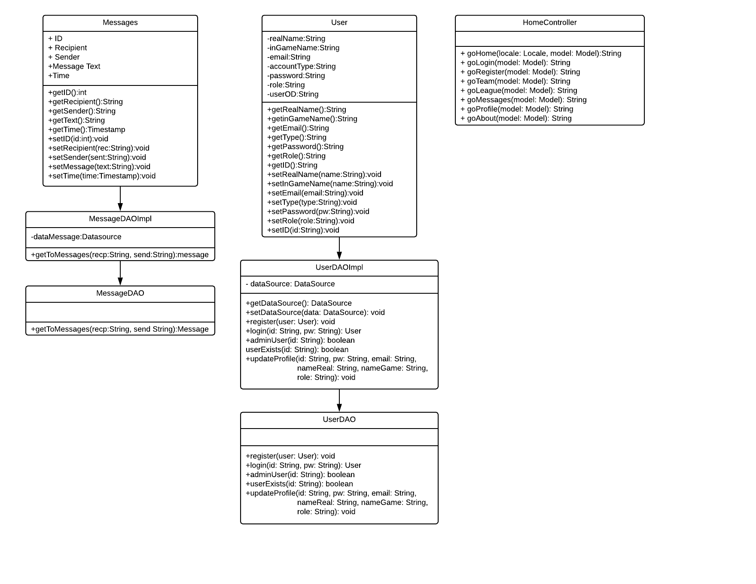

**10. Look and Feel Requirements**

**10a. Appearance Requirements**

The visual aesthetic of Scrims and Ladders will be similar to the main colors and themes of League of Legends. The style of the website use aspects of GitHub and op.gg, an online statistic database keeping track of everything that can be quantified in matches.

**10b. Style Requirements** This product will have a social media feel while still staying close to the style and theme of League of Legends.  
Fit Criterion: Users should be able to identify that this product is created to be utilized with League of Legends, and have a sense that this is a social platform to connect players.

**11. Usability and Humanity Requirements**

**11a. Ease of Use Requirements**

* The product will be simplistic to use for both users looking to sign up and those selecting users for a team.
* The user should be able to come back and easily have inputs saved, be able to edit information or responses with a few simple inputs.
* Users will overall be very satisfied having a system that is easy to use and allows them to actively participate in their new teams.
* 80% of users will understand the system and be able to successfully create an account and fill in their profile page upon first using the application.
* A vast majority, if not all users, will easily be able to transverse the site after minimal usage.

**11b. Learning Requirements**

Scrims and Ladders is a web server that will include many statistics and ideas from the _____________game League of Legends and will have the form and look of the social media aspects

of GitHub and op.gg. Anyone who has previously used a website that involves a

profile and knows the basic terms and statistics of League of Legends should have an

easier time learning this system.

The application will be easy for users that have previously used a social media

platform.

Administrators will require a bit more knowledge regarding League of Legends and

team management ideas.

A user should be able to create an account and fill in their profile within minutes of _____________navigating to the website.

Administrators will require a little bit more time to go through the process of starting a _____________team or league.

**11c. Understandability and Politeness Requirements**

While using the product, users will be required to understand both the way the _______application works and also the terms taken from League of Legends to more easily use _______the site. The site will only use basic terms when it comes to creating a profile and will _______include a not possible to answer option for some inputs when it comes to filling in one’s _______profile. Users will be able to understand whats going on within their team, league, and _______statistics page through the use of more easily understandable concepts and also _______descriptions of different terms that may seem a bit more obscure or are harder to _______understand. The application will only use terms and symbols that are relevant to the _______game League of Legends or are basic internet lingo.

**11d. Accessibility Requirements**

The application will be fully usable to all users, including those who cannot hear or those _____________who can only partially see.

**12. Performance Requirements  
 12a. Speed and Latency Requirements**

* Each web page shall have a maximum response time of 5 seconds after a user triggered event.
* The system will refresh every half hour (30 minutes) to assure that the most up to date information is displayed.

**12b. Reliability and Availability Requirements**

The product will be available seven days a week, 24 hours a day, expect for scheduled maintenance time on Sundays, between 3am and 5am EST. **12c. Capacity Requirements**

A maximum of 3,500 online users shall be accommodated simultaneously at any time outside of our delegated time for updates and maintenance.

**13. Maintainability Requirements** There will be a constant monitoring of updates made to League of Legends and updates to Scrims and Ladders will be made to accomodate said updates. These updates and any security updates made to Scrims and Ladders will take place during the lowest use time(Sunday between 3 and 5 AM EST) to assure lack of impact on users. The system will test these changes in a staging environment and once verified will be released to users.

**14. Security Requirements  
 14a. Access Requirements**

* Administrators will have access to creating and modifying teams.
* All users with an internet connection have access to this product.
* Standard users have access to view players profiles and to remove teammates they do not want to associate with.
* All registered users have access to the team builder API.
* Admin users will have access to do reporting on games, and individual players
* All registered users have the ability to modify their own stats.
* All registered users have the ability to send private messages to

teammates that they are paired with.

**14b. Privacy Requirements**

* Users shall complete a web registration form to gain access to the   
  product.
* The accounts will contain a unique identifying username and a password   
  will be required to access the product.
* The product will protect users data by adhering to Internet, copyright and privacy laws.
* All users will be notified of all updates to the system.

**15. Open Issues** // not available yet

**16. Risks**

* Excessive Schedule Pressure: It is possible that the web application will not be completed fully, due to time constraints. A timeline that documents weekly goals should be followed and the team should meet often to discuss progress and remedies for issues past due.
* Troubleshooting: Half the group has not used certain technologies and platforms such as balsamiq, Github for Desktop and Visual Studios. Because of this there will most likely be issues with setting up the coding environment, along with unexpected issues while coding. These issues may not be solved in the most efficient way. Team members may also not know the strengths and weakness of each software, and that may cause delays in developing the web-application.
* System outage: If the server hosting the system goes down, the website will be unavailable to all users. The maintenance team should be notified to fix this problem.
* Maintenance: The project will most likely not be maintained by another team after this semester is complete. This can affect the lifespan of the system, and render it unusable in the future, as updates will not be made to it.

**17. User Documentation**

Multiple documents will be created to provide information at a basic level to the different user groups. Development documentation will be included as comments in source code, along with a basic update log stating the current issues being worked on. Two different user documentation will be available, one for the regular user base(players), and one for the administrative user base (managers/coaches), depicting the functionality of the project, along with instructions for completing specific tasks.

**18. Waiting Room**

Expand to other games.