QUEUES MANAGEMENT APPLICATIO

ASSIGNMENT 2

STUDENT NAME: Ciontea Rares-Cosmin
GROUP:30425

CONTENTS

1. Assignment Objective 3
2. Problem Analysis, Modeling, Scenarios, Use Cases 3
3. Design 3
4. Implementation 3
5. Results 3
6. Conclusions 3
7. Bibliography 3

Assignment Objective

Main Objective
Design and implement a queue management application to minimize clients' waiting time in queues.

Sub-Objectives

1. Define simulation parameters:
- Allow user input for the number of clients (N), number of queues (Q), simulation interval, arrival time bounds, and service time bounds.
2. Generate clients:
- Randomly generate N clients, each with a unique ID, arrival time, and service time within the specified bounds.
3. Implement queue management:
- Design a system to manage multiple queues, ensuring clients are assigned to the queue with the shortest waiting time.
4. Simulate the queue system:
- Run the simulation over the specified interval, tracking the status of clients and queues at each timestep.
5. Log events:
- Record the state of clients and queues at each timestep in a log file for analysis.

6. Compute average waiting time:
- Calculate the average waiting time for clients throughout the simulation.
7. Ensure thread safety:
- Use appropriate synchronized data structures to manage concurrent queue operations.
8. Implement a graphical user interface:
- Provide a GUI for simulation setup and real-time display of queue evolution.
9. Display simulation results:
- Show results including average waiting time, average service time, and peak hour in the GUI or log file.
10. Use object-oriented programming principles:
- Design the application with proper object-oriented principles, including class and method structure.
11. Apply Strategy pattern for client allocation:
- Implement and use the Strategy pattern to allocate clients either based on the shortest time or the shortest queue.

Problem Analysis, Modeling, Scenarios, Use Cases
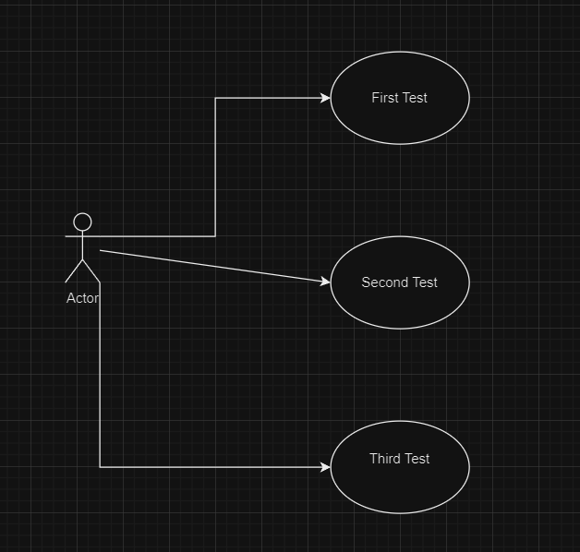

Design
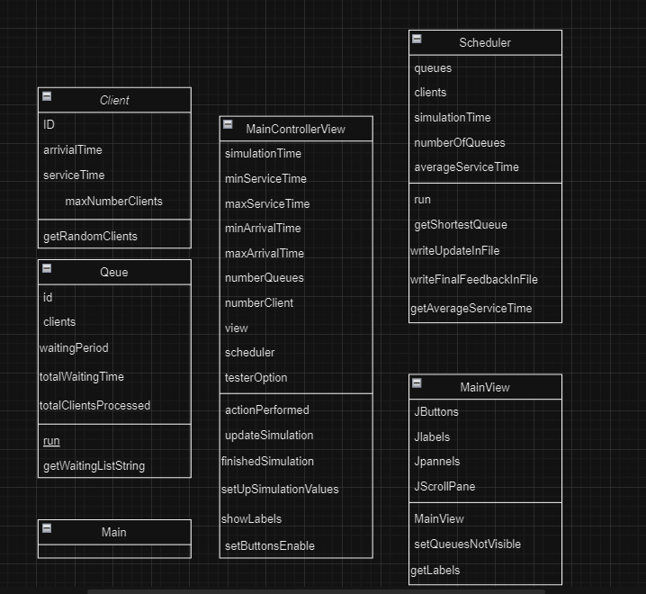

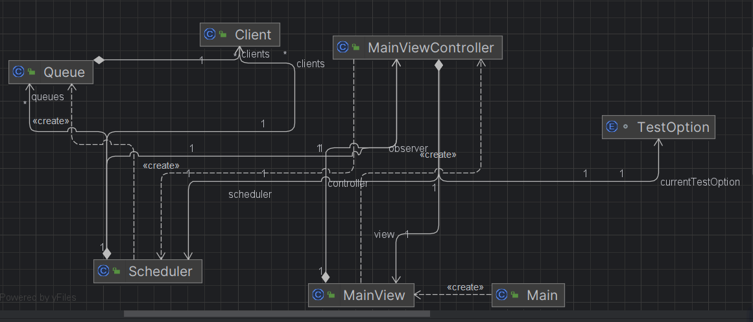

Implementation

Class: Client
Package: Model
Fields:
- `private int ID`:
- Unique identifier for each client.
- `private AtomicInteger arrivalTime`:
- The simulation time when the client is ready to enter the queue.
- `private AtomicInteger serviceTime`:
- The duration needed to serve the client.
- `public static final int maxNumberClients`:
- Constant defining the maximum number of clients.

Important Methods:
- Constructor:
- `public Client(int ID, AtomicInteger arrivalTime, AtomicInteger serviceTime)`:
- Initializes the client with a unique ID, arrival time, and service time.
- compareTo:
- `@Override public int compareTo(Client o)`:
- Compares clients based on their arrival times for sorting.
- Static Methods:
- `public static ArrayList<Client> getRandomClients(int numberClients, int minArrivalTime, int maxArrivalTime, int minServiceTime, int maxServiceTime)`:
- Generates a list of random clients within specified bounds and sorts them by arrival time.
- `public static String getClientsString(ArrayList<Client> clients)`:
- Returns a string representation of the clients list.
- `private static int getRandomNumber(int min, int max)`:
- Returns a random number between the specified minimum and maximum values.

Class: Queue
Package: Model
Fields:
- `private int ID`:
- Unique identifier for each queue.
- `private ArrayBlockingQueue<Client> clients`:
- The queue of clients being processed.
- `private AtomicInteger waitingPeriod`:
- The total waiting period for the clients in the queue.
- `private boolean activeSimulation`:
- Flag to indicate if the simulation is active.
- `private AtomicInteger totalWaitingTime`:
- The total waiting time for all clients processed by this queue.
- `private AtomicInteger totalPeopleProcessed`:
- The total number of clients processed by this queue.
Important Methods:
- Constructor:
- `public Queue(int ID)`:
- Initializes the queue with a unique ID and sets up the client queue, waiting period, and other fields.
- Public Methods:
- `public void run()`:
- Runs the queue processing logic. Processes clients by their service time, updates total waiting time, and removes clients from the queue once served.
- `public void addClient(Client client)`:
- Adds a client to the queue and updates the waiting period.
- `public String getWaitingListsString()`:
- Returns a string representation of the current state of the queue, including clients and their details.

Class: Scheduler
Package: Model
Fields:
- `private ArrayList<Queue> queues`:
- List of queues managed by the scheduler.
- `private ArrayList<Client> clients`:
- List of clients to be processed.
- `private int simulationTime`:
- Total duration of the simulation.
- `private int numberQueues`:
- Number of queues in the simulation.
- `private int numberClients`:
- Number of clients in the simulation.
- `private int minArrivalTime`:
- Minimum arrival time for clients.
- `private int maxArrivalTime`:
- Maximum arrival time for clients.
- `private int minServiceTime`:
- Minimum service time for clients.
- `private int maxServiceTime`:
- Maximum service time for clients.
- `private double averageWaitingTime`:
- Average waiting time for all clients.
- `private double averageServiceTime`:
- Average service time for all clients.
- `public static AtomicInteger currentSimulationTime`:
- Current time of the simulation.
- `private File outputFile`:
- File to log the simulation results.
- `private FileWriter fileWriter`:
- FileWriter for logging simulation results.
- `private MainViewController observer`:
- Observer for updating the graphical user interface.
Important Methods:
- Constructor:
- `public Scheduler(int numberQueues, int numberClients, int simulationTime, int minArrivalTime, int maxArrivalTime, int minServiceTime, int maxServiceTime)`:
- Initializes the scheduler with given parameters, generates random clients, and sets up queues and logging.
- Public Methods:
- `public void run()`:
- Runs the simulation, distributing clients to queues, updating the log file, and notifying the observer.
- Private Methods:
- `private Queue getShortestQueue()`:
- Finds and returns the queue with the shortest waiting period.
- `private void writeUpdateInFile()`:
- Writes the current state of the simulation to the log file.
- `private void writeFinalFeedBackInFile(double averageWaitingTime, int peakHour, double averageServiceTime)`:
- Writes the final feedback, including average waiting time, peak hour, and average service time, to the log file.
- `private double getAverageServiceTime()`:
- Calculates and returns the average service time for the clients.

Class: MainViewController
Package:Controller
Fields:
- `private int simulationTime`
- Total duration of the simulation.
- `private int minServiceTime`
- Minimum service time for clients.
- `private int maxServiceTime`
- Maximum service time for clients.
- `private int minArrivalTime`
- Minimum arrival time for clients.
- `private int maxArrivalTime`
- Maximum arrival time for clients.
- `private int numberQueues`
- Number of queues in the simulation.
- `private int numberClients`
- Number of clients in the simulation.
- `private MainView view`
- Reference to the main view (GUI).
- `private Scheduler scheduler`
- Scheduler instance for managing the simulation.
- `private TestOption currentTestOption`
- Enum to track the selected test option.
Important Methods:
- Constructor:
- `public MainViewController(MainView mainView)`
- Initializes the controller with the given main view.
- Public Methods:
- `public void updateSimulation(AtomicInteger simulationTime, ArrayList<Queue> queues, ArrayList<Client> clients)`
- Updates the view with the current simulation time, queues, and clients.
- `public void finishedSimulation(double averageWaitingTime, int peakHour, double averageServiceTime)`
- Updates the view with the final simulation results and adjusts the window size based on the test option.
- ActionListener Method:
- `@Override public void actionPerformed(ActionEvent e)`
- Handles button clicks to set up and start the simulation based on the selected test option.
- Private Methods:
- `private void setUpSimulationValues()`
- Sets up simulation values based on the selected test option and starts the simulation.
- `private void showLabels()`
- Initializes and shows labels in the view for the simulation.
- `private void setButtonsEnabled(boolean visibility)`
- Enables or disables the test buttons in the view.
Enum:
- TestOption:
- `First`
- `Second`
- `Third`

Class: MainView
Package: View
Fields:
- `private MainViewController controller`:
- Reference to the controller.
- `private JPanel mainPanel`:
- Main panel of the view.
- `private JButton firstTestButton`:
- Button for the first test.
- `private JButton secondTestButton`:
- Button for the second test.
- `private JButton thirdTestButton`:
- Button for the third test.
- `private JPanel resultPanel`:
- Panel for displaying the simulation results.
- `private JLabel queue1` to `private JLabel queue20`:
- Labels representing queues.
- `private JLabel timeLabel`:
- Label for displaying the simulation time.
- `private JLabel waitingListLabel`:
- Label for displaying the waiting list.
- `private JLabel averageWaitingTimeLabel`:
- Label for displaying the average waiting time.
- `private JLabel peakHourLabel`:
- Label for displaying the peak hour.
- `private JLabel averageServiceTimeLabel`:
- Label for displaying the average service time.
- `private JScrollPane scrollPanel`:
- Scroll panel for the waiting list.
Important Methods:
- Constructor:
- `public MainView()`:
- Initializes the main view.

Results
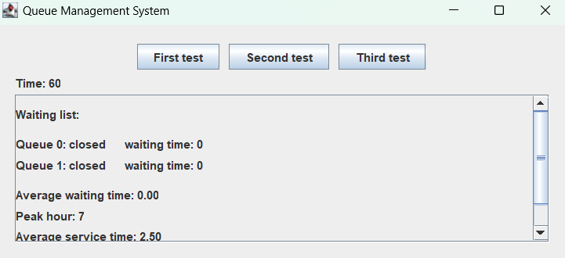

Conclusions
Conclusions:

The assignment involved developing a Queue Management System using Java, which included implementing classes for clients, queues, and the scheduler, along with a graphical user interface (GUI) for interaction. The system simulates the flow of clients through multiple queues over a specified simulation time.

What I have learned from the assignment:

1. Concurrency Handling: Implementing concurrent processes in Java using threads to manage multiple queues simultaneously.
2. Graphical User Interface Design:Designing and implementing GUI components using Swing to provide a user-friendly interface for interacting with the system.
3. File Handling: Managing file I/O operations to log simulation events and results for analysis and future reference.
4. Algorithm Design: Designing algorithms to efficiently manage client queues, optimize resource utilization, and calculate key metrics such as average waiting time and peak hour.

Future Developments:

1. Enhanced User Experience: Implementing features such as real-time updates on queue status and interactive visualization of queue dynamics to enhance user engagement.
2.Performance Optimization: Optimizing the scheduling algorithm and queue management strategies to minimize client waiting time and maximize throughput.
3. Customization Options: Providing options for users to customize simulation parameters such as queue capacity, service times, and arrival patterns to simulate different scenarios.
4. Integration with External Systems: Integrating the Queue Management System with external systems for data exchange and interoperability, enabling seamless integration into larger software ecosystems.

Bibliography
- https://www.youtube.com/watch?v=r_MbozD32eo
- https://www.youtube.com/watch?v=J09TLPgwd0Y
- https://www.infoacademy.ro/course/java-programmer-240610?gad_source=1&gclid=CjwKCAjwvIWzBhAlEiwAHHWgvcy00qsZ9R1C_yQuPijdAFt0ek0MniW1-palQgVc7PjaUBJCS-g3ABoCW5AQAvD_BwE
- https://wwws.youtube.com/watch?v=ScUJx4aWRi0

