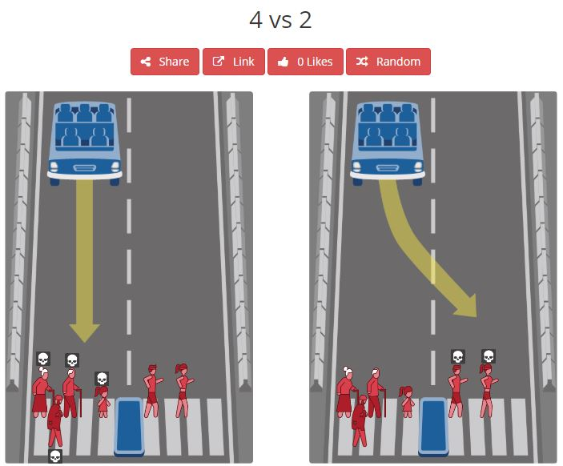

In this scenario, driving straight will result in the death of 1 elderly woman, 1 elder man, 1 girl, and 1 homeless person. Swerving left will result in the death of 1 male athlete and 1 female athlete. According to the ACM Software Engineering Code of Ethics, either decision will go against the public interest by defying “...does not diminish quality of life…”; however, saving four lives rather than two is in the better interest of the public. In regards to the client and employer, engineers shall “promote no interest adverse to their employer or client, unless a higher ethical concern is being compromised.” Thus, while keeping our driver safe, our vehicle has no adverse reactions towards either group crossing the street; yet the higher ethical decision is to save the group of four. While our product ultimately failed to maintain road safety, our standards only sway when faced with an ethical decision. Our product must make these decisions only when “properly authorized” in order to ensure the maximum number of lives are saved. This ties into professional judgement calls, as we are not singling out one group over the other. Our vehicle makes an on-the-spot decision to strive to “maintain human values” and support the better of two detrimental cases. Based on software management, this automated decision is agreed upon throughout the hierarchy to justify saving as many lives as possible. To follow the code of ethics, the programming is put into place and no single engineer will take the blame for the tragedy. Public interest is held in high regards in the engineering profession, therefore, we would not implement a decision that could ruin one’s career. This decision does not promote anyone’s self interests, for it is a group effort to implement this life saving feature. This leads into the principle of colleagues, for engineers are encouraged to “be fair and supportive…” This type of decision will not weigh lightly on one’s conscience, so support is key and the programming is not without full consideration. Furthermore, engineers are dedicated to learning and improving their skills, while applying an ethical approach. This means that an engineer shall “not give unfair treatment to anyone because of any irrelevant prejudices.” While the ultimate decision is tragic, by following the Software Engineering Code of Ethics, this is the best case to ensure that the maximum number of lives are saved.