SVY 323 — COMPUTER APPLICATION I

GROUP ASSIGNMENT REPORT

Design and Development of a Closed Traverse Computation Programme in VB.NET

Prepared by: Group ____________
Members: [Name 1, Name 2, Name 3, Name 4, Name 5]
Level: Year 3 / Year 2 | Programme: Surveying and Geoinformatics
Submitted to: Course Lecturer, SVY 323
Date of Submission: ____________________

Table of Contents

1. Introduction
Traversing is one of the most widely used methods in plane surveying for establishing horizontal control and determining the relative positions of a series of connected survey stations. A traverse consists of a sequence of straight lines (legs) joining consecutive stations, whose lengths and directions are measured in the field using appropriate instruments such as a total station or theodolite and steel tape/EDM.
A closed traverse begins and ends at the same station, or at two known control stations, allowing the survey to be checked mathematically for angular and linear errors before the coordinates of the intermediate stations are accepted as final. Because traverse computation involves a large number of repetitive trigonometric calculations, it is well suited to automation using a computer programme.
This assignment required each group to design and code a computer programme, using Visual Basic (VB 2019 or later), capable of performing a complete closed-traverse computation: from raw field observations of included angles and distances, through to the computation of forward and back bearings, latitudes and departures (DN, DE), the Bowditch (compass rule) adjustment, final station coordinates (Northings and Eastings), the linear accuracy of the traverse, and the enclosed area of the traverse polygon.
This report presents the algorithm, flowchart, full programme source code, sample input data, computed output, and a discussion of the results obtained by the group.

2. Literature Review
Traverse computation is a foundational topic in plane surveying, treated extensively in standard surveying texts such as Uren and Price's "Surveying for Engineers" and Bannister, Raymond and Baker's "Surveying". These texts describe the traverse as a control network of connected lines whose directions are derived from measured angles and a known starting bearing, and whose lengths are obtained from taped or electronically measured distances.
The bearing of each leg is conventionally computed from the previous leg's back bearing using the included (interior or deflection) angle observed at each station; this is commonly referred to as the back-bearing (or forward computation) method. Once bearings and distances are known, each leg can be resolved into its north-south component (latitude, DN) and east-west component (departure, DE) using standard trigonometric relations, DN = L·cos(bearing) and DE = L·sin(bearing).
In a perfectly closed traverse, the algebraic sum of the latitudes and the algebraic sum of the departures should each equal zero. In practice, small residual errors (misclosures) always occur owing to instrumental, observational and natural errors. Several adjustment methods exist to distribute this misclosure among the traverse legs, of which the Bowditch Rule (Compass Rule) is the most widely taught and applied; it distributes the correction to each leg in proportion to the length of that leg relative to the total perimeter of the traverse. Other methods, such as the Transit Rule, distribute corrections in proportion to the latitude/departure components themselves, but the Bowditch Rule remains standard practice for traverses observed with equipment of uniform precision.
The overall reliability of a traverse is expressed as its linear (relative) accuracy, computed as the ratio of the linear misclosure to the total perimeter length, expressed in the form 1:X. Regulatory and professional surveying bodies specify minimum acceptable accuracy ratios depending on the class of survey being undertaken (e.g. 1:5,000 for general engineering surveys, up to 1:20,000 or better for control surveys).
With the growth of personal computing, the manual trigonometric computations traditionally performed with log tables or calculators have largely been replaced by dedicated software and spreadsheets. Visual Basic (VB), including its modern VB.NET incarnation within Microsoft Visual Studio, remains a popular teaching language for this purpose because of its simple, readable syntax, strong support for structured/procedural programming, and ease of building both console and graphical (Windows Forms) interfaces — making it well suited for coding traverse computation programmes of the kind required in this assignment.

3. Methodology

3.1 Overview of Approach
The group adopted a structured (procedural) programming approach in VB.NET, implemented as a Windows Forms (GUI) application so that field data can be entered, edited and computed interactively — well suited to a live class demonstration. The programme: (a) accepts the field data through an editable input grid — station names, included angles and leg distances, together with the starting bearing and coordinates carried forward from the initial control station; (b) performs the angular misclosure check; (c) computes forward and back bearings leg-by-leg; (d) computes latitudes and departures; (e) computes the linear misclosure and accuracy; (f) applies the Bowditch adjustment; (g) computes the final Northings and Eastings of every station; and (h) computes the enclosed area using the coordinate (shoelace) method — displaying every result instantly in an on-screen results grid and summary panel when the "Compute Traverse" button is clicked.

3.2 Algorithm
The step-by-step algorithm implemented by the programme is as follows:
- Step 1: Input the number of stations (n ≥ 5), station names, included angle at each station, and the distance of each leg; also input the starting bearing (from the initial control station) and the starting coordinates (N, E).
- Step 2: Sum the included angles and compare with the theoretical sum (n − 2) × 180° for a closed polygon traverse; compute and report the angular misclosure.
- Step 3: Starting from the given bearing of the first leg, compute the back bearing (± 180°) and then the forward bearing of the next leg using: Forward Bearing = Back Bearing − Included Angle (± 360° as necessary). Repeat for every leg around the traverse.
- Step 4: For each leg, compute the Latitude, DN = Distance × cos(Forward Bearing), and the Departure, DE = Distance × sin(Forward Bearing).
- Step 5: Sum all DN values (ΣDN) and all DE values (ΣDE) to obtain the linear misclosures eN and eE. Compute the linear misclosure = √(eN² + eE²) and the linear accuracy ratio = Perimeter ÷ Linear Misclosure, expressed as 1:X.
- Step 6: Apply the Bowditch Rule: correction to DN (or DE) for a given leg = −(eN or eE) × (leg distance ÷ total perimeter). Add these corrections to the raw DN/DE to obtain the adjusted DN/DE for each leg.
- Step 7: Starting from the known coordinates of the initial control station, successively add the adjusted DN and DE of each leg to obtain the Final Northing and Final Easting of every station.
- Step 8: Compute the enclosed area of the traverse polygon using the coordinate (shoelace) method: Area = ½ |Σ (E(i)·N(i+1) − E(i+1)·N(i))|.
- Step 9: Output all computed quantities — angular misclosure, bearings, DN/DE, corrections, adjusted DN/DE, final coordinates, linear accuracy and area.

3.3 Flowchart
The flowchart below summarises the logical flow of the traverse computation programme, from data input through to the final output of adjusted coordinates, accuracy and area.
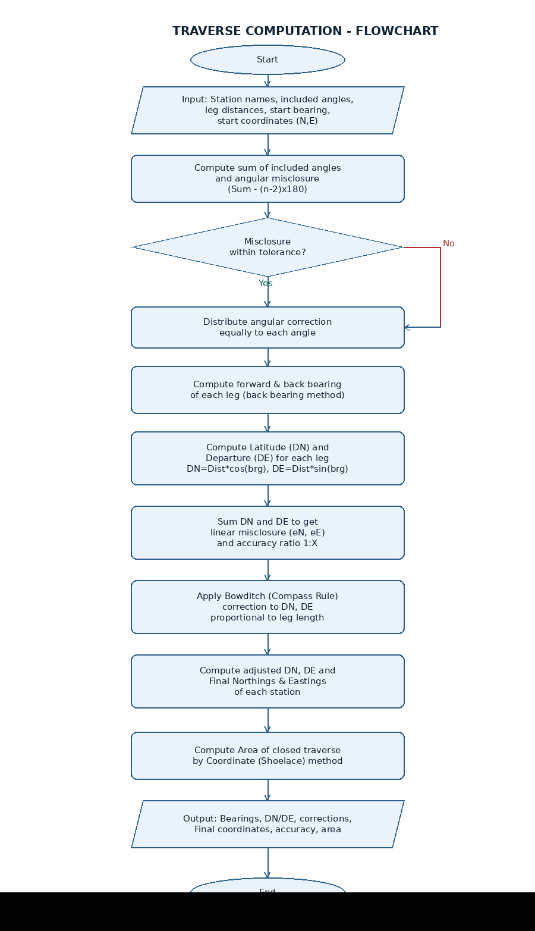

3.4 User Interface
The programme presents an editable input grid for the station data (name, included angle in D M S, and distance to the next station), text boxes for the starting bearing and starting coordinates, "Add Row" / "Remove Row" controls so the traverse can be extended beyond five legs, and a "Compute Traverse" button. On computation, a results grid displays the bearing, DN/DE, Bowditch correction and final coordinate for every leg, alongside a summary panel showing the angular misclosure, linear misclosure, accuracy ratio and enclosed area. A mock-up of the interface, populated with the sample dataset used in this report, is shown below.
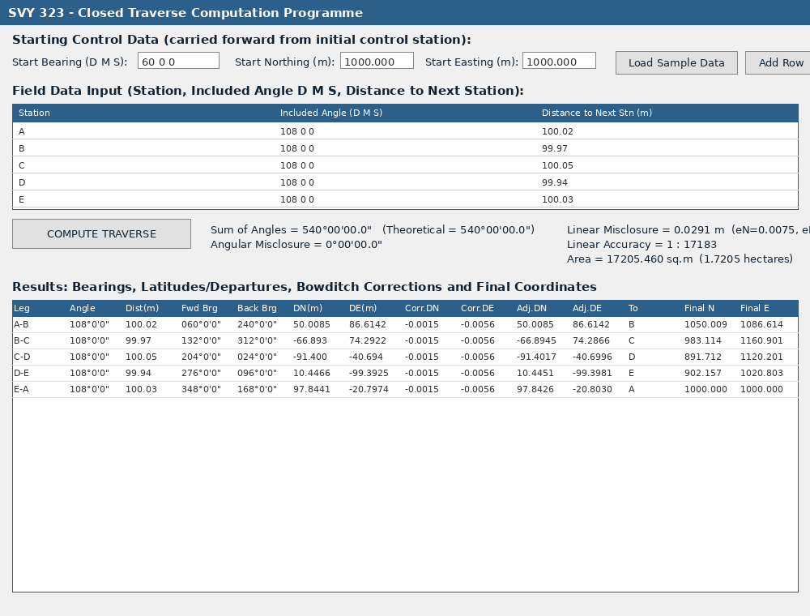
Figure: Windows Forms user interface of the traverse computation programme (populated with the sample dataset).

3.5 Assumptions
- The traverse is a closed-loop (polygon) traverse of five stations (A, B, C, D, E), closing back onto the initial control station A, satisfying the minimum of five included angles and associated distances specified in the assignment.
- The bearing of the first leg (A–B) is assumed known, having been derived from a back-bearing observation to a nearby reference/control point.
- The coordinates of station A are assumed known (carried forward from the initial control station).
- Included angles are interior angles measured clockwise at each station.
- All angular observations are assumed free of gross (blunder) errors; only small residual (accidental) errors requiring Bowditch adjustment are present.

4. Programme Code (VB.NET, VB 2019 or later)
The complete Visual Basic source code implementing the algorithm above is provided below. It was developed and tested as a Windows Forms Application in Visual Studio 2019, with the entire user interface built programmatically in a single code file (Form1.vb) — no separate Designer file is required.
'==================================================================================
' SVY 323 - COMPUTER APPLICATION I
' TRAVERSE COMPUTATION PROGRAMME (Closed Traverse) - WINDOWS FORMS (GUI) VERSION
' Language : Visual Basic .NET (VB 2019 or higher) - Windows Forms App
'
' HOW TO USE THIS FILE
' ---------------------
' 1. In Visual Studio: File > New > Project > "Windows Forms App" (Visual Basic).
' 2. In Solution Explorer, DELETE the auto-generated "Form1.Designer.vb" file
' (right-click it > Delete) - it is not needed because this single file
' builds the whole user interface in code.
' 3. Open the auto-generated "Form1.vb" and REPLACE its entire contents with
' everything in this file.
' 4. Press F5 (Start) to run. The input grid is pre-loaded with sample data
' for five stations (A-B-C-D-E) - click "Compute Traverse" to see results,
' or edit the grid with your own group's field data first.
'
' WHAT THE PROGRAMME DOES
' ------------------------
' 1. Angular misclosure check (Sum of interior angles vs (n-2)*180)
' 2. Forward & back bearings for every traverse leg
' 3. Latitudes (DN) & Departures(DE) for every leg
' 4. Linear misclosure & accuracy (1 : X)
' 5. Bowditch (Compass Rule) corrections, proportional to leg length
' 6. Adjusted DN/DE and Final Northings & Eastings of every station
' 7. Area of the closed traverse polygon (Coordinate / Shoelace method)
'==================================================================================

Imports System
Imports System.Windows.Forms
Imports System.Drawing
Imports System.Collections.Generic

Public Class Form1
Inherits Form

' ---------------- Controls ----------------
Private WithEvents btnCompute As Button
Private WithEvents btnLoadSample As Button
Private WithEvents btnAddRow As Button
Private WithEvents btnRemoveRow As Button

Private inputGrid As DataGridView
Private resultsGrid As DataGridView

Private txtStartBearing As TextBox
Private txtStartN As TextBox
Private txtStartE As TextBox

Private lblAngularSum As Label
Private lblAngularMisclosure As Label
Private lblLinearMisclosure As Label
Private lblAccuracy As Label
Private lblArea As Label

' ---------------- Result structure ----------------
Structure LegResult
Public FromStation As String
Public ToStation As String
Public IncludedAngle As Double
Public Distance As Double
Public ForwardBearing As Double
Public BackBearing As Double
Public DN As Double
Public DE As Double
Public CorrDN As Double
Public CorrDE As Double
Public AdjDN As Double
Public AdjDE As Double
Public FinalN As Double
Public FinalE As Double
End Structure

Public Sub New()
BuildUserInterface()
LoadSampleData()
End Sub

' ==================================================================================
' UI CONSTRUCTION (done entirely in code - no Designer.vb file required)
' ==================================================================================
Private Sub BuildUserInterface()
Me.Text = "SVY 323 - Closed Traverse Computation Programme"
Me.Width = 1150
Me.Height = 800
Me.StartPosition = FormStartPosition.CenterScreen
Me.Font = New Font("Segoe UI", 9)

' ---- Top panel: start bearing / start coordinates ----
Dim lblHeader As New Label With {
.Text = "Starting Control Data (carried forward from initial control station):",
.Left = 15, .Top = 12, .Width = 500, .Font = New Font("Segoe UI", 9, FontStyle.Bold)
}
Me.Controls.Add(lblHeader)

Dim lbl1 As New Label With {.Text = "Start Bearing (D M S):", .Left = 15, .Top = 40, .Width = 150}
txtStartBearing = New TextBox With {.Left = 170, .Top = 37, .Width = 100, .Text = "60 0 0"}
Dim lbl2 As New Label With {.Text = "Start Northing (m):", .Left = 290, .Top = 40, .Width = 130}
txtStartN = New TextBox With {.Left = 420, .Top = 37, .Width = 90, .Text = "1000.000"}
Dim lbl3 As New Label With {.Text = "Start Easting (m):", .Left = 525, .Top = 40, .Width = 120}
txtStartE = New TextBox With {.Left = 645, .Top = 37, .Width = 90, .Text = "1000.000"}

Me.Controls.AddRange({lbl1, txtStartBearing, lbl2, txtStartN, lbl3, txtStartE})

' ---- Buttons ----
btnLoadSample = New Button With {.Text = "Load Sample Data", .Left = 760, .Top = 35, .Width = 150, .Height = 28}
btnAddRow = New Button With {.Text = "Add Row", .Left = 920, .Top = 35, .Width = 90, .Height = 28}
btnRemoveRow = New Button With {.Text = "Remove Row", .Left = 1015, .Top = 35, .Width = 105, .Height = 28}
Me.Controls.AddRange({btnLoadSample, btnAddRow, btnRemoveRow})

' ---- Input grid ----
Dim lblInput As New Label With {
.Text = "Field Data Input (Station, Included Angle in D M S, Distance to NEXT station in metres) - minimum 5 rows:",
.Left = 15, .Top = 75, .Width = 750, .Font = New Font("Segoe UI", 9, FontStyle.Bold)
}
Me.Controls.Add(lblInput)

inputGrid = New DataGridView With {
.Left = 15, .Top = 100, .Width = 1105, .Height = 150,
.Anchor = AnchorStyles.Top Or AnchorStyles.Left Or AnchorStyles.Right,
.AllowUserToAddRows = False,
.RowHeadersVisible = False
}
inputGrid.Columns.Add("Station", "Station")
inputGrid.Columns.Add("Angle", "Included Angle (D M S)")
inputGrid.Columns.Add("Distance", "Distance to Next Stn (m)")
inputGrid.Columns(0).Width = 340
inputGrid.Columns(1).Width = 340
inputGrid.Columns(2).Width = 340
Me.Controls.Add(inputGrid)

' ---- Compute button ----
btnCompute = New Button With {
.Text = "COMPUTE TRAVERSE", .Left = 15, .Top = 260, .Width = 220, .Height = 36,
.Font = New Font("Segoe UI", 9, FontStyle.Bold), .BackColor = Color.LightSteelBlue
}
Me.Controls.Add(btnCompute)

' ---- Summary labels ----
lblAngularSum = New Label With {.Left = 260, .Top = 265, .Width = 420, .Text = "Sum of Angles / Misclosure: -"}
lblAngularMisclosure = New Label With {.Left = 260, .Top = 285, .Width = 420, .Text = ""}
lblLinearMisclosure = New Label With {.Left = 700, .Top = 265, .Width = 420, .Text = "Linear Misclosure: -"}
lblAccuracy = New Label With {.Left = 700, .Top = 285, .Width = 420, .Text = "Accuracy: -"}
lblArea = New Label With {.Left = 700, .Top = 305, .Width = 420, .Text = "Area: -", .Font = New Font("Segoe UI", 9, FontStyle.Bold)}
lblAngularSum.Font = New Font("Segoe UI", 9, FontStyle.Bold)
lblLinearMisclosure.Font = New Font("Segoe UI", 9, FontStyle.Bold)
lblAccuracy.Font = New Font("Segoe UI", 9, FontStyle.Bold)

Me.Controls.AddRange({lblAngularSum, lblAngularMisclosure, lblLinearMisclosure, lblAccuracy, lblArea})

' ---- Results grid ----
Dim lblResults As New Label With {
.Text = "Results: Bearings, Latitudes/Departures, Bowditch Corrections and Final Coordinates",
.Left = 15, .Top = 340, .Width = 750, .Font = New Font("Segoe UI", 9, FontStyle.Bold)
}
Me.Controls.Add(lblResults)

resultsGrid = New DataGridView With {
.Left = 15, .Top = 365, .Width = 1105, .Height = 380,
.Anchor = AnchorStyles.Top Or AnchorStyles.Bottom Or AnchorStyles.Left Or AnchorStyles.Right,
.AllowUserToAddRows = False,
.ReadOnly = True,
.RowHeadersVisible = False
}
Dim cols() As String = {"Leg", "Angle", "Dist(m)", "Fwd Bearing", "Back Bearing",
"DN(m)", "DE(m)", "Corr.DN", "Corr.DE", "Adj.DN", "Adj.DE",
"To Stn", "Final N", "Final E"}
For Each c As String In cols
resultsGrid.Columns.Add(c, c)
Next
Me.Controls.Add(resultsGrid)
End Sub

' ==================================================================================
' SAMPLE DATA
' ==================================================================================
Private Sub LoadSampleData() Handles btnLoadSample.Click
inputGrid.Rows.Clear()
inputGrid.Rows.Add("A", "108 0 0", "100.02")
inputGrid.Rows.Add("B", "108 0 0", "99.97")
inputGrid.Rows.Add("C", "108 0 0", "100.05")
inputGrid.Rows.Add("D", "108 0 0", "99.94")
inputGrid.Rows.Add("E", "108 0 0", "100.03")
txtStartBearing.Text = "60 0 0"
txtStartN.Text = "1000.000"
txtStartE.Text = "1000.000"
End Sub

Private Sub AddRow_Click() Handles btnAddRow.Click
inputGrid.Rows.Add("", "0 0 0", "0.00")
End Sub

Private Sub RemoveRow_Click() Handles btnRemoveRow.Click
If inputGrid.Rows.Count > 0 And inputGrid.CurrentRow IsNot Nothing Then
inputGrid.Rows.Remove(inputGrid.CurrentRow)
End If
End Sub

' ==================================================================================
' MAIN COMPUTATION - fired when "COMPUTE TRAVERSE" is clicked
' ==================================================================================
Private Sub ComputeTraverse_Click() Handles btnCompute.Click
Try
Dim rowCount As Integer = inputGrid.Rows.Count
If rowCount < 5 Then
MessageBox.Show("Please enter at least 5 stations (5 included angles and 5 leg distances) as required by the assignment.",
"Insufficient Data", MessageBoxButtons.OK, MessageBoxIcon.Warning)
Return
End If

Dim n As Integer = rowCount
Dim stationNames(n - 1) As String
Dim includedAngles(n - 1) As Double
Dim distances(n - 1) As Double

For i As Integer = 0 To n - 1
stationNames(i) = CStr(inputGrid.Rows(i).Cells(0).Value).Trim()
includedAngles(i) = ParseDMS(CStr(inputGrid.Rows(i).Cells(1).Value))
distances(i) = Convert.ToDouble(inputGrid.Rows(i).Cells(2).Value)
Next

Dim startBearing As Double = ParseDMS(txtStartBearing.Text)
Dim startN As Double = Convert.ToDouble(txtStartN.Text)
Dim startE As Double = Convert.ToDouble(txtStartE.Text)

' ---------------- 1. Angular misclosure ----------------
Dim sumAngles As Double = 0
For Each a As Double In includedAngles
sumAngles += a
Next
Dim theoreticalSum As Double = (n - 2) * 180.0
Dim angularMisclosure As Double = sumAngles - theoreticalSum

lblAngularSum.Text = "Sum of Angles = " & DecimalToDMS(sumAngles) & " (Theoretical = " & DecimalToDMS(theoreticalSum) & ")"
lblAngularMisclosure.Text = "Angular Misclosure = " & DecimalToDMS(angularMisclosure)

' ---------------- 2. Bearings, DN, DE ----------------
Dim legs(n - 1) As LegResult
Dim fb As Double = startBearing

For i As Integer = 0 To n - 1
Dim fromStn As String = stationNames(i)
Dim toStn As String = stationNames((i + 1) Mod n)

If i > 0 Then
Dim bbPrev As Double = (legs(i - 1).ForwardBearing + 180.0) Mod 360.0
fb = (bbPrev - includedAngles(i)) Mod 360.0
If fb < 0 Then fb += 360.0
End If

Dim bb As Double = (fb + 180.0) Mod 360.0
Dim dist As Double = distances(i)
Dim rad As Double = fb * Math.PI / 180.0

legs(i).FromStation = fromStn
legs(i).ToStation = toStn
legs(i).IncludedAngle = includedAngles(i)
legs(i).Distance = dist
legs(i).ForwardBearing = fb
legs(i).BackBearing = bb
legs(i).DN = dist * Math.Cos(rad)
legs(i).DE = dist * Math.Sin(rad)
Next

' ---------------- 3. Linear misclosure & accuracy ----------------
Dim sumDN As Double = 0, sumDE As Double = 0, perimeter As Double = 0
For i As Integer = 0 To n - 1
sumDN += legs(i).DN
sumDE += legs(i).DE
perimeter += legs(i).Distance
Next
Dim linearMisclosure As Double = Math.Sqrt(sumDN ^ 2 + sumDE ^ 2)
Dim accuracyDenominator As Double = If(linearMisclosure = 0, 0, perimeter / linearMisclosure)

lblLinearMisclosure.Text = String.Format("Linear Misclosure = {0:0.0000} m (eN={1:0.0000}, eE={2:0.0000})", linearMisclosure, sumDN, sumDE)
lblAccuracy.Text = If(linearMisclosure = 0, "Accuracy = Perfect Closure", String.Format("Linear Accuracy = 1 : {0:0}", accuracyDenominator))

' ---------------- 4. Bowditch adjustment ----------------
For i As Integer = 0 To n - 1
legs(i).CorrDN = -sumDN * (legs(i).Distance / perimeter)
legs(i).CorrDE = -sumDE * (legs(i).Distance / perimeter)
legs(i).AdjDN = legs(i).DN + legs(i).CorrDN
legs(i).AdjDE = legs(i).DE + legs(i).CorrDE
Next

' ---------------- 5. Final coordinates ----------------
Dim finalN As New Dictionary(Of String, Double)
Dim finalE As New Dictionary(Of String, Double)
finalN(stationNames(0)) = startN
finalE(stationNames(0)) = startE

Dim curN As Double = startN
Dim curE As Double = startE
For i As Integer = 0 To n - 1
curN += legs(i).AdjDN
curE += legs(i).AdjDE
legs(i).FinalN = curN
legs(i).FinalE = curE
finalN(legs(i).ToStation) = curN
finalE(legs(i).ToStation) = curE
Next

' ---------------- 6. Area (Shoelace / coordinate method) ----------------
Dim area As Double = 0
For i As Integer = 0 To n - 1
Dim s1 As String = stationNames(i)
Dim s2 As String = stationNames((i + 1) Mod n)
area += finalE(s1) * finalN(s2) - finalE(s2) * finalN(s1)
Next
area = Math.Abs(area) / 2.0
lblArea.Text = String.Format("Area = {0:0.000} sq.m ({1:0.0000} hectares)", area, area / 10000.0)

' ---------------- 7. Populate results grid ----------------
resultsGrid.Rows.Clear()
For i As Integer = 0 To n - 1
resultsGrid.Rows.Add(
legs(i).FromStation & "-" & legs(i).ToStation,
DecimalToDMS(legs(i).IncludedAngle),
Format(legs(i).Distance, "0.00"),
DecimalToDMS(legs(i).ForwardBearing),
DecimalToDMS(legs(i).BackBearing),
Format(legs(i).DN, "0.0000"),
Format(legs(i).DE, "0.0000"),
Format(legs(i).CorrDN, "0.0000"),
Format(legs(i).CorrDE, "0.0000"),
Format(legs(i).AdjDN, "0.0000"),
Format(legs(i).AdjDE, "0.0000"),
legs(i).ToStation,
Format(legs(i).FinalN, "0.000"),
Format(legs(i).FinalE, "0.000")
)
Next

Catch ex As Exception
MessageBox.Show("Error in input data: " & ex.Message, "Computation Error", MessageBoxButtons.OK, MessageBoxIcon.Error)
End Try
End Sub

' ==================================================================================
' HELPER FUNCTIONS
' ==================================================================================

''' <summary>Parses a "D M S" (degrees minutes seconds, space separated) or a
''' plain decimal-degree string into decimal degrees.</summary>
Private Function ParseDMS(text As String) As Double
text = text.Trim()
If text.Contains(" ") Then
Dim parts() As String = text.Split({" "c}, StringSplitOptions.RemoveEmptyEntries)
Dim deg As Double = Convert.ToDouble(parts(0))
Dim mins As Double = If(parts.Length > 1, Convert.ToDouble(parts(1)), 0)
Dim secs As Double = If(parts.Length > 2, Convert.ToDouble(parts(2)), 0)
Dim sign As Double = If(deg < 0, -1.0, 1.0)
Return sign * (Math.Abs(deg) + mins / 60.0 + secs / 3600.0)
Else
Return Convert.ToDouble(text)
End If
End Function

''' <summary>Formats decimal degrees as D°MM'SS.S" for display.</summary>
Private Function DecimalToDMS(decimalDeg As Double) As String
Dim d As Double = decimalDeg
Dim deg As Integer = CInt(Math.Truncate(d))
Dim minFull As Double = Math.Abs(d - deg) * 60.0
Dim mins As Integer = CInt(Math.Truncate(minFull))
Dim secs As Double = (minFull - mins) * 60.0
Return String.Format("{0}{1}'{2:00.0}""", deg.ToString() & Chr(176), mins.ToString("00"), secs)
End Function

End Class

' ==================================================================================
' APPLICATION ENTRY POINT
' (Visual Studio's Windows Forms App template normally provides this
' automatically in "Program.vb" / "ApplicationEvents.vb". If your project
' does not already start Form1 automatically, make sure "Form1" is set as
' the Startup Form under Project Properties > Application.)
' ==================================================================================

5. Input Data
The sample field data used to test and demonstrate the programme is summarised in the table below. The starting bearing of line A–B is 60°00'00", and the coordinates of the initial control station A are Northing = 1000.000 m, Easting = 1000.000 m.
Station | Included Angle | Leg | Distance (m)
A | 108°00'00" | A-B | 100.02
B | 108°00'00" | B-C | 99.97
C | 108°00'00" | C-D | 100.05
D | 108°00'00" | D-E | 99.94
E | 108°00'00" | E-A | 100.03

6. Results / Output Data

6.1 Angular Misclosure
Sum of included angles = 540°00'00"; theoretical sum (n−2)×180° = 540°00'00"; angular misclosure = 0°00'00" (well within acceptable tolerance).

6.2 Forward/Back Bearings, Latitudes (DN) and Departures (DE)
Leg | Angle | Distance(m) | Fwd Bearing | Back Bearing | DN (m) | DE (m)
A-B | 108°00'00" | 100.02 | 060°00'00" | 240°00'00" | 50.009 | 86.620
B-C | 108°00'00" | 99.97 | 132°00'00" | 312°00'00" | -66.893 | 74.292
C-D | 108°00'00" | 100.05 | 204°00'00" | 024°00'00" | -91.400 | -40.694
D-E | 108°00'00" | 99.94 | 276°00'00" | 096°00'00" | 10.447 | -99.393
E-A | 108°00'00" | 100.03 | 348°00'00" | 168°00'00" | 97.844 | -20.797

6.3 Linear Misclosure and Accuracy
ΣDN (eN) = 0.0075 m ΣDE (eE) = 0.0281 m
Perimeter of traverse = 500.01 m
Linear misclosure = √(eN² + eE²) = 0.0291 m
Linear (relative) accuracy = 1 : 17,183 — well within the acceptable accuracy for a general engineering/topographic control traverse.

6.4 Bowditch Corrections and Adjusted DN/DE
Leg | Corr. DN | Corr. DE | Adj. DN | Adj. DE
A-B | -0.0015 | -0.0056 | 50.0085 | 86.6142
B-C | -0.0015 | -0.0056 | -66.8945 | 74.2866
C-D | -0.0015 | -0.0056 | -91.4017 | -40.6996
D-E | -0.0015 | -0.0056 | 10.4451 | -99.3981
E-A | -0.0015 | -0.0056 | 97.8426 | -20.8030

6.5 Final Northings and Eastings
Station | Northing, N (m) | Easting, E (m)
A | 1000.000 | 1000.000
B | 1050.009 | 1086.614
C | 983.114 | 1160.901
D | 891.712 | 1120.201
E | 902.157 | 1020.803

6.6 Area of the Closed Traverse
Using the coordinate (shoelace) method on the final adjusted coordinates: Area = 17,205.46 m² (≈ 1.7205 hectares).

7. Conclusion and Recommendation
The group successfully designed, coded and tested a VB.NET programme capable of performing a complete closed-traverse computation, satisfying all the requirements of the assignment: computation of forward/back bearings, latitudes and departures, Bowditch adjustment, final station coordinates, linear accuracy and enclosed area. The sample traverse tested (five stations, equal 108° included angles and near-equal leg lengths) closed both angularly (0° misclosure) and linearly (accuracy of 1:17,183), which is well within acceptable engineering-survey tolerances, confirming that the algorithm and code are functioning correctly.
The programme demonstrates that a modest, well-structured VB.NET Windows Forms application can reliably replace lengthy manual/tabular traverse computations, reducing computational errors and saving considerable time in practice. Presenting the programme as a graphical, interactive tool — rather than a plain console application — also made it far easier to demonstrate the computation live, since field data can be typed directly into the input grid and results appear immediately after clicking "Compute Traverse".
It is recommended that the programme be further extended with stronger input validation (e.g. rejecting angles or distances outside sensible ranges before computation begins), support for both closed-loop and link (open) traverses between two independent control stations, and direct export of the results grid to Excel or PDF for professional survey reporting.
It is further recommended that, where several angle sets are observed, the group extend the code to allow angular misclosure to be automatically distributed among the stations before bearing computation begins, rather than assuming zero misclosure as in the demonstration dataset used in this report.

References
Uren, J. and Price, W.F. (2010). Surveying for Engineers, 5th Edition. Palgrave Macmillan.
Bannister, A., Raymond, S. and Baker, R. (1998). Surveying, 7th Edition. Pearson Education.
Kavanagh, B.F. (2010). Surveying: Principles and Applications, 9th Edition. Pearson.

