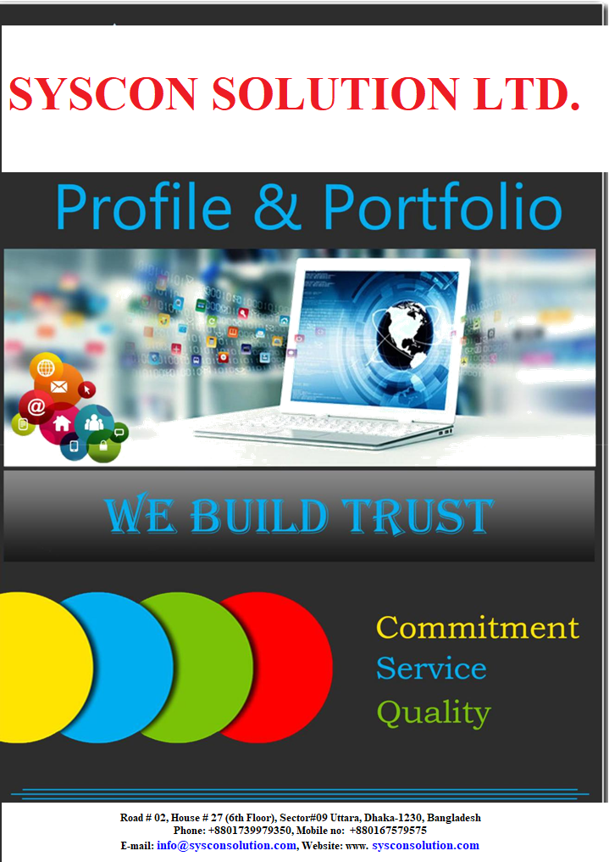

0 | P a g e

CONTENTS

About Company: 2

Highlight: 3

Our Service: 3

Our Products: 4

Product Description: 4

Our Core Values: 7

Strength Of SYSCON SOLUTION LTD.: 7

Working Environment: 8

Organogram: 9

Our Human Resource 10

Technology We Use: 11

Software Development Life Cycle (Sdlc) 12

Client List 14

1 | P a g e
ABOUT COMPANY:

SYSCON SOLUTION LTD. is one of the top Bangladeshi Information and Communication Technologies (ICT) service provider and software developer. We provide a complete business solution like Software, Application, Website Design and Development, CCTV, Networking, Hardware and etc. We design, develop, support and promote software ICT applications using integrated, state-of-the-art technology.

SYSCON SOLUTION LTD. is an established and strong working environmental software firm in Bangladesh. SYSCON SOLUTION LTD. is a strong and experienced company by its experts. Our main key is technology, creativity and honesty. We all put it together for the creation of wonder to surprise the world with new things and innovations. We are very sincere and honest for our work and maintain out time schedule and our team to make a solution of all IT related problems. Our customers are in all sizes company like a start-up to large companies and we provide the same service to all the companies who realize that they need a professional solution to generate revenue streams, established communication channels and stream line businesses operation.

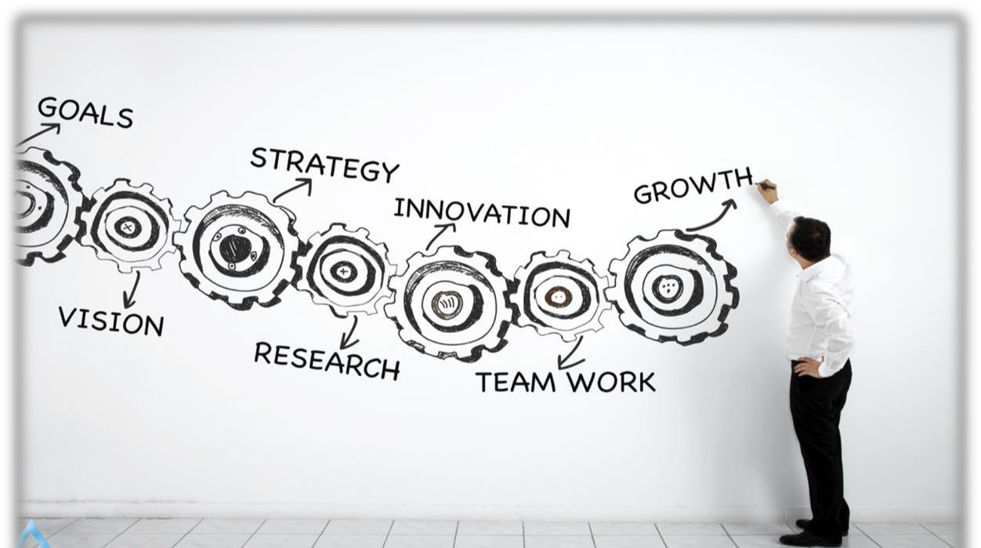

Highlight:

Company Name: |  | SYSCON SOLUTION LTD.
Office Address: |  | Road # 02, House # 27 (6th Floor), Sector#09 Uttara, Dhaka-1230 Bangladesh
Business Starting Year: |  | 2011(with the name of SYSCON ENGINEERING LTD.), 2020 (with the
 |  | Name of SYSCON SOLUTION LTD.)
Service Region: |  | Bangladesh and other countries like, UAE, USA, Canada &
 |  | UK
Project Type: |  | Point of Sale (POS), ERP solution, HR & Payroll, Accounting
 |  | Solution, Advocate Diary, Hotel ERP, Education ERP, Hospital
 |  | Management.
Service Type: |  | Software Development, Web Design & Development, Apps
 |  | Development, Business Solution, IT Enable Service(ITES),
 |  | Domain & Hosting, Network & Hardware Solution, IT
 |  | Infrastructure Design and Develop. Security and Surveillance,
 |  | Automation, IT Consultancy and Professional Training.
Web Address : |  | www.sysconsolution.com
Facebook Page: |  | www.facebook.com/ sysconsolution
Linked In Page:
Location: |  | Bangladesh
Incorporation Certificate |  | YES
Trade License |  | YES
BASIS Membership |  | YES
TIN Certificate |  | YES
VAT Certificate |  | YES

Mission:

Our Mission is committed to the continuous improvement of its professional service

Vision:

Our Vision is to continually improve the business globally, pioneer state of the art technological solutions.

Our Service:

SYSCON SOLUTION LTD. Specializes in providing the following services:
- Software Development

- Web Development

- Mobile Apps Development

- Business Automation

- IT Enable Service (ITES)

- IT Infrastructure Design and Develop

- Security and Survailance.

- Networking Solution

- Hardware Solution

- IT Consultancy

- Manage Service of any Office.

- Professional Training

Our Products:
- Point of Sale (POS)
- ERP Solution

- HR and Payroll
- Accounting System
- Advocate Diary
- Inventory Management System
- Hotel Reservation System
- Educational Institution Management System
- Diagnostic Management System
- Maintenance Management Software- For Battery
- Maintenance Management Software- For Auto Mobile
- Hospital Management System
- Restaurant Management System
- Financial Accounting Management System

- Inventory Management System

Product Description:

Point of Sale (POS) –Basic Configuration, User Settings, Purchase Module, Inventory Module, Sales Module, HR, Accounts, Reports.
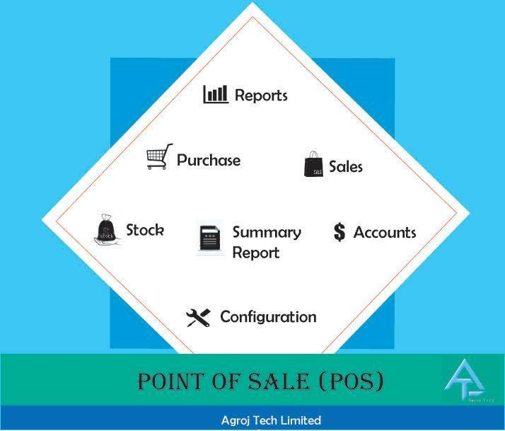

ERP Solution:
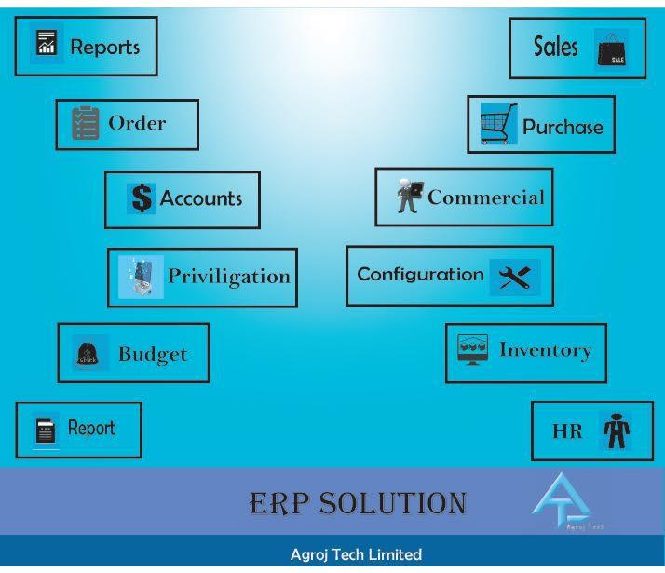
- Configuration Module

- Previligation Module

- Order Module

- Purchase Module

- Inventory Module

- Production Module

- Commercial Module

- Sales Module

- Budget Module

- Accounts Module

- HR Module

- Reporting

HR &Payroll Solution:

- Configuration

- User Setting
- Career
- Employee Info
- Leave
- Duty Schedule
- Loan

- Promotion
- Retirement
- Punishment
- Tax
- Salary
- KPI

- Document
- Photo Gallery
- Reporting
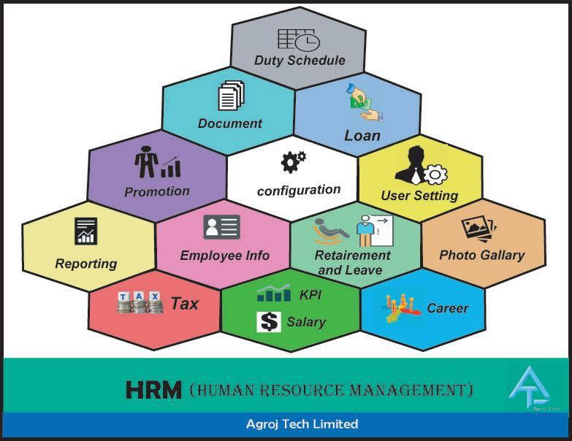

Accounts Software:

- General Ledger Module, Chart of Accounts Module

- Trial Balance Module
- Balance Sheet Module
- Accounts Receivable Module
- Accounts Payable Module
- Fixed Assets Module
- Personnel and Payroll Module

- Stock Module
- Reports

5 | P a g e

Hotel ERP:

- Online Reservation,

- Offline Reservation,

- Front Office (Check In, Check Out, Service, House Keeping, Room Setup, Customer Ledgr)

- Purchase

- Inventory

- HRM

- Accounts

Education ERP:

- Admission

- Academic

- Exam

- Result

- Student Account

- Core Account

- Purchase

- Inventory

- HRM

- Parent Pannel

- Class Schdule

- Student Panel

- Teacher Panel

- SMS Send Option
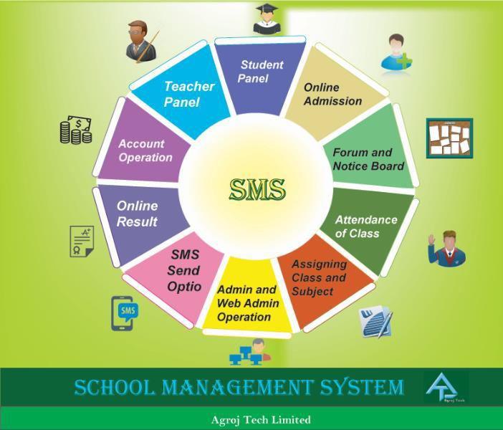

Business Automation and Security Solution

➢ IP Camera, Attendance Device, NVR/DVR, POS Machine Set
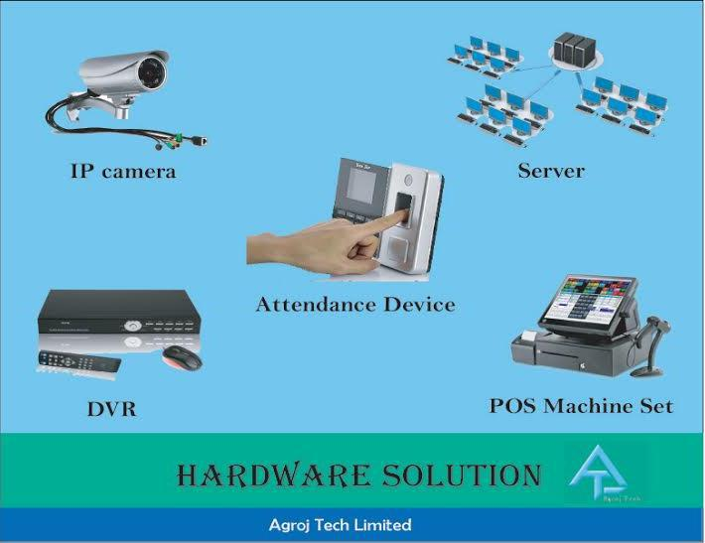

6 | P a g e

Professional Training:

Freelancing, Software Development, Apps Development, Graphics Design, Social Media Marketing, Video Editing, 3D Animation.
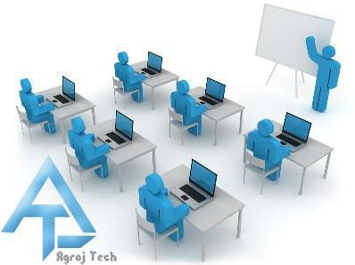

Our Core Values:

CUSTOMERS are the beginning and the end of everything we do. We understand their needs, exceed their expectations in ways that are meaningful to them, and enable their success.

PEOPLE are our most important asset. To our customers, our people are our company. We attract the best people and create an environment where they reach their full potential. EXCELLENCE is our enduring aspiration. We take pride in our work and continuously improve.

WINNING is our ultimate goal. We stretch ourselves, we overcome obstacles, we play fair – and we win.

INNOVATION is our passion. With enthusiasm and creativity we develop high impact innovations.

Strength of ICT TECHNOLOGIES:
- Flexible Production Schedule

- Assured Information Security and Confidentiality

- Cost Effective Outsourcing Destination

- Global Market Experience

- Young Energetic Team

- Very honest and sincere.

- Good customer service

- Monitoring and Reporting Via In-House Software.

- Work Based On The Time Line Of The Project

7 | P a g e
- Provide 24x7 Support Service.

- Call Center Facility for Support or inquiry

- Well trained and skilled professional with divers experience

Working Environment:

- 3000 Square Feet Office Space with Clean and Silent Environment

- Power Backup with Generator and IPS

- 20 MB Internet Connectivity
- 25 People Sitting Arrangement
- 20 Computers
- One conference/Meeting Room Available

- Managing Director Room
- Reception for Guest
- Separated Marketing, Development and Support Department
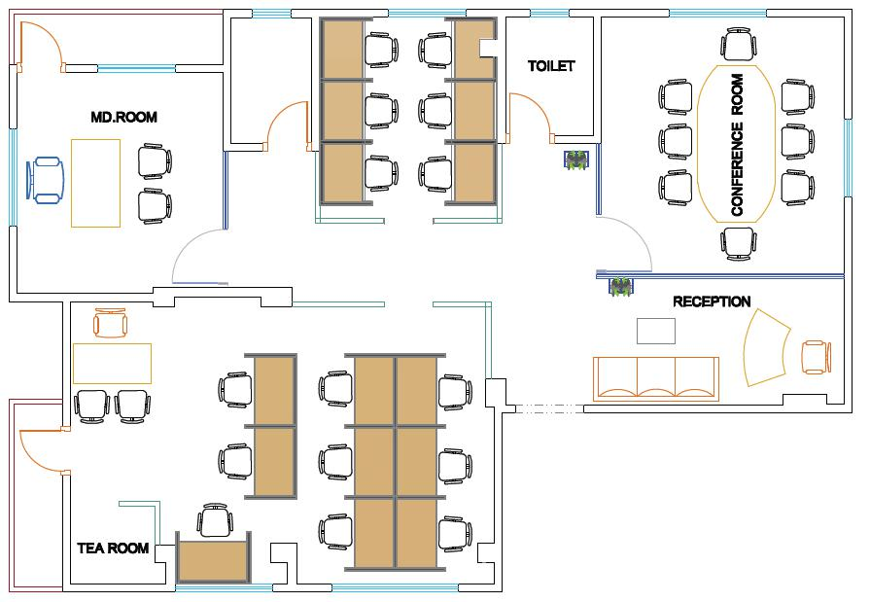

Fig: Office layout

8 | P a g e

Organogram:

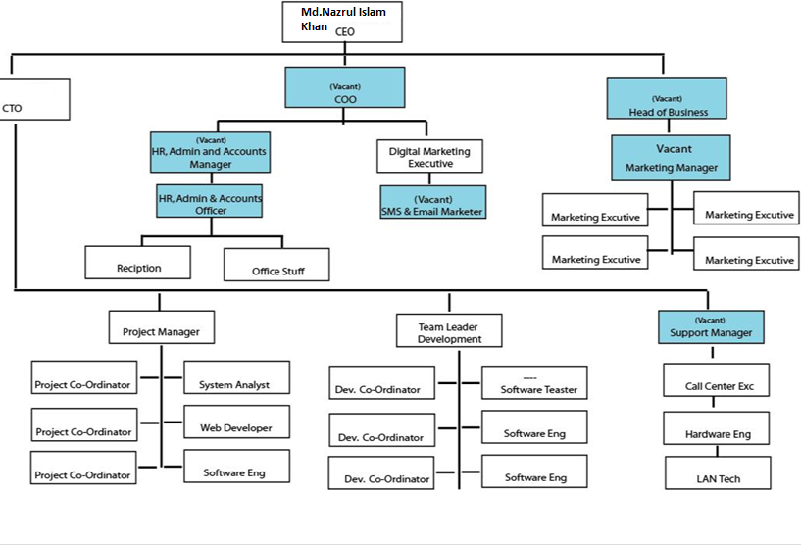
9 | P a g e

Our Human Resource



SR |  | Resource Person |  | Designation |  | Department |  | Remarks
No#
1 |  | Md.Nazrul Islam Khan |  | Chairman & (COO) |  | Management |  | 17 Years
2 |  | Md.Taslim Haque |  | Managing Director |  | Management |  | 15 years
3 |  | Md.Masud Iqbal Chowdhury |  | Director |  | Marketing |  | 15 Years
4 |  | Zakaria Jubery |  | Director |  | Marketing |  | 15 Years
5 |  | Abdul Hadit |  | Director |  | Software Dev |  | 7 Years
6 |  | Md.Rubel Dewan |  | Director |  | Software Dev |  | 7 years
7 |  |  |  | Software Engineer |  | Software Dev |  | 1 years
8 |  |  |  | Marketing Executive |  | Marketing |  | 1.5 years
9 |  |  |  | Marketing Executive |  | Marketing |  | 1 years
10 |  |  |  | Marketing Executive |  | Marketing |  | 1 years
11 |  |  |  | Marketing Executive |  | Marketing |  | 1 years
12 |  |  |  | Marketing Executive |  | Marketing |  | 1 years
13 |  |  |  | Project Coordinator |  | Software Dev |  | 1 years
14 |  |  |  | Software Engineer |  | Software Dev |  | 1 years
15 |  |  |  | Project Coordinator |  | Software Dev |  | 3 years
16 |  |  |  | Marketing Executive |  | Marketing |  | 1 year
17 |  |  |  | Development Team leader |  | Software Dev |  | 5 years
18 |  |  |  | Development Coordinator |  | Software Dev |  | 2 years
19 |  |  |  | Development Coordinator |  | Software Dev |  | 2 years
20 |  |  |  | Software Engineer |  | Web Development |  | 2 years
21 |  |  |  | Software Engineer |  | Software Dev |  | 1 years
 |  |  |  | (development)
22 |  |  |  | Software Engineer |  | Software Dev |  | 1 years
 |  |  |  | (development)
23 |  |  |  | Software Engineer |  | Software Dev |  | 1 years
 |  |  |  | (development)
24 |  |  |  | Project Coordinator |  | Software Dev |  | 1 Years
25 |  |  |  | Software Engineer |  | Web Developer |  | 2 Yers

Technology We Use:

We have a Strong team of IT minds with different specialization and tools who can be involved into OSDCs .We have all modern facilities and equipment’s.
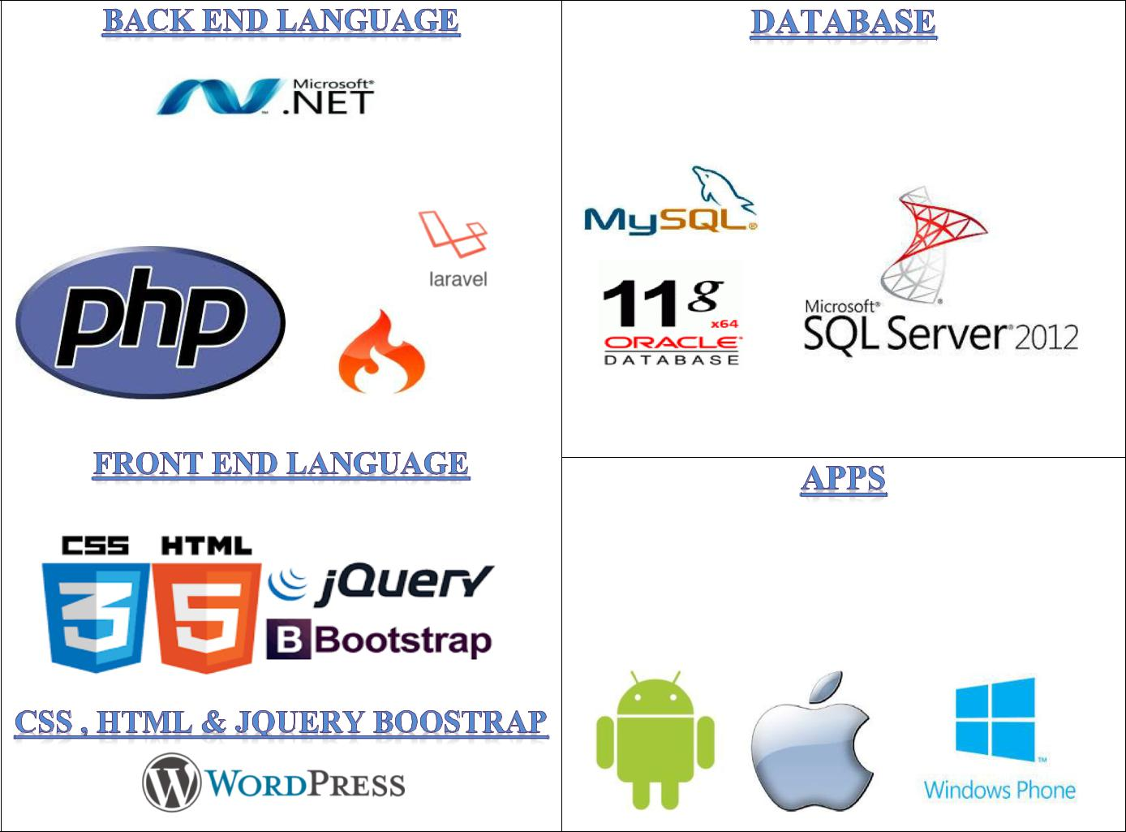

SQL SERVER,ORACLE ,MY SQL SERVER

ASP.NET & MVC Frame work

PHP Codeigniter

ANDROID APPLE WINDOWS HONE

11 | P a g e

SOFTWARE DEVELOPMENT LIFE CYCLE (SDLC)

Development Approach:

At SYSCON SOLUTION LTD, we understand that project success is directly proportional to project planning and phase of project development. Our Software Development Life Cycle (SDLC) differs based on the size, cost, time of each project so that it enables us to provide a cost-effective and efficient solution. Top management workforces at SYSCON SOLUTION LTD. Our development approach starts by working closely with the customer to identify and understand the mission or problem statement and translate the related objectives into requirements and a candidate top level solution approach. We attempt to match the customer requirements with a top-level solution or system that either exist or are realizable with low to medium risk. The next step is definition of detailed requirements for the system – these will include the number of actual-tors, actuator spacing, temporal bandwidth (at a specified gain margin), optical requirements over a wide capture field of view and narrow operational field of view, and other require-ments that are critical for high performance.

Requirement Collection & Specification

Quality full software depends on good requirement. A good requirement engineering can collect good requirements. This is the first and main step of developing a software is when we gather the System Requirements, or all the details of the Business Logic of the software, to be translated later to a working Software.

First of all we need to understand the needs of your client, the one who made the request for the software. Requirements are the most basic understanding about the business logics of the problem to be solved. Our domain expert always collects requirements from a different level of stakeholders. We involve all possible stakeholders to make and deploy effective software. Sometimes, they even don't know what they want and keep changing functionalities, or does not understand about software at all. In order to start any software development, from the most basic to the most complicated one, is to create something called User Stories, followed by the list of Functional and Non-Functional Requirements.

Requirement Analysis, Design and Documentation

Requirements analysis can be a long and tiring process during which many delicate psychological skills are involved. Large systems may confront analysts with hundreds or thousands of system requirements. New systems change the environment and relationships between people, so it is important to identify all the stakeholders, take into account all their needs and ensure they understand the implications of the new systems. Analysts can employ several techniques to explicit the requirements from the customer. These may include the development of scenarios (represented as, the identification of use cases, the use of workplace observation or ethnography, holding interviews, or focus groups (more apply

12 | P a g e

Named in this context as requirements workshops, or requirements review sessions) and creating requirements lists. Prototyping may be used to develop an example system that can be demonstrated to stakeholders. Where necessary, the analyst will employ a combination of these methods to establish the exact requirements of the stakeholders, so that a system that meets the business needs is produced. Requirements quality can be improved through these and other methods

Coding and Testing:

In agile development, we write high-level test cases before coding even starts. This is a good practice no matter what development methodology you’re using. Testers are skilled at helping business experts clarify their requirements for a particular feature or piece of functionality, and using those to provide the big picture for what the code needs to do.

When coding starts, it’s time for testers to turn the examples of desired behavior that they’ve stimulated from customers into executable tests that will let the team know when the functionality is "done". If these tests aren’t automatable, the programmers are unlikely to actually run them. However, as we write tests that will be automated, we also think ahead to the important exploratory testing we’ll need to do as coding is completed.

Deployment and Support:

This phase starts with Deployment of the Project. Initial set-up of the hardware and all the software platforms necessary to run the project is set up at this stage. Project Leader will send Support Executives to the Client end to ensure complete and successful set-up of hardware and software and the software will be handed over to the client for User testing.

Development Methodology:

Our software development methodology is based on ISO standards, and our experience and confidence. Depending on customer’s wishes and project scope, we can apply one of the following methodologies:

- Agile

- Waterfall

Our customers and managers control the development progress via the following planning and project tracking tools:

- Microsoft Project Professional
- Manage Engine Service Desk Plus
- Zoho Projects
- OneSoft Connect

- SYSCON SOLUTION LTD is one of the top Bangladeshi Information and Communication Technologies (ICT) service provider and software developer. We provide complete business solution like Software, Application, Website Design and Development, CCTV, Networking, Hardware and etc. We design, develop, support and promote software ICT applications using integrated, state-of-the-art technology.

13 | P a g e

