Student Portal — System Analysis and Design
Code-informed presentation companion · 20 October 2026
Purpose and scope
This companion describes selected system-design views of the Student Information Portal: its current application architecture, major data flows, a subset of the relational model, role-based use cases, and representative authentication and teacher workflow sequences.
The diagrams are based on the code and schema artifacts reviewed for this pack. They are deliberately bounded for presentation clarity and should not be treated as an exhaustive feature or entity inventory.
Recommended presentation flow
Introduce the portal and its actors; explain the system boundary and architecture; walk through DFD context and level 1; use the two ERDs to describe academic and admissions/finance data; then explain role use cases and one sequence. Conclude with limitations, readiness checks, and the next acceptance-test steps.
Trust and implementation notes
Protected operations rely on backend authorization and ownership checks. The browser is a client, not the security boundary. Private files require authorized server-side access. The temporary Quick Tunnel is a testing route and must not be presented as a stable production endpoint.
Payment attempts have database foreign keys to fees and students, and reconciliation entries reference payment attempts. Admission application approval and student-account provisioning are workflow-related but are not represented as a direct application-to-student foreign key in the selected ERD.
A configured email or payment-related screen does not by itself establish provider integration readiness. Check the project integration and release checklist, and verify the exact pilot environment before quoting database, migration, operational, or provider status.
Presentation and confidentiality checklist
Use synthetic data. Do not share .env files, secrets, tokens, MFA material, database dumps, real student/staff/applicant information, payment records, internal hostnames, or the temporary tunnel URL as a permanent address. Keep demo access details separate and share them only through an approved secure channel.
A live health check is not a substitute for authenticated acceptance testing of student, teacher, and administrator workflows. Present optional or partial integrations as such and clearly distinguish current implementation from proposed or pending operational controls.
Current dashboards — illustrative mock data
These screenshots use the project's current dashboard HTML and styles, with JavaScript/API calls disabled and clearly synthetic sample values inserted for presentation. They are not authenticated captures and do not show live account or system data.

System Architecture
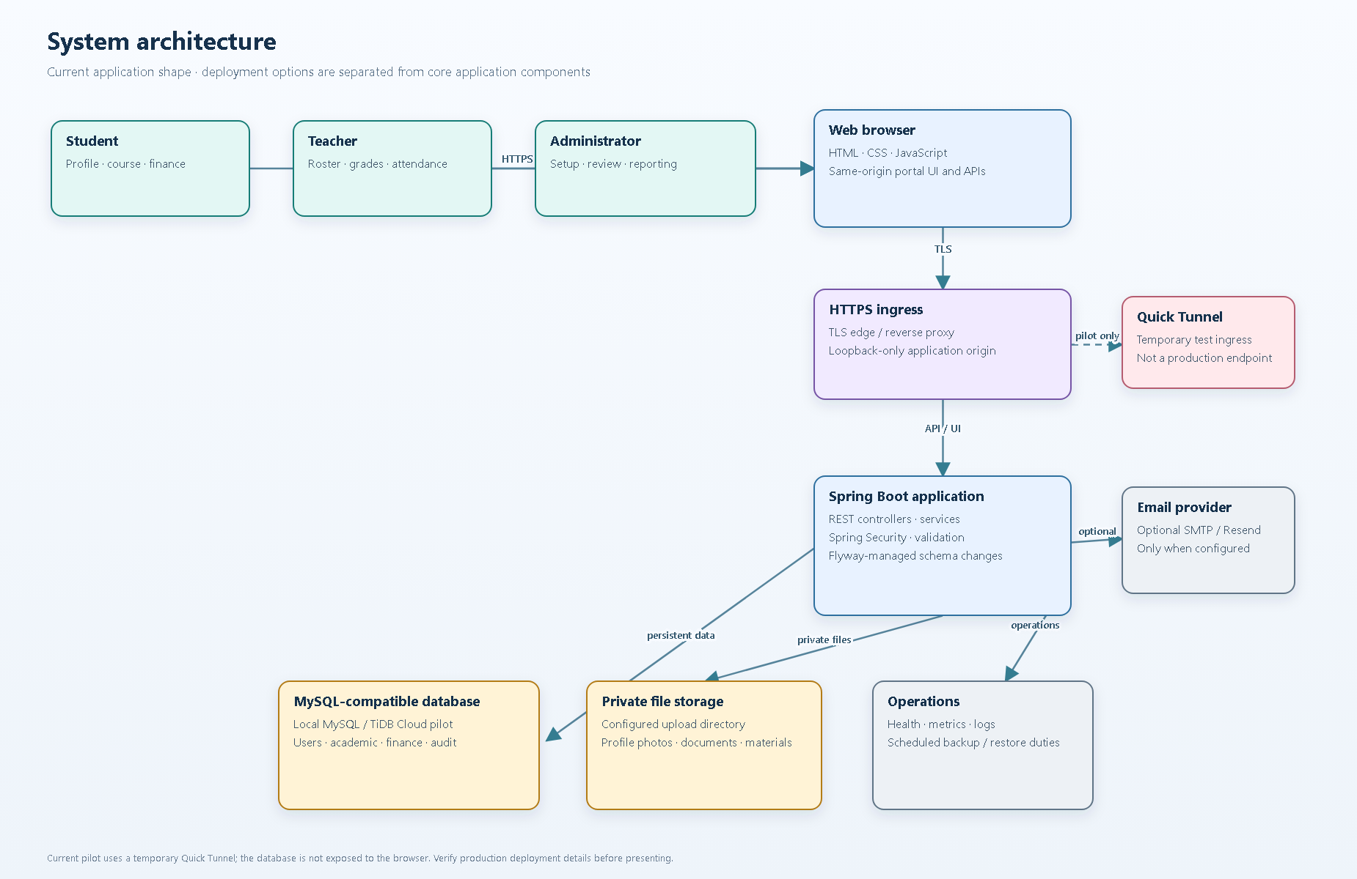
System Architecture — selected code-informed view.

DFD 0 — System Context
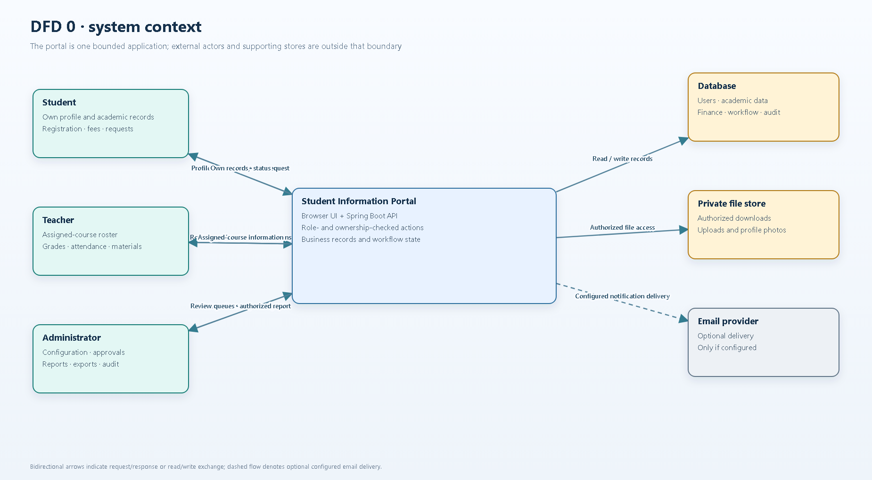
DFD 0 — System Context — selected code-informed view.

DFD 1 — Processes and Data Stores
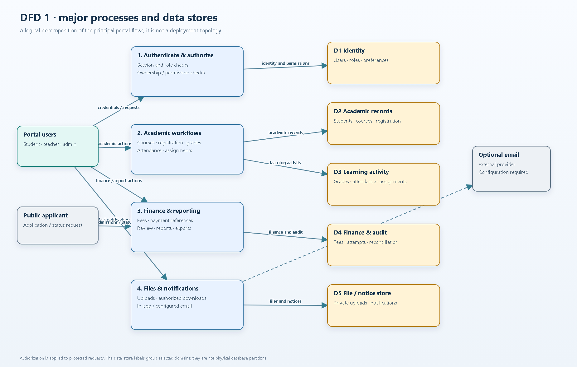
DFD 1 — Processes and Data Stores — selected code-informed view.

ERD 1 — Identity and Academic Core
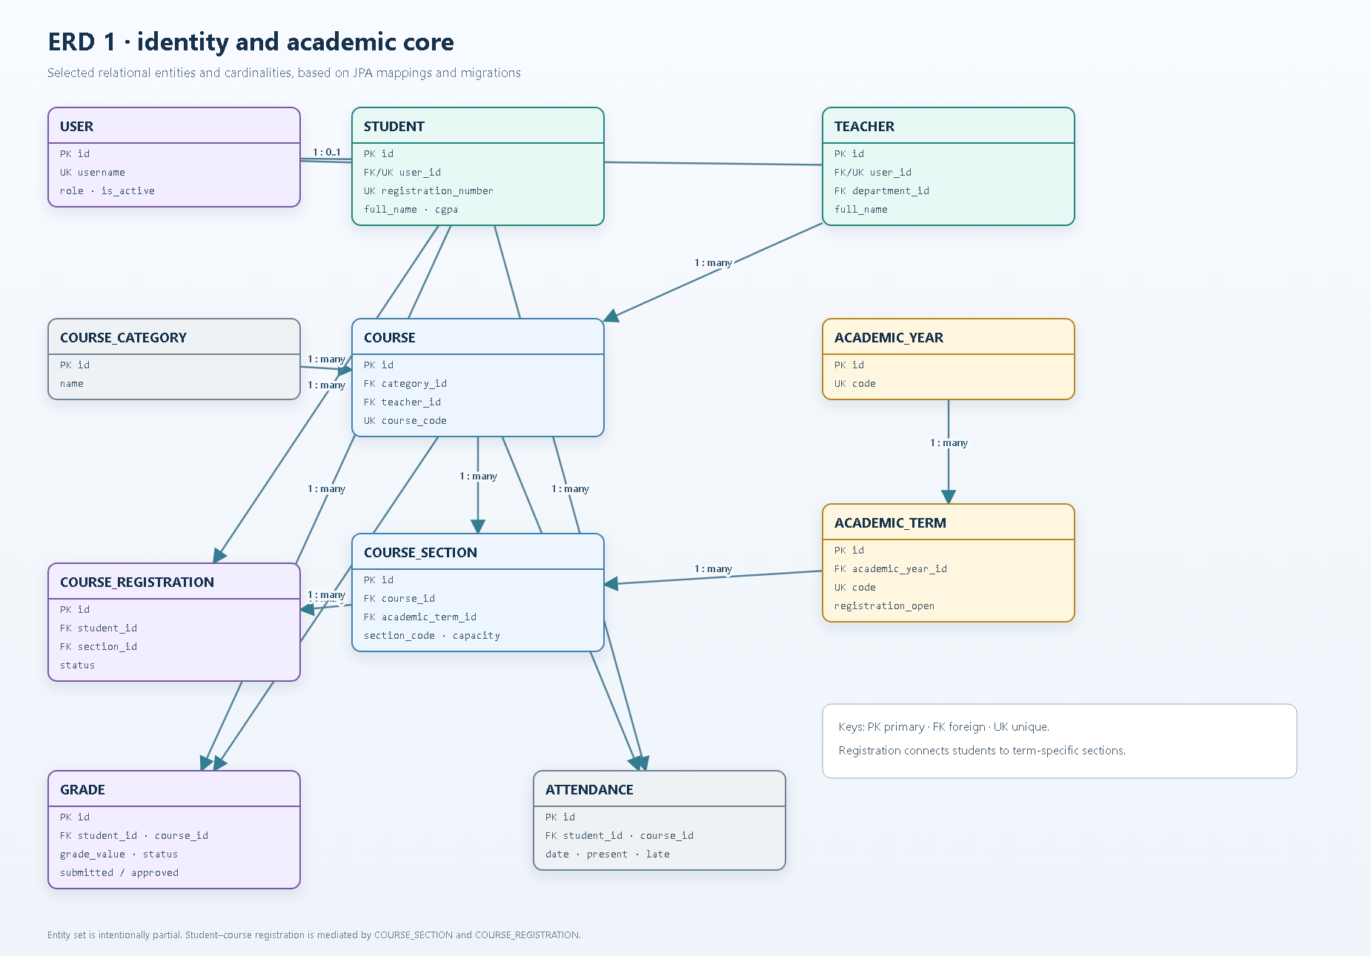
ERD 1 — Identity and Academic Core — selected code-informed view.

ERD 2 — Admissions and Finance
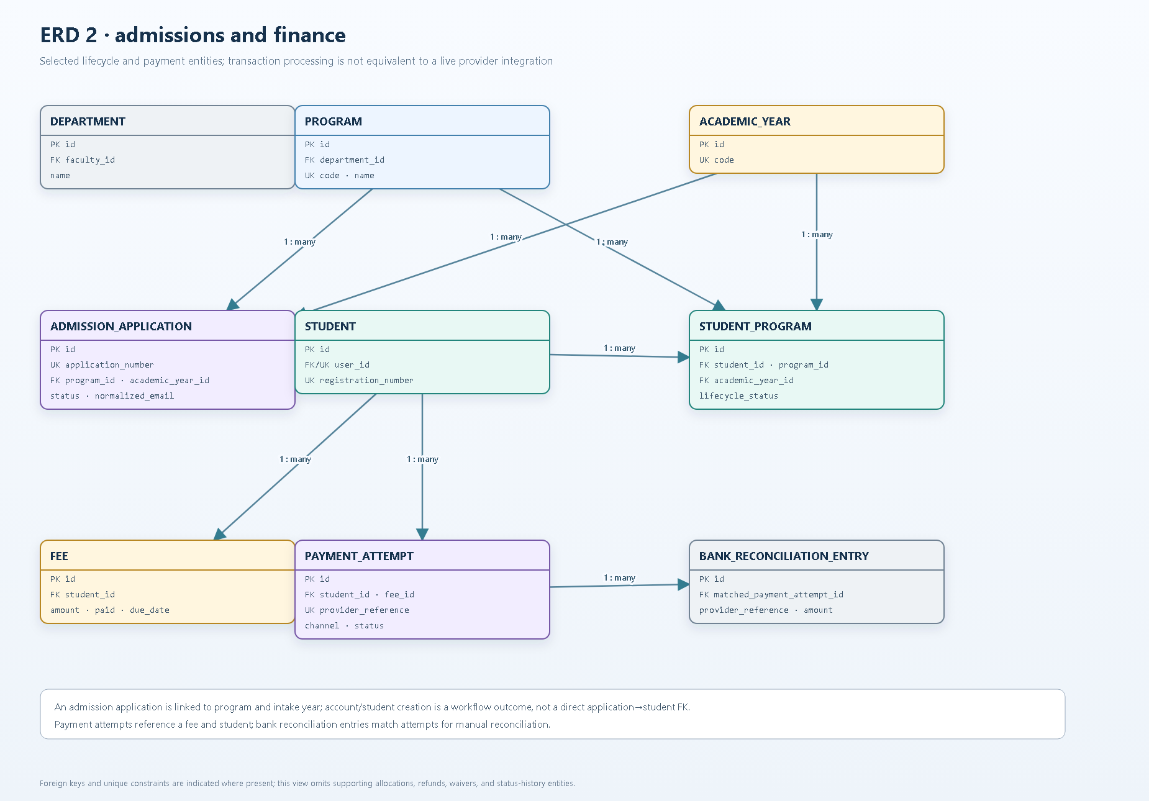
ERD 2 — Admissions and Finance — selected code-informed view.

UML Use Cases — Role Capabilities
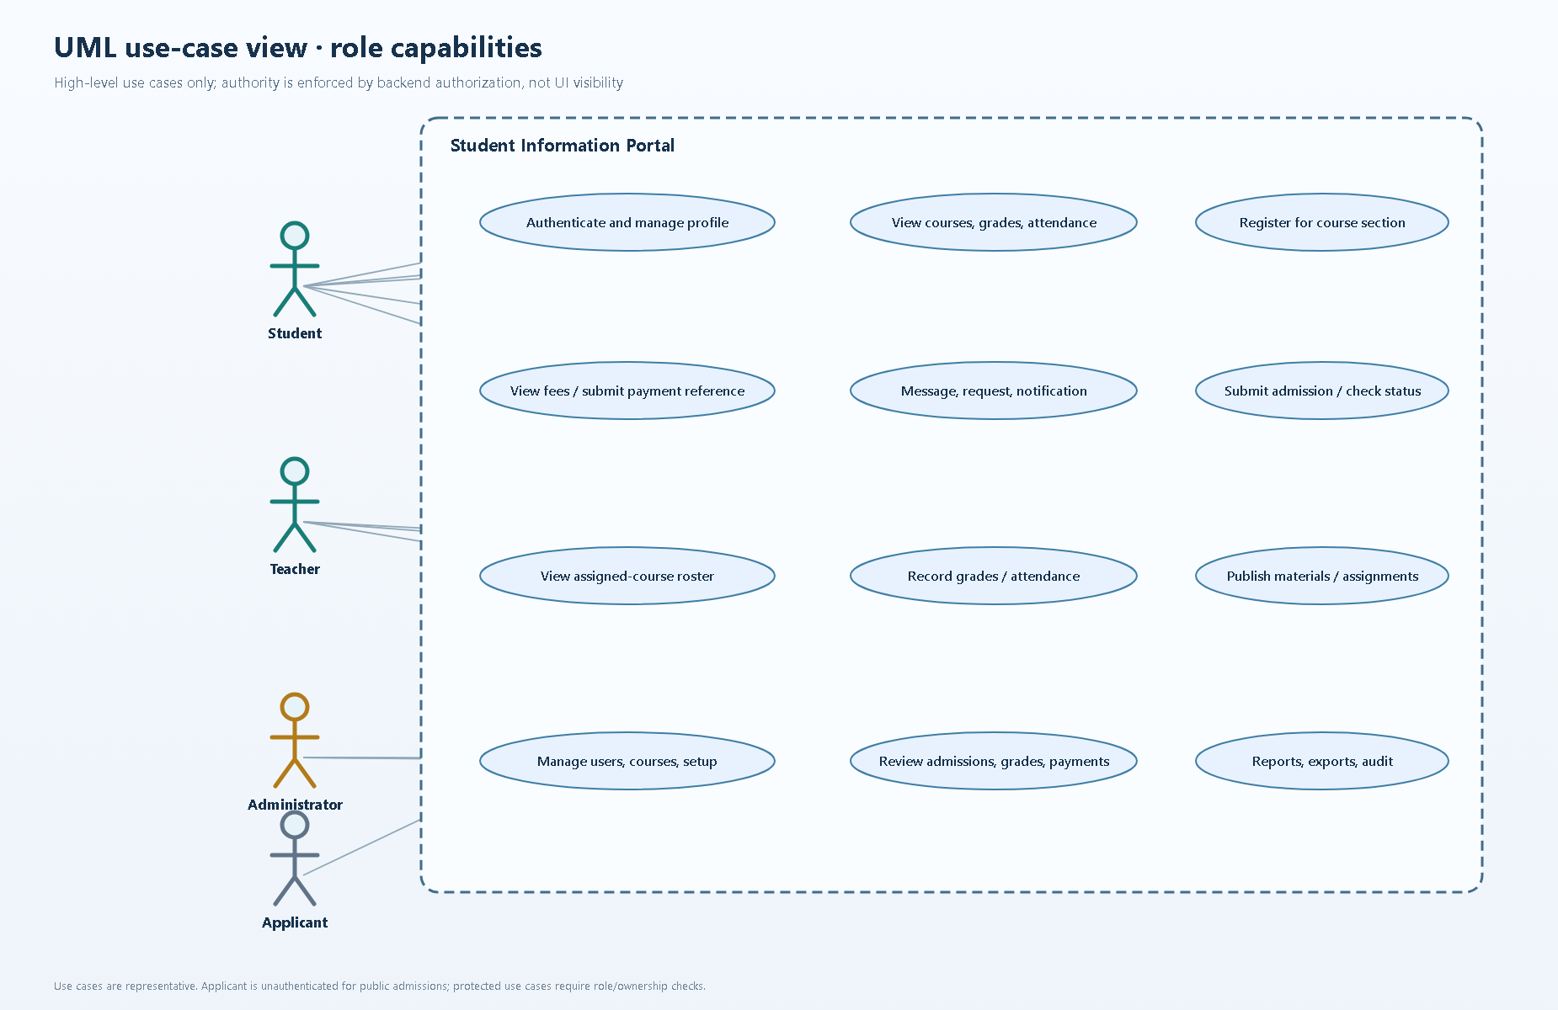
UML Use Cases — Role Capabilities — selected code-informed view.

UML Sequence — Authentication and Access Control
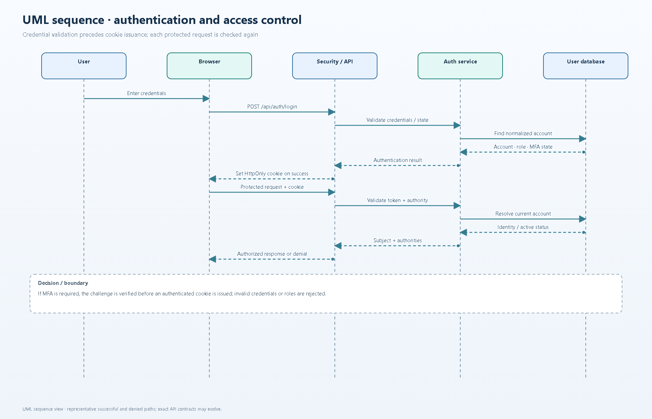
UML Sequence — Authentication and Access Control — selected code-informed view.

UML Sequence — Teacher Roster, Photo, and CSV
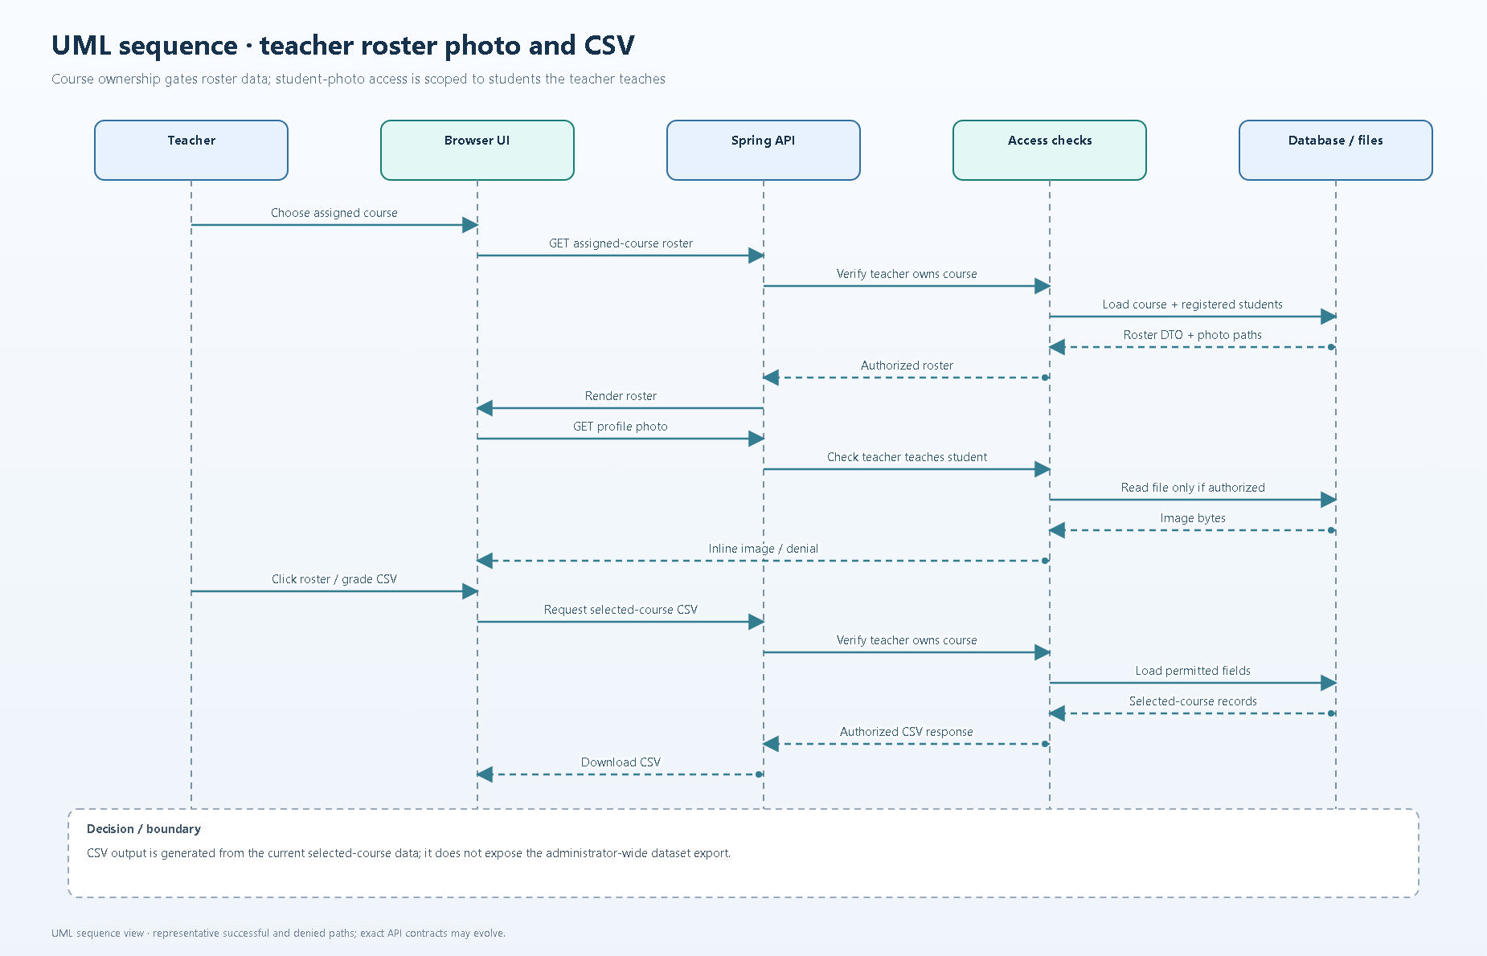
UML Sequence — Teacher Roster, Photo, and CSV — selected code-informed view.

Student Dashboard · Illustrative Mock Data
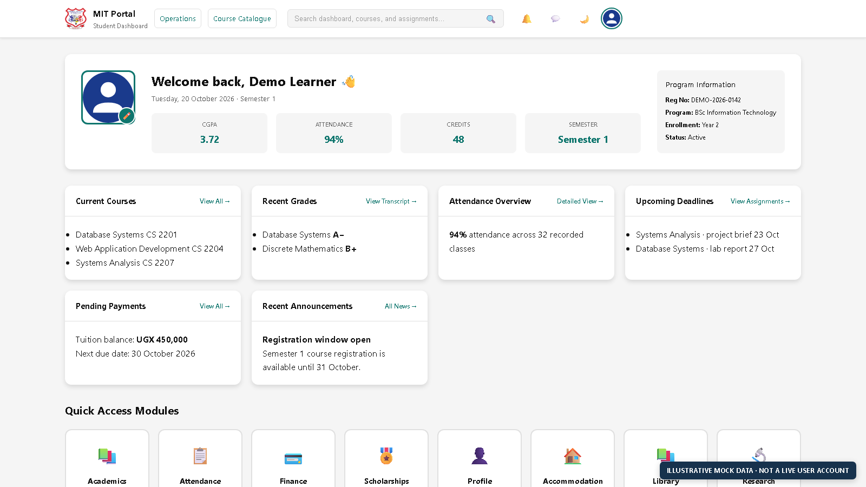
Illustrative dashboard view · synthetic data only · not a live user account.

Teacher Dashboard · Illustrative Mock Data
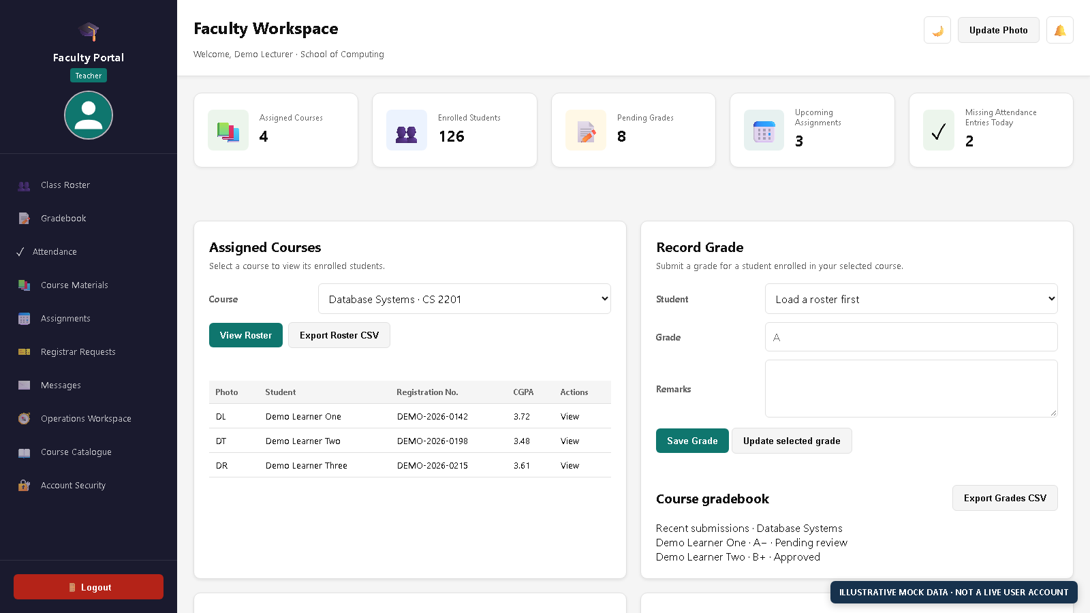
Illustrative dashboard view · synthetic data only · not a live user account.

Administrator Dashboard · Illustrative Mock Data
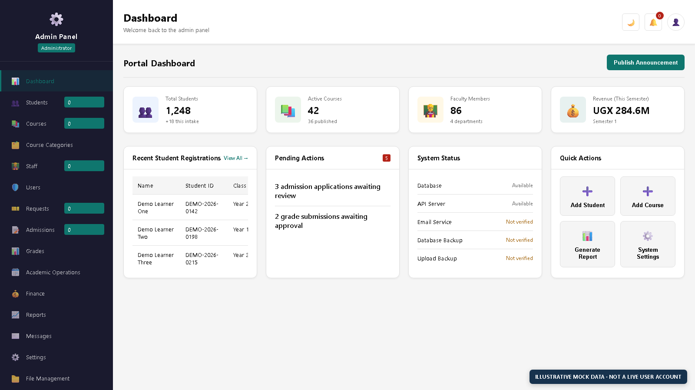
Illustrative dashboard view · synthetic data only · not a live user account.

