PostgreSQL Entity Relationship Design
Sangha and Education Data Platform
Item | Details
Purpose | Normalised logical PostgreSQL design for identity, roles, scopes, people, contacts, organisations, positions, legal evidence, exams, candidates, applications, documents, imports and audit.
Core decision | Person and position are separate. Each business status is represented by an append-only event. The current state is derived from the latest valid event rather than overwriting history.
Architecture alignment | Confirmed: Prisma/PostgreSQL, protected server actions/API routes, Auth.js, server-side role-and-scope authorisation, private object storage, and atomic business/history/audit transactions.
Boundary | Synthetic, fictional, non-identifying data only. This logical ERD neither creates legal authority nor approves real-data processing, public disclosure or retention periods.
Verification method | Normalisation and history design review. No migration, database constraint, query plan, policy or product test is claimed as executed.

Status Labels
Label | Meaning
Confirmed | Established architecture or history/security constraint; not a release or legal decision.
Proposal | Logical tables, fields, indexes and workflow constraints to confirm before migration.
Needs Legal Review | Retention, official status, real-data use, public release, source authority and document policy requiring review.

1 Core Entity Relationship Diagram
Arrow labels show parent-to-child cardinality. Relationship tables use explicit foreign keys; audit_event and approval_decision_event are documented controlled-reference exceptions because they can point to several entity classes.
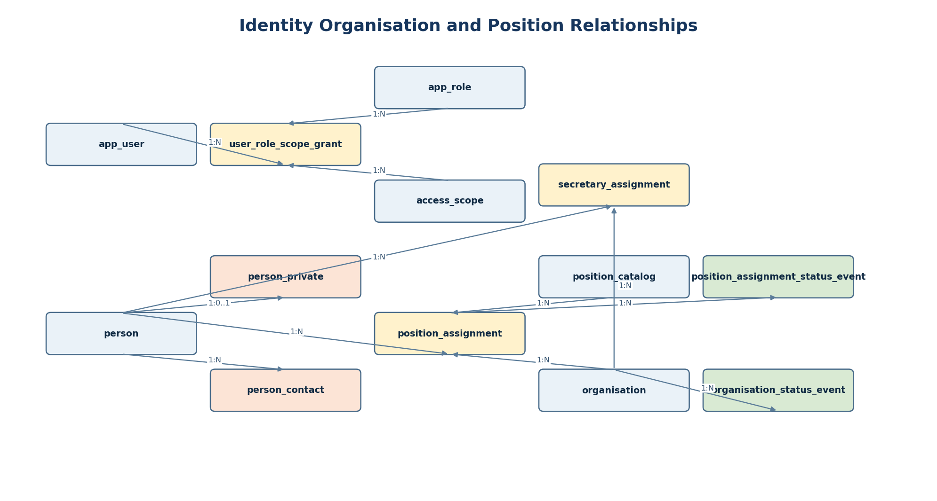
Confirmed: no position, organisation role or contact information is stored on person as a duplicate. A position assignment joins a person to a position and organisation for an effective period.

2 Workflow and Governance Relationships
The workflow domain connects candidates, sessions and centres through application. Documents are anchored in private object metadata then linked through explicit application, legal-source or approval association tables.
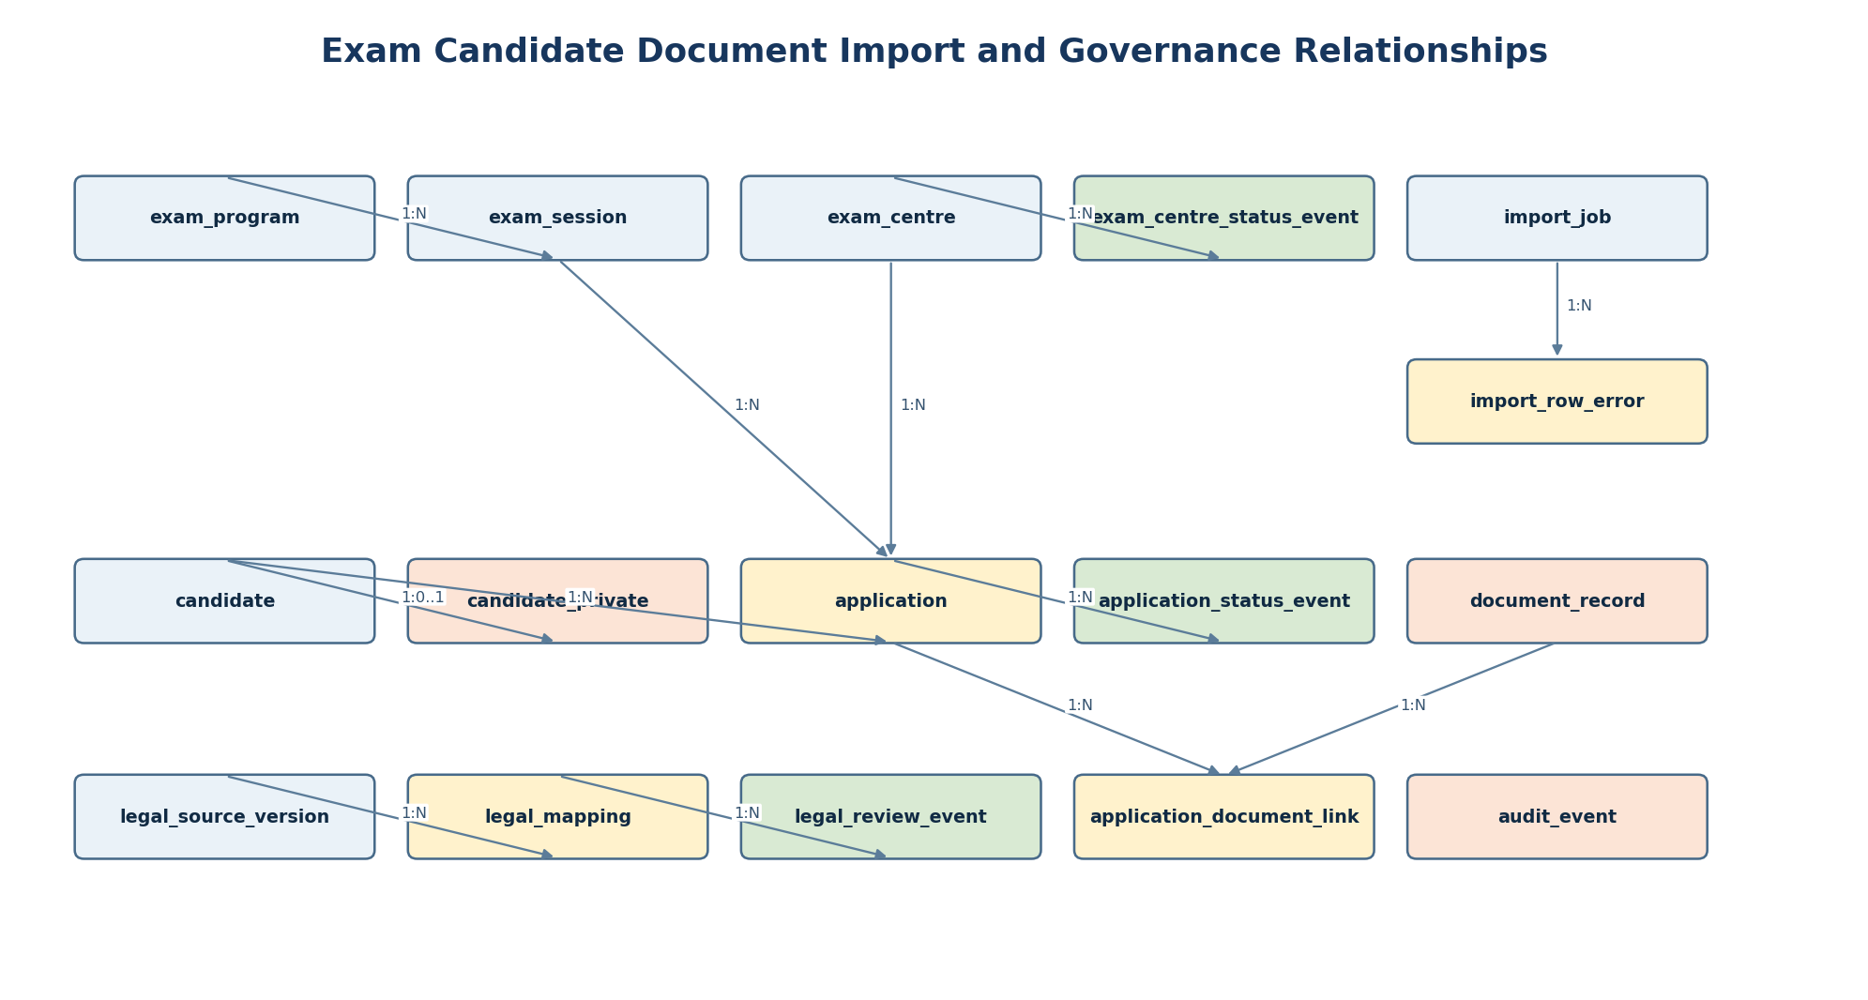
Proposal: legal mapping, evidence review and publication/approval decisions remain separate from operational workflow data. A legal reviewer role has no implied operating-data access.

3 Access and Identity Tables
Table | Primary key | Foreign keys | Normalised purpose and constraints | Class | Status
app_user | user_id UUID | person_id -> person nullable | Auth subject and synthetic marker; unique auth_provider + subject. | Internal | Confirmed
app_role | role_id UUID | none | Stable role_code unique; role meaning is configuration. | Internal | Proposal
access_scope | scope_id UUID | organisation_id -> organisation nullable | Scope type and organisation boundary; unique scope_type + organisation_id. | Internal | Proposal
user_role_scope_grant | grant_id UUID | user_id -> app_user; role_id -> app_role; scope_id -> access_scope | Effective range; grant never overwritten; revocation is event. | Restricted | Proposal
user_role_scope_event | event_id UUID | grant_id -> user_role_scope_grant; actor_user_id -> app_user | GRANTED/REVOKED/CORRECTED event; append-only. | Highly Restricted | Confirmed
person | person_id UUID | none | Synthetic minimal identity reference only; no position or contact fields. | Restricted | Proposal
person_private | person_id UUID | person_id -> person | One-to-one sensitive attributes; separated from operational directory rows. | Highly Restricted | Proposal
person_contact | contact_id UUID | person_id -> person | Contact channel/type/value protected separately; default never public. | Highly Restricted | Proposal

4 Organisation Position and History Tables
Table | Primary key | Foreign keys | Normalised purpose and constraints | Class | Status
organisation | organisation_id UUID | parent_organisation_id -> organisation nullable | Adjacency hierarchy; org_code unique; display name internal/restricted. | Restricted | Proposal
organisation_status_event | event_id UUID | organisation_id -> organisation; decision_id -> approval_decision_event nullable | Status transition event with effective_at; append-only. | Restricted | Confirmed
position_catalog | position_id UUID | none | Position taxonomy only; position_code unique; no person data. | Restricted | Proposal
position_assignment | assignment_id UUID | position_id -> position_catalog; organisation_id -> organisation; person_id -> person nullable | Separates position from person. Effective range; one current assignment constraint proposed. | Restricted | Proposal
position_assignment_status_event | event_id UUID | assignment_id -> position_assignment; decision_id -> approval_decision_event nullable | Appointment/correction/term event; append-only. | Highly Restricted | Confirmed
secretary_assignment | assignment_id UUID | organisation_id -> organisation; person_id -> person; related_position_assignment_id nullable | Separate secretary relationship and dates; no role fields copied to person. | Restricted | Proposal

5 Legal Evidence and Approval Tables
Table | Primary key | Foreign keys | Normalised purpose and constraints | Class | Status
legal_source | source_id UUID | none | Supplied source title/issuer only; no inferred law names or sections. | Restricted | Proposal
legal_source_version | source_version_id UUID | source_id -> legal_source | Section reference, effective dates, evidence ref, verification state. | Highly Restricted | Proposal
legal_mapping | mapping_id UUID | source_version_id -> legal_source_version nullable | Topic/control mapping; absent source remains TO VERIFY. | Restricted | Proposal
legal_review_event | event_id UUID | mapping_id -> legal_mapping; reviewer_user_id -> app_user nullable | Role-based outcome, evidence reference and timestamp; append-only. | Highly Restricted | Confirmed
approval_decision_event | decision_id UUID | actor_user_id -> app_user; source_version_id -> legal_source_version nullable | Cross-domain approval evidence; target_type/id is controlled reference. | Highly Restricted | Proposal

6 Exam Candidate Document Import and Audit Tables
Table | Primary key | Foreign keys | Normalised purpose and constraints | Class | Status
exam_program | program_id UUID | none | Synthetic program taxonomy; program_code unique. | Restricted | Proposal
exam_session | session_id UUID | program_id -> exam_program | Session lifecycle and dates; not a public result record. | Restricted | Proposal
exam_centre | centre_id UUID | organisation_id -> organisation nullable | Centre identity and scope; centre_code unique. | Restricted | Proposal
exam_centre_status_event | event_id UUID | centre_id -> exam_centre; decision_id -> approval_decision_event nullable | Lifecycle transition event; append-only. | Restricted | Confirmed
candidate | candidate_id UUID | person_id -> person nullable | Synthetic candidate reference; person fields not duplicated. | Highly Restricted | Proposal
candidate_private | candidate_id UUID | candidate_id -> candidate | Sensitive eligibility/declaration fields separated one-to-one. | Highly Restricted | Proposal
application | application_id UUID | candidate_id -> candidate; session_id -> exam_session; centre_id -> exam_centre nullable | Unique candidate + session; immutable submitted snapshot fields only where necessary. | Highly Restricted | Proposal
application_status_event | event_id UUID | application_id -> application; decision_id -> approval_decision_event nullable | DRAFT/SUBMITTED/etc event; append-only, no update of prior decision. | Highly Restricted | Confirmed
document_record | document_id UUID | none | Private object metadata, storage key and integrity reference; binary not in PostgreSQL. | Highly Restricted | Confirmed
application_document_link | link_id UUID | application_id -> application; document_id -> document_record | Explicit FK attachment link; category/received state; no polymorphic owner field. | Highly Restricted | Proposal
legal_source_document_link | link_id UUID | source_version_id -> legal_source_version; document_id -> document_record | Evidence document link with explicit FK. | Highly Restricted | Proposal
approval_document_link | link_id UUID | decision_id -> approval_decision_event; document_id -> document_record | Approval evidence link with explicit FK. | Highly Restricted | Proposal
import_job | job_id UUID | submitted_by_user_id -> app_user | Private synthetic import processing job; template version and counts. | Internal | Proposal
import_row_error | error_id UUID | job_id -> import_job | Structured error code/field; raw rejected values stored separately/redacted. | Restricted | Proposal
import_error_detail | detail_id UUID | error_id -> import_row_error | Highly restricted rejected value/detail; shortest diagnostic retention. | Highly Restricted | Proposal
audit_event | audit_id UUID | actor_user_id -> app_user nullable | Append-only access/mutation audit; entity_type/entity_id controlled reference exception. | Highly Restricted | Confirmed

7 Key Constraints and Indexes
Area | Unique and primary-key rules | Foreign-key and check rules | Recommended indexes | Status
Identity and access | UUID PKs. app_user unique auth_provider + auth_subject. app_role unique role_code. | FK grant -> user/role/scope. Check valid_until is null or >= valid_from. | app_user(auth_provider, auth_subject); grant(user_id, role_id, scope_id, valid_until); event(grant_id, occurred_at DESC). | Proposal
Organisation and positions | organisation unique org_code. position_catalog unique position_code. | Self FK organisation parent rejects self-parent. Check assignment effective_to >= effective_from. | organisation(parent_organisation_id); assignment(organisation_id, position_id, effective_from DESC); assignment(person_id, effective_from DESC). | Proposal
One current assignment | No duplicate overlapping active person/position/org assignment. | Proposal: PostgreSQL daterange/tstzrange exclusion constraint where business rule is confirmed; do not enforce inferred hierarchy semantics. | GiST index supporting range exclusion; status event(entity FK, effective_at DESC). | Proposal
Exam and application | exam_program unique program_code. application unique candidate_id + session_id. centre unique centre_code. | FK application -> candidate/session/centre. Check selected centre belongs to permitted session/org only after rule confirmation. | application(candidate_id, session_id); application(session_id, centre_id); status_event(application_id, occurred_at DESC). | Proposal
Documents and imports | document integrity_ref unique when populated. import_row_error unique job_id + row_number + error_code + field_name. | Binary is absent from PostgreSQL. Check object state/category against controlled enumerations. | document(storage_key); import_job(submitted_by_user_id, created_at DESC); row_error(job_id, row_number). | Confirmed
Legal and approval | legal_source stable internal identifier; source-version unique source_id + version_label. | Effective range checks only; no law name/section is invented. source absent remains TO VERIFY. | source_version(source_id, effective_from DESC); mapping(topic_code, review_state); review(mapping_id, occurred_at DESC). | Needs Legal Review
Audit | audit_event UUID PK and immutable sequence/timestamp combination. | Check action code/outcome enum. Cross-domain entity_type/entity_id is a controlled-reference exception, not a universal FK. | audit(actor_user_id, occurred_at DESC); audit(entity_type, entity_id, occurred_at DESC); audit(request_id). | Confirmed
Index note: confirm actual query patterns and PostgreSQL EXPLAIN results after implementation; no performance assertion is made by this design.

8 History Transactions and Retention
Concern | Required implementation rule | Tables affected | Status
Append-only history | Insert a later event for correction, revocation, reinstatement or term change. Do not UPDATE/DELETE earlier business history. Current state is a view/query over valid latest event. | organisation_status_event; position_assignment_status_event; exam_centre_status_event; application_status_event; user_role_scope_event; legal_review_event; approval_decision_event; audit_event | Confirmed
Atomic decision write | A protected mutation commits business row, status/history event, approval reference and audit event together. On failure, roll back all related writes. | All protected mutations and audit_event | Confirmed
Server authorisation | Server evaluates user, role, action, purpose and scope before read, export, history query or mutation. UI/client claims never grant access. | app_user through user_role_scope_grant; access_scope; protected domain tables | Confirmed
Document boundary | Private object storage holds file bytes. PostgreSQL stores minimal document_record metadata, integrity reference and explicit FK links. | document_record and link tables | Confirmed
Retention | Do not hard-code a legal/official retention period. Store retention_policy_ref and disposition state only after DPO/legal/owner decision; preserve disposal evidence as event. | Documents, audit, imports, legal evidence and private person/candidate data | Needs Legal Review
Public projection | Build a separate release-gated read model. Do not query private tables directly from public route and do not expose relationship keys/history/audit/free text. | Projection outside core tables; source tables remain private | Needs Legal Review

9 Failure Modes and Recovery
Failure mode | Detection and containment | Recovery | Status
Missing scope or role grant | Server cannot resolve current valid grant for action/target. | Fail closed with safe 403/not-found; log permitted metadata; request authorised grant change. | Confirmed
Event insert or audit insert fails | Transaction does not complete atomically. | Roll back business mutation; show action failure; reconcile only from committed latest state. | Confirmed
Source/legal evidence absent | Mapping/source-version remains TO VERIFY. | Block authority/release action needing verified evidence; append reviewer outcome when evidence arrives. | Needs Legal Review
Suspected real data in import/document | Synthetic marker, validation or reviewer flags input. | Quarantine private object, stop processing, notify designated owner/DPO/legal reviewer; do not certify outcome. | Needs Legal Review
Overlapping assignment detected | Range/exclusion constraint or service validation rejects write. | Do not overwrite existing assignment; create a correction/decision workflow after owner review. | Proposal

10 Normalisation and History Review Checklist
Review item | Pass condition | Current design result
First normal form | Atomic fields; repeating contacts, documents, grants and status records use separate tables. | Mapped
Second normal form | Association tables use keys and fields dependent on the association, not copied parent attributes. | Mapped
Third normal form | Person, position, organisation, role, scope, program, session and status facts are separated to avoid transitive duplication. | Mapped
Person position separation | Position assignment links person + position + organisation. Person does not carry current office/role/contact duplicates. | Mapped
Event history | Status/decision/review/grant/audit corrections append events; no normal overwrite path. | Mapped
Explicit document relationships | Application, legal source and approval attachments use separate FK link tables, avoiding generic polymorphic attachment ownership. | Mapped
Controlled reference exceptions | approval_decision_event and audit_event use target/entity type + id for cross-domain references; this exception is documented and constrained in service code. | Mapped
Required domains | Users, roles, scopes, people/private/contacts, orgs, positions, history, status, legal, exam, candidate, application, docs, import and audit included. | Mapped
Verification note: the executed review checks this logical catalogue and relationship coverage only. No PostgreSQL migration, Prisma schema, database constraint, SQL transaction, retention job, authorisation policy or product test has been executed or certified.

