Solution Architecture
Sangha and Education Data Platform
Item | Architecture statement
Outcome | A secure modular-monolith web platform with protected server actions/API routes, append-only history and governed asynchronous processing.
Confirmed baseline | Next.js App Router, TypeScript, PostgreSQL, Prisma, Auth.js, private object storage, queue/jobs and CDN/WAF.
Security boundary | Authorization is evaluated on the server by action, role, active grant, geographic/org scope, data class and workflow state. UI never grants access.
Data boundary | Only synthetic fictional data is within scope. Object bytes are private; PostgreSQL holds minimal document metadata and explicit links.
Review method | Architecture review of the logical design. No deployment, migration, backup restore, load, security scan or product test is claimed as executed.

Status Labels
Label | Meaning
Confirmed | Approved architecture or mandatory design boundary.
Proposal | Implementation detail or operating target requiring owner confirmation.
Needs Legal Review | Authority, real-data use, retention, public release or evidence decision requiring review.

1 Target Architecture
The target is a modular monolith. Next.js serves public and private experiences, while domain modules centralize policy enforcement, transaction orchestration and event/audit creation. Background workers execute only committed work through a queue; they do not substitute for a successful protected write.
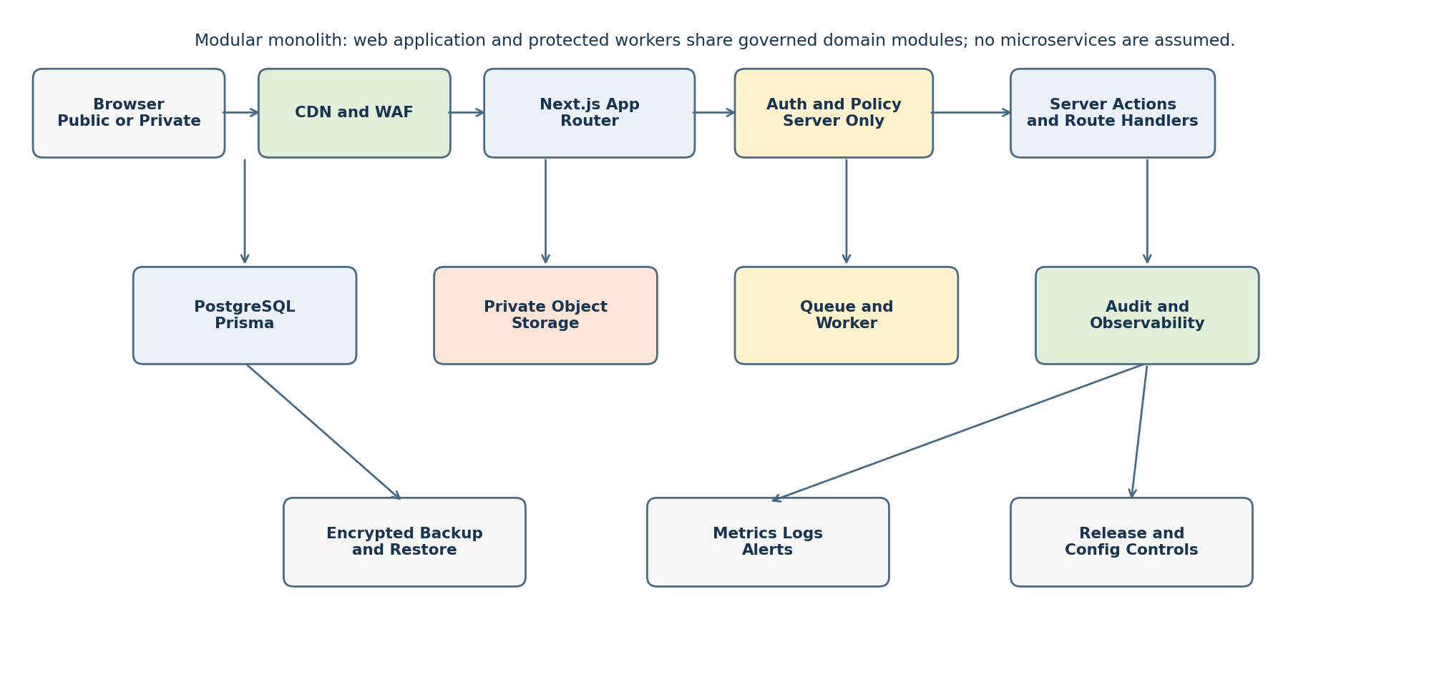
Layer | Responsibility | Boundary | Status
Edge | CDN cache for approved public assets; WAF and rate limits before origin. | No private data cache; protected responses set no-store/private. | Proposal
Web | Next.js App Router, route handlers and Server Actions in TypeScript. | No direct client authorization or database credentials. | Confirmed
Domain | Policy checks, validation, maker-checker and transaction orchestration. | Shared server-only modules; deny by default. | Confirmed
Data | PostgreSQL accessed through Prisma; event tables derive current state. | No overwrite of business history; protected migrations only. | Confirmed
Objects | Private object storage for document bytes and integrity metadata. | Short-lived server-authorized retrieval only; no public bucket. | Confirmed
Async | Queue and worker for import processing, notifications, projection, retention candidates. | Idempotent handler, explicit retry and dead-letter/review path. | Proposal

2 Routes and Server Boundaries
Route family | Examples | Server rule | Cache and response | Status
Public | /; /directory; /exam-centres; /public/status | Use release-gated projection only; never query private operational tables directly. | CDN only for approved projection; cache tags/versioning; no identity keys. | Needs Legal Review
Authentication | /api/auth/* | Auth.js handlers only; callback and session settings from environment. | No-store; avoid account enumeration. | Confirmed
Private UI | /app/*; /admin/* | Page loader performs server session/policy check before data query. | Private/no-store by default; 403 or safe not-found. | Confirmed
Protected mutation | Server Actions and /api/* route handlers | Resolve action, role grant, geo/org scope, target and workflow state inside server module. | No-store; atomic transaction; audit before success response. | Confirmed
Objects and export | /api/documents/*; /api/exports/* | Authorize every retrieval/creation; issue short-lived object reference only after policy check. | No CDN for private bytes; download/export rate and volume controls. | Proposal
Operational | /health/ready; /health/live; /internal/jobs/* | Readiness has no secrets; internal jobs require machine identity and allow-listed network/control. | No-store; minimal response. | Proposal

3 Authentication Authorization and Transactions
Auth.js establishes identity; it does not by itself grant domain access. A protected operation resolves the actor’s current grant from PostgreSQL and applies the RBAC and geographic/organisation scope model. The server ignores client-supplied role, action, scope and target ownership claims.
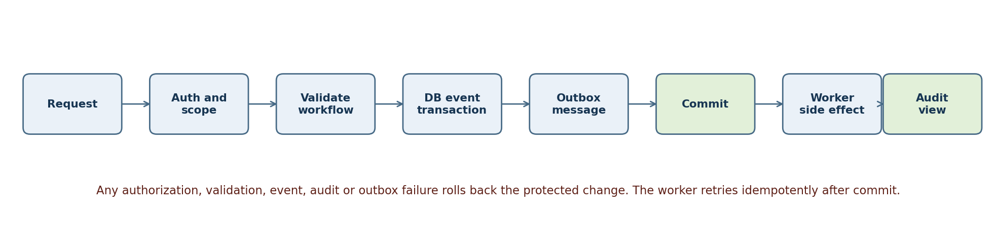
Concern | Architecture rule | Implementation boundary | Status
Session | Authenticate request and check account state on protected entry points. | Server components, Server Actions and route handlers. | Confirmed
Authorization | Resolve action + role + active grant + geo/org scope + target + workflow; insufficient result is 403. | Server-only policy module and scope-filtered Prisma queries. | Confirmed
Protected write | Write domain change, immutable status/decision event, audit and outbox record in one PostgreSQL transaction. | Prisma interactive transaction with bounded duration. | Confirmed
Correction | Create a later correction/revocation event rather than changing prior historical fact. | Event append service; current-state view/query. | Confirmed
Async handoff | Publish from durable outbox after commit; worker de-duplicates by message key. | Queue adapter and idempotent job handler. | Proposal
Maker-checker | Reject same maker/checker for configured decision classes; checker repeats scope and policy check. | Decision service and unique/check constraints where feasible. | Proposal

4 Data Storage and Migration Strategy
Area | Design | Operational control | Status
PostgreSQL | Normalized tables in the ERD; UUID keys; FK/unique/check/index constraints; event-derived status. | Migration reviewed, versioned and applied through controlled deployment. | Proposal
Prisma | Schema maps the approved logical model. Transactions retain database constraints as final authority. | No schema push from developer runtime to production. | Proposal
Object storage | Private bytes; document_record stores storage key, integrity reference and minimal metadata. | Server checks scope/action before signed retrieval; scan/quarantine path for imports. | Confirmed
Cache | Public projection may use explicit cache invalidation/tag/version after approved release. Private reads remain no-store. | Do not cache authorization decisions or highly restricted rows at edge. | Confirmed
Search/read models | Create separate, release-gated projection for public directories; operational source tables remain private. | Projection build is queued, versioned and auditable. | Needs Legal Review
Retention | Store policy reference/disposition event, not hard-coded official periods. | DPO/legal/owner decision required before real-data retention or disposal automation. | Needs Legal Review

5 Queue Jobs and Rate Limits
Area | Design requirement | Failure and recovery | Status
Import jobs | Upload private object then create import_job; worker validates template and rows without promoting until checker rule is met. | Quarantine invalid/suspected real data; retry safe step or send to review queue. | Proposal
Projection jobs | Build public projection from approved source and release decision, never from client request. | Keep prior approved projection; publish only an atomic version switch. | Needs Legal Review
Notifications | Use outbox and idempotency key; notification is side effect after committed decision. | Retry with backoff; dead-letter for review; never reverse domain event automatically. | Proposal
Rate limit | Apply edge limits for public requests and tighter identity/action/scope-aware limits for login, object, export and mutation routes. | Return 429 with safe retry guidance; monitor repeated denials. | Proposal
Worker trust | Jobs carry opaque target IDs, not trusted authorization claims. Worker reloads current policy/state before side effect. | Reject stale/invalid job; audit disposition. | Confirmed

6 Audit Monitoring Backup and Environments
Area | Baseline | Recovery evidence | Status
Audit | Append audit_event for protected reads/mutations/denials where permitted; redact sensitive values. | Correlate request, actor, action, scope outcome, target reference and result. | Confirmed
Monitoring | Metrics for latency, error rate, queue depth, job failures, authorization denials, database connection health and backup status. | Alert on thresholds; runbook links to containment and recovery actions. | Proposal
Logs | Structured server/worker logs with request and job correlation IDs; no secrets or raw private fields. | Restrict access; retain/dispose under approved policy. | Needs Legal Review
Backup | Encrypted PostgreSQL backups and object inventory/version protection; independently controlled backup credentials. | Scheduled restore verification in non-production once approved; document RPO/RTO target. | Proposal
Environments | local synthetic-only, test synthetic-only, staging synthetic-only, production gated for real data only after readiness decision. | Separate databases/buckets/queue namespaces and credentials. | Confirmed
Secrets | Environment-injected secrets; no secret in repository, browser bundle, seed, fixture or log. | Rotate/revoke after exposure; audit deployment/config access. | Confirmed

Environment Variables
Group | Examples of names only | Rule | Status
Identity | AUTH_SECRET; AUTH_URL; AUTH_PROVIDER_* | Server-only; rotate through approved secret process. | Confirmed
Database | DATABASE_URL; DIRECT_DATABASE_URL | Server-only; least-privilege runtime and migration credentials are separate. | Proposal
Objects | OBJECT_STORAGE_ENDPOINT; OBJECT_STORAGE_BUCKET; OBJECT_STORAGE_* | Private endpoint/credentials only; never prefixed for browser exposure. | Confirmed
Queue and observability | QUEUE_URL; OTEL_EXPORTER_*; ERROR_REPORTING_DSN | Separate per environment; redact payloads. | Proposal
Edge | WAF_POLICY_ID; RATE_LIMIT_*; CDN_REVALIDATE_SECRET | Configuration reviewed; invalidate/revoke on incident. | Proposal

7 Failure Modes and Recovery
Failure mode | Containment | Recovery | Status
Authorization service/scope ambiguity | Fail closed: 403 with no private/existence disclosure; no mutation. | Restore scope/policy data; retry with fresh server decision; review denied/audit signals. | Confirmed
Transaction/event/audit/outbox failure | Rollback all related protected writes. | Reconcile only committed latest state; do not manually overwrite history. | Confirmed
Queue outage or poison job | Retain outbox/job state; pause side effect and do not lose committed domain record. | Retry idempotently with bounded backoff; dead-letter and review. | Proposal
Database outage | Readiness fails; reject protected writes; preserve consistency. | Restore service/replica/backup under runbook; validate before reopening. | Proposal
Object store outage | Block upload/download confirmation; no fallback public bucket. | Retry safely; preserve document metadata as pending only where transaction design permits. | Confirmed
WAF or rate-limit false positive | Return safe 403/429; preserve request correlation. | Review rule/rate configuration with change control; roll back rule if approved. | Proposal
Suspected real data in synthetic route | Quarantine object/import/log pathway; block release and export. | Notify owner/DPO/legal reviewer; do not claim compliance outcome. | Needs Legal Review

8 Architecture Decision Records
ADR | Decision | Reason and consequence | Status
ADR 01 | Adopt modular monolith, not microservices. | Single governed codebase lowers early operational complexity; domain modules retain clear boundaries. Reassess only with measured scaling/ownership evidence. | Confirmed
ADR 02 | Use server-side policy authorization for every protected read/write. | Client/UI is not a security boundary. Scope-filtered queries and safe 403 are mandatory. | Confirmed
ADR 03 | Use PostgreSQL event history and derived current state. | Status, grant, review and audit corrections append events; earlier records are not overwritten. | Confirmed
ADR 04 | Keep document bytes in private object storage. | Database stores metadata/integrity/explicit links only; retrieval is separately authorized. | Confirmed
ADR 05 | Use transactional outbox and idempotent workers. | Avoid side effects before commit and support retry without duplicate notification/projection. | Proposal
ADR 06 | Use separate public projection and release gate. | Avoid accidental exposure from operational tables; release authority and content require review. | Needs Legal Review
ADR 07 | Keep real data out until readiness gate. | Synthetic-only environments/seeds/logs enable design work without asserting authorization for real-data processing. | Confirmed

9 Architecture Review Checklist
Review item | Evidence requested | Status
Route boundaries | Confirm public projection routes, private route families and internal health/job exposure. | Proposal
Policy contract | Confirm action codes, scope inheritance and maker-checker decision classes. | Proposal
Operations | Set SLOs, RPO/RTO, backup restore cadence, on-call/runbooks and alert thresholds. | Proposal
Legal/governance | Approve real-data readiness, retention/disposal, public release and official authority evidence. | Needs Legal Review
Implementation review | Review migrations, server guards, object authorization, queue idempotency and negative cross-scope=403 tests after build. | Proposal

