PPs Understanding of FG

FG – Business Processes | Supported Business Processes
PS Financial Gateway supports the following business processes.  Legend:  Phase 1  Phase 2* - Not covered in this document | Payment processing.  Bank statement processing.  Payment acknowledgement processing.
LAYOUTS  Payment Layouts to be used for this integration:  - CORECRDTRN – ISO 20022 PAyment Initiation  - STPCREDTRN – ISO 20022 STP Credit Transfer*  Bank Statement Layouts to be used for this integration:  - BAI2/MT940/MT942*  End-of-Day Statement – MT940  Intra-day Statement – MT942  Bank Payment Acknowledgement Layouts to be used for this integration:  - PMTINITACK – ISO 20022 payment status XML | 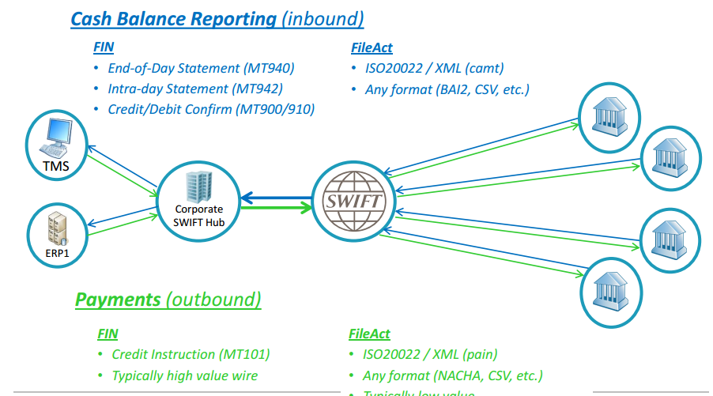  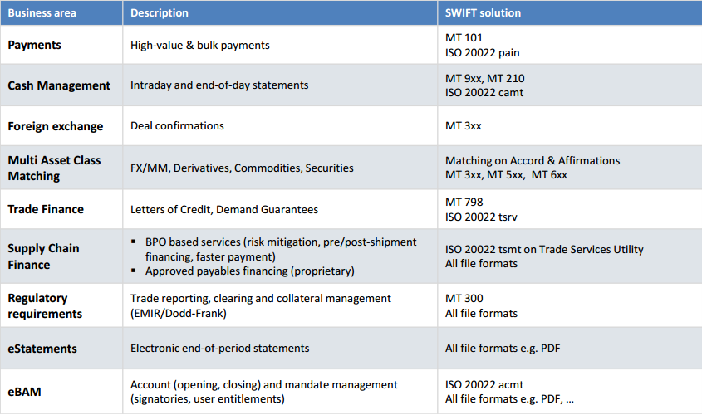
UNU will make use of ‘AP’ as the source application for Financial Gateway | 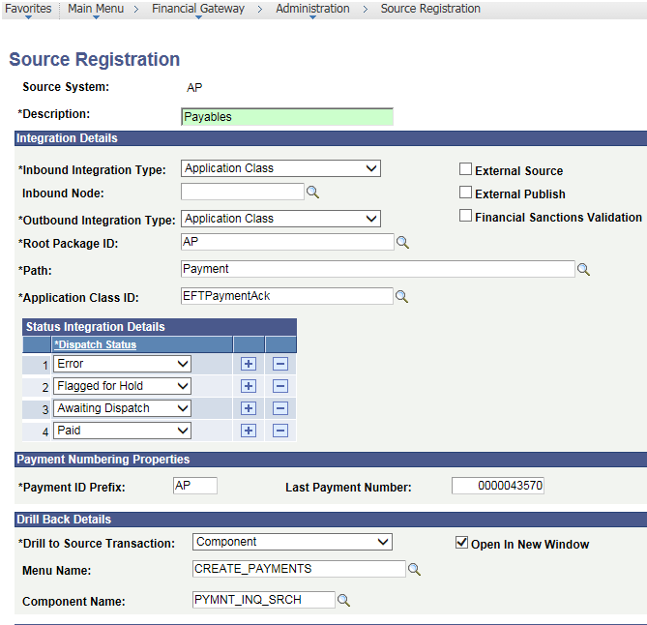  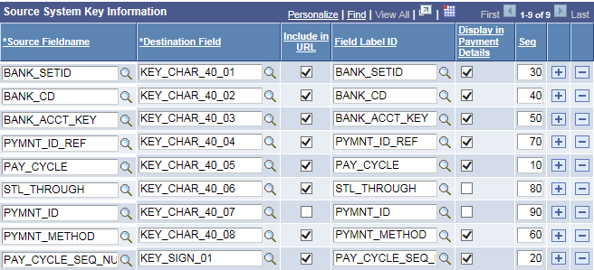
Dispatch Payment Process  - Trigger AE PMT_DISPATCH – It can be manual or in the batch. Initially this program will ONLY be triggered manually;  - Output is transformed to ISO 20022 XML format pain.xxx.xxx.xx.xml;  - Payment file is generated in a specific directory;  - PeopleSoft Pluggable Encryption Technology can be used to load PGP encryption libraries (which needs to be purchased and has an additional installation procedure), however, in this case, it is recommended to encrypt the files after they have been generated in a physical directory before being transmitted to the bank; | 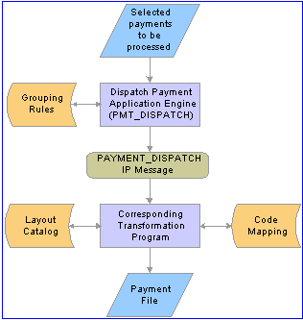
Prenotifications

A payment prenotification or ‘prenote’ is a zero-dollar, payment file sent to a debtor’s bank to test if the payments can be made to a creditor through the bank account.
ISO20022 STANDARD CHARACTER ENCODING TABLE
A B C D E F G H I J K L M N O P Q R S T U V W X Y Z
a b c d e f g h i j k l m n o p q r s t u v w x y z
0 1 2 3 4 5 6 7 8 9 / - ? : ( ) . , ‘ + space
Payment acknowledgement import process  - Payment acknowledgement file(s) are received from the bank in a pre-determined directory on the Atlas Server(s);  - File Import Process – IMPORT_FILES is triggered to read the files and calls appropriate transformation program;  - Payments and payment files are updated in FG and Source System;  - Users review the acknowledgment files  - FG does not track prenote status;  Types of Acknowledgment Files  - First Acknowledgment – sent after file is received and passes basic bank validations. This acknowledgment indicates whether the file is good to process or has errors;  - Second Acknowledgment – sent after the actual payment is made. It could be a payment confirmation or error message;  - Third Acknowledgment – notifies sender of payment errors;  - Fourth Acknowledgment – Prenotification errors | 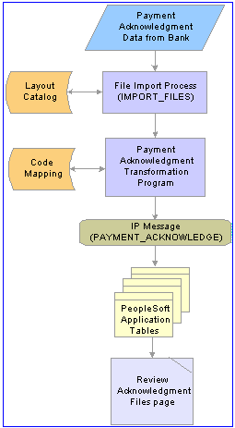
Setup Payment Processing  Define Payment Grouping Rules  Navigation:  Main Menu > Banking > Administer Bank Integration > Payment Grouping Rules  Initially the system groups all payments by  - Bank Code,  - SetID,  - Payment Layout, and  - Payment Method  This level of filtering is hard coded in the system and cannot be changed or overwritten.  Indicates how many payment files are ultimately created  How payments within a file are grouped together  These cannot be changed as this is shared across agencies which are using the ISO 20022 XML layout for integration. | 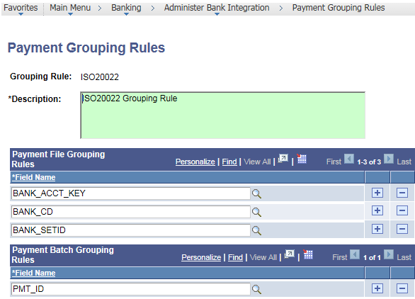
Payment Security  Navigation:  Main Menu > Financial Gateway > Security > Security Options | 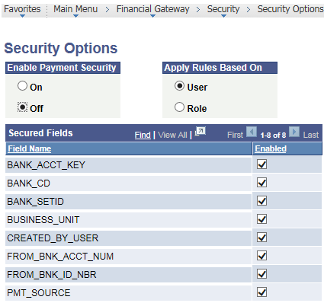

T1 - Setup | Financial Gateway
Bank Setup  Navigation:  Main Menu > Banking > Bank Accounts > External Accounts  Payment Method EFT is left as is.  New Payment Method – Financial Gateway Transfer is added. Note the Layout and Settle By option. | 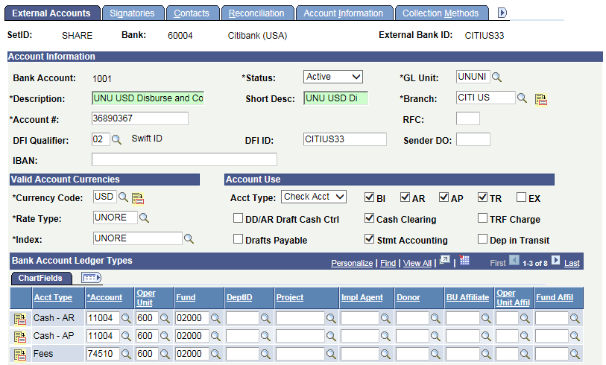  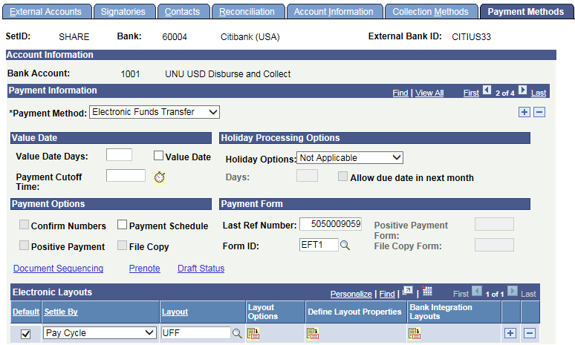  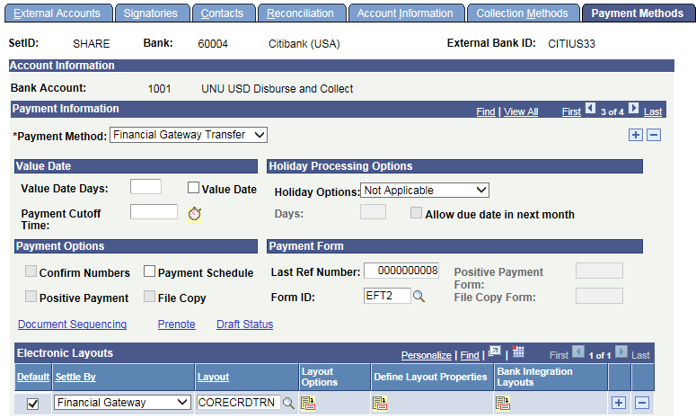
BANK INTEGRATION LAYOUTS  FILENAME - UNU_CIT_%UNUBNK%pain002_%yyyyMMdd_HHmmss%.xml  FILEPATH - /n02/PSFILEDIR/ptfs/UNDP/UNDPFST1/data/UNUTREES/ | 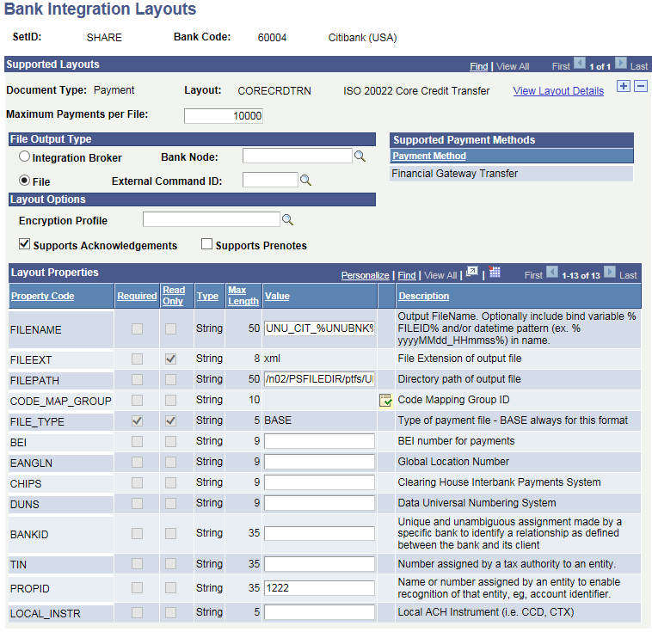
Pay Cycle Setup  Navigation:  Main Menu > Accounts Payable > Payments > Pay Cycle Processing > Payment Selection Criteria | 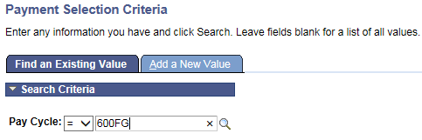
 | 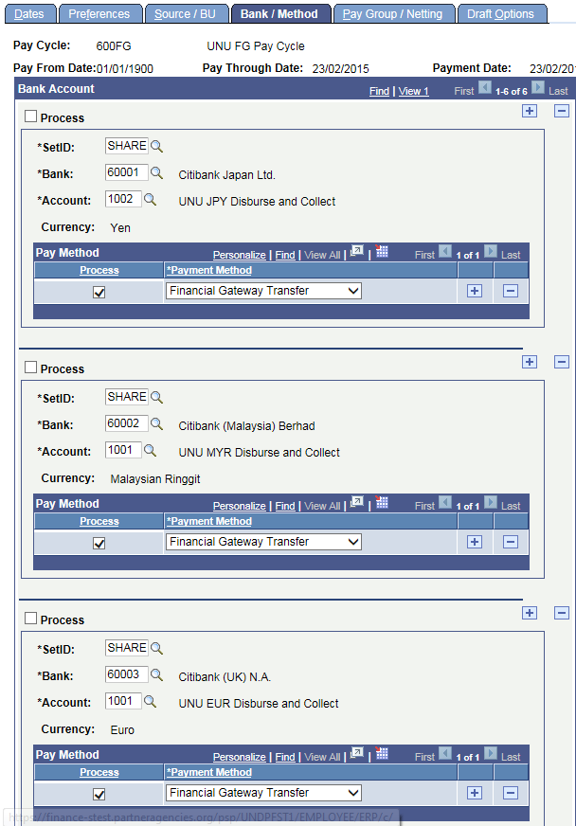
 | 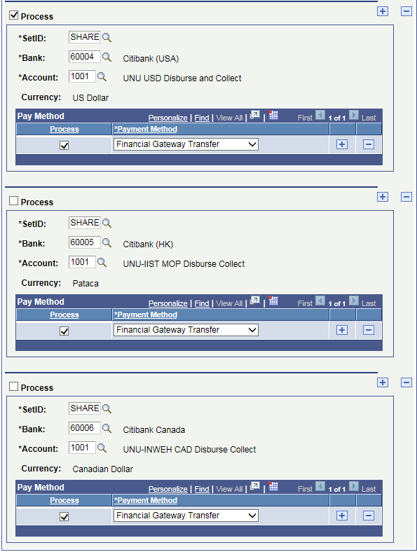
Layout Catalog  Navigation:  Main Menu > Banking > Administer Bank Integration > Layout Catalog  UNDP has made a custom app engine program – UN_TRPMT_XFM  Delivered one – PMT_SWFT_XFM | 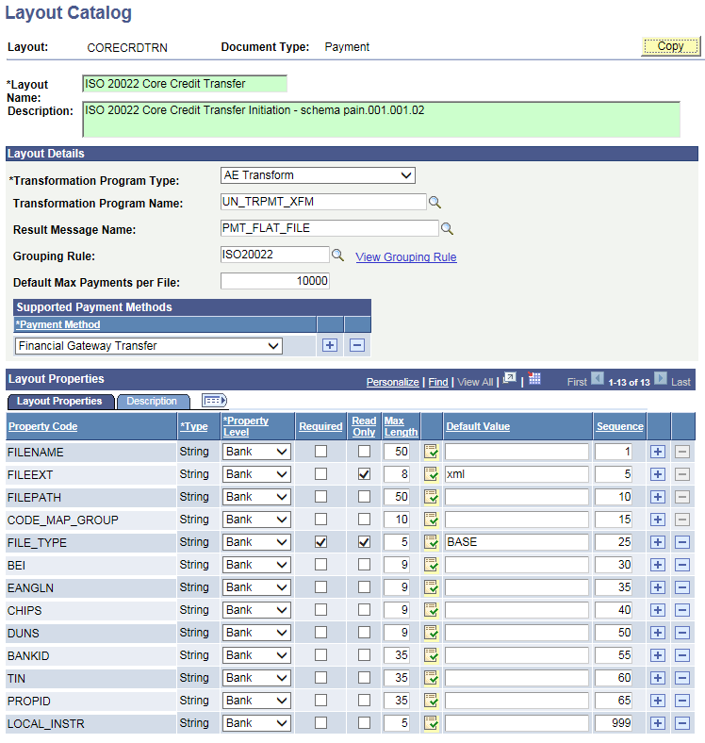

D1 - Setup | Financial Gateway
Bank Setup  Navigation:  Main Menu > Banking > Bank Accounts > External Accounts  Payment Method EFT is changed to add a new Settle By Option of Financial Gateway  PS – New ISOV2 layout was created in D1 (created as per FSCM 9.2.11) | 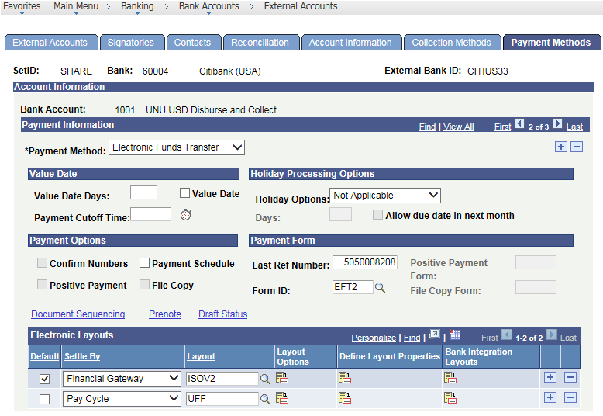
BANK INTEGRATION LAYOUTS  FILENAME - Blank  FILEPATH - Blank | 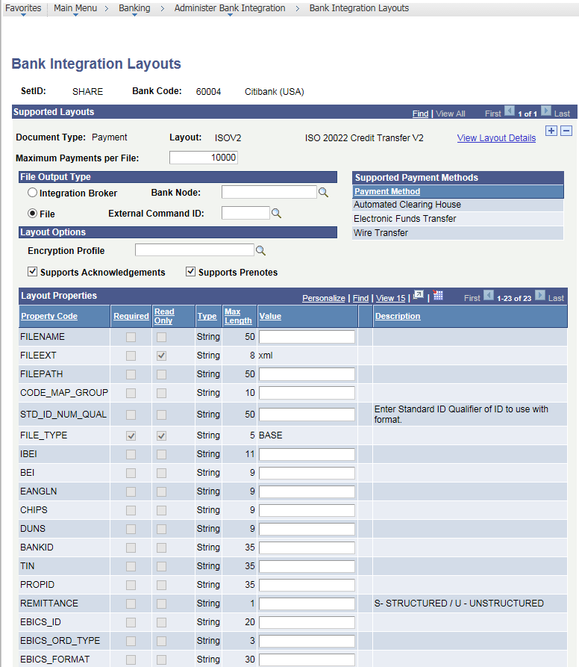  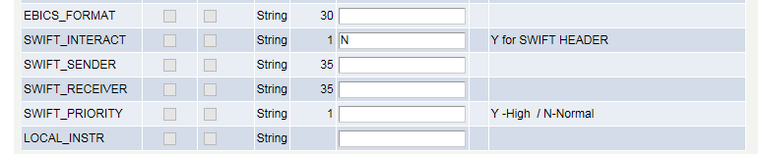
Pay Cycle Setup

Navigation:
Main Menu > Accounts Payable > Payments > Pay Cycle Processing > Payment Selection Criteria

No change in Pay cycle setup
How to change the Layout on a Voucher  Navigation:  Main Menu > Accounts Payable > Vouchers > Add/Update > Regular Entry  Select Layout on Payment Tab to choose from UFF & ISOV2 | 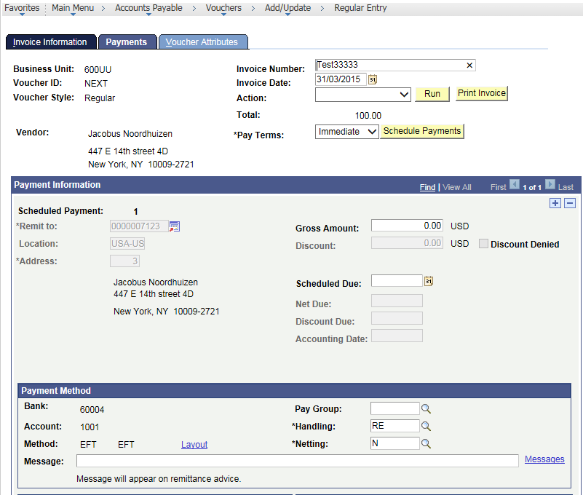  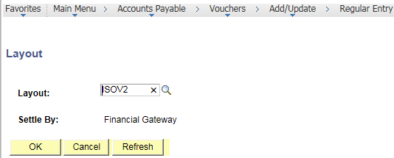  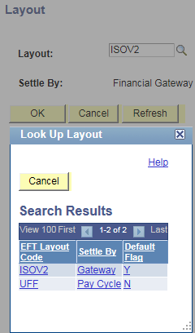
Layout Catalog  Navigation:  Main Menu > Banking > Administer Bank Integration > Layout Catalog  UNDP has made a custom app engine program – UN_TRPMT_XFM  Delivered one in 9.2.11 – PMT_SFT2_XFM  Currently the layout has been setup with custom AE as development has not been done in D1 instance.  The Transformation Program Name will change after a CR is raised. | 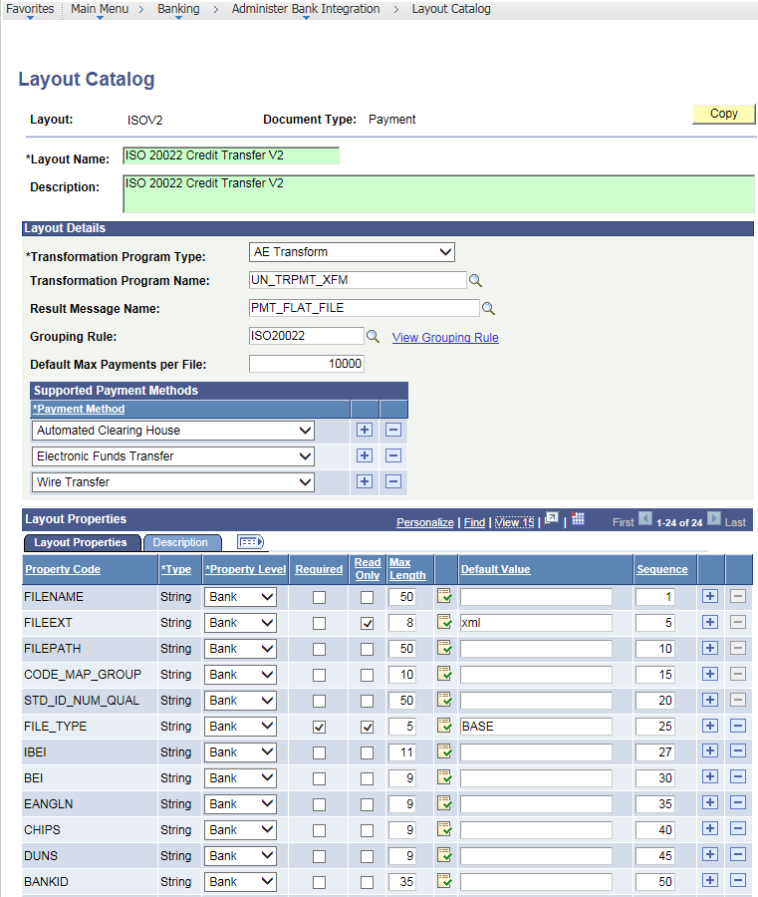  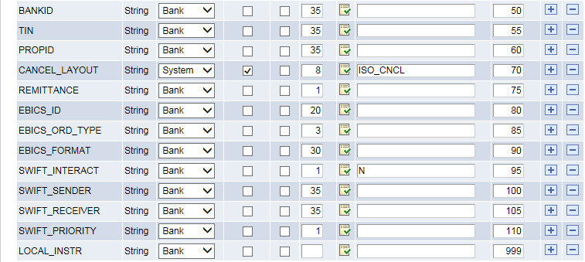
Payment File  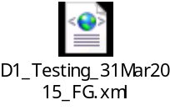 | 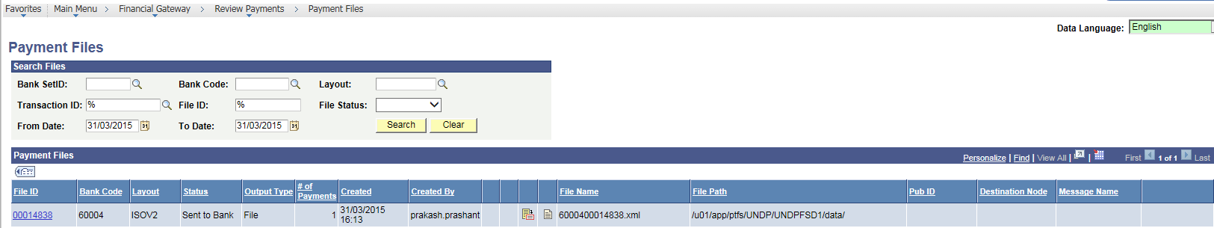  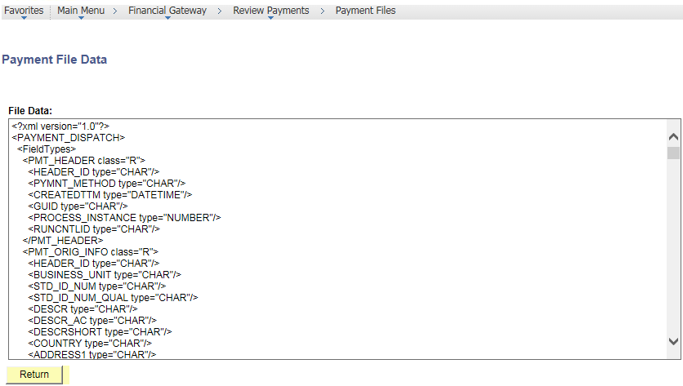
Payment Table Stats | 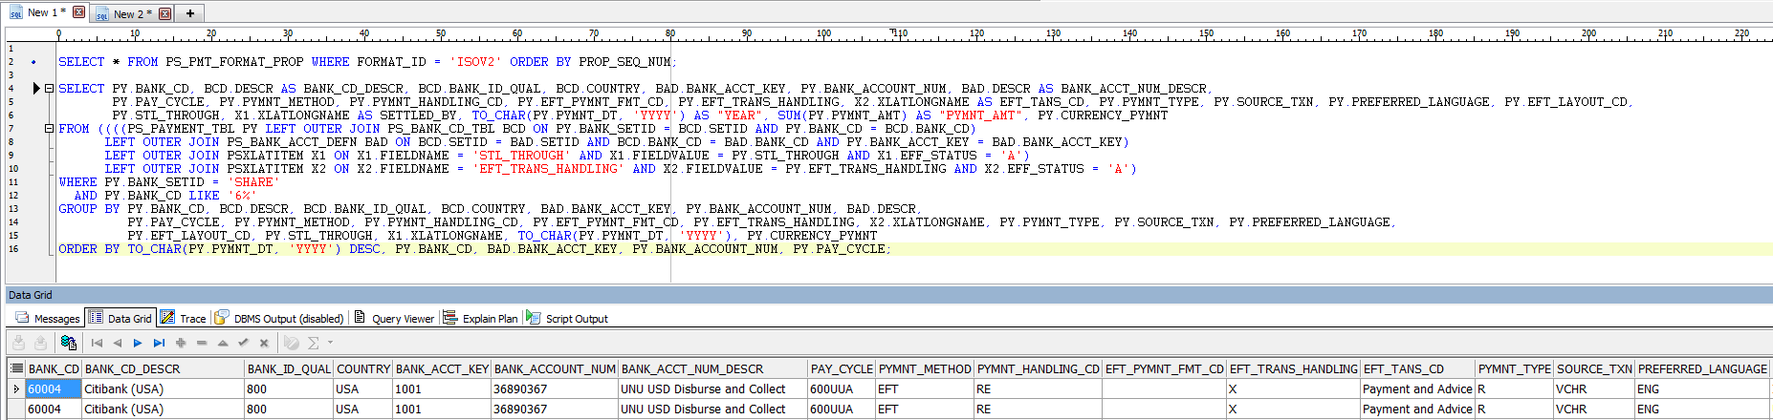  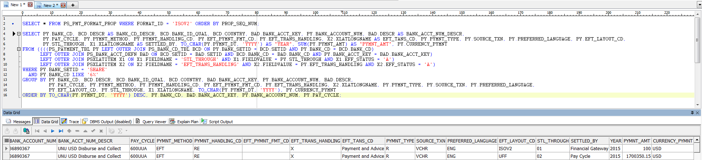
Vendor name testing | 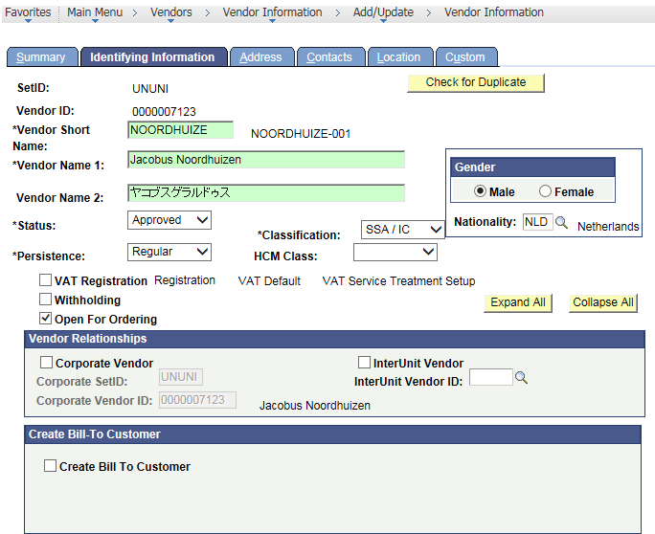  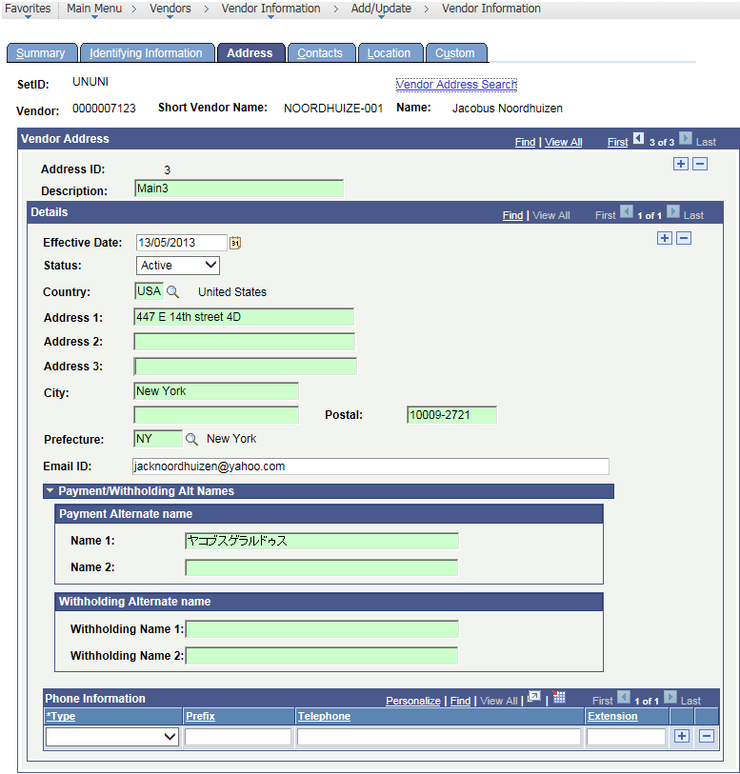
Payment file before transformation | 