The Simulation as a Sampled Neural Cellular Automaton
A useful mental model is to treat each particle as a moving sample of material. Like a neural cellular automaton, every sample perceives a local chemical neighborhood, applies the same learned rule, and returns a state change to shared space. Pooling many sample contributions recovers a cell-scale update.
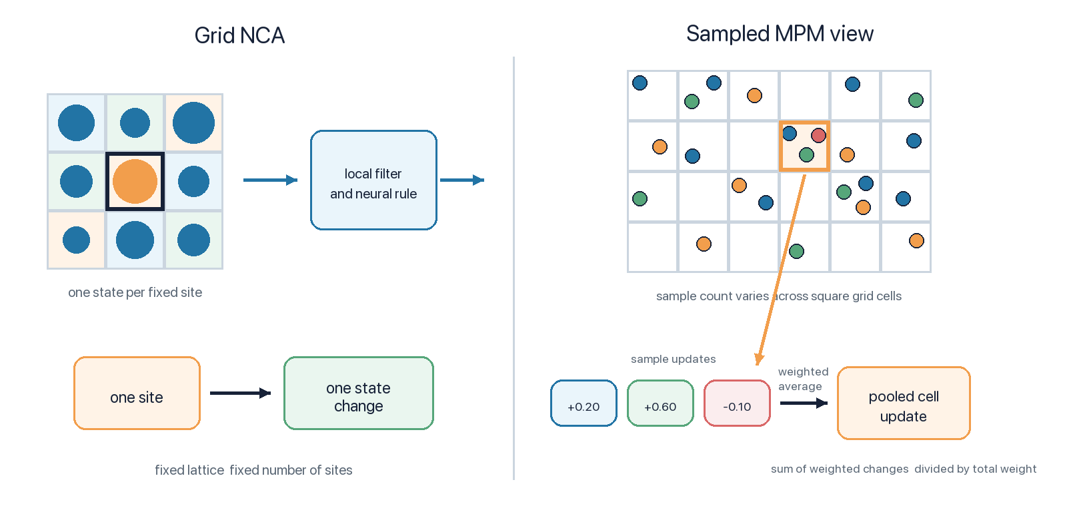
Figure 1 Uneven particle samples are pooled into grid space updates

The correspondence
Concept | Grid NCA | This simulation
Where state lives | A fixed lattice of cells | Moving material samples plus shared spatial fields
Local perception | A convolutional neighborhood | Bilinear field values and shared Sobel gradients at each sample
Shared rule | The same neural update at every site | The same evolved policy at every particle
Communication | Neighbor states flow through the kernel | Particles deposit chemistry and later sample the resulting field
Coarse update | One delta per lattice cell | A density-normalized spatial pool of sample contributions

One update in the model
The model alternates between a spatial communication field, a pointwise neural rule, and material mechanics. The chemical part is especially close to an NCA update.
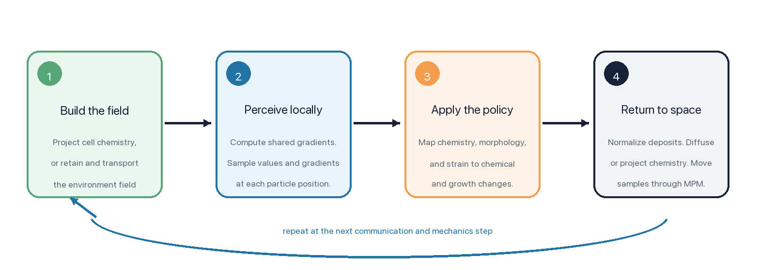
Figure 2 One communication and mechanics cycle

Why averaging recovers an NCA like update
Imagine placing a temporary grid over the material. Several particles may sample the same grid region. Each particle reads nearly the same local neighborhood but from its exact position, then proposes a chemical change. Averaging those proposals produces one stable regional update. As sample density increases, the result behaves like a convolutional rule evaluated over a continuous material.
In the current implementation, this pooling is spatial rather than based on explicit cell membership. Particle deposits are accumulated on chemical grids and can be normalized by represented material density. That operation plays the role of averaging overlapping samples before the field is sensed again.

Where the analogy stops
- Particles move with MLS MPM mechanics; ordinary NCA sites stay fixed on their lattice.
- The policy also senses morphology and elastic strain and controls growth, not only chemical state.
- Chemical channels can use different spatial scales, and the field may be persistent or rebuilt from cell-owned chemistry.
The compact description is therefore: a continuous, moving NCA whose cells are represented by spatial samples, whose neighborhood operator is a shared chemical field, and whose sample updates are pooled back into space.

