|  |
| --- |
| **Switzerland compared to the world** |

|  |
| --- |
| Products and reviews of Swiss products on Amazon: quick facts |

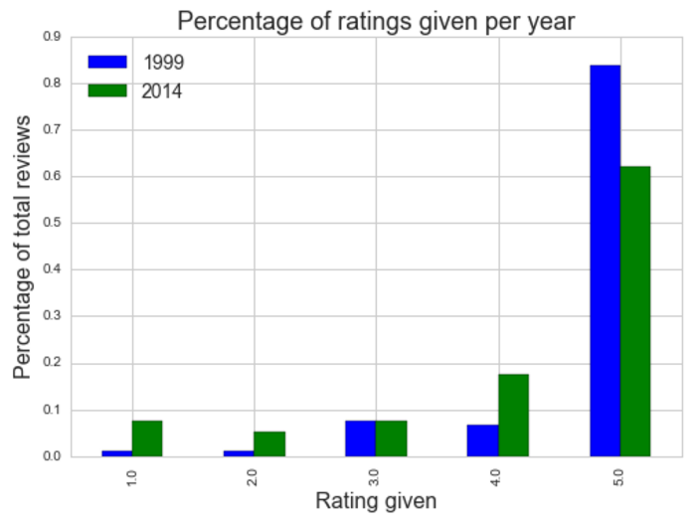

Identified brands:

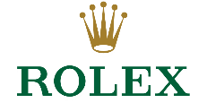**Average price:** **$79.73**

**Most expensive product:**

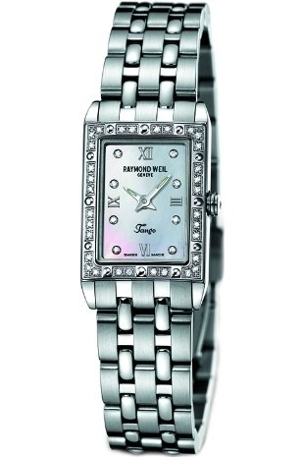 **$999 watch**

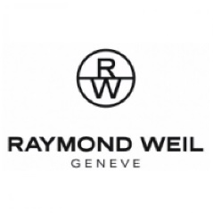







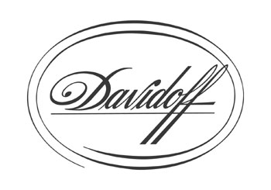

|  |
| --- |
| Amazon Swiss product reviews compared to the world |

|  |  |
| --- | --- |
| **Analysis of the world** | **Analysis of Switzerland** |
| http://minimaxir.com/img/amazon-spark/item_count_cum.png |  |
| http://minimaxir.com/img/amazon-spark/item_histogram.png |  |
| http://minimaxir.com/img/amazon-spark/avg_rating_desc.png  http://minimaxir.com/img/amazon-spark/avg_rating_desc.png |  |

By Juta Staes, Ciprian Tomoiaga and Valentin Vasiliu