1. Create OMS in Azure
2. Go to the log analytics created, and get installation command for OMS agent in Linux under “Advanced Settings -> Linux Servers -> “Download and Onboard agent for Linux”.
3. Run that command in the Linux server you created, with Mongo DB installed.

Follow the below steps to enable Mongo logging by OMS

1. Create a user in MongoDB with admin access or access to read stats
2. Go to the mongo.conf located @ /etc/opt/microsoft/omsagent/sysconf/omsagent.d/ and move it to /etc/opt/microsoft/omsagent/<workspace id>/conf/omsagent.d/

(command used in ubuntu

cp /etc/opt/microsoft/omsagent/sysconf/omsagent.d/mongo.conf /etc/opt/microsoft/omsagent/<workspace id>/conf/omsagent.d/)

1. Edit the copied mongo.conf file, and replace the user credentials (user and password) in the section given

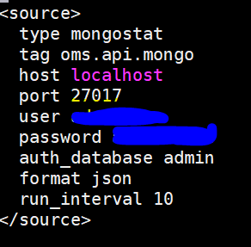

1. Save the file and quit.
2. Restart oms agent

sudo /opt/microsoft/omsagent/bin/service_control restart <workspace id> (workspace id need not to be specified, if there is only on OMS agent installed)

1. Check the log using command “tail /var/opt/microsoft/omsagent/<workspace id>/log/omsagent.log” for any errors

The below steps are for enabling OMS agent in Linux VM to send the logs to Azure log analytics

All the logs are collected using the below methodology

1. Create a shell script with the following functionalities
   1. Evaluate stats command directly in mongo db and output it in a JSON file
   2. Format the JSON it into OMS agent readable format and put back in the same file
   3. Modify the read permission for the JSON file

Modify the location, and required parameters suiting your needs.

1. Run the shell script once, to get file in the location specified in the shell script
2. Add the necessary <source> and <match> tag in the mongo.conf for reading the JSON file.
3. Restart the OMS agent and check logs, for any errors
4. Schedule a cron job, at required interval, to run the shell script created for generating JSON file statistics. OMS agent will read and send the logs to log analytics accordingly

The shell scripts performing the above operations for few of the stats are given below.



The configuration file used is given below (please provide respective db user-name and password of the db you have)



Each of the <match> tag will create a custom log component in the log analytics. For example, the tag “<match oms.api.mongostat>” in the config file given will create “mongostat_CL” in the log analytics available in Azure.

