This document gives the details of metrics that can be collected and depicted for MONGO in Azure Log Analytics (under OMS)

# **STATS**

The mongo db provides the following stats regarding the db, collection and of the server itself.

Mongostat

Mongtop

Db.stats()

Db.collection.stats()

Db.serverStatus()

# **METRICS**

**MONGOSTAT**

The total # of open connection recorded as per time

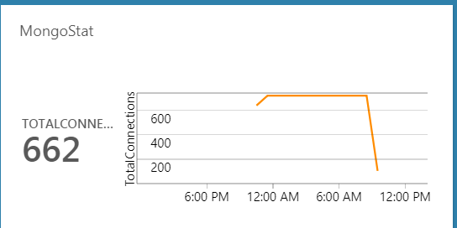

Average query time recorded – total count, insert queries count, delete queries and update queries counts

Network flow – size of data (in KB) flow in and out of the network

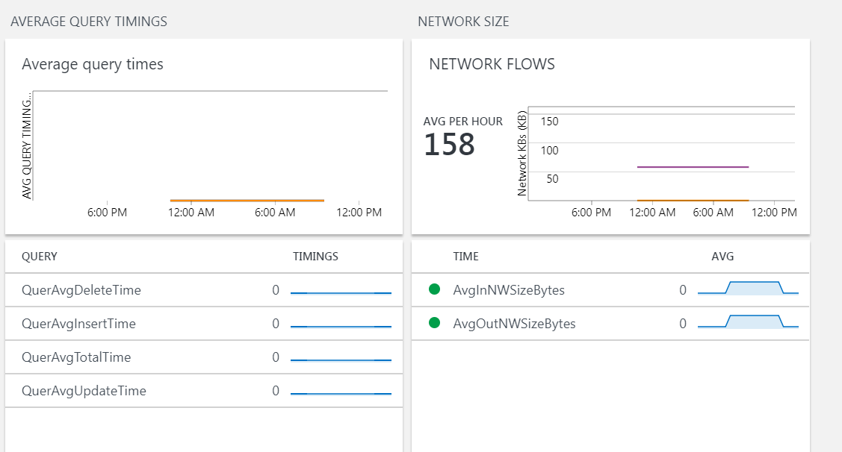

**COLLECTION STATS**

Allocated storage to each collection. (collection-wise)

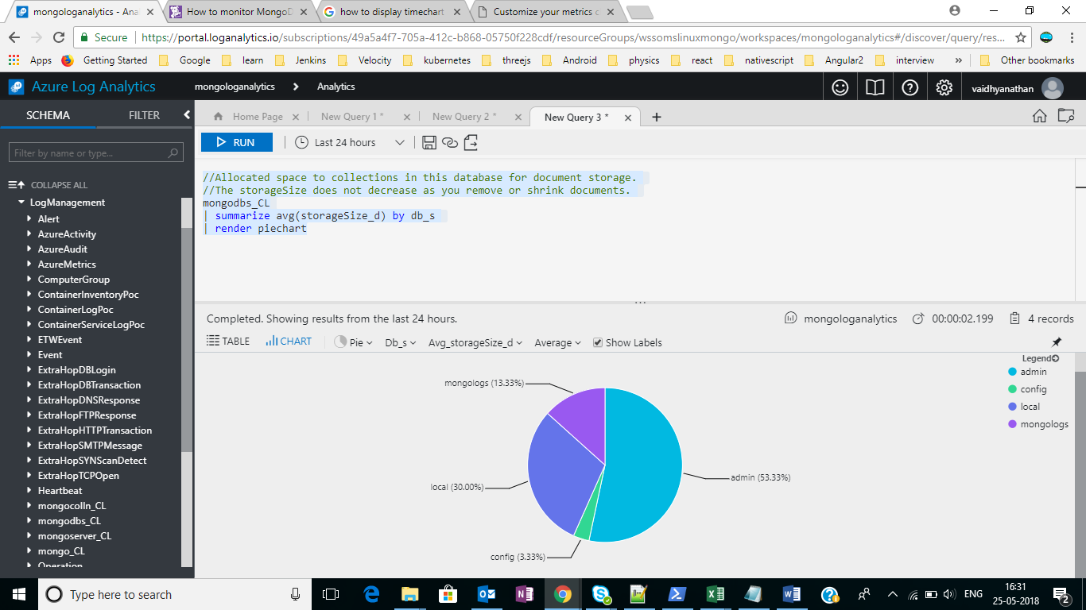

Number of collections in a database.

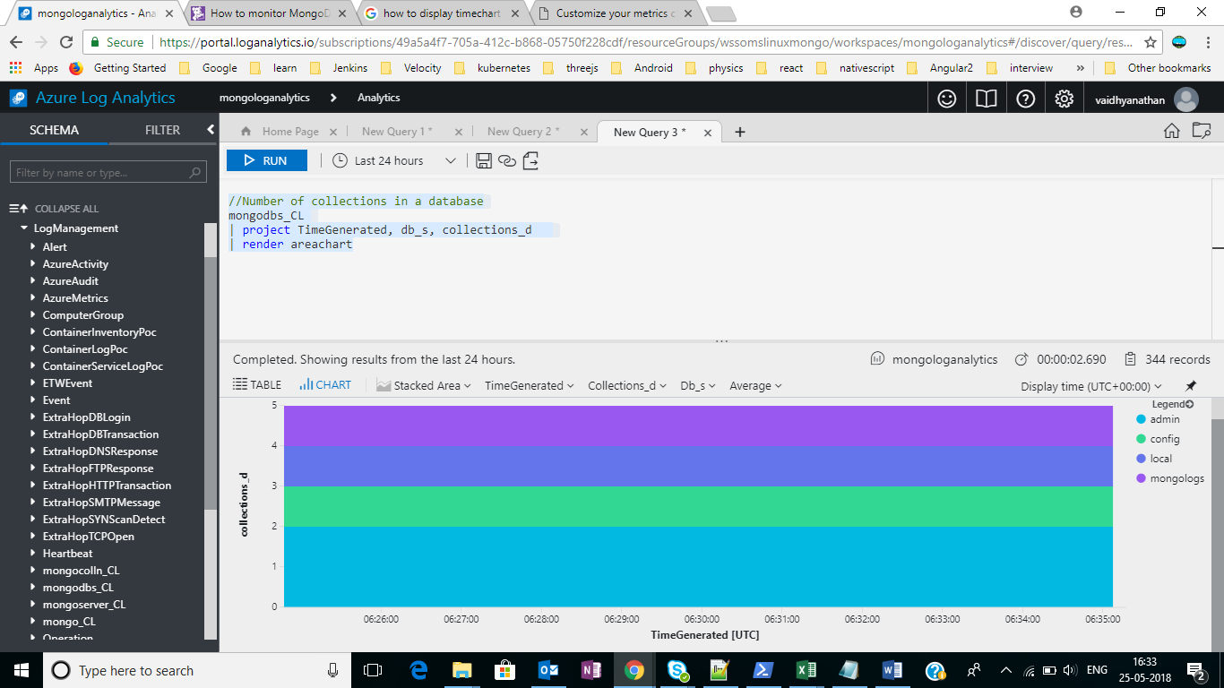

Number of documents in a database.

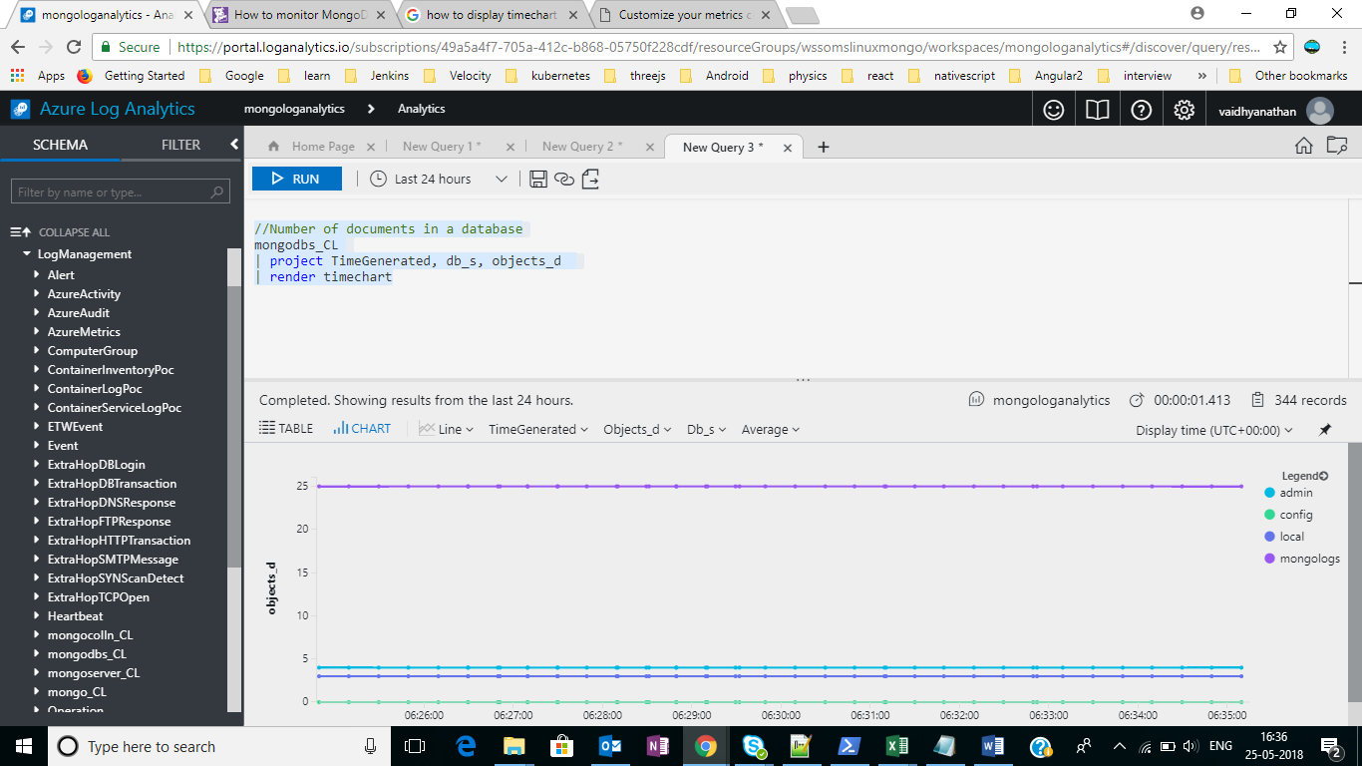

Total size of the uncompressed data held in database. ( datasize )

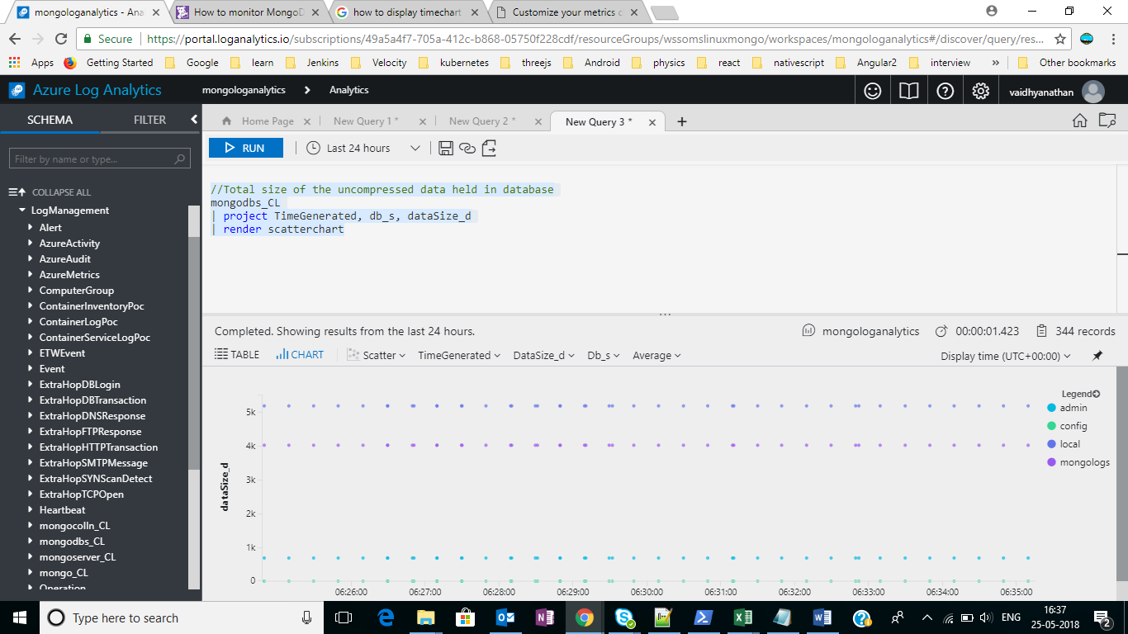

Count of the total number of indexes across all collections in the database.

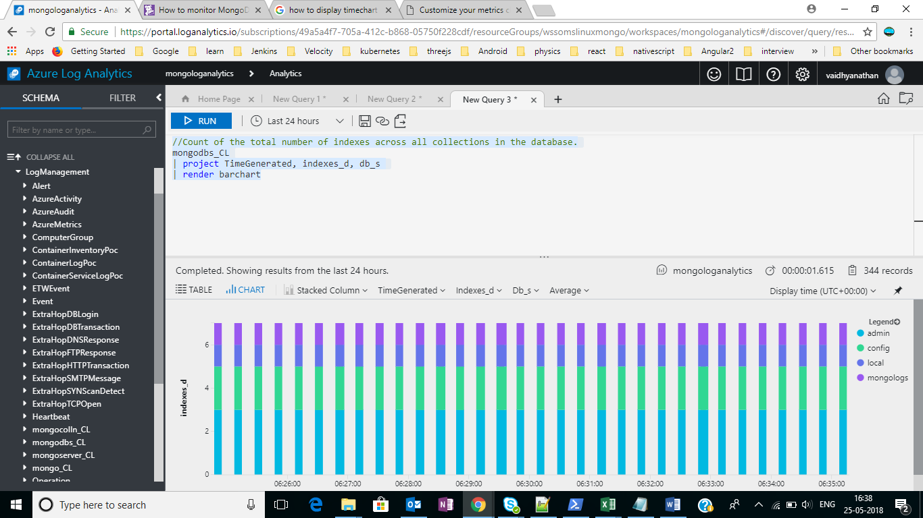

Total size of all indexes created in database.

