Contents

Entity relationship diagram 2

Create all tables 4

Students table data insert 8

Course tables insert data 9

Lecture tables insert data 10

Assessment table insert data 11

Subjects table insert data 11

Enroll tables insert data 12

Outline tables insert data 15

Sub_assessment table insert data 16

Student assesment table insert data 18

Query answer 26

# Entity relationship diagram

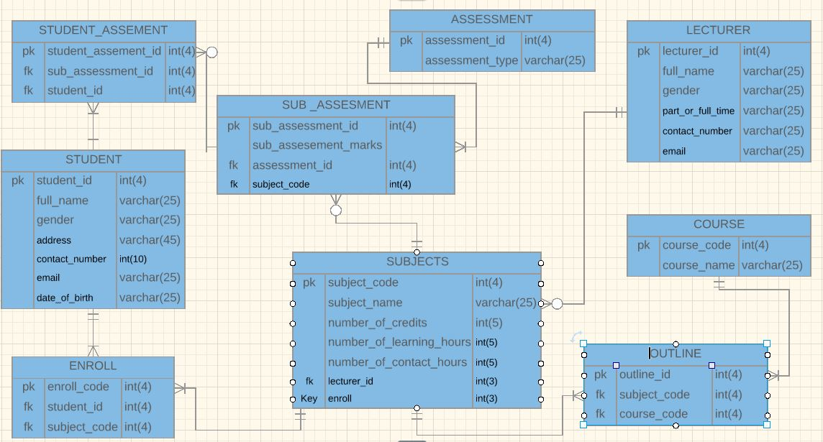

Create database avidcollege

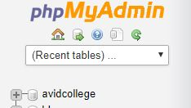

# Create all tables

CREATE TABLE `COURSE` (

`course_code` int(4),

`course_name` varchar(25),

KEY `pk` (`course_code`)

);

CREATE TABLE `STUDENT` (

`student_id` int(4),

`full_name` varchar(25),

`gender` varchar(25),

`address` varchar(45),

`contact_number` int(10),

`email` varchar(25),

`date_of_birth` varchar(25),

KEY `pk` (`student_id`)

);

CREATE TABLE `OUTLINE` (

`outline_id` int(4),

`subject_code` int(4),

`course_code` int(4),

KEY `pk` (`outline_id`),

KEY `fk` (`subject_code`, `course_code`)

);

CREATE TABLE `SUB_ASSESMENT` (

`sub_assessment_id` int(4),

`sub_assesement_marks` int(3),

`assessment_id` int(4),

`subject_code` int(4),

KEY `pk` (`sub_assessment_id`),

KEY `fk` (`assessment_id`, `subject_code`)

);

CREATE TABLE `LECTURER` (

`lecturer_id` int(4),

`full_name` varchar(25),

`gender` varchar(25),

`part_or_full_time` varchar(25),

`contact_number` varchar(25),

`email` varchar(25),

KEY `pk` (`lecturer_id`)

);

CREATE TABLE `ASSESSMENT` (

`assessment_id` int(4),

`assessment_type` varchar(25),

KEY `pk` (`assessment_id`)

);

CREATE TABLE `SUBJECTS` (

`subject_code` int(4),

`subject_name` varchar(25),

`number_of_credits` int(5),

`number_of_learning_hours` int(5),

`number_of_contact_hours` int(5),

`lecturer_id` int(3),

KEY `pk` (`subject_code`),

KEY `fk` (`lecturer_id`)

);

CREATE TABLE `ENROLL` (

`enroll_code` int(4),

`student_id` int(4),

KEY `pk` (`enroll_code`),

KEY `fk` (`student_id`)

);

CREATE TABLE `STUDENT_ASSEMENT` (

`student_assement_id` int(4),

`sub_assessment_id` int(4),

`student_id` int(4),

KEY `pk` (`student_assement_id`),

KEY `fk` (`sub_assessment_id`, `student_id`)

);

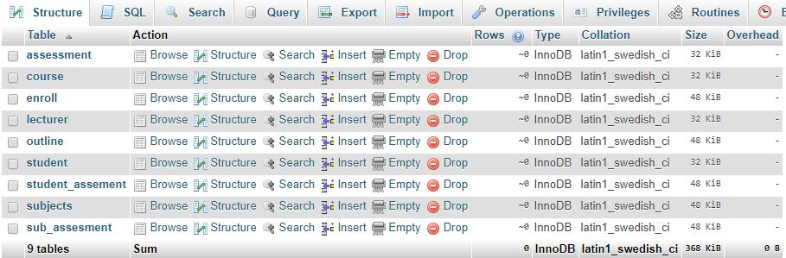

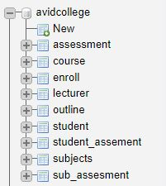

# Students table data insert

INSERT INTO `avidcollege`.`student` (`student_id`, `full_name`, `gender`, `address`, `contact_number`, `email`, `date_of_birth`) VALUES (NULL, 'Ahmed Moosa', 'Male', 'G.hiyaa', '7888888', 'ahmed@gmail.com', '25/12/1990');

INSERT INTO `avidcollege`.`student` (`student_id`, `full_name`, `gender`, `address`, `contact_number`, `email`, `date_of_birth`) VALUES (NULL, 'Ismail Mohamed', 'Male', 'G Ulhiya', '7555555', 'ismail@gmail.com', '22/05/2000');

INSERT INTO `avidcollege`.`student` (`student_id`, `full_name`, `gender`, `address`, `contact_number`, `email`, `date_of_birth`) VALUES (NULL, 'Ali Shaah', 'Male', 'H.Finifenmaage', '9999933', 'shaah@gmail.com', '12/02/1986');

INSERT INTO `avidcollege`.`student` (`student_id`, `full_name`, `gender`, `address`, `contact_number`, `email`, `date_of_birth`) VALUES (NULL, 'Mariyam Didi', 'Female', 'Ma.Luckyhiyaa', '7589494', 'Mary@gmail.com', '18/09/2002');

INSERT INTO `avidcollege`.`student` (`student_id`, `full_name`, `gender`, `address`, `contact_number`, `email`, `date_of_birth`) VALUES (NULL, 'Shaan Junaidh', 'Male', 'M.Asseyri', '7222288', 'junaidh@gmail.com', '10/02/1987');

INSERT INTO `avidcollege`.`student` (`student_id`, `full_name`, `gender`, `address`, `contact_number`, `email`, `date_of_birth`) VALUES (NULL, 'Mariyam Junaina', 'Female', 'H.Mala', '7464646', 'juna@gmail.com', '12/09/2002');

INSERT INTO `avidcollege`.`student` (`student_id`, `full_name`, `gender`, `address`, `contact_number`, `email`, `date_of_birth`) VALUES (NULL, 'Luya Mohamed', 'Female', 'H.Sosunge', '9000393', 'luya@gmail.com', '09/08/1989');

INSERT INTO `avidcollege`.`student` (`student_id`, `full_name`, `gender`, `address`, `contact_number`, `email`, `date_of_birth`) VALUES (NULL, 'Hassan Naazir', 'Male', 'H.jazeera', '7383838', 'naazir@gmail.com', '12/12/2000');

INSERT INTO `avidcollege`.`student` (`student_id`, `full_name`, `gender`, `address`, `contact_number`, `email`, `date_of_birth`) VALUES (NULL, 'Maadhih Juha', 'Male', 'G.Reyfana', '7440044', 'juha@gmail.com', '12/12/2000');

INSERT INTO `avidcollege`.`student` (`student_id`, `full_name`, `gender`, `address`, `contact_number`, `email`, `date_of_birth`) VALUES (NULL, 'Laila Ali', 'Female', 'Vilaamathi', '9883838', 'laila@gmail.com', '12/12/1989');

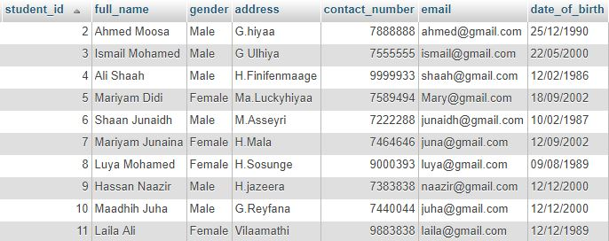

# Course tables insert data

INSERT INTO `avidcollege`.`course` (`course_code`, `course_name`) VALUES (NULL, 'Diploma in IT');

INSERT INTO `avidcollege`.`course` (`course_code`, `course_name`) VALUES (NULL, 'Diploma in HR');

INSERT INTO `avidcollege`.`course` (`course_code`, `course_name`) VALUES (NULL, 'Certificate 3 in BA');

INSERT INTO `avidcollege`.`course` (`course_code`, `course_name`) VALUES (NULL, 'Diploma in DM');

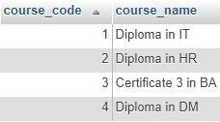

# Lecture tables insert data

INSERT INTO `avidcollege`.`lecturer` (`lecturer_id`, `full_name`, `gender`, `part_or_full_time`, `contact_number`, `email`) VALUES (NULL, 'Ali Shaan', 'Male', 'full time', '9487577', 'a.shaan@gmail.com');

INSERT INTO `avidcollege`.`lecturer` (`lecturer_id`, `full_name`, `gender`, `part_or_full_time`, `contact_number`, `email`) VALUES (NULL, 'David Isaac', 'Male', 'Part Time', '7466464', 'd.isaac@gmail.com');

INSERT INTO `avidcollege`.`lecturer` (`lecturer_id`, `full_name`, `gender`, `part_or_full_time`, `contact_number`, `email`) VALUES (NULL, 'Bilaal Philips', 'Male', 'Full Time', '7484840', 'b.philips@gmail.com');

INSERT INTO `avidcollege`.`lecturer` (`lecturer_id`, `full_name`, `gender`, `part_or_full_time`, `contact_number`, `email`) VALUES (NULL, 'Elizabeth Dia', 'Female', 'Part Time', '7363636', 'e.dia@gmail.com');

INSERT INTO `avidcollege`.`lecturer` (`lecturer_id`, `full_name`, `gender`, `part_or_full_time`, `contact_number`, `email`) VALUES (NULL, 'John Dave', 'Male', 'Part Time', '9484848', 'j.dave@gamil.com');

INSERT INTO `avidcollege`.`lecturer` (`lecturer_id`, `full_name`, `gender`, `part_or_full_time`, `contact_number`, `email`) VALUES (NULL, 'Di john', 'Male', 'Full Time', '7464600', 'd.john@gmail.com');

INSERT INTO `avidcollege`.`lecturer` (`lecturer_id`, `full_name`, `gender`, `part_or_full_time`, `contact_number`, `email`) VALUES (NULL, 'Maria Djerash', 'Female', 'Full Time', '9949494', 'M.Djerash@gmail.com');

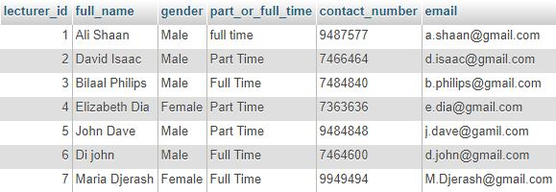

# Assessment table insert data

INSERT INTO `avidcollege`.`assessment` (`assessment_id`, `assessment_type`) VALUES (NULL, 'Unit Test');

INSERT INTO `avidcollege`.`assessment` (`assessment_id`, `assessment_type`) VALUES (NULL, 'Presentation');

INSERT INTO `avidcollege`.`assessment` (`assessment_id`, `assessment_type`) VALUES (NULL, 'Assingment');

INSERT INTO `avidcollege`.`assessment` (`assessment_id`, `assessment_type`) VALUES (NULL, 'Project');

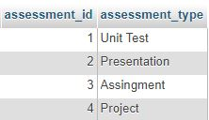

# Subjects table insert data

INSERT INTO `avidcollege`.`subjects` (`subject_code`, `subject_name`, `number_of_credits`, `number_of_learning_hours`, `number_of_contact_hours`, `lecturer_id`) VALUES (NULL, 'Database Principles', '10', '50', '30', '1');

INSERT INTO `avidcollege`.`subjects` (`subject_code`, `subject_name`, `number_of_credits`, `number_of_learning_hours`, `number_of_contact_hours`, `lecturer_id`) VALUES (NULL, 'Operating System', '15', '52', '32', '2');

INSERT INTO `avidcollege`.`subjects` (`subject_code`, `subject_name`, `number_of_credits`, `number_of_learning_hours`, `number_of_contact_hours`, `lecturer_id`) VALUES (NULL, 'Introduction to Software ', '15', '53', '35', '3');

INSERT INTO `avidcollege`.`subjects` (`subject_code`, `subject_name`, `number_of_credits`, `number_of_learning_hours`, `number_of_contact_hours`, `lecturer_id`) VALUES (NULL, 'Accounting', '15', '54', '36', '4');

INSERT INTO `avidcollege`.`subjects` (`subject_code`, `subject_name`, `number_of_credits`, `number_of_learning_hours`, `number_of_contact_hours`, `lecturer_id`) VALUES (NULL, 'Statistics', '10', '50', '25', '4');

INSERT INTO `avidcollege`.`subjects` (`subject_code`, `subject_name`, `number_of_credits`, `number_of_learning_hours`, `number_of_contact_hours`, `lecturer_id`) VALUES (NULL, 'Learning Managment', '10', '49', '25', '5');

INSERT INTO `avidcollege`.`subjects` (`subject_code`, `subject_name`, `number_of_credits`, `number_of_learning_hours`, `number_of_contact_hours`, `lecturer_id`) VALUES (NULL, 'Leadership', '12', '55', '40', '6');

INSERT INTO `avidcollege`.`subjects` (`subject_code`, `subject_name`, `number_of_credits`, `number_of_learning_hours`, `number_of_contact_hours`, `lecturer_id`) VALUES (NULL, 'System Analysis', '12', '50', '35', '7');

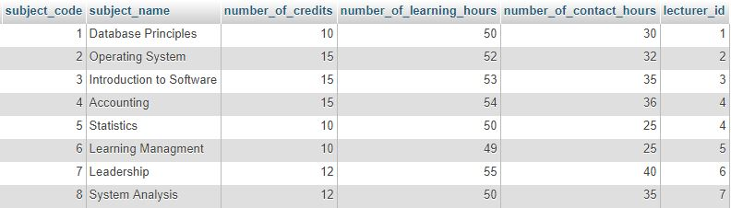

# Enroll tables insert data

INSERT INTO `avidcollege`.`enroll` (`enroll_code`, `student_id`, `subject_code`) VALUES ('0', '2', '1');

INSERT INTO `avidcollege`.`enroll` (`enroll_code`, `student_id`, `subject_code`) VALUES (NULL, '2', '2');

INSERT INTO `avidcollege`.`enroll` (`enroll_code`, `student_id`, `subject_code`) VALUES (NULL, '2', '3');

INSERT INTO `avidcollege`.`enroll` (`enroll_code`, `student_id`, `subject_code`) VALUES (NULL, '3', '1');

INSERT INTO `avidcollege`.`enroll` (`enroll_code`, `student_id`, `subject_code`) VALUES (NULL, '3', '2');

INSERT INTO `avidcollege`.`enroll` (`enroll_code`, `student_id`, `subject_code`) VALUES (NULL, '3', '3');

INSERT INTO `avidcollege`.`enroll` (`enroll_code`, `student_id`, `subject_code`) VALUES (NULL, '4', '1');

INSERT INTO `avidcollege`.`enroll` (`enroll_code`, `student_id`, `subject_code`) VALUES (NULL, '4', '2');

INSERT INTO `avidcollege`.`enroll` (`enroll_code`, `student_id`, `subject_code`) VALUES (NULL, '4', '3');

INSERT INTO `avidcollege`.`enroll` (`enroll_code`, `student_id`, `subject_code`) VALUES (NULL, '6', '8');

INSERT INTO `avidcollege`.`enroll` (`enroll_code`, `student_id`, `subject_code`) VALUES (NULL, '6', '4');

INSERT INTO `avidcollege`.`enroll` (`enroll_code`, `student_id`, `subject_code`) VALUES (NULL, '7', '8');

INSERT INTO `avidcollege`.`enroll` (`enroll_code`, `student_id`, `subject_code`) VALUES (NULL, '7', '4');

INSERT INTO `avidcollege`.`enroll` (`enroll_code`, `student_id`, `subject_code`) VALUES (NULL, '8', '4');

INSERT INTO `avidcollege`.`enroll` (`enroll_code`, `student_id`, `subject_code`) VALUES (NULL, '8', '8');

INSERT INTO `avidcollege`.`enroll` (`enroll_code`, `student_id`, `subject_code`) VALUES (NULL, '9', '4');

INSERT INTO `avidcollege`.`enroll` (`enroll_code`, `student_id`, `subject_code`) VALUES (NULL, '9', '8');

INSERT INTO `avidcollege`.`enroll` (`enroll_code`, `student_id`, `subject_code`) VALUES (NULL, '5', '5');

INSERT INTO `avidcollege`.`enroll` (`enroll_code`, `student_id`, `subject_code`) VALUES (NULL, '5', '6');

INSERT INTO `avidcollege`.`enroll` (`enroll_code`, `student_id`, `subject_code`) VALUES (NULL, '5', '7');

INSERT INTO `avidcollege`.`enroll` (`enroll_code`, `student_id`, `subject_code`) VALUES (NULL, '10', '5');

INSERT INTO `avidcollege`.`enroll` (`enroll_code`, `student_id`, `subject_code`) VALUES (NULL, '10', '6');

INSERT INTO `avidcollege`.`enroll` (`enroll_code`, `student_id`, `subject_code`) VALUES (NULL, '10', '7');

INSERT INTO `avidcollege`.`enroll` (`enroll_code`, `student_id`, `subject_code`) VALUES (NULL, '11', '5');

INSERT INTO `avidcollege`.`enroll` (`enroll_code`, `student_id`, `subject_code`) VALUES (NULL, '11', '6');

INSERT INTO `avidcollege`.`enroll` (`enroll_code`, `student_id`, `subject_code`) VALUES (NULL, '11', '7');

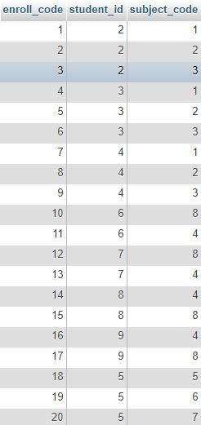

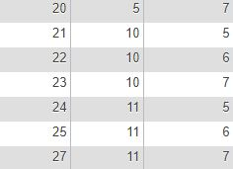

# Outline tables insert data

INSERT INTO `avidcollege`.`outline` (`outline_id`, `subject_code`, `course_code`) VALUES (NULL, '1', '1');

INSERT INTO `avidcollege`.`outline` (`outline_id`, `subject_code`, `course_code`) VALUES (NULL, '2', '1');

INSERT INTO `avidcollege`.`outline` (`outline_id`, `subject_code`, `course_code`) VALUES (NULL, '3', '1');

INSERT INTO `avidcollege`.`outline` (`outline_id`, `subject_code`, `course_code`) VALUES (NULL, '4', '2');

INSERT INTO `avidcollege`.`outline` (`outline_id`, `subject_code`, `course_code`) VALUES (NULL, '8', '2');

INSERT INTO `avidcollege`.`outline` (`outline_id`, `subject_code`, `course_code`) VALUES (NULL, '4', '3');

INSERT INTO `avidcollege`.`outline` (`outline_id`, `subject_code`, `course_code`) VALUES (NULL, '8', '3');

INSERT INTO `avidcollege`.`outline` (`outline_id`, `subject_code`, `course_code`) VALUES (NULL, '5', '3');

INSERT INTO `avidcollege`.`outline` (`outline_id`, `subject_code`, `course_code`) VALUES (NULL, '5', '4');

INSERT INTO `avidcollege`.`outline` (`outline_id`, `subject_code`, `course_code`) VALUES (NULL, '6', '4');

INSERT INTO `avidcollege`.`outline` (`outline_id`, `subject_code`, `course_code`) VALUES (NULL, '7', '4');

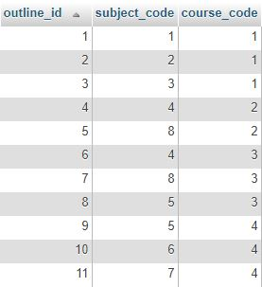

# Sub_assessment table insert data

INSERT INTO `avidcollege`.`sub_assesment` (`sub_assessment_id`, `sub_assesement_marks`, `assessment_id`, `subject_code`) VALUES (NULL, '20', '2', '1');

INSERT INTO `avidcollege`.`sub_assesment` (`sub_assessment_id`, `sub_assesement_marks`, `assessment_id`, `subject_code`) VALUES (NULL, '30', '3', '1');

INSERT INTO `avidcollege`.`sub_assesment` (`sub_assessment_id`, `sub_assesement_marks`, `assessment_id`, `subject_code`) VALUES (NULL, '50', '4', '1');

INSERT INTO `avidcollege`.`sub_assesment` (`sub_assessment_id`, `sub_assesement_marks`, `assessment_id`, `subject_code`) VALUES (NULL, '20', '2', '2');

INSERT INTO `avidcollege`.`sub_assesment` (`sub_assessment_id`, `sub_assesement_marks`, `assessment_id`, `subject_code`) VALUES (NULL, '30', '3', '2');

INSERT INTO `avidcollege`.`sub_assesment` (`sub_assessment_id`, `sub_assesement_marks`, `assessment_id`, `subject_code`) VALUES (NULL, '50', '4', '2');

INSERT INTO `avidcollege`.`sub_assesment` (`sub_assessment_id`, `sub_assesement_marks`, `assessment_id`, `subject_code`) VALUES (NULL, '20', '2', '3');

INSERT INTO `avidcollege`.`sub_assesment` (`sub_assessment_id`, `sub_assesement_marks`, `assessment_id`, `subject_code`) VALUES (NULL, '30', '3', '3');

INSERT INTO `avidcollege`.`sub_assesment` (`sub_assessment_id`, `sub_assesement_marks`, `assessment_id`, `subject_code`) VALUES (NULL, '50', '4', '3');

INSERT INTO `avidcollege`.`sub_assesment` (`sub_assessment_id`, `sub_assesement_marks`, `assessment_id`, `subject_code`) VALUES (NULL, '50', '2', '4');

INSERT INTO `avidcollege`.`sub_assesment` (`sub_assessment_id`, `sub_assesement_marks`, `assessment_id`, `subject_code`) VALUES (NULL, '50', '3', '4');

INSERT INTO `avidcollege`.`sub_assesment` (`sub_assessment_id`, `sub_assesement_marks`, `assessment_id`, `subject_code`) VALUES (NULL, '50', '2', '8');

INSERT INTO `avidcollege`.`sub_assesment` (`sub_assessment_id`, `sub_assesement_marks`, `assessment_id`, `subject_code`) VALUES (NULL, '50', '3', '8');

INSERT INTO `avidcollege`.`sub_assesment` (`sub_assessment_id`, `sub_assesement_marks`, `assessment_id`, `subject_code`) VALUES (NULL, '50', '2', '5');

INSERT INTO `avidcollege`.`sub_assesment` (`sub_assessment_id`, `sub_assesement_marks`, `assessment_id`, `subject_code`) VALUES (NULL, '50', '4', '5');

INSERT INTO `avidcollege`.`sub_assesment` (`sub_assessment_id`, `sub_assesement_marks`, `assessment_id`, `subject_code`) VALUES (NULL, '50', '2', '6');

INSERT INTO `avidcollege`.`sub_assesment` (`sub_assessment_id`, `sub_assesement_marks`, `assessment_id`, `subject_code`) VALUES (NULL, '50', '4', '6');

INSERT INTO `avidcollege`.`sub_assesment` (`sub_assessment_id`, `sub_assesement_marks`, `assessment_id`, `subject_code`) VALUES (NULL, '50', '2', '7');

INSERT INTO `avidcollege`.`sub_assesment` (`sub_assessment_id`, `sub_assesement_marks`, `assessment_id`, `subject_code`) VALUES (NULL, '50', '4', '7');

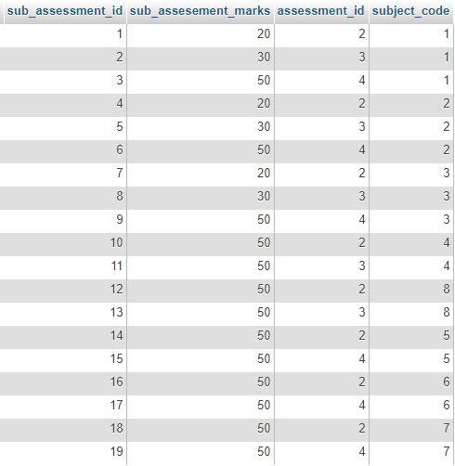

# Student assesment table insert data

INSERT INTO `avidcollege`.`student_assement` (`student_assement_id`, `student_marks`, `sub_assessment_id`, `student_id`) VALUES (NULL, '13', '1', '2');

INSERT INTO `avidcollege`.`student_assement` (`student_assement_id`, `student_marks`, `sub_assessment_id`, `student_id`) VALUES (NULL, '29', '2', '2');

INSERT INTO `avidcollege`.`student_assement` (`student_assement_id`, `student_marks`, `sub_assessment_id`, `student_id`) VALUES (NULL, '45', '3', '2');

INSERT INTO `avidcollege`.`student_assement` (`student_assement_id`, `student_marks`, `sub_assessment_id`, `student_id`) VALUES (NULL, '19', '4', '2');

INSERT INTO `avidcollege`.`student_assement` (`student_assement_id`, `student_marks`, `sub_assessment_id`, `student_id`) VALUES (NULL, '25', '5', '2');

INSERT INTO `avidcollege`.`student_assement` (`student_assement_id`, `student_marks`, `sub_assessment_id`, `student_id`) VALUES (NULL, '42', '6', '2');

INSERT INTO `avidcollege`.`student_assement` (`student_assement_id`, `student_marks`, `sub_assessment_id`, `student_id`) VALUES (NULL, '16', '7', '2');

INSERT INTO `avidcollege`.`student_assement` (`student_assement_id`, `student_marks`, `sub_assessment_id`, `student_id`) VALUES (NULL, '27', '8', '2');

INSERT INTO `avidcollege`.`student_assement` (`student_assement_id`, `student_marks`, `sub_assessment_id`, `student_id`) VALUES (NULL, '42', '9', '2');

INSERT INTO `avidcollege`.`student_assement` (`student_assement_id`, `student_marks`, `sub_assessment_id`, `student_id`) VALUES (NULL, '14', '1', '3');

INSERT INTO `avidcollege`.`student_assement` (`student_assement_id`, `student_marks`, `sub_assessment_id`, `student_id`) VALUES (NULL, '30', '2', '3');

INSERT INTO `avidcollege`.`student_assement` (`student_assement_id`, `student_marks`, `sub_assessment_id`, `student_id`) VALUES (NULL, '46', '3', '3');

INSERT INTO `avidcollege`.`student_assement` (`student_assement_id`, `student_marks`, `sub_assessment_id`, `student_id`) VALUES (NULL, '17', '4', '3');

INSERT INTO `avidcollege`.`student_assement` (`student_assement_id`, `student_marks`, `sub_assessment_id`, `student_id`) VALUES (NULL, '25', '5', '3');

INSERT INTO `avidcollege`.`student_assement` (`student_assement_id`, `student_marks`, `sub_assessment_id`, `student_id`) VALUES (NULL, '45', '6', '3');

INSERT INTO `avidcollege`.`student_assement` (`student_assement_id`, `student_marks`, `sub_assessment_id`, `student_id`) VALUES (NULL, '19', '7', '3');

INSERT INTO `avidcollege`.`student_assement` (`student_assement_id`, `student_marks`, `sub_assessment_id`, `student_id`) VALUES (NULL, '17', '8', '3');

INSERT INTO `avidcollege`.`student_assement` (`student_assement_id`, `student_marks`, `sub_assessment_id`, `student_id`) VALUES (NULL, '32', '9', '3');

INSERT INTO `avidcollege`.`student_assement` (`student_assement_id`, `student_marks`, `sub_assessment_id`, `student_id`) VALUES (NULL, '15', '1', '4');

INSERT INTO `avidcollege`.`student_assement` (`student_assement_id`, `student_marks`, `sub_assessment_id`, `student_id`) VALUES (NULL, '30', '2', '4');

INSERT INTO `avidcollege`.`student_assement` (`student_assement_id`, `student_marks`, `sub_assessment_id`, `student_id`) VALUES (NULL, '49', '3', '4');

INSERT INTO `avidcollege`.`student_assement` (`student_assement_id`, `student_marks`, `sub_assessment_id`, `student_id`) VALUES (NULL, '17', '4', '4');

INSERT INTO `avidcollege`.`student_assement` (`student_assement_id`, `student_marks`, `sub_assessment_id`, `student_id`) VALUES (NULL, '22', '5', '4');

INSERT INTO `avidcollege`.`student_assement` (`student_assement_id`, `student_marks`, `sub_assessment_id`, `student_id`) VALUES (NULL, '46', '6', '4');

INSERT INTO `avidcollege`.`student_assement` (`student_assement_id`, `student_marks`, `sub_assessment_id`, `student_id`) VALUES (NULL, '13', '7', '4');

INSERT INTO `avidcollege`.`student_assement` (`student_assement_id`, `student_marks`, `sub_assessment_id`, `student_id`) VALUES (NULL, '13', '8', '4');

INSERT INTO `avidcollege`.`student_assement` (`student_assement_id`, `student_marks`, `sub_assessment_id`, `student_id`) VALUES (NULL, '39', '9', '4');

INSERT INTO `avidcollege`.`student_assement` (`student_assement_id`, `student_marks`, `sub_assessment_id`, `student_id`) VALUES (NULL, '25', '10', '5');

INSERT INTO `avidcollege`.`student_assement` (`student_assement_id`, `student_marks`, `sub_assessment_id`, `student_id`) VALUES (NULL, '45', '11', '5');

INSERT INTO `avidcollege`.`student_assement` (`student_assement_id`, `student_marks`, `sub_assessment_id`, `student_id`) VALUES (NULL, '46', '12', '5');

INSERT INTO `avidcollege`.`student_assement` (`student_assement_id`, `student_marks`, `sub_assessment_id`, `student_id`) VALUES (NULL, '20', '13', '5');

INSERT INTO `avidcollege`.`student_assement` (`student_assement_id`, `student_marks`, `sub_assessment_id`, `student_id`) VALUES (NULL, '29', '10', '6');

INSERT INTO `avidcollege`.`student_assement` (`student_assement_id`, `student_marks`, `sub_assessment_id`, `student_id`) VALUES (NULL, '45', '11', '6');

INSERT INTO `avidcollege`.`student_assement` (`student_assement_id`, `student_marks`, `sub_assessment_id`, `student_id`) VALUES (NULL, '49', '12', '6');

INSERT INTO `avidcollege`.`student_assement` (`student_assement_id`, `student_marks`, `sub_assessment_id`, `student_id`) VALUES (NULL, '22', '13', '6');

INSERT INTO `avidcollege`.`student_assement` (`student_assement_id`, `student_marks`, `sub_assessment_id`, `student_id`) VALUES (NULL, '29', '10', '7');

INSERT INTO `avidcollege`.`student_assement` (`student_assement_id`, `student_marks`, `sub_assessment_id`, `student_id`) VALUES (NULL, '45', '11', '7');

INSERT INTO `avidcollege`.`student_assement` (`student_assement_id`, `student_marks`, `sub_assessment_id`, `student_id`) VALUES (NULL, '50', '12', '7');

INSERT INTO `avidcollege`.`student_assement` (`student_assement_id`, `student_marks`, `sub_assessment_id`, `student_id`) VALUES (NULL, '22', '13', '7');

INSERT INTO `avidcollege`.`student_assement` (`student_assement_id`, `student_marks`, `sub_assessment_id`, `student_id`) VALUES (NULL, '46', '14', '7');

INSERT INTO `avidcollege`.`student_assement` (`student_assement_id`, `student_marks`, `sub_assessment_id`, `student_id`) VALUES (NULL, '22', '15', '7');

INSERT INTO `avidcollege`.`student_assement` (`student_assement_id`, `student_marks`, `sub_assessment_id`, `student_id`) VALUES (NULL, '25', '10', '8');

INSERT INTO `avidcollege`.`student_assement` (`student_assement_id`, `student_marks`, `sub_assessment_id`, `student_id`) VALUES (NULL, '45', '11', '8');

INSERT INTO `avidcollege`.`student_assement` (`student_assement_id`, `student_marks`, `sub_assessment_id`, `student_id`) VALUES (NULL, '47', '12', '8');

INSERT INTO `avidcollege`.`student_assement` (`student_assement_id`, `student_marks`, `sub_assessment_id`, `student_id`) VALUES (NULL, '25', '13', '8');

INSERT INTO `avidcollege`.`student_assement` (`student_assement_id`, `student_marks`, `sub_assessment_id`, `student_id`) VALUES (NULL, '46', '14', '8');

INSERT INTO `avidcollege`.`student_assement` (`student_assement_id`, `student_marks`, `sub_assessment_id`, `student_id`) VALUES (NULL, '50', '15', '8');

INSERT INTO `avidcollege`.`student_assement` (`student_assement_id`, `student_marks`, `sub_assessment_id`, `student_id`) VALUES (NULL, '45', '14', '9');

INSERT INTO `avidcollege`.`student_assement` (`student_assement_id`, `student_marks`, `sub_assessment_id`, `student_id`) VALUES (NULL, '45', '15', '9');

INSERT INTO `avidcollege`.`student_assement` (`student_assement_id`, `student_marks`, `sub_assessment_id`, `student_id`) VALUES (NULL, '49', '16', '9');

INSERT INTO `avidcollege`.`student_assement` (`student_assement_id`, `student_marks`, `sub_assessment_id`, `student_id`) VALUES (NULL, '25', '17', '9');

INSERT INTO `avidcollege`.`student_assement` (`student_assement_id`, `student_marks`, `sub_assessment_id`, `student_id`) VALUES (NULL, '16', '18', '9');

INSERT INTO `avidcollege`.`student_assement` (`student_assement_id`, `student_marks`, `sub_assessment_id`, `student_id`) VALUES (NULL, '30', '19', '9');

INSERT INTO `avidcollege`.`student_assement` (`student_assement_id`, `student_marks`, `sub_assessment_id`, `student_id`) VALUES (NULL, '35', '14', '10');

INSERT INTO `avidcollege`.`student_assement` (`student_assement_id`, `student_marks`, `sub_assessment_id`, `student_id`) VALUES (NULL, '45', '15', '10');

INSERT INTO `avidcollege`.`student_assement` (`student_assement_id`, `student_marks`, `sub_assessment_id`, `student_id`) VALUES (NULL, '39', '16', '10');

INSERT INTO `avidcollege`.`student_assement` (`student_assement_id`, `student_marks`, `sub_assessment_id`, `student_id`) VALUES (NULL, '25', '17', '10');

INSERT INTO `avidcollege`.`student_assement` (`student_assement_id`, `student_marks`, `sub_assessment_id`, `student_id`) VALUES (NULL, '46', '18', '10');

INSERT INTO `avidcollege`.`student_assement` (`student_assement_id`, `student_marks`, `sub_assessment_id`, `student_id`) VALUES (NULL, '30', '19', '10');

INSERT INTO `avidcollege`.`student_assement` (`student_assement_id`, `student_marks`, `sub_assessment_id`, `student_id`) VALUES (NULL, '39', '14', '11');

INSERT INTO `avidcollege`.`student_assement` (`student_assement_id`, `student_marks`, `sub_assessment_id`, `student_id`) VALUES (NULL, '45', '15', '11');

INSERT INTO `avidcollege`.`student_assement` (`student_assement_id`, `student_marks`, `sub_assessment_id`, `student_id`) VALUES (NULL, '29', '16', '11');

INSERT INTO `avidcollege`.`student_assement` (`student_assement_id`, `student_marks`, `sub_assessment_id`, `student_id`) VALUES (NULL, '25', '17', '11');

INSERT INTO `avidcollege`.`student_assement` (`student_assement_id`, `student_marks`, `sub_assessment_id`, `student_id`) VALUES (NULL, '36', '18', '11');

INSERT INTO `avidcollege`.`student_assement` (`student_assement_id`, `student_marks`, `sub_assessment_id`, `student_id`) VALUES (NULL, '50', '19', '11');

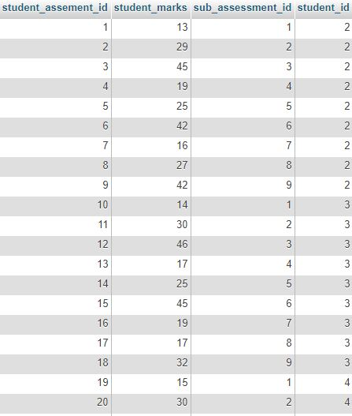

# Query answer

**Q1 show in groups the number of students from each gender;**

select 'Male' as Gender, count(gender) as number_of_students from student where gender= 'Male'

union (

select 'Female' as Gender, count(gender) as number_of_students from student where gender= 'Female' )

union (

select 'Total' as Gender, count(gender) as number_of_students from student )

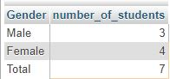

**Q2 List the student id,full name and age of all students who are older than 23 years old?**

SELECT student_id, full_name, TIMESTAMPDIFF(YEAR,date_of_birth, CURDATE())as age from student where TIMESTAMPDIFF(YEAR,date_of_birth, CURDATE())>23;

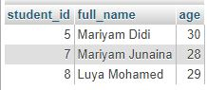

**Q3 List the name and contact number of all parttime lecturers**

SELECT full_name,contact_number FROM lecturer where part_or_full_time="Part Time";

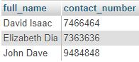

**Q4 List the number of subject name and contact hours for all the subjects taught in under the course Diploma in IT?**

select count(subject_name)as number_of_subjects, sum( number_of_contact_hours) as Number_of_contact_hours from outline inner join subjects using (subject_code) inner join course using (course_code) where course_name='Diploma in IT';

C:\Users\userpc\Documents\Desktop\Capture.JPG

**Q5 List the numbe of students who have registered for database principles, subject?**

Select subject_name, count(full_name) as number_of_students from enroll inner join student using (student_id) inner join subjects using (subject_code) where subject_name='Database Principles';

C:\Users\userpc\Documents\Desktop\Capture.JPG

**Q6 List all subject names and their assessment types?**

select subject_name, assessment_type from sub_assesment inner join subjects using (subject_code) inner join assessment using (assessment_id);

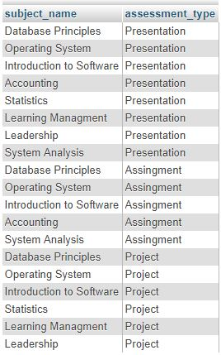

**Q7 Count the number of subjects taught by each lecturer?**

select full_name as 'lecutere name' ,count(subject_name) as 'number of subjects taught' from subjects inner join lecturer using (lecturer_id) group by full_name;

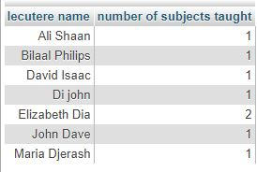

**Q8 List the subject names, and the number of students who has registered for them?**

select subject_name as 'Subject Name', count(student_id) as 'number of students' from enroll inner join subjects using (subject_code) inner join student using (student_id) group by subject_name;

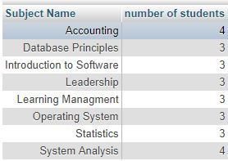

**Q9 List subject names and the lecturer names of lecturers who teach them?**

select subject_name as Subject ,full_name as 'lecutere name' from subjects inner join lecturer using (lecturer_id) group by subject_name;

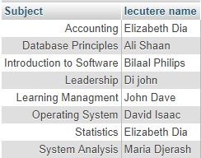

**Q10 List the subject name. Student name, and assessment type, assessment marks for all subjects?**

select subject_name,full_name,assessment_type,student_marks from student_assement inner join student using (student_id) inner join sub_assesment using (sub_assessment_id) inner join subjects using (subject_code) inner join assessment using(assessment_id) order by full_name;

