Software Design Specification

Poject Name

Document No. | 1
Author: | Name
Revision: | 1.0
Date Created | Date

Version History

Revision | Date | Author | Description of Change

Table of Contents
1 Introduction 4
1.1 Purpose 4
1.2 Scope 4
1.3 Definitions acronims abreviations 4
2 Architectural Representation 5
3 Goals and constrains 6
3.1 LBC, Process Control Software Architectural 6
3.2 MB , Object Brokers Software Architectural Model an PCSA 7
3.3 CP, Object broker Architecture and Model View. 8
4 Use Case View 9
4.1 Deployment 9
4.2 Configuration 9
4.3 Monitoring and Operation 9
4.4 Logs Reports 9
5 Logical View 10
6 Process View 11
6.1 Block diagrams (detailed) 11
6.1.1 Local board process 11
6.1.2 Master board process 11
6.1.3 Control board processes 11
6.2 Class Diagrams 11
6.3 Sequence Diagrams 11
7 Deployment view 12
8 Performance and Size 13

Introduction

Purpose

This document provides a comprehensive architectural overview of the system, using a number of different architectural views to depict different aspects of the system. It is intended to capture and convey the significant architectural decisions which have been made on the system.

Scope

This Software Architecture Document provides an architectural overview of the …

Definitions acronims abreviations

Definition | Description
CP | Control panel
MB | Master board
LCB | Local Board
LOAD | Consumer of electricity
CHARGER | Charger for Cell
CELL | Ez CELL
PCSA | Process Control Software Architecture

Architectural Representation
This document presents the architecture as:

- use case view
- logical view
- process view
- deployment view

The views on an underlying Unified Modeling Language (UML) model developed using BOUML

Goals and constrains

Consdering the complexity of the hardware architecture we woud use different software architectural models as described. The LB#, MB# and CP# are the major software verticals groupped by functionalilty.

Local Board Controller, Process Control Software

The Local Board controller software block diagram is illustrated in Image 3.1. The blue blocks are software deliverables.

Image:3.1
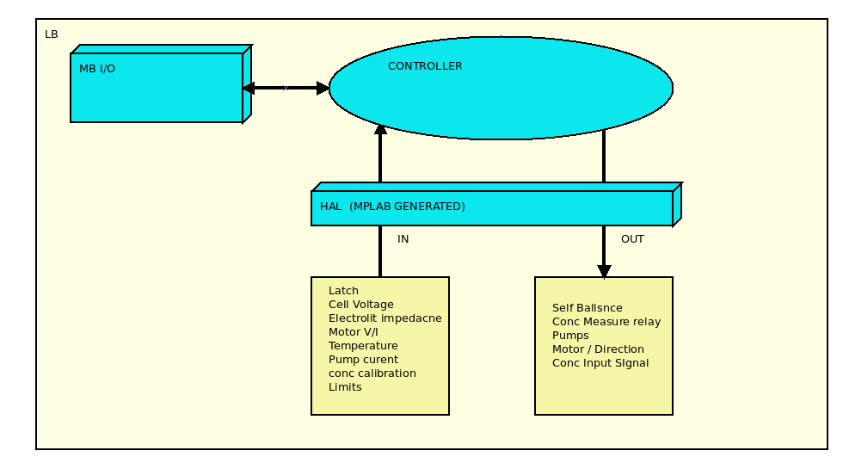

- MB IO
- LB Embedded Software targeting PIC chipset with following funcitonalities
  - LB-1 Software package designated to Read inputs & Write Outputs.
  - Communicated to MB.
- LB-2 Logic, the Software controller.
  - Keeps the cell in working parameters. Image 3.1.2
  - Power mode saving

MB , Object Brokers Software Architectural Model an PCSA

Master board controller software block diagram is illustrated in img 3.2.1
Img 3.2.1
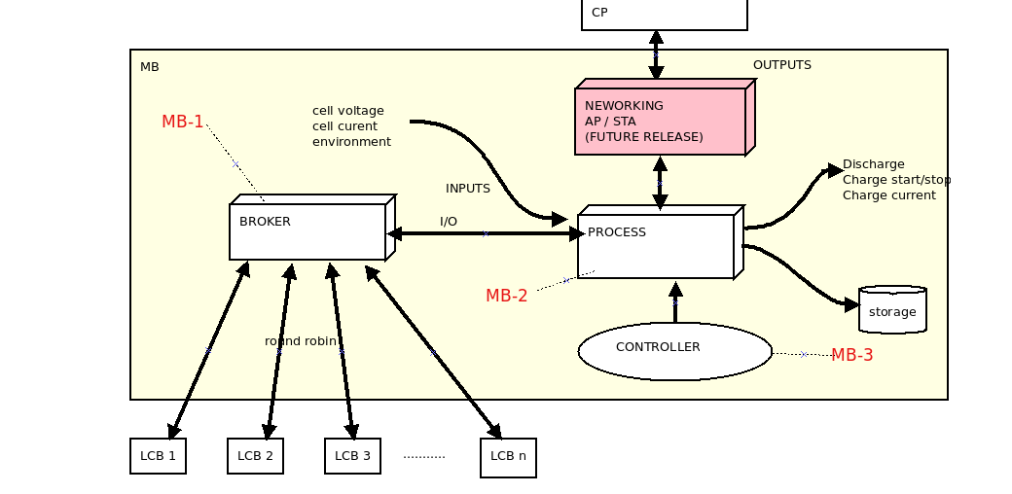

- MB- Embedded RTOS software with following funcitonalities grouped by role
  - MB-1 A round robin RTOS thread designated to communicate with each Local Boards and to controller
  - MB-2 A RTOS Thread designated
    - Read data from the broker
    - Read environment data
    - Read cell data
    - Writes tor the actuators
    - Writes to broker (tu update Local Boards)
  - MB-3 Software logic for the proces
    - Power mode logic
    - Keeps the cell banc in parameters
    - Saves data to local storage
    - Communicates to Control panel
      - This is not yet defined
      - Proposition
        - Searches specific netowrk AP by name. The router name has to be ‘XXXXX’
        - Logs in a LAN using hard coded passwords.
        - Acts as a TCP server on which the controller connects to.

CP, Object broker Architecture and Model View.

The control panel software block diagram is isslustrated in img 3.3.1. T
Img 3.3.1
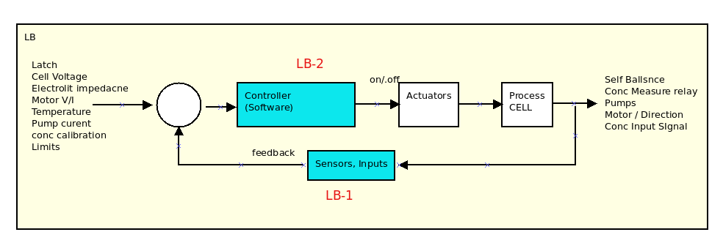

- CP is a local service capable of running on Linux, Mac OS and Windows operating systems developped in C++.
  - CP-1 Is the view software which is a thread running a standalone light web server capable of serving web pages to Opera, Safari or Firefox web browsers. The user would iteract with the system using a standard browser.
  - CP-2 Is the main thread of the application. It gets the user requests and sends the to the broker.
  - CP-3 Is the Software communication broker to the local cell banks.
    - Tries to log in autmatically to a specific AP name and preset password on WPA2.
    - Scans all the Ip’s expcet self and the LAN Gateway IP
    - Sends rewuest id for each detected IP
    - Adds each detected ip and authentuicated IP (detected as MB) to the broker
- ACTOR uses a browser to browse local IP on adress 8090

Use Case View

A description of the use-case view of the software architecture. The Use Case View is important input to the
selection of the set of scenarios and/or use cases that are the focus of an iteration. It describes the set of
scenarios and/or use cases that represent some significant, central functionality. It also describes the set of
scenarios and/or use cases that have a substantial architectural coverage (that exercise many architectural
elements) or that stress or illustrate a specific, delicate point of the architecture

Deployment

Configuration

Monitoring and Operation

Logs Reports

Logical View

A description of the logical view of the architecture. Describes the most important classes, their organization in service packages and subsystems, and the organization of these subsystems into layers. Also describes the most important use-case realizations, for example, the dynamic aspects of the architecture. Class diagrams may be included to illustrate the relationships between architecturally significant classes, subsystems, packages and layers.
The logical view of the course registration system is comprised of the 3 main packages: User Interface, Business Services, and Business Objects.

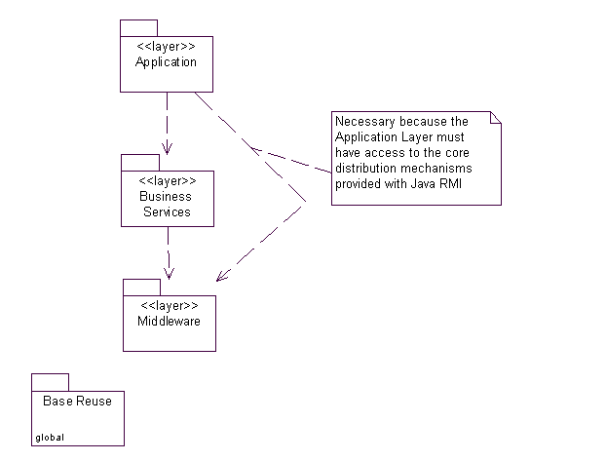

- Sdf
- sdf
- sdf

Process View

A description of the process view of the architecture. Describes the tasks (processes and threads) involved in the
system's execution, their interactions and configurations. Also describes the allocation of objects and classes to
tasks.
The Process Model illustrates the course registration classes organized as executable processes. Processes exist to support student registration, professor functions, registration closing, and access to the external Billing System and Course Catalog System.

Block diagrams (detailed)

Local board process

Master board process

Control board processes

Class Diagrams

Sequence Diagrams

Deployment view
A description of the deployment view of the architecture Describes the various physical nodes for the most typical platform configurations. Also describes the allocation of tasks (from the Process View) to the physical nodes.
This section is organized by physical network configuration; each such configuration is illustrated by a deployment diagram, followed by a mapping of processes to each processor.

Performance and Size

ANEXA

Octavian Marius Chincisan
Thu Nov 5 2020

