Table of Contents

**1. Introduction2**

1.1 Purpose2

1.2 Document Conventions2

1.2 Intended Audience and Reading Suggestions2

1.3 Project Scope2

1.4 References3

**2. Overall Description4**

2.1 Product Features4

2.2 User classes and Characteristics2

2.3 Operating Environment2

**1. INTRODUCTION**

**1.1 Purpose**

The purpose of this document is to present a detailed description of the Distributed Road Network Monitoring System. It will explain the purpose and features of the system, the interfaces of the system, what the system will do, the constraints under which

h it must operate and how the system will react to external stimuli. This document is intended for both the stakeholders and the developers of the system.

**1.2 Document Conventions**

This Document was created based on the IEEE template for System Requirement Specification Documents.

**1.3 Intended Audience and Reading Suggestions**

* App Users, who want to Learn more about the Distributed Road Network Monitoring System.
* System Users, who want to use the Distributed Road Network Monitoring System for visualization of the road condition and detailed data (system administrators).
* Project Developers, who will implement and verify the correct functioning of the system.

**1.4 Project Scope**

The purpose of the distributed road network monitoring system will be designed to ease road detection, which consists of two parts: a cross-platform mobile application for driver and web system for administrators.

More specifically, the app allows drivers to know their driving stability ranking among users who use the app and records the condition of the road when drivers are driving their cars. The web system provides a high-level visualization of the road condition for system administrators. This system is based on a relational database with its data handling and data storage functions. We will have a database server supporting hundreds of clients.

**1.5 Definitions, acronyms, and abbreviations**

SRS: Software Requirements Specification

**1.4 References**

* Singh, G., Bansal, D., Sofat, S., & Aggarwal, N. (2017). Smart patrolling: An efficient road surface monitoring using smartphone sensors and crowdsourcing. Pervasive and Mobile Computing,40, 71-88.
* Forslöf, L., & Jones, H. (2015). Roadroid: Continuous road condition monitoring with smart phones. Journal of Civil Engineering and Architecture,9(4),485-496.
* IEEE. IEEE Std 830-1998 IEEE Recommended Practice for Software Requirements Specifications. IEEE Computer Society, 1998.

**1.5 Overview**

The next chapter, the Overall Description section, of this document gives an overview of the functionality of the product. It describes the informal requirements and is used to establish a context for the technical requirements specification in the next chapter.

The third chapter, Requirements Specification section, of this document is written primarily for the developers and describes in technical terms the details of the functionality of the product.

Both sections of the document describe the same software product in its entirety, but are intended for different audiences and thus use different language.

**2. OVERALL DESCRIPTION**

**2.1 Product Perspective**

**2.1.1** **System requirement**

*Context diagram(add)*

**2.1.2 Operations**

*Activity diagram(add)*

**2.2 Product Functions** *Use case diagram(modified)*

The major features of road network monitoring system as shown in below:

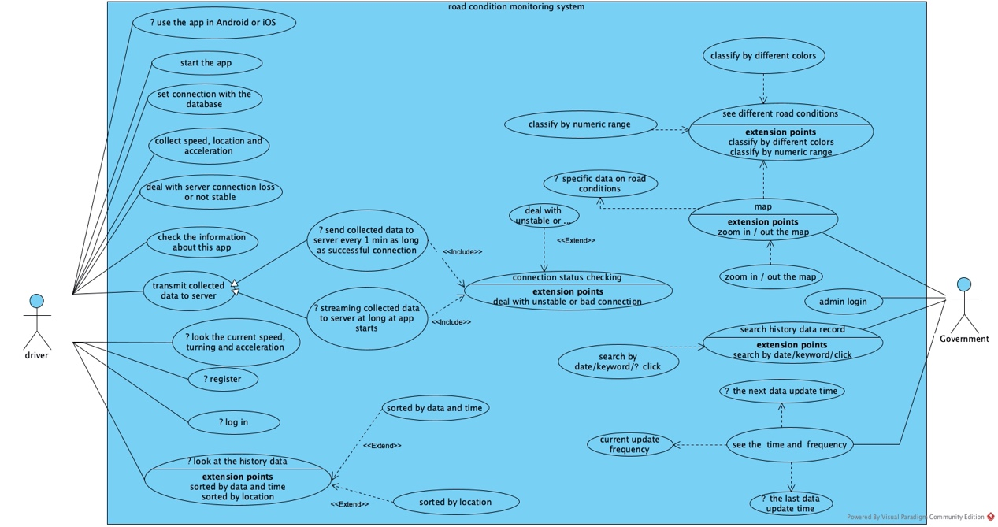

Usecase1 diagram draft

Usecase1 specification:

Name: check the road condition

Purpose: check the road surface conditions by statistical information

Precondition: admin is login

Base path:

1.open the map

2. see the map of the place monitored (e.g. UNNC campus)

3. zoom in or zoom out the map

4. see the representation of different road conditions with a numeric range and different colors

5. see the data update time and the last update time and update frequency

6. focus the cursor on certain part of sign of the road on the map

7. see the current specific data on the box turning up

8. click on certain part of sign of the road on the map

9. see the history data records of this part of the road

10. click the searching button.

11. search for the data through date or keyword

**2.3 User Class and Characteristics**

*User stories(add)*

*personas + scenarios(**modified)*

Some personas and scenarios of road network monitoring system as shown in below:

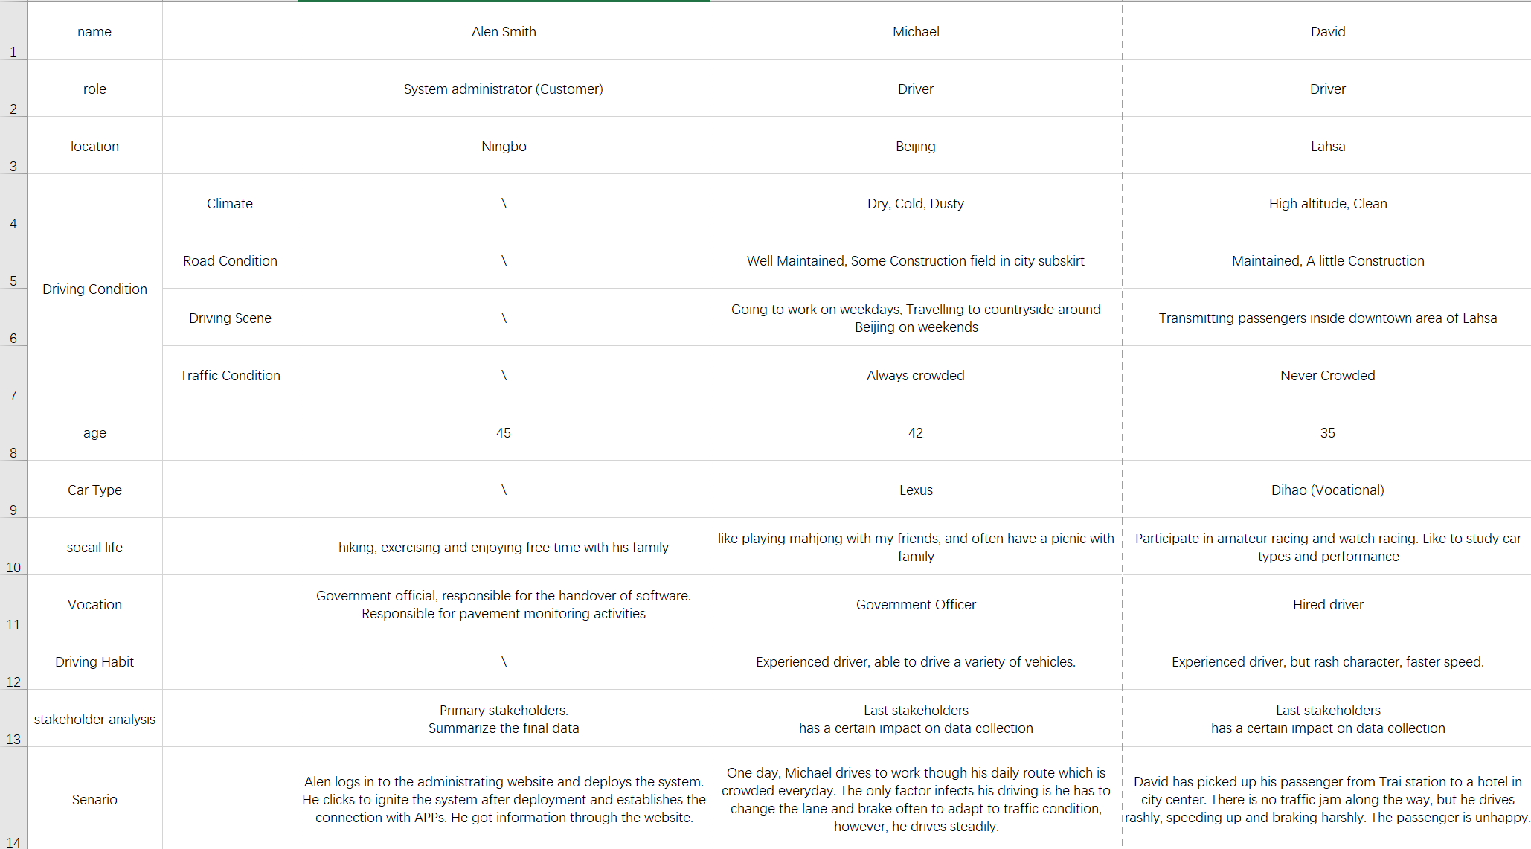

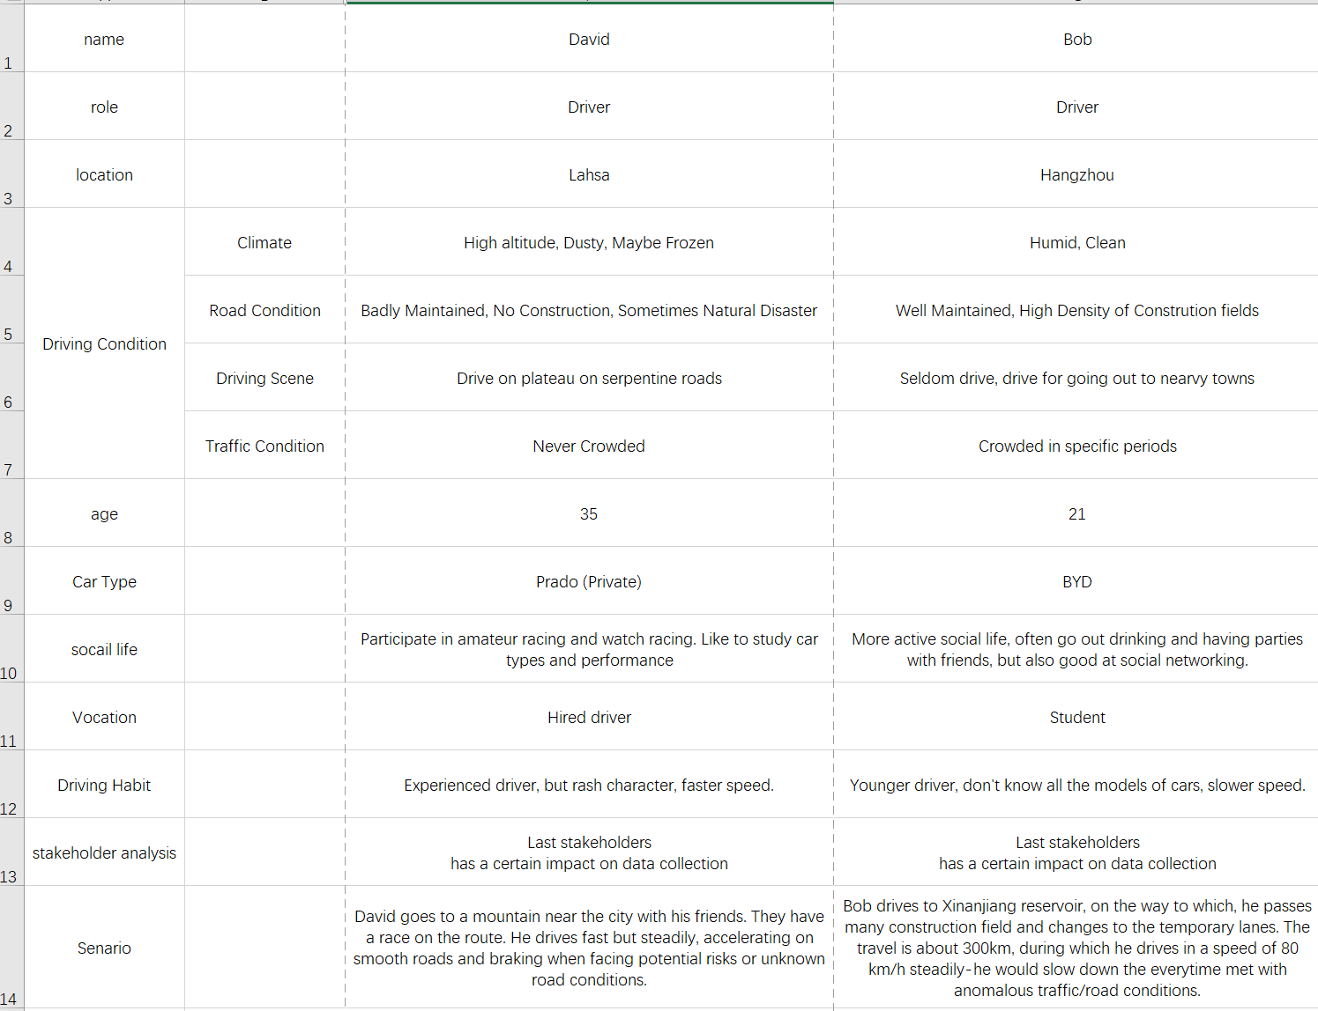

**2.4 Operating Environment**

Operating environment for road network monitoring system is as listed below.

* distributed database
* App operating system: iOS + Android
* database:
* platform: java

**2.5 Design and Implementation Constraints**

* Application: User interface shall be composed using Flutter framework and developed in Java.
* Web system: Python/Django

**2.6 Assumptions and Dependencies**

**3. SPECIFICATION REQUIREMENT**