I have setup my system folders to match the example in the tutorial to show how I got an error when executing the “Run Custom Tool” command.
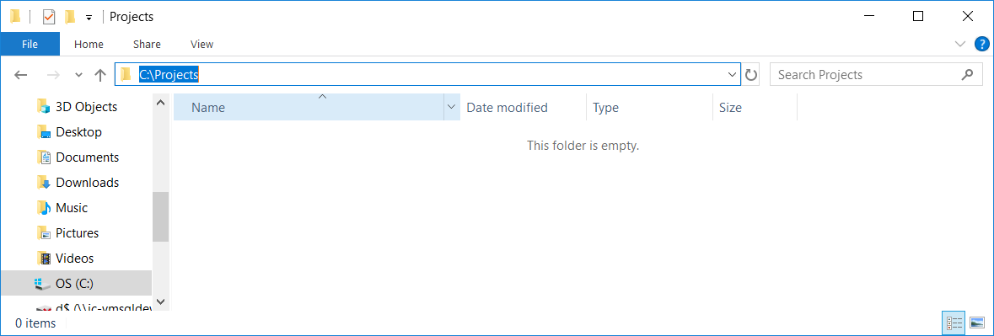

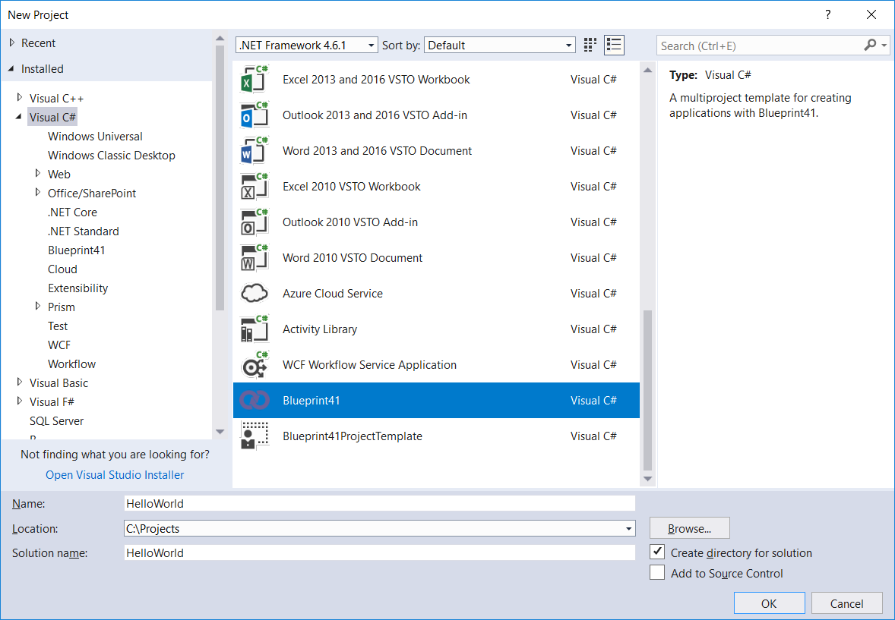

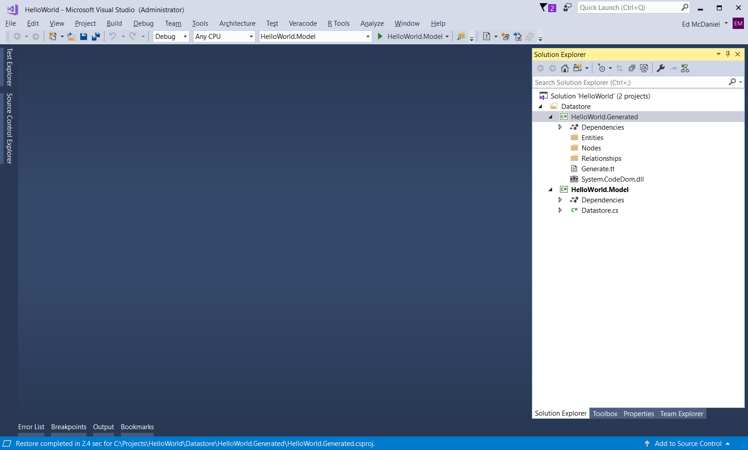

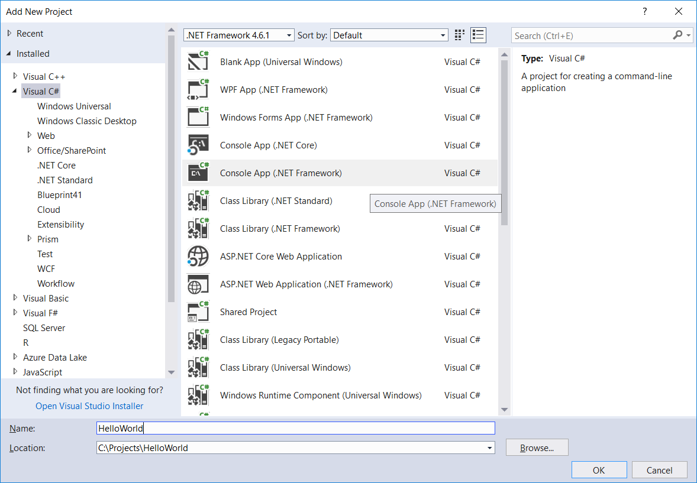
In the below screen shots of the project folders on my system you can see the folder/file structure is different than what is displayed in your getting started tutorial
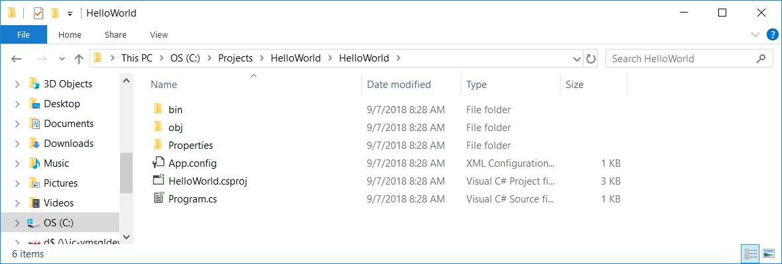

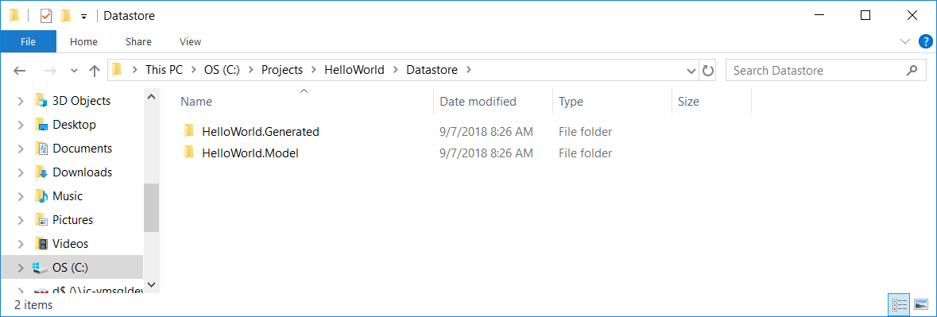
The following screen shots show that I followed the remaining steps in the tutorial as outlined.
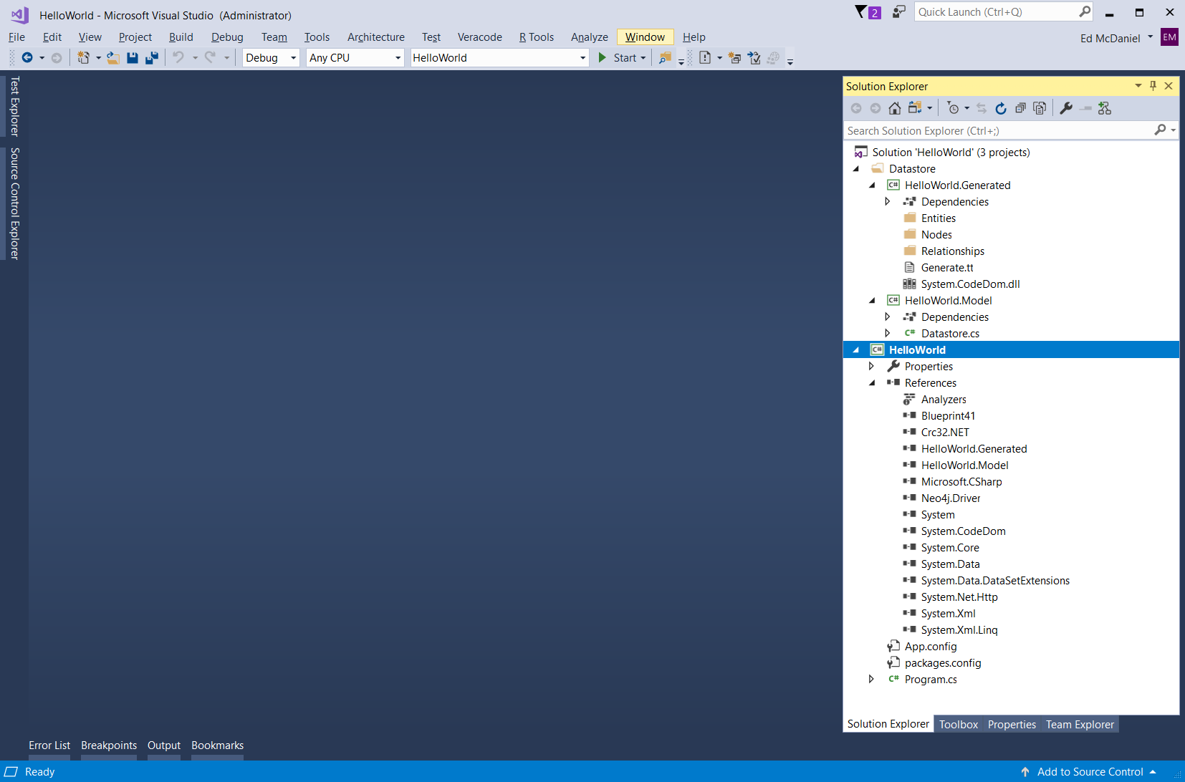

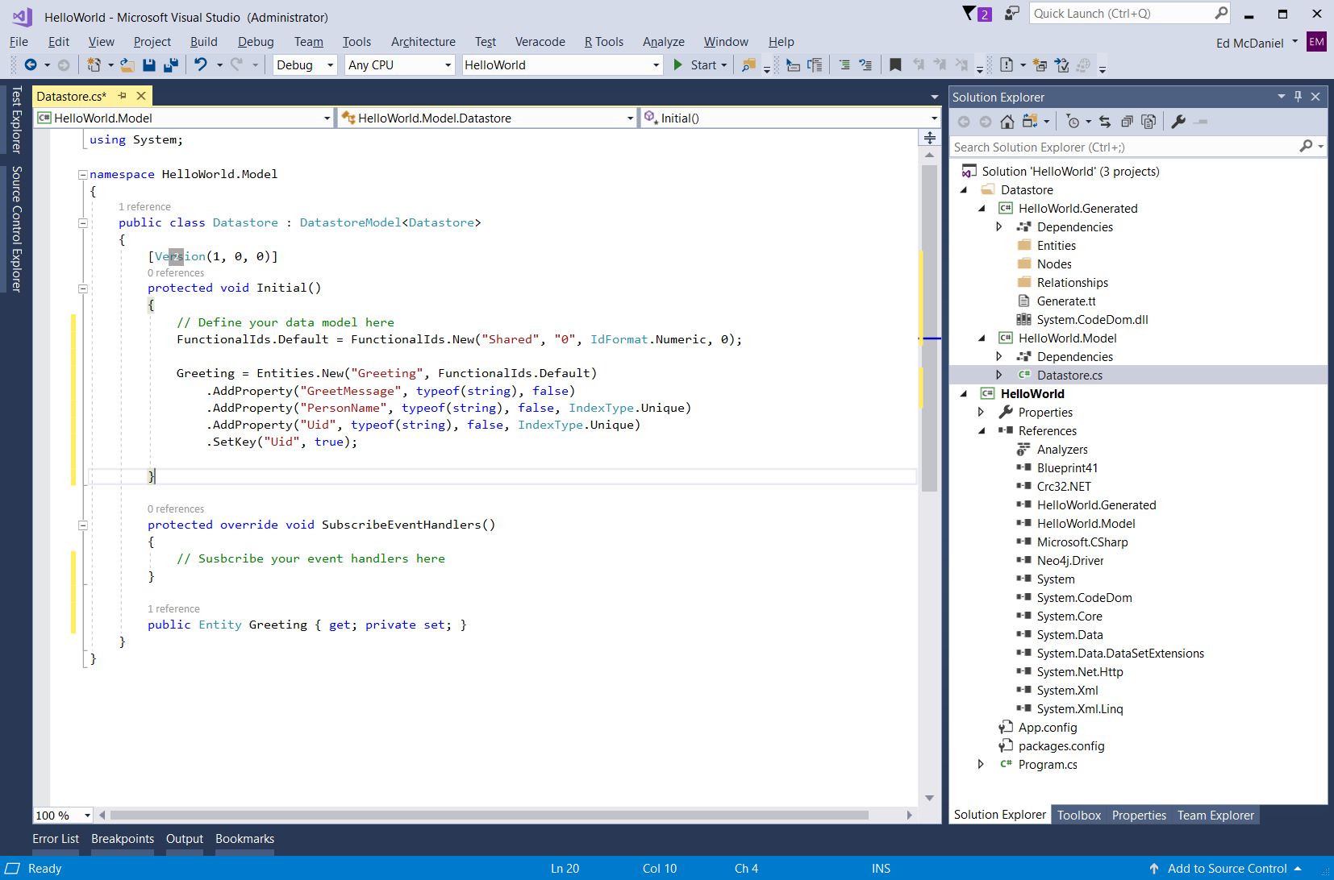

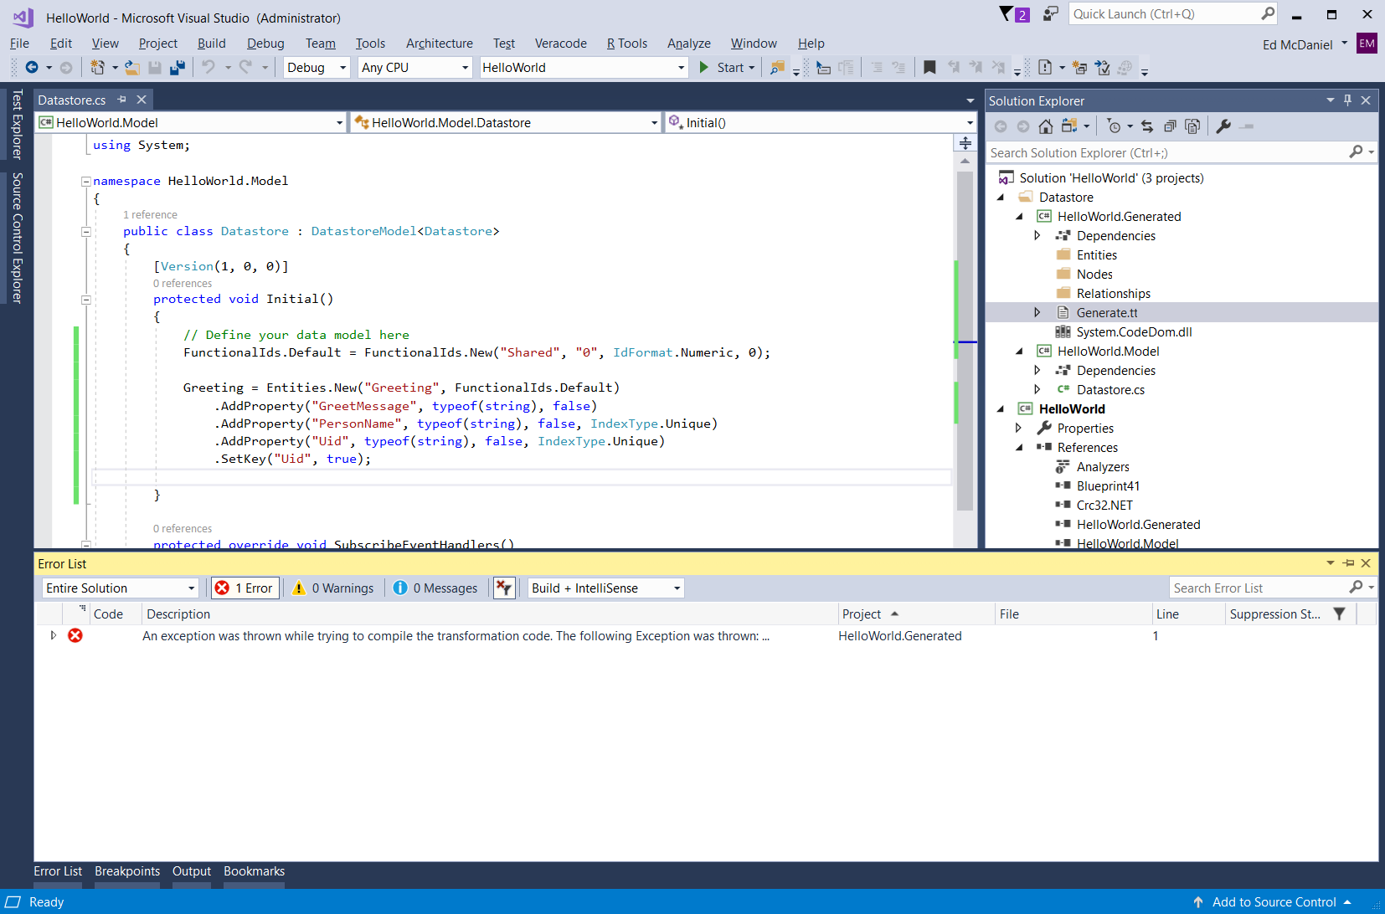

This is the error I am getting when I execute “Run Custom Tool” command.
Error An exception was thrown while trying to compile the transformation code. The following Exception was thrown:
System.IO.FileNotFoundException: Could not find a part of the path 'C:\Projects\HelloWorld\DataStore\bin\Debug\netstandard2.0\Blueprint41.dll'.
File name: 'C:\Projects\HelloWorld\DataStore\bin\Debug\netstandard2.0\Blueprint41.dll' ---> System.IO.DirectoryNotFoundException: Could not find a part of the path 'C:\Projects\HelloWorld\DataStore\bin\Debug\netstandard2.0\Blueprint41.dll'.
at System.IO.__Error.WinIOError(Int32 errorCode, String maybeFullPath)
at System.IO.FileStream.Init(String path, FileMode mode, FileAccess access, Int32 rights, Boolean useRights, FileShare share, Int32 bufferSize, FileOptions options, SECURITY_ATTRIBUTES secAttrs, String msgPath, Boolean bFromProxy, Boolean useLongPath, Boolean checkHost)
at System.IO.FileStream..ctor(String path, FileMode mode, FileAccess access, FileShare share)
at Roslyn.Utilities.FileUtilities.OpenFileStream(String path)
at Roslyn.Utilities.FileUtilities.OpenFileStream(String path)
at Microsoft.CodeAnalysis.MetadataReference.CreateFromFile(String path, MetadataReferenceProperties properties, DocumentationProvider documentation)
at Microsoft.VisualStudio.TextTemplating.CompilerBridge.<>c.<.ctor>b__15_0(String x)
at System.Linq.Enumerable.WhereSelectListIterator`2.MoveNext()
at System.Linq.Enumerable.<UnionIterator>d__67`1.MoveNext()
at System.Linq.Enumerable.<UnionIterator>d__67`1.MoveNext()
at System.Linq.Buffer`1..ctor(IEnumerable`1 source)
at System.Linq.Enumerable.ToArray[TSource](IEnumerable`1 source)
at System.Collections.Immutable.ImmutableArray.CreateRange[T](IEnumerable`1 items)
at Microsoft.CodeAnalysis.ImmutableArrayExtensions.AsImmutableOrEmpty[T](IEnumerable`1 items)
at Microsoft.CodeAnalysis.Compilation.ValidateReferences[T](IEnumerable`1 references)
at Microsoft.CodeAnalysis.CSharp.CSharpCompilation.WithReferences(IEnumerable`1 references)
at Microsoft.CodeAnalysis.CSharp.CSharpCompilation.CommonWithReferences(IEnumerable`1 newReferences)
at Microsoft.VisualStudio.TextTemplating.CompilerBridge.PrepareNewCompilation()
at Microsoft.VisualStudio.TextTemplating.CompilerBridge.Compile()
at Microsoft.VisualStudio.TextTemplating.TransformationRunner.Compile(String source, String inputFile, IEnumerable`1 references, Boolean debug, SupportedLanguage language, String compilerOptions) HelloWorld.Generated 1

You can see from the following screen shots the tool is looking in the wrong folder for the desired *.dll file. Is this because the Blueprint41 project template are in error or is there an error in the Run Custom Tool?
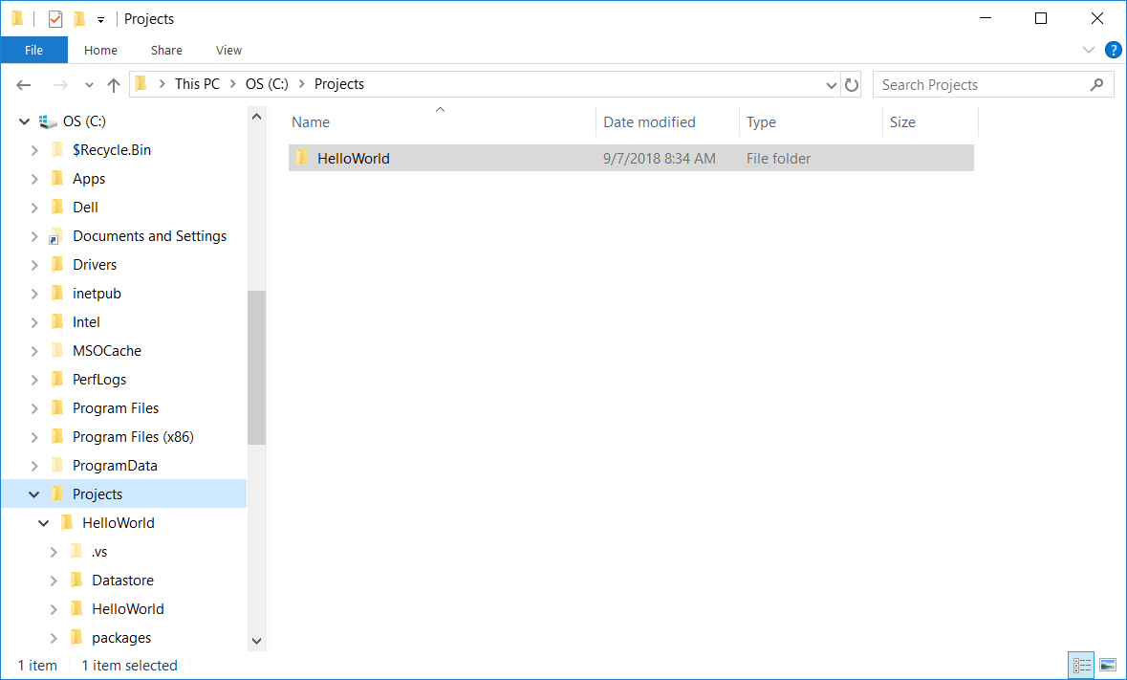
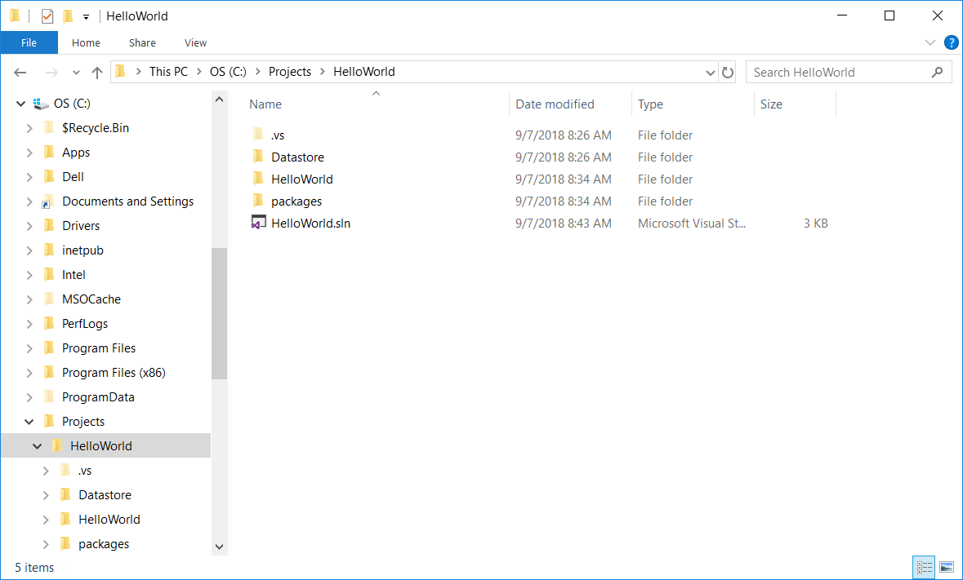
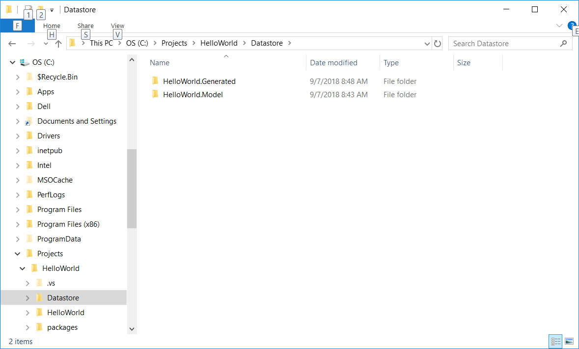
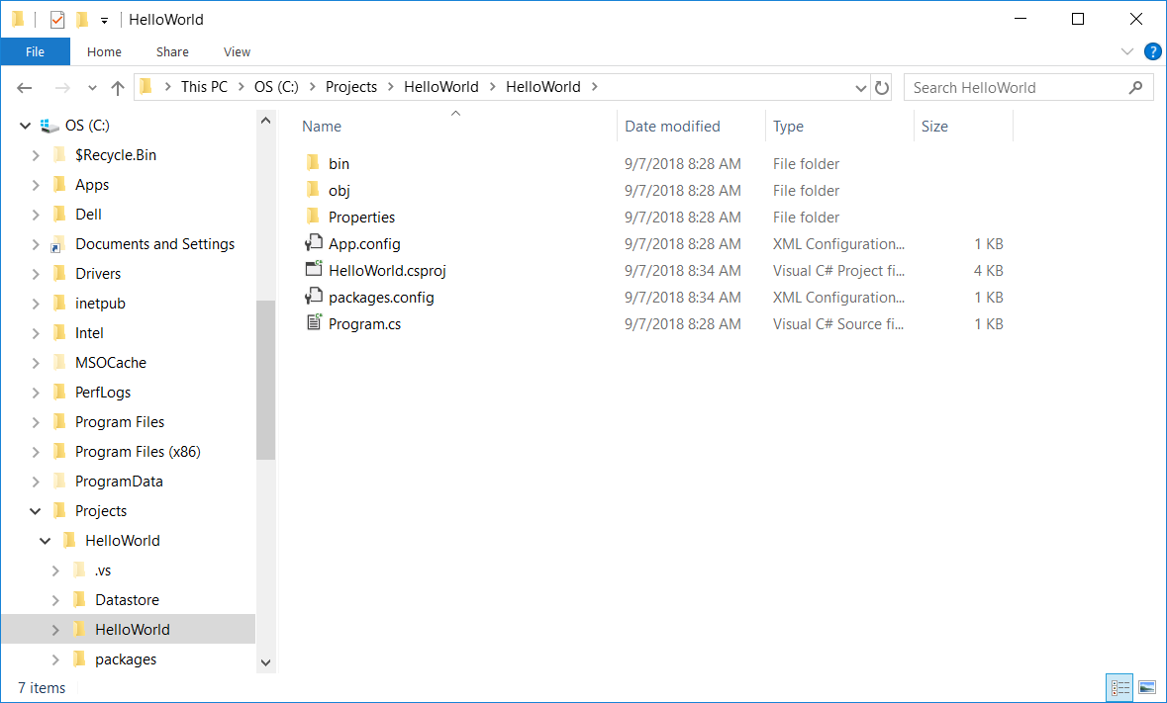
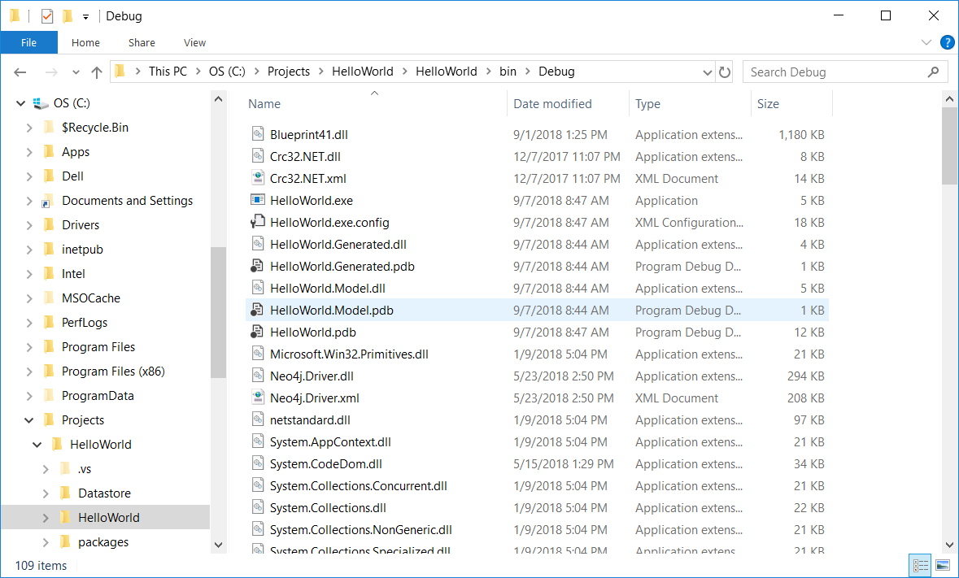
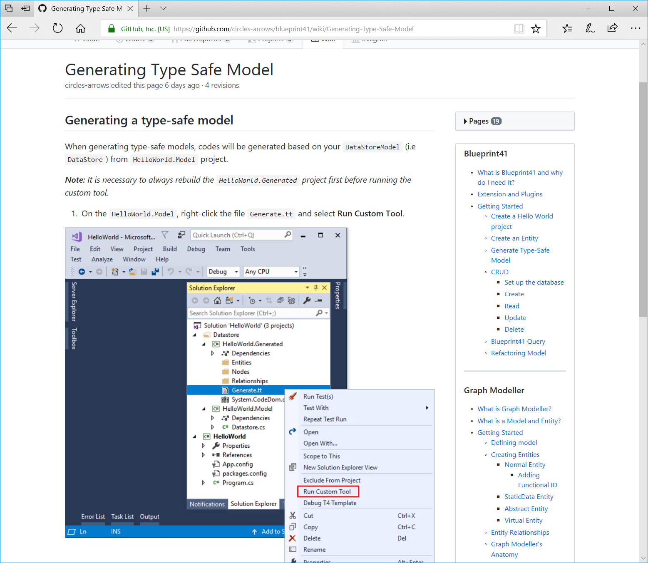
Error: Generate.tt is not in the HelloWorld.Model project

