table of contents

## defining the problem

Problem Statement 2

Initial Design Specification 2

Context Diagram 3

Data Flow Diagram 4

## understanding the problem

Social and Ethical Considerations 5

Gantt Chart 7

Screen Design 8

Storyboard 9

defining the problem

# problem statement

The flexibility of Internet Relay Chat has contributed to its status as one of the most influential features of the Internet. Its simplicity of use has allowed it to garner an impressive audience of users over the many years since its conception in 1988; however, other forms of recently developed IP communications such as video chat have surpassed IRC in popularity. This solution aims to revitalise the Internet Relay Chat scene through its provision of r.IRC, a revolutionary new IRC client with innovative features, unprecedented end user customisation, and future support for third party add-on development.

# initial design specification

r.IRC aims to:

* provide an interface for group text communication via the IRC protocol
* do so through the provision of an attractive and featured user interface

r.IRC DOES NOT aim to:

* serve as a complete replacement of large scale official communications for businesses, organisations, and governments
* provide a guaranteed secure medium through which users can communicate in secrecy
* facilitate the transfer of data wherein the data type is of a nature other than text e.g. image, video, audio

r.IRC will be developed using:

* Ruby version 1.9.3
* Shoes version 3.1.0

r.IRC will aim to support the following platforms (subject to change):

* GNU/Linux
* Microsoft Windows (Vista and above)

# context diagram

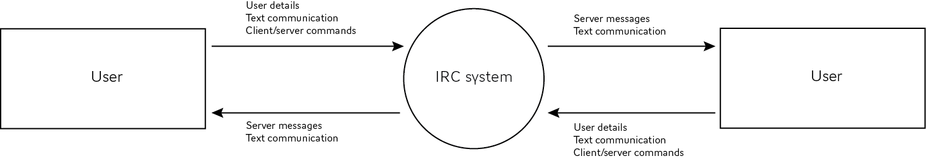

# data flow diagram

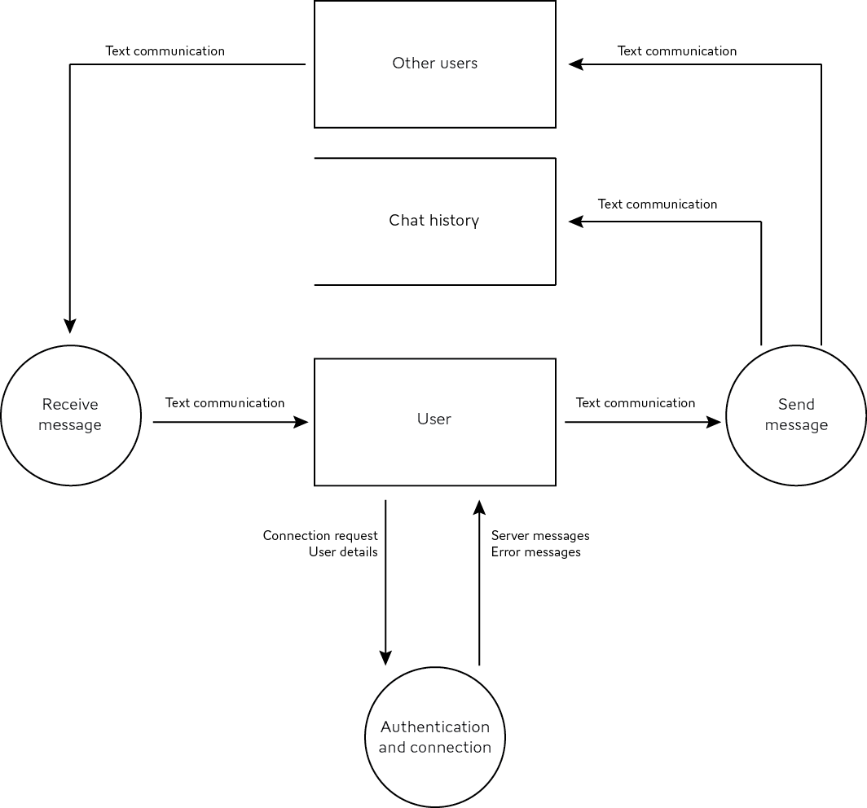

understanding the problem

# social and ethical considerations

Accessibility

One of the disadvantages of IRC is its relative unfriendliness to new users. The myriad of IRC commands that users need to know in order to use IRC, such as those for setting nicknames and joining and leaving chat rooms, is a major factor in restricting the popularity and widespread use of IRC, particularly with the majority of IRC clients which are based in the terminal, which further increases the learning curve of IRC.

r.IRC aims to address this issue through its provision of an IRC client in a modern and intuitive user interface. A system of menus and other window controls allows new users to familiarise themselves with the workings of IRC without having to consult documentation.

As well as this, users with disabilities that affect their inability to operate certain input devices required for general text communication, such as the keyboard, may find themselves unable to use such software. r.IRC makes use of generic window text input controls in order to allow for the operating system and any third-party input modifiers to perform their role in allowing disabled users to utilise aids such as text dictation to input text.

Inclusivity

The main issue concerning inclusivity is that of the divide between seasoned IRC users, who are accustomed to the various IRC commands, and new users, who are unfamiliar with these commands. The former of the two would obviously prefer to retain the method of typing commands into the chat box, whilst the latter might prefer a system of graphical menus and other window controls to replace chat box commands. In order to address both sides of this inclusivity argument, r.IRC is planned to retain the traditional chat box command method, but also include an intuitive system of window controls which users can utilise as an alternative to the former.

Ergonomics

Extended and uninterrupted periods of computer use may result in bodily harm. In this case, ergonomic issues are relevant due to the non-dynamic nature of text on the screen; users may experience eye strain when attempting to decipher words on screen for extended periods of time, particularly if the colour scheme and font used for aforementioned text is not optimised for screen display.

r.IRC recognises that incorrect interfacing may result in adverse effects and that different users have different preferences in regard to their user interface, and thus aims to provide options where users can specify the colour of font and background in order to allow users to set up their own ergonomic environment and best optimise their user experience.

Privacy and security of data

The use of IRC, and indeed any other text-based messaging system, is the intrinsic threat of other individuals searching through chat history and logs, whether obtained through legitimate means or not, and using this data for their own purposes. Whilst the recording and storage of chat history and logs is a necessity to ensure the correct operation of the system, the insufficient security of these may allow the aforementioned to occur.

r.IRC aims to minimise the threat of this through allowing users to specify the length of history to store, as well as only storing history on users’ local machines to minimise the incentive to attack IRC servers and thus to minimise the threat to and burden upon IRC server owners. However, it must be noted that these measures are not enough to ensure the continued privacy and security of user data, and users are encouraged to abstain from communicating sensitive and personal data using an unsecured electronic medium such as IRC, but rather through either encrypted means, non-electronic encrypted means, or simply not at all.

# gantt chart



# screen design

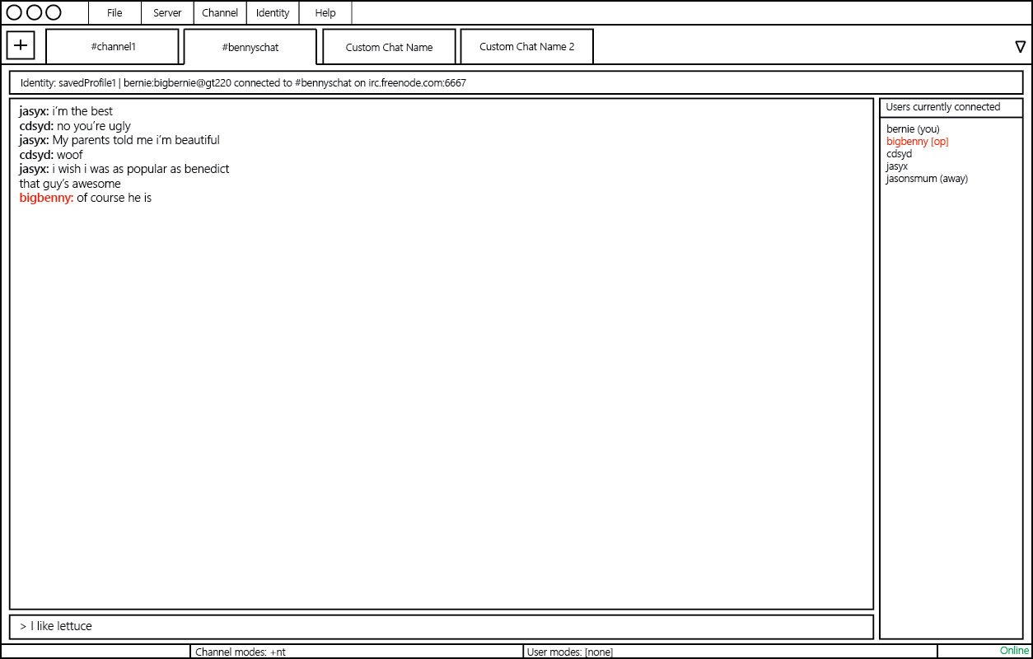

# storyboard

