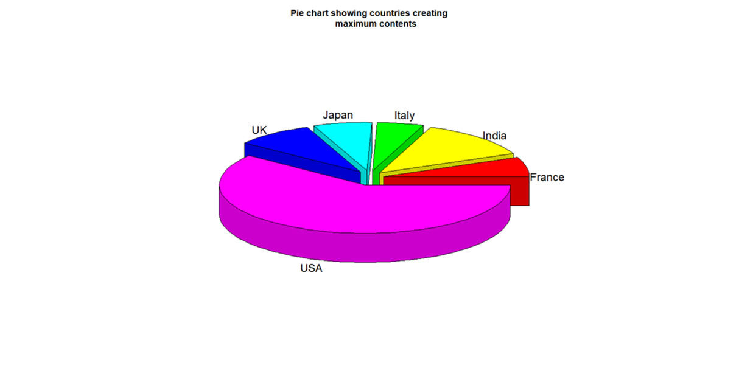

From the above graph we understand or infer that among all the countries mentioned in the IMDB dataset, we are able to see these six countries that is USA, UK, Japan, Italy, India and France are the ones making maximum no of films since the earliest days, and USA accounts to almost more than 50% of the films made, making it the largest country in the world with respect to Production and creation of Movies and films.

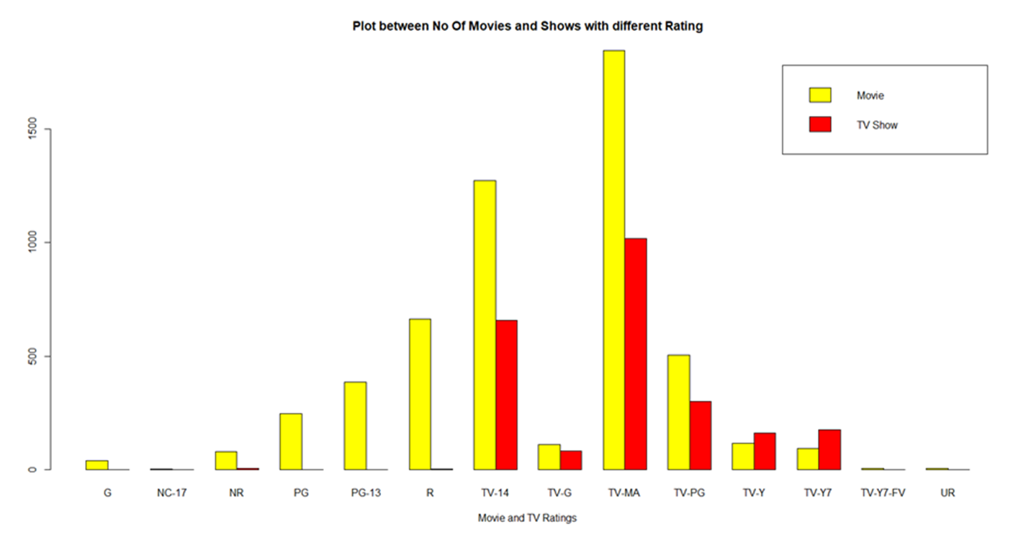

From this graph it was taken was from the Netflix dataset, where we can understand the count of Movies or TV shows are having what rating, this could let us know to segregate for

Conclusion:

So, from the above plots we have performed Exploratory data analysis on IMDB and Netflix dataset, which had wide variety of columns giving us lot of insights about what content people prefer to watch in which region, and the most preferred genres and most voted writers in their region and also have visualized the various OTT platform for their performance with IMDB ratings and from the plots we have concluded that “Netflix” is the currently best OTT platform in terms of producing more number of good quality content as compared to Amazon prime, Hulu or Disney+. Apart from the inbuilt plotting and various plotting library that is used in RStudio we have also used Microsoft Excel and Tableau; the data pre-processing was done in R and then later the tools mentioned above were used for plotting and data visualization.

Future Works:

1. In this project we have analysed and visualized the data from IMDB and Netflix dataset, so from this we can expand the base of our project to not just data visualization but to make movie or series recommender systems.
2. Collaborative filtering (CF) is a technique used by [recommender systems](https://en.wikipedia.org/wiki/Recommender_system). Collaborative filtering has two senses, a narrow one and a more general one. In the newer, narrower sense, collaborative filtering is a method of making automatic [predictions](https://en.wikipedia.org/wiki/Prediction) (filtering) about the interests of a [user](https://en.wikipedia.org/wiki/End_user) by collecting preferences or [taste](https://en.wikipedia.org/wiki/Taste_(sociology)) information from [many users](https://en.wikipedia.org/wiki/Crowdsourcing) (collaborating).
3. In our current data we have wide variety of information ranging from most voted writers to the watch genres and also ratings for various genres, so keeping in mind with all this data, we can make a application where in a user could enter his/her preferences and the application could recommend a movie or tv show of their liking.
4. The application can also store the previously entered data and when the user opens the application to recommend new content based on the previously known data, this task can be achieved by applying Reinforcement Learning.