Machine Learning Fundamentals Lab-1

# Name: Gaurav Prasanna

# Reg No: 19BEC1315

**Aim:**

1. To read in dataset in format of csv file and visualize the data using Pandas and Matplotlib libraries.
2. To show and understand different Performance measures for knowing how well a model performs for the given dataset.

**Software Required:**

1. Anaconda Navigator
2. Jupyter Notebook

**Libraries Required:** Numpy, Sci-kit Learn, Pandas, Matplotlib

**Code And Outputs: Part a)**

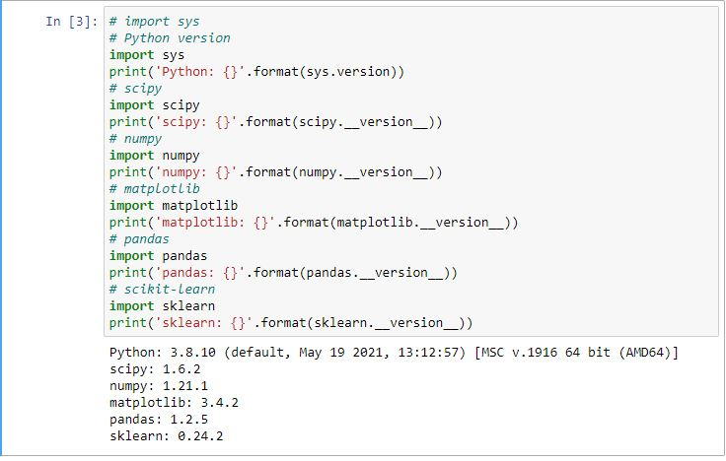

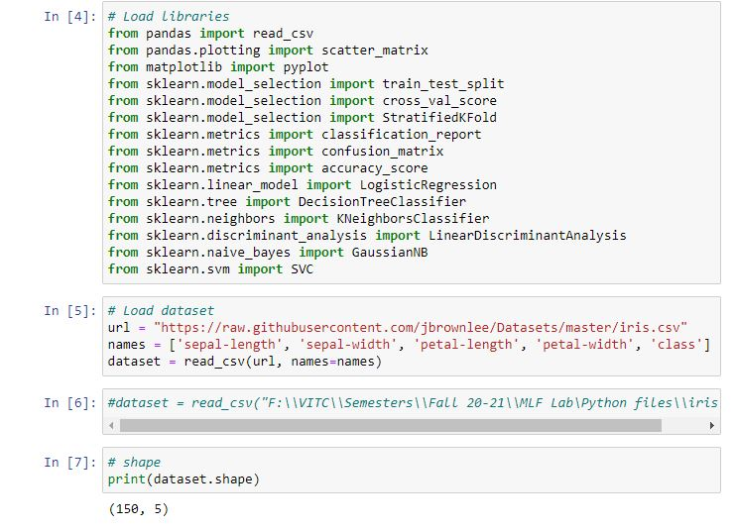

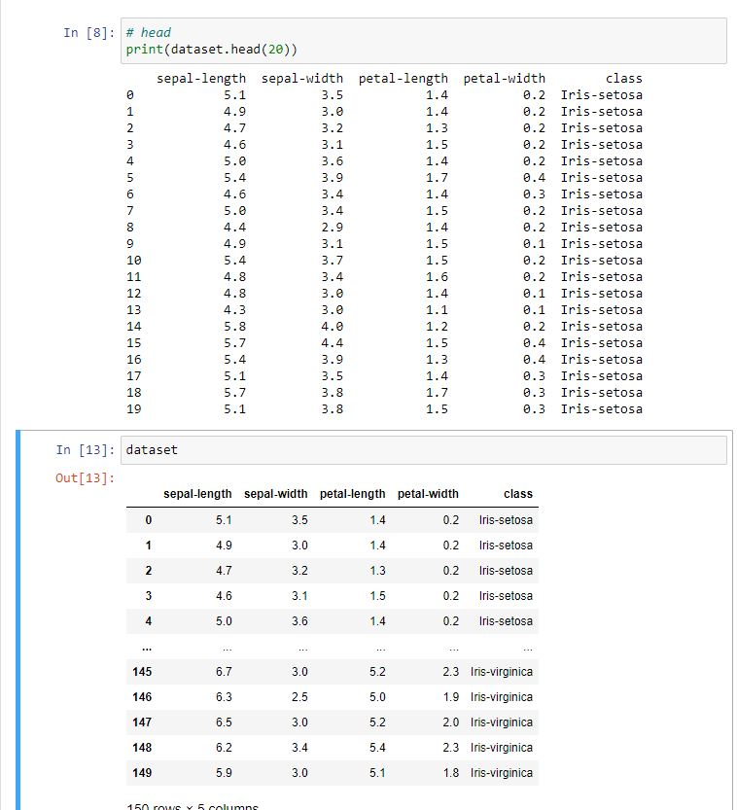

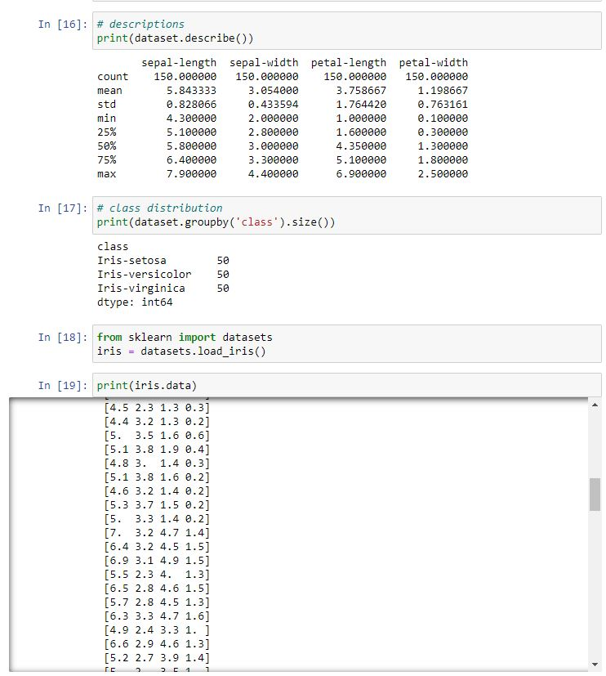

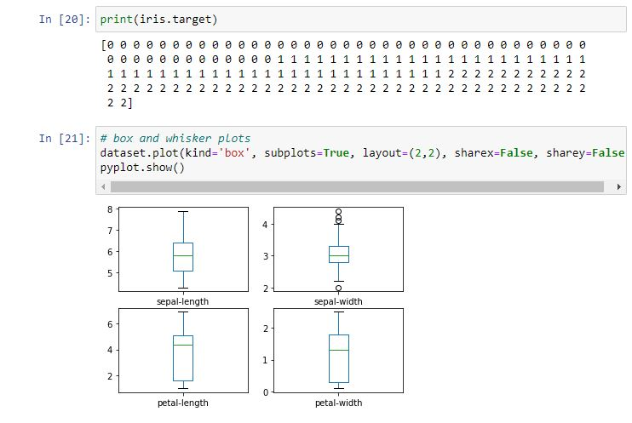

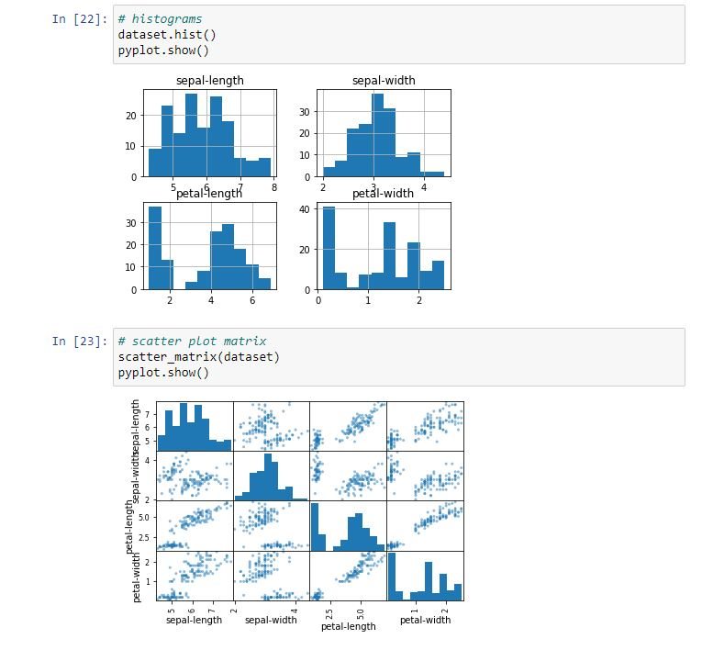

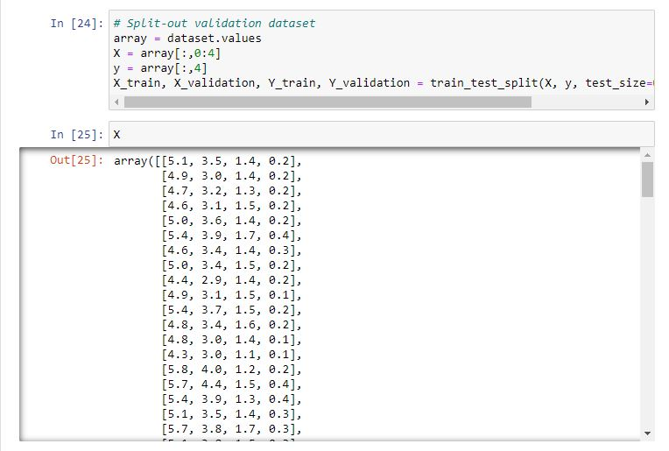

**Part b)**

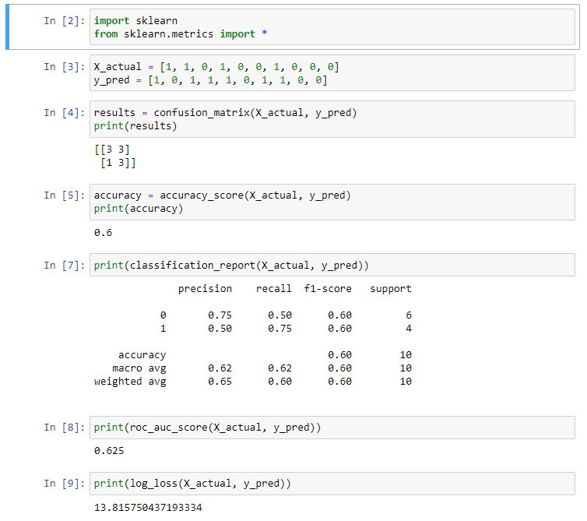

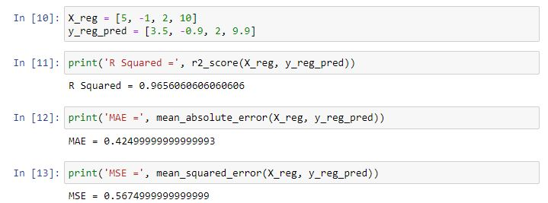

**Inference:** So from the above code, we have imported the required libraries for performing various functionalities, for the first part we read in the iris dataset as csv file using pd.read_csv a function in pandas library and using scatter plot function in pandas and pyplot function in matplotlib to visualize the dataset. In next part we have used sci-kit learn to understand about various performance measures, these measures helps us to understand how well a model works with different measures.

**Result:** All the code and output have been executed and shown for the respective cells in jupyter notebook and calculated performance measures are also shown.