Machine Learning Fundamentals Lab-2

# Name: Gaurav Prasanna

# Reg No: 19BEC1315

**Aim:**

1. To show Logistic Regression without using sci-kit learn and using the inbuilt formula and using matplotlib to visualize the regression lines.
2. Using sci-kit learn library of logistic Regression for array data using numpy.
3. Using sci-kit learn to use the Logistic Regression library and the using the metrics from scikit learn to evaluate and then plotting to visualize.( Using 50-startups dataset)

**Software Required:**

1. Ananconda Navigator
2. Jupyter Notebook

**Libraries Required:** Numpy, Matplotlib, Scik-kit learn, Pandas

**Code and Outputs:**

1. Logistic Regression Mathematically:

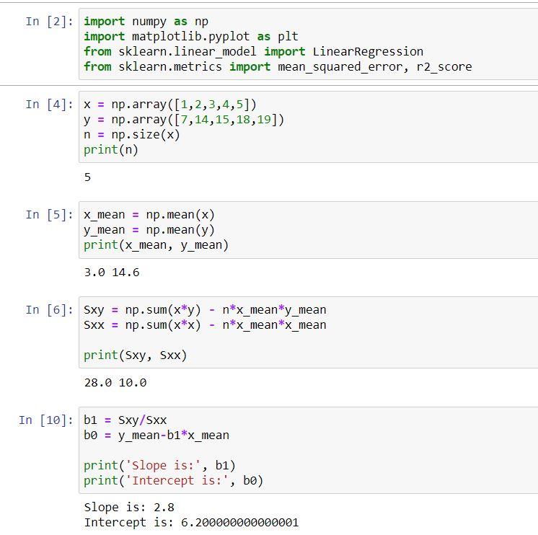

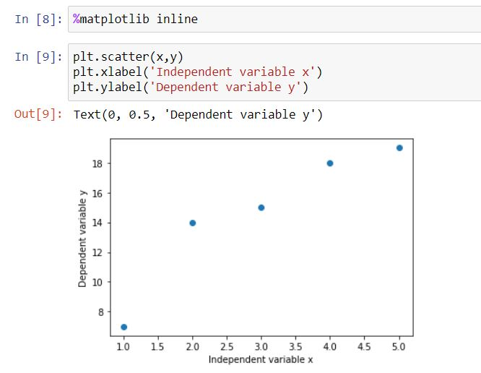

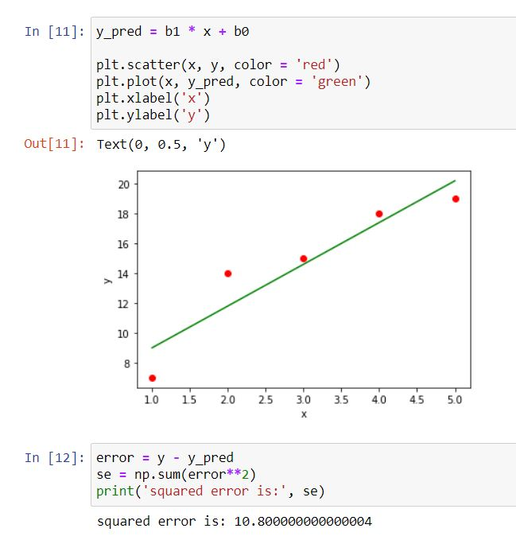

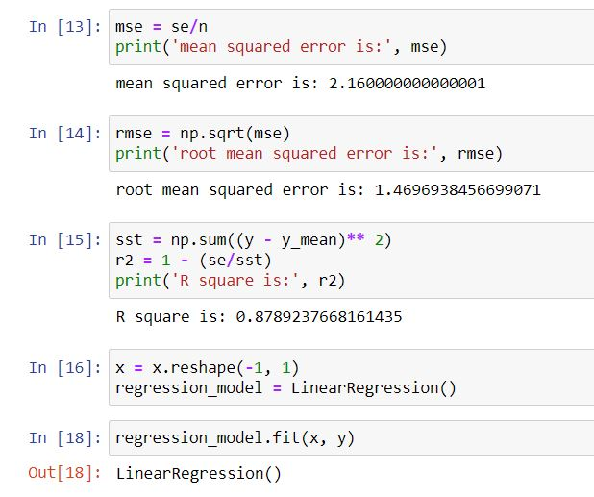

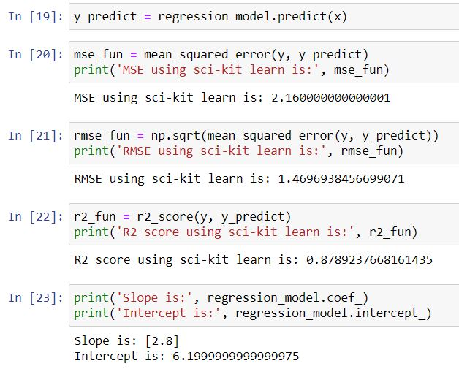

1. Logistic Regression for Numpy array fitting and Predicting:

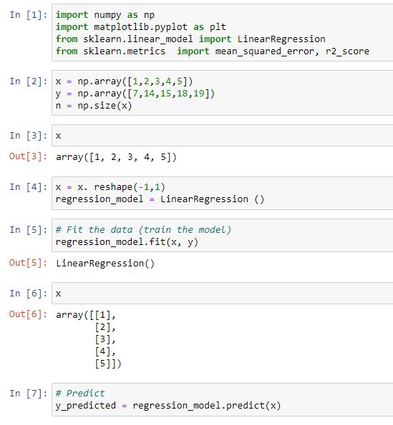

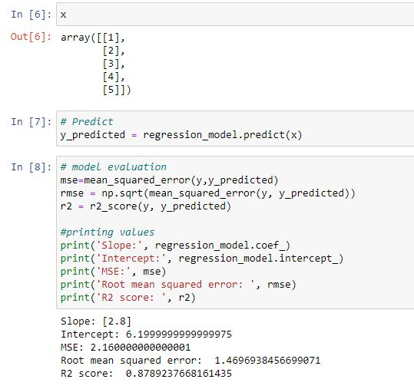

1. Logistic Regression using Sci-kit learn and 50 startups dataset:

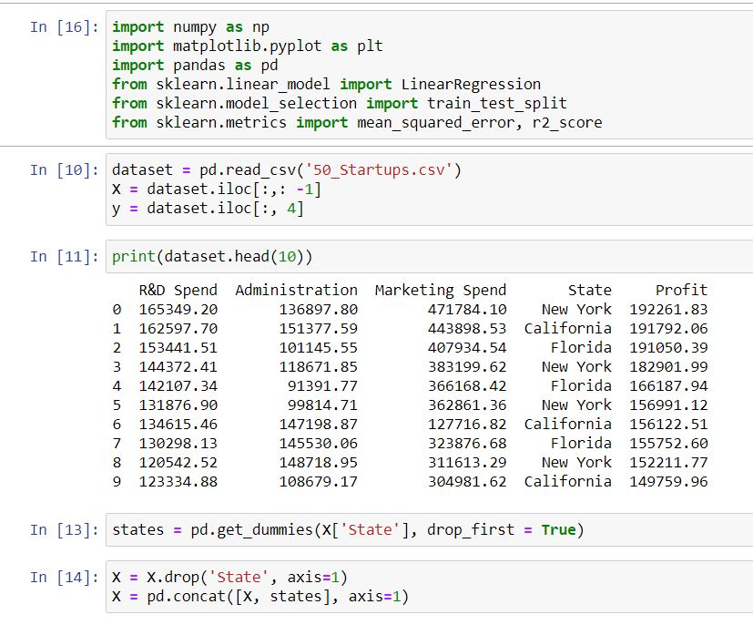

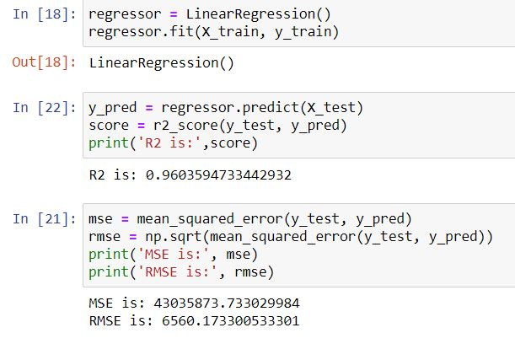

**Inference:**

So from the above two parts, we understand logistic regression mathematically by implementing the mathematical logic in the code and in the second part we have used in the inbuilt libraries using scikit learn and various metrics and the graphs are visualized using matplotlib.

**Results:**

Logistic Regression is proved and the metrics scored are verified both theortically and the graphs are visualized and plotted using matplotlib.