Machine Learning Fundamentals- Lab-3

# Name: Gaurav Prasanna

# Reg No: 19BEC1315

**Aim:**

1. To show Data cleaning method with the help Numpy library and visualizing using Matplotlib with oil-spill dataset.
2. To show Data Duplication using Pandas library for Iris dataset.

**Software Required:**

1. Anaconda Navigator
2. Jupyter Notebook

**Libraries Required:** Numpy, Pandas, Matplotlib

**Code and Outputs:**

1. **Data Cleaning using oil-spill dataset**

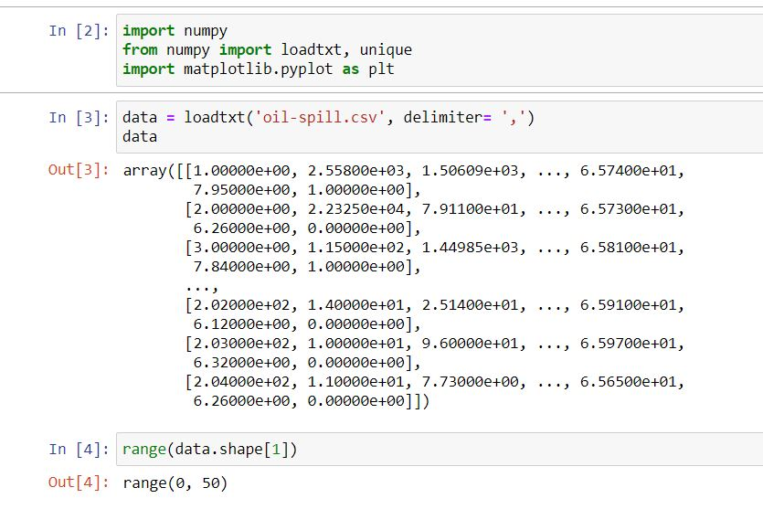

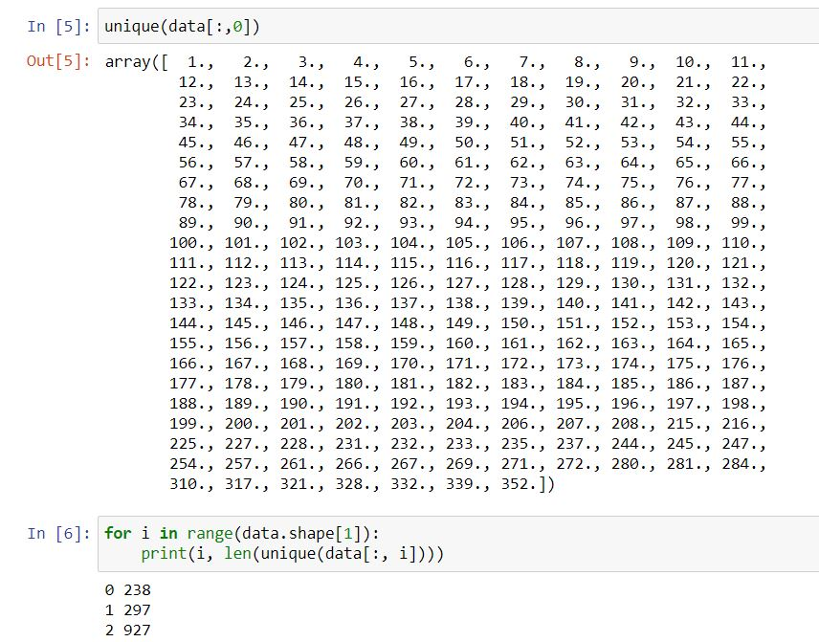

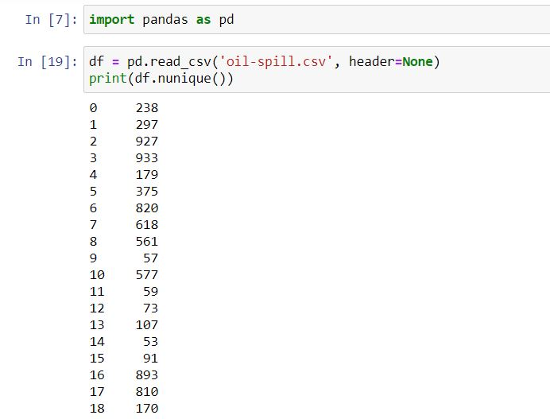

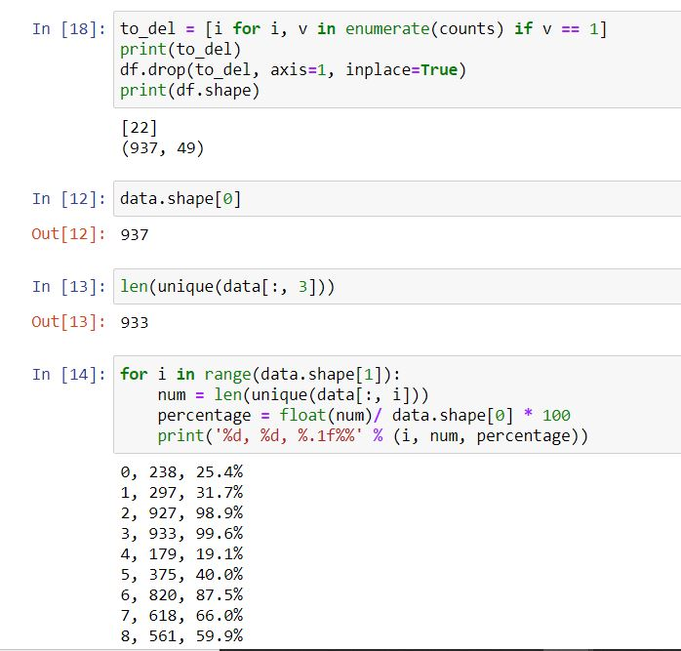

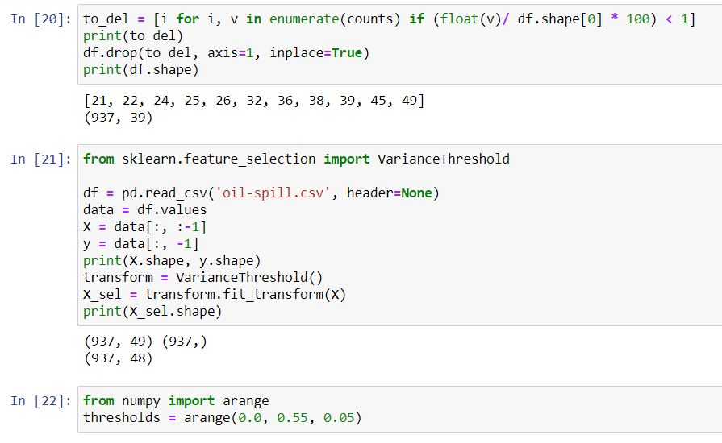

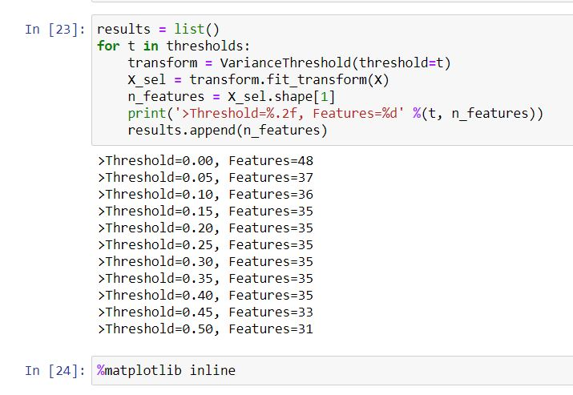

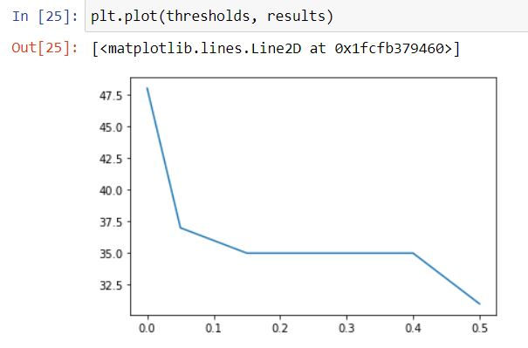

1. **Data Duplication in Iris Dataset**

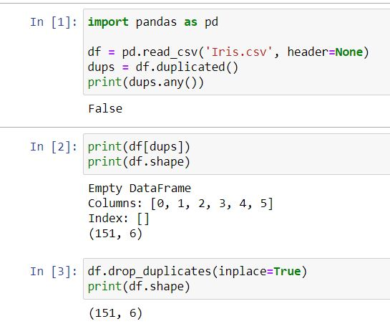

**Inference:** So from the above two parts we understand the data cleaning and duplication using Numpy and Pandas, so various dataset to do necessary operations needed for data before building a machine learning model.

**Result:** Data cleaning and duplication is shown and visualized using different libraries in Jupyter Notebook.