Machine Learning Fundamentals – Lab-4

# Name: Gaurav Prasanna

# Reg No: 19BEC1315

**Aim:**

1. To show Gradient Descent and achieve the Global minimum from scratch.
2. To implement and visualize Logistic Regression on digits dataset using sci-kit learn library.
3. To implement and visualize Logistic Regression on given dataset from scratch without any inbuilt libraries or functions.

**Software Required:**

1. Anaconda Navigator
2. Jupyter Notebook

**Libraries Required:** Scikit-Learn, Pandas, Numpy, Matplotlib

**Codes and Outputs:**

1. **Gradient Descent:**

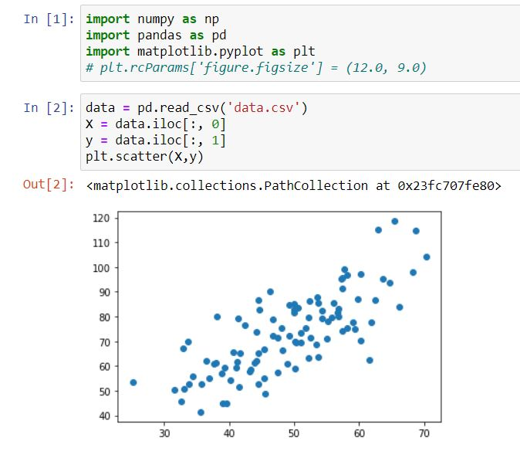

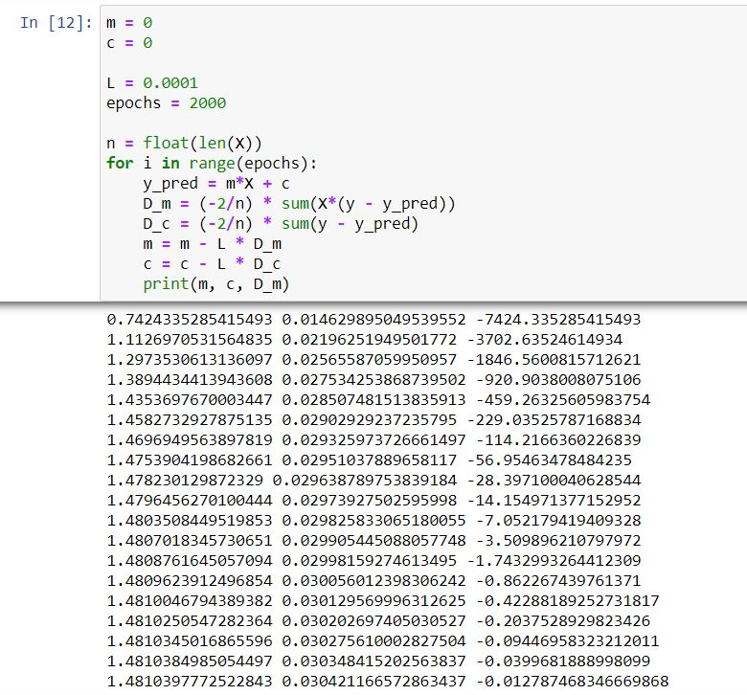

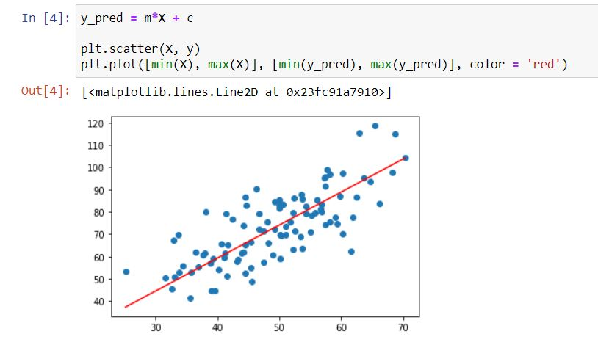

1. **Logistic Regression Using Scikit-Learn**

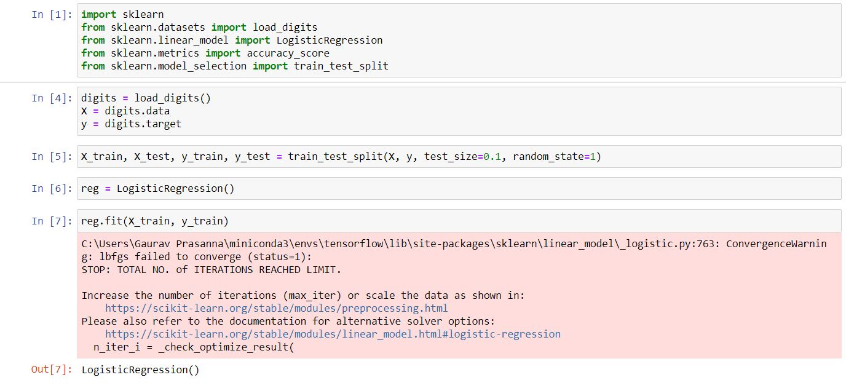

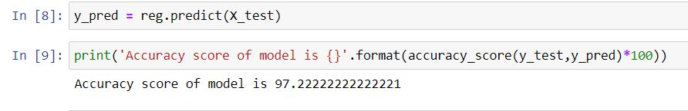

1. **Logistic Regression from Scratch**

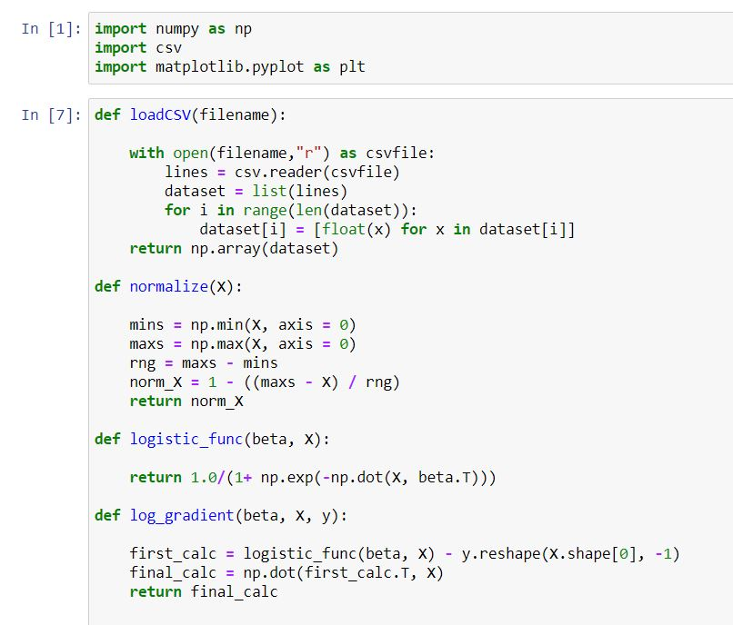

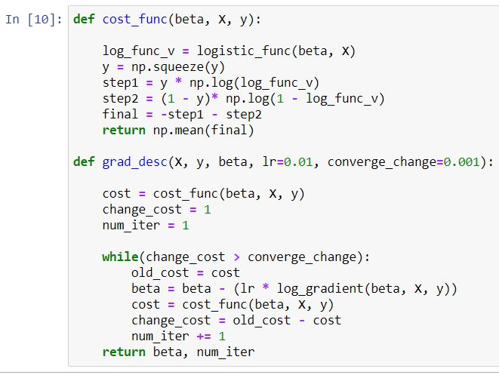

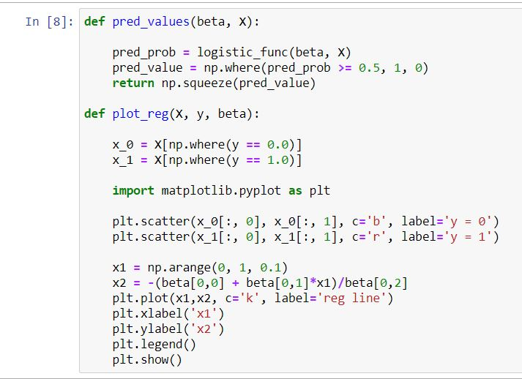

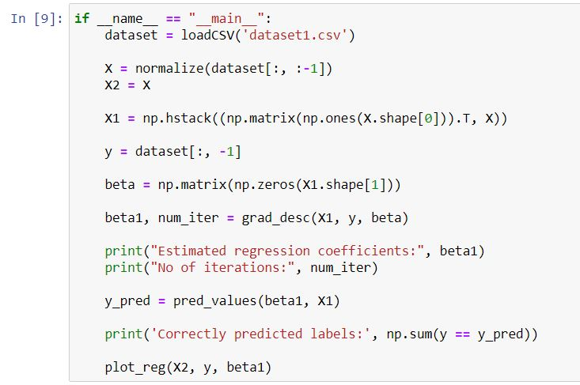

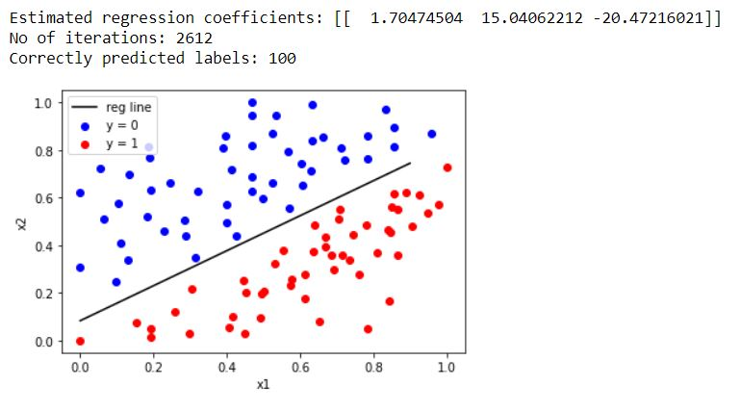

**Inference:** So, from the first part we understand gradient descent and how it approaches the global minimum and its variations in changing the learning rate or tweaking it and also varying the number of epochs. In the second part we import the digits dataset from scikit-learn library and using the inbuilt package of Logistic Regression is performed using the same and the accuracy score is calculated. And from the final part we implement the logistic regression from scratch by writing functions for each operation and to compute the regression coefficients and to finally visualize it using Matplotlib.

**Result:** Gradient Descent, Logistic Regression using Scikit-Learn and also implementing from scratch is shown and visualized using in Jupyter Notebook.