Machine Learning Fundamentals Lab-7

# Name: Gaurav Prasanna

# Reg No: 19BEC1315

**Aim:**

1. To implement KNN algorithm on abalone dataset and find out the required predictions.
2. To implement KNN algorithm on same data as above and find the loss using mean squared error.

**Software Required:**

1. Jupyter Notebook
2. Anaconda Navigator

**Libraries Required:** Numpy, Matplotlib, Sci-kit Learn, Pandas.

**Code and Outputs:**

1. KNN Required Predictions:

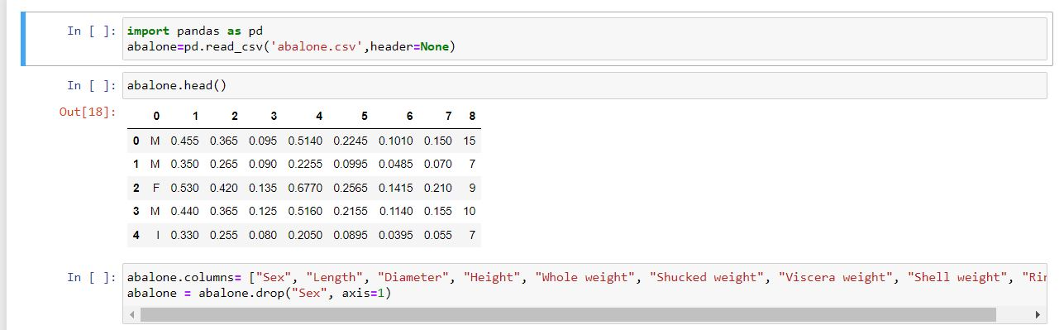

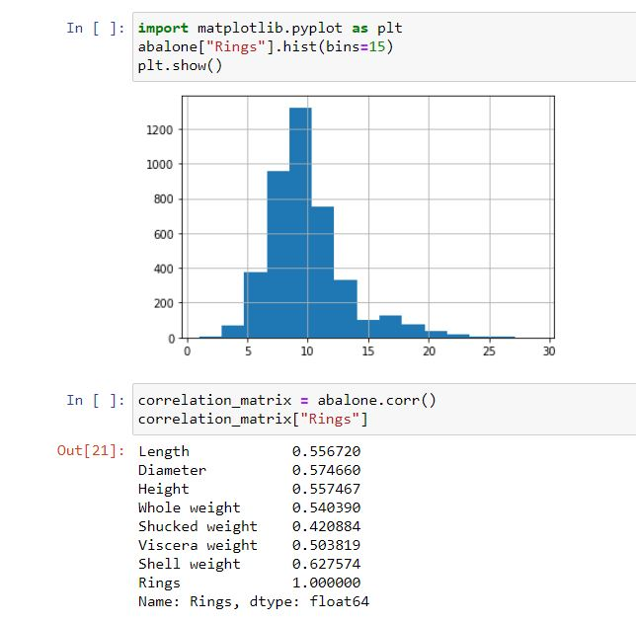

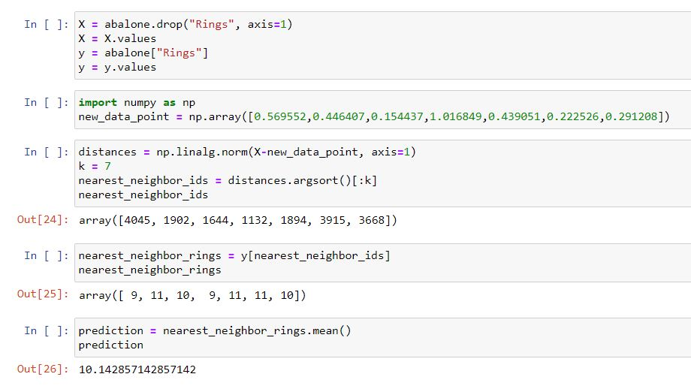

1. KNN Algorithm Loss:

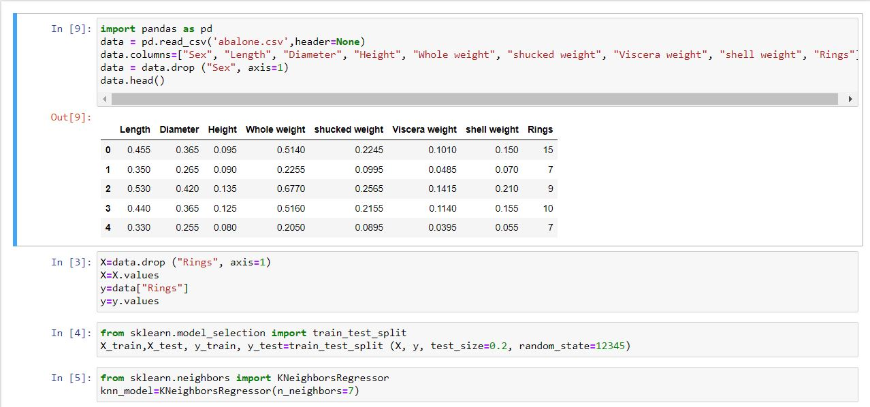

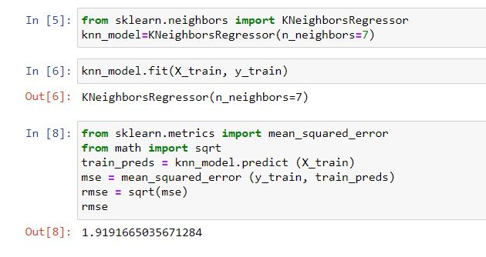

**Inference:** KNN is a type of [classification](https://en.wikipedia.org/wiki/Classification) where the function is only approximated locally and all computation is deferred until function evaluation. Since this algorithm relies on distance for classification, if the features represent different physical units or come in vastly different scales then [normalizing](https://en.wikipedia.org/wiki/Normalization_(statistics)) the training data can improve its accuracy dramatically.

**Result:** KNN is implemented and visualized using Jupyter notebook and the required plots are shown.