Machine Learning Fundamentals Lab-8

# Name: Gaurav Prasanna

# Reg No: 19BEC1315

**Aim:**

1. To implement and understand the Support Vector Machine or SVM algorithm on inbuilt dataset in scikit learn of Breast Cancer.
2. To implement SVM algorithm on Iris dataset using different kernels and to inspect the changes in accuracies.
3. To implement and visualize the hyperplane of SCM in 3d scatter plot using Axes3d package from mpl_toolkits library.

**Software Required:**

1. Jupyter Notebook
2. Anaconda Navigator

**Libraries Required:** Numpy, Matplotlib, Sci-kit Learn, Pandas, mpl_toolkits.

**Code and Outputs:**

1. SVM on Breast Cancer:

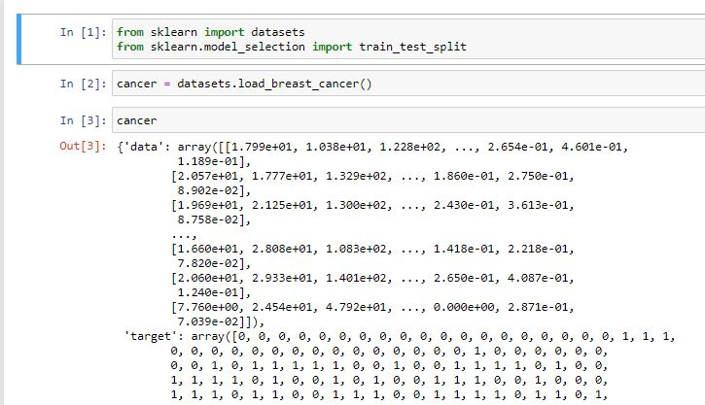

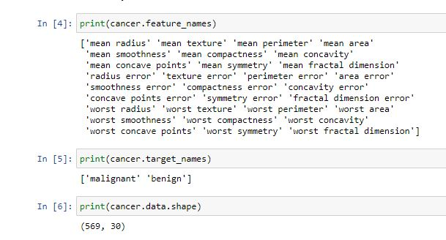

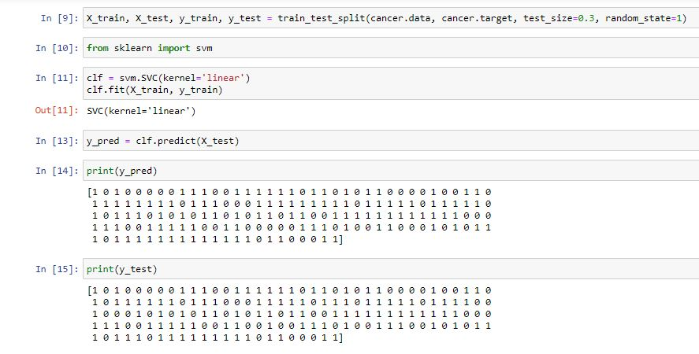

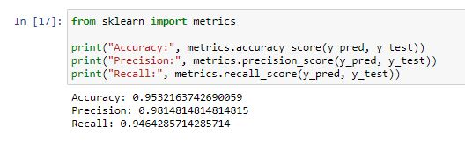

1. SVM on Iris Dataset with different Kernels:

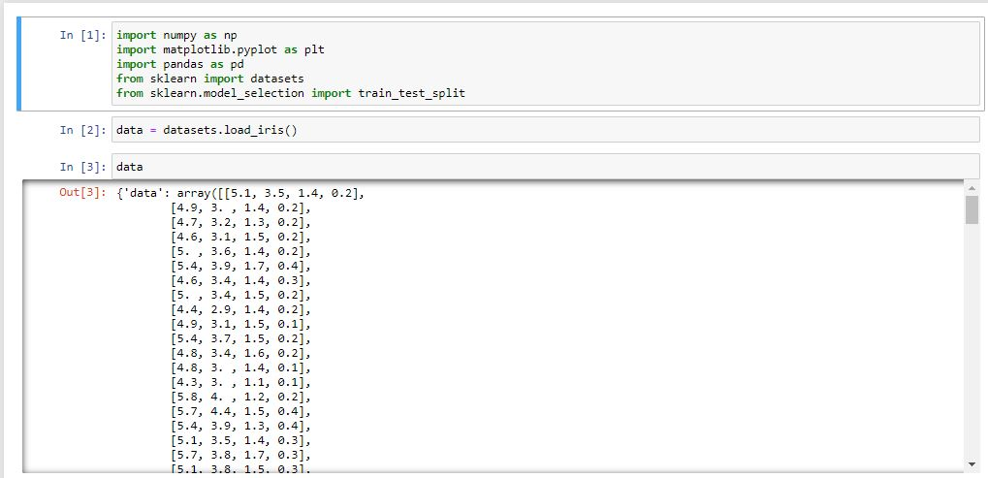

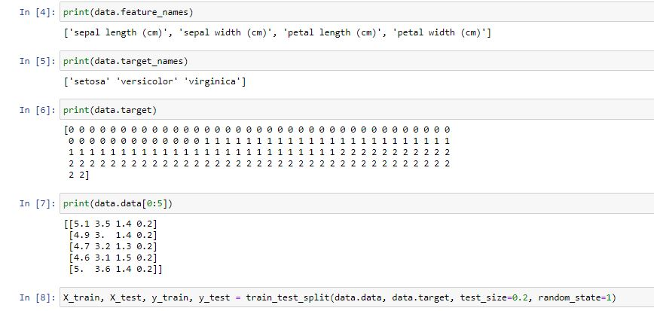

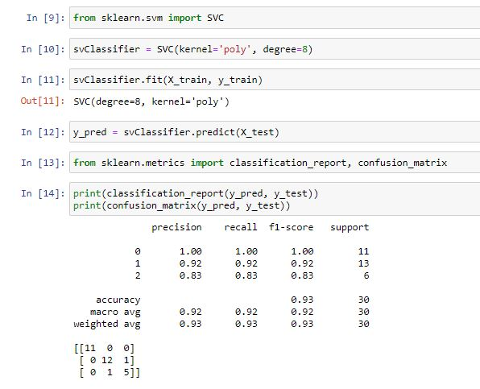

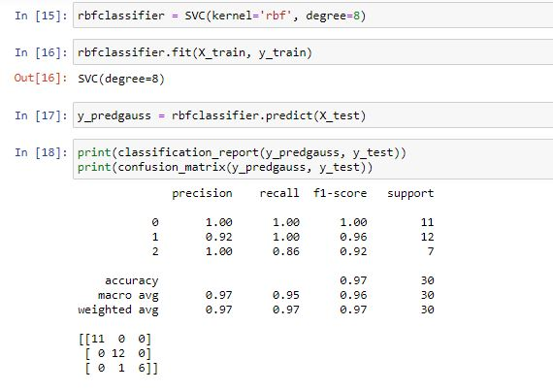

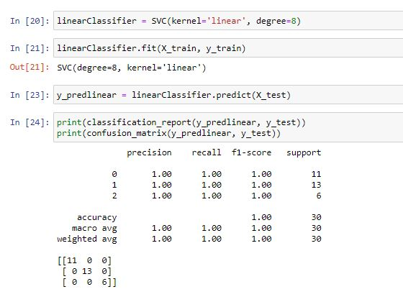

1. Visualizing 3d Scatterplot and Hyperplane

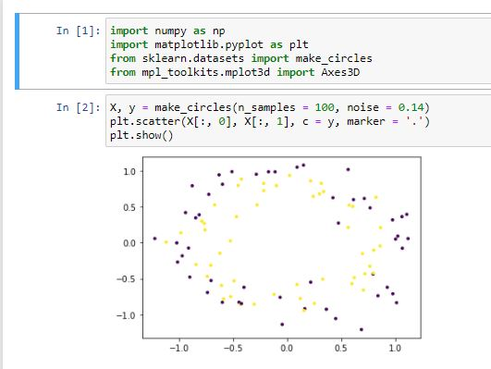

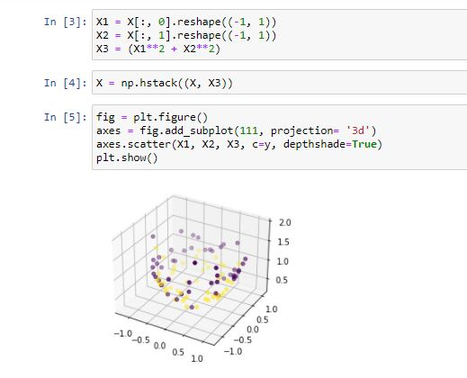

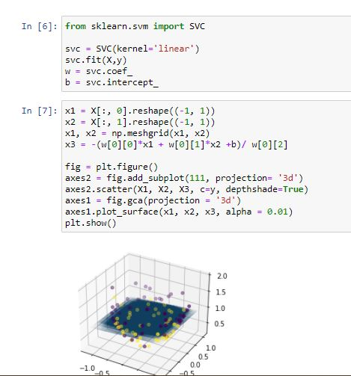

**Inference:**

1. From first we infer that the SVM is a good classification algorithm for breast cancer dataset, while using linear kernel we achieve accuracy of about 95.3%.
2. From second we can infer that the with different kernels such as polynomial, gaussian and linear how the accuracy and various other metrics vary and which hyperparameter works best with the given dataset.
3. From the third one, we can infer and visualize the plot of hyperplane and how it divides the axis, and its through 3d scatterplot. Helps us to understand how SVM works even better.

**Result:** SVM on Breast cancer , iris dataset is implemented and Hyperplane is visualized using Jupyter notebook and the required plots are shown.