Machine Learning Fundamentals Lab-9

# Name: Gaurav Prasanna

# Reg No: 19BEC1315

**Aim:**

1. To implement K Means Clustering Algorithm on given dataset and predict the outcomes without support of classes or labels.
2. To implement, find the centroids of clusters and to plot them.

**Software Required:**

1. Jupyter Notebook
2. Anaconda Navigator

**Libraries Required:** Numpy, Matplotlib, Seaborn, Sci-kit Learn, Pandas

**Code and Outputs:**

1. Train Ticket Dataset K Means

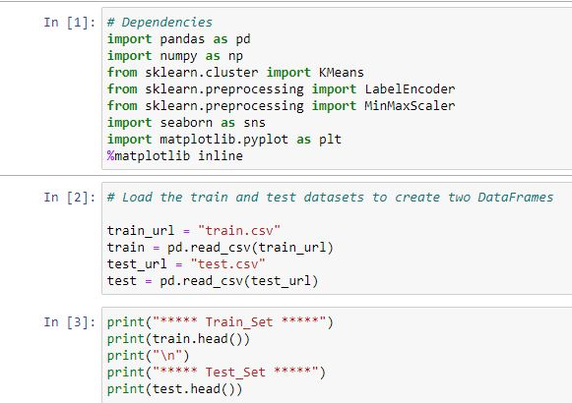

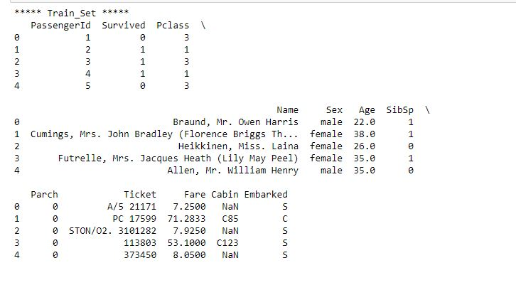

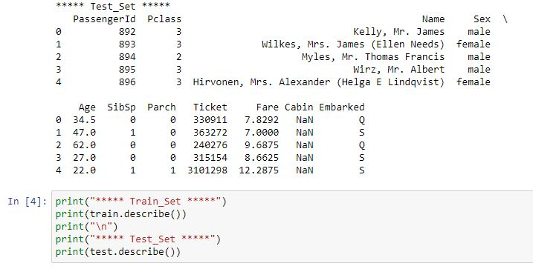

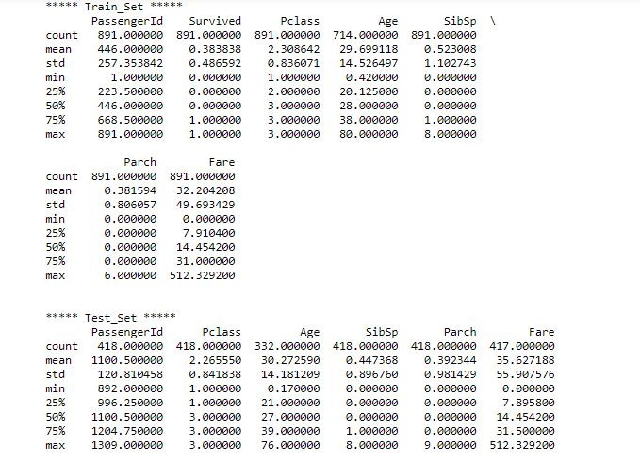

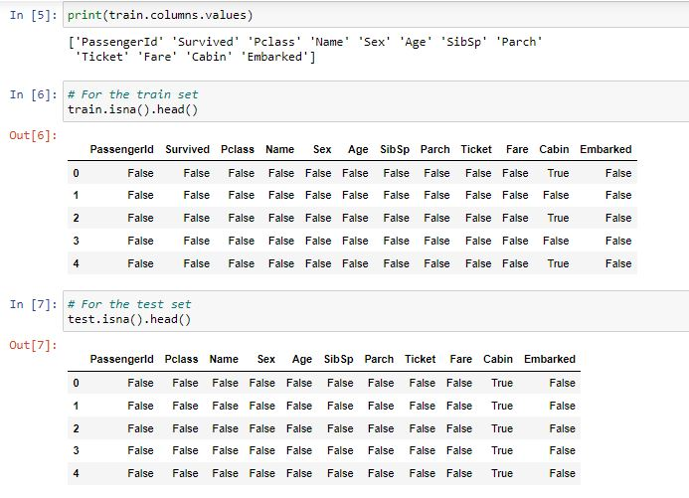

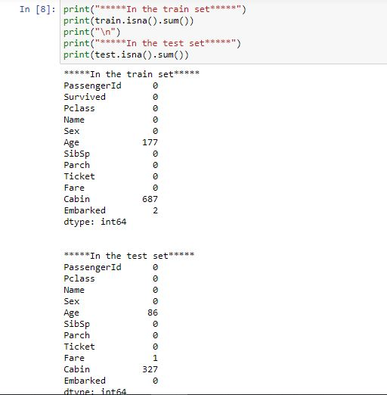

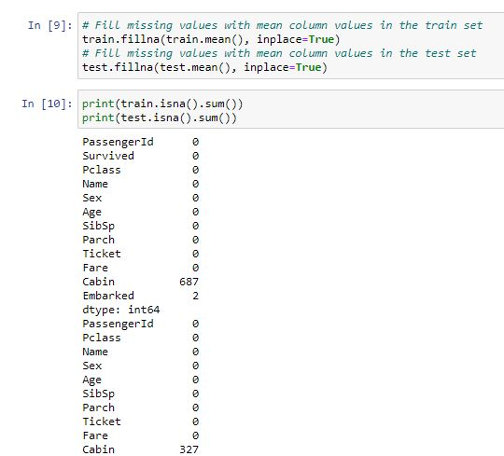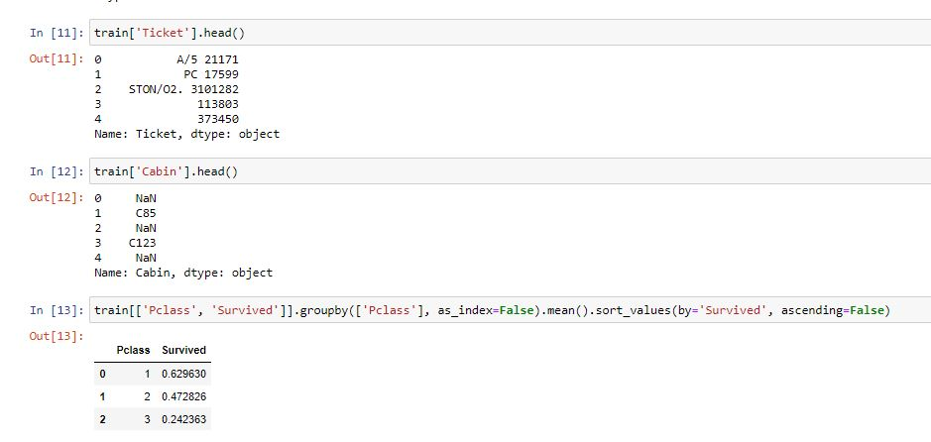

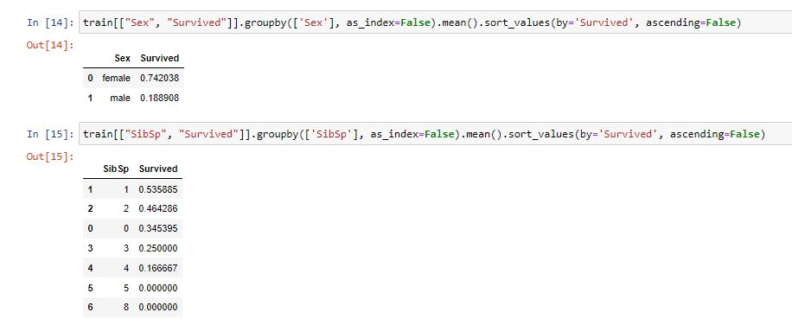

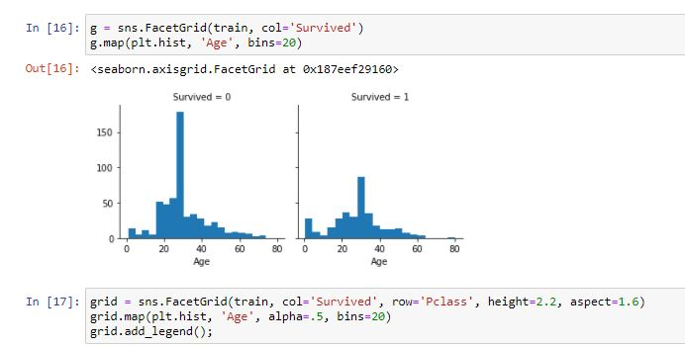

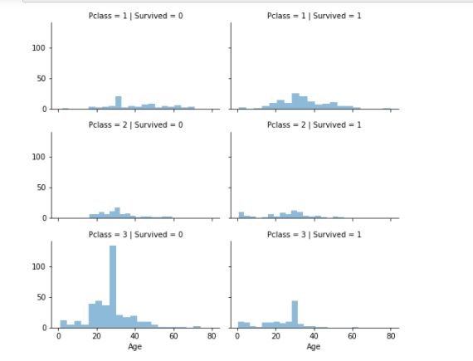

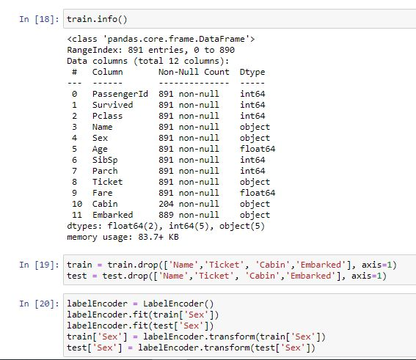

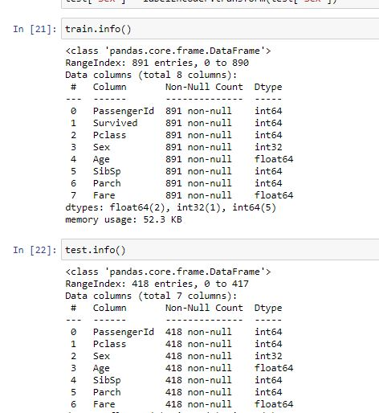

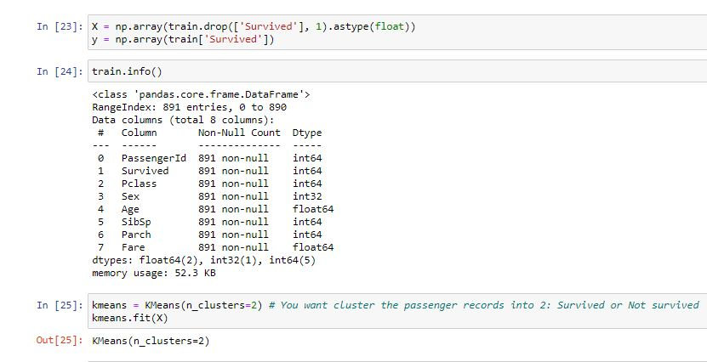

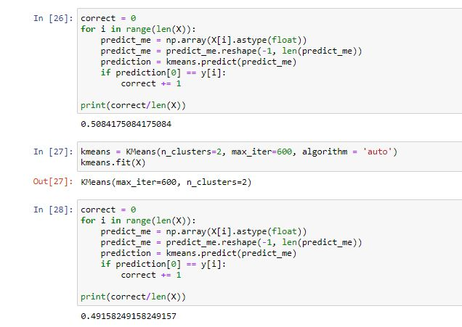

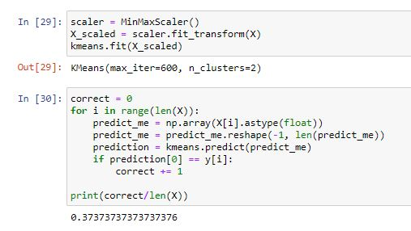

1. Cluster Centroids

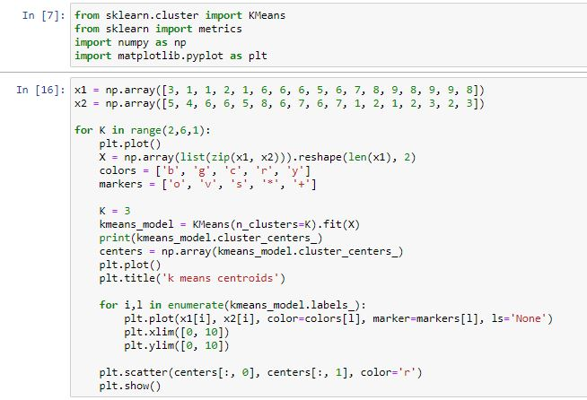

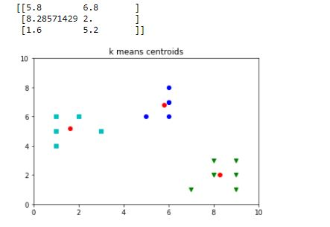

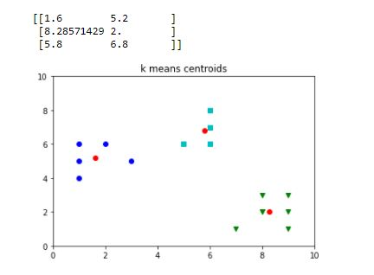

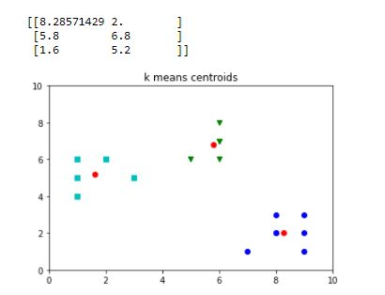

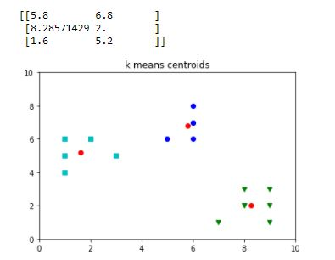

**Inference:**

1. From the first one we infer that K means clustering is an unsupervised learning algorithm and it can be used in classifying the classes without labels by looking into the features, and even the prediction along with accuracy of predictions is given.
2. From second one we see the plot of centroids has the value of K changes from 2 to 6.

**Result:** K Means on train tickets dataset is implemented and the required plots are visualized using Jupyter notebook.