
CA-2(internship project)
Topic: “plc program to maintain the pressure head in a bottle filling system”

School of Electronics and Electrical
Engineering
Course Code: petv144
Submitted by:
Anshu Chauhan [12400852]
Roll No: 08
Section: 9PV40, G1
Submitted to: Dr. Harpreet singh bedi

TABLE OF CONTENTS

S. No. | Contents
1 | Introduction
2 | PLC Input/Output Table
3 | Ladder Diagram
4 | System Working with Flow Chart
5 | Simulation Results
6 | Applications
7 | Conclusion and Future Scope

1. Introduction
Programmable Logic Controllers (PLCs) are widely used in industrial automation because they can control machines and processes automatically, reliably, and efficiently. A PLC uses input signals from sensors and switches, processes them according to a programmed logic, and controls output devices such as motors, pumps, and valves.
This project presents a PLC-based bottle filling system with pressure-head control. The system is designed to automatically control the movement of bottles, filling operation, and liquid pressure using a ladder logic program. The complete system is simulated using LogixPro 500 PLC Simulator.
In the proposed system, a conveyor motor transports the bottle to the filling station. When the bottle sensor detects the bottle, the conveyor stops and the filling valve is activated. A timer controls the filling duration. In this project, the filling timer is set with a 0.1-second time base and a preset value of 50, resulting in a filling time of 5 seconds.
The pressure head is maintained using pressure sensors. When the pressure becomes low, the pump is activated. The pump continues to operate until the normal pressure level is reached. When normal pressure is detected, the pump is switched OFF. This provides automatic pressure control during the bottle filling process.
The project demonstrates the use of PLC ladder logic, timers, internal memory bits, sensors, motor control, valve control, and pump control in an industrial automation application.

Objectives
- To design a PLC-based automatic bottle filling system.
- To control the conveyor motor using a bottle detection sensor.
- To control the filling valve using a PLC timer.
- To maintain the required pressure head using a pump.
- To develop and test the ladder logic program using LogixPro 500 Simulator.
- To understand the practical application of PLCs in industrial automation.

2. PLC Input and Output Assignment
The following table shows the input and output addresses used in the PLC ladder logic program.

Input Table
Address | Input Device | Function
I:1/0 | START Push Button | Starts the complete system
I:1/1 | STOP Push Button | Stops the complete system
I:1/2 | Bottle Sensor | Detects the presence of a bottle
I:1/3 | Low Pressure Sensor | Detects low pressure condition
I:1/4 | Normal Pressure Sensor | Detects normal pressure condition

Output Table
Address | Output Device | Function
O:2/0 | System ON | Indicates that the system is running
O:2/1 | Conveyor Motor | Moves bottles to and from the filling station
O:2/2 | Filling Valve | Controls the flow of liquid into the bottle
O:2/3 | Pump Motor | Increases the pressure head when pressure is low

Internal Memory and Timer
Address | Type | Function
B3:0/0 | Internal Bit | Indicates filling cycle completion
B3:0/1 | Internal Bit | Pump run command
T4:0 | Timer | Controls filling duration

Timer Settings
- Timer Address: T4:0
- Time Base: 0.1 seconds
- Preset Value: 50
- Total Filling Time: 50 × 0.1 = 5 seconds

3. PLC Ladder Logic Program
The ladder diagram was developed and simulated using LogixPro 500 Simulator.
The ladder program consists of the following major control sections:
- Start/Stop Control:
A seal-in circuit is used to keep the system ON after the START button is released. The STOP button is used to turn the system OFF.
- Conveyor Control:
The conveyor motor runs when the system is ON and no bottle is detected. When the bottle sensor detects a bottle, the conveyor stops.
- Filling Control:
The bottle sensor activates the filling timer. The filling valve remains ON while the timer is running.
- Timer Control:
Timer T4:0 controls the filling duration. With a time base of 0.1 seconds and a preset of 50, the filling time is 5 seconds.
- Pressure Control:
When low pressure is detected, the pump is activated. When normal pressure is reached, the pump is switched OFF.

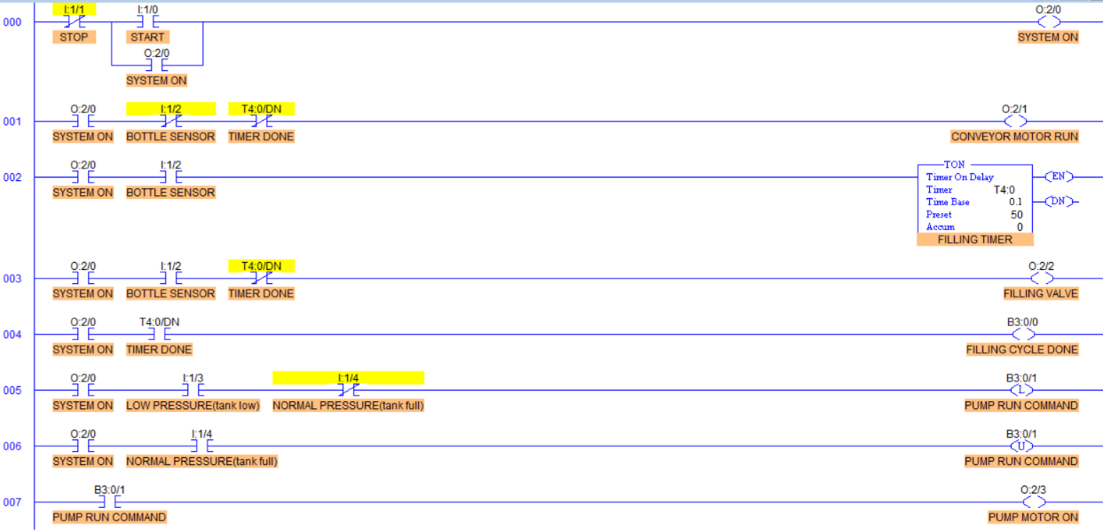

4. System Working
The system begins when the operator presses the START push button. The PLC activates the system and starts the conveyor motor. The conveyor transports the bottle towards the filling station.
When the bottle sensor detects the presence of a bottle, the conveyor stops. The PLC then activates the filling valve and starts the filling timer.
The timer is programmed for 5 seconds. During this time, the filling valve remains ON and liquid flows into the bottle. After 5 seconds, the timer reaches its preset value and its Done bit becomes active. The filling valve then turns OFF.
When the bottle leaves the filling station and the bottle sensor becomes OFF, the conveyor motor starts again and transports the filled bottle away from the station.
At the same time, the pressure control system operates independently. When the pressure becomes low, the low-pressure sensor activates the pump. The pump increases the pressure head. When normal pressure is reached, the normal-pressure sensor activates the reset logic and the pump is switched OFF.

Flow Chart
START
↓
Press START Push Button
↓
SYSTEM ON
↓
Is Bottle Detected?
├── NO → Conveyor Motor ON
│ ↓
│ Continue Moving Bottle
│
└── YES
↓
Conveyor Motor OFF
↓
Filling Valve ON
↓
Start Timer T4:0
↓
Wait for 5 Seconds
↓
Timer Done
↓
Filling Valve OFF
↓
Bottle Leaves Filling Station
↓
Bottle Sensor OFF
↓
Conveyor Motor ON
↓
Next Bottle

Parallel Pressure Control
LOW PRESSURE DETECTED
↓
PUMP MOTOR ON
↓
PRESSURE INCREASES
↓
NORMAL PRESSURE REACHED
↓
PUMP MOTOR OFF

5. Simulation Results
The PLC program was successfully developed and tested using the LogixPro 500 Simulator. The simulation verified the operation of the automatic bottle filling system and pressure-head control system.

System Start and Conveyor Operation
When the START input (I:1/0) is activated, the system output O:2/0 turns ON and the system starts. When no bottle is detected, the conveyor motor O:2/1 operates. When the bottle sensor I:1/2 detects a bottle, the conveyor stops.
Result: The system start/stop and bottle movement operations were successfully controlled.

Bottle Filling Operation
When the bottle sensor is activated, the filling valve O:2/2 turns ON and timer T4:0 starts.
- Time Base: 0.1 seconds
- Preset Value: 50
- Filling Time: 5 seconds
After the timer reaches its preset value, the filling valve turns OFF automatically.
Result: The bottle filling operation was successfully controlled for 5 seconds.
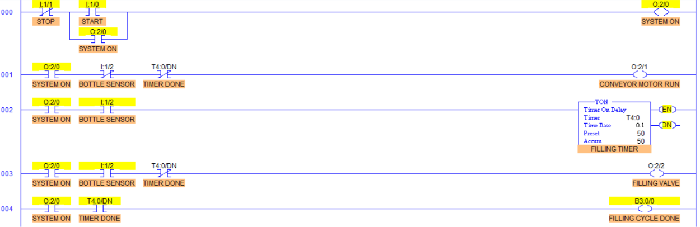

Pressure-Head Control
When the low-pressure sensor I:1/3 is activated, the pump run command B3:0/1 becomes active and the pump motor O:2/3 turns ON. When the normal-pressure sensor I:1/4 is activated, the pump command is reset and the pump motor turns OFF.
Result: The pump was successfully controlled according to the pressure condition.
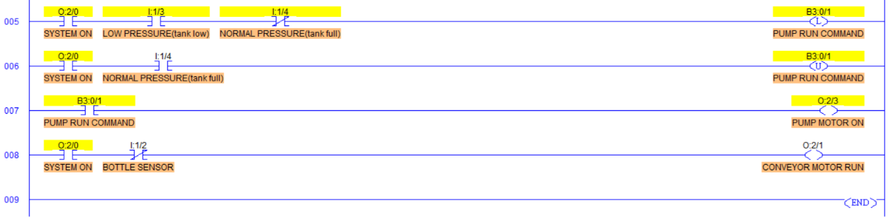

6. Applications
The PLC-based bottle filling and pressure-head control system can be used in various industrial applications.

1. Beverage Industries
The system can be used for filling bottles with soft drinks, juices, mineral water, and other beverages.

2. Water Bottling Plants
Automatic bottle detection, conveyor control, and timed filling are commonly used in water bottling plants.

3. Chemical Industries
The system can be adapted for filling liquid chemicals into containers with controlled pressure and filling time.

4. Pharmaceutical Industries
PLC-based filling systems can be used for controlled filling of liquid medicines and pharmaceutical products.

5. Food Processing Industries
The system can be used for automatic filling of edible oils, sauces, and other liquid food products.

6. Industrial Automation Training
The project is useful for understanding PLC programming, ladder logic, sensors, timers, motors, pumps, and valves.

7. Pressure-Controlled Liquid Systems
The pressure control concept can be applied to liquid storage tanks and pumping systems where maintaining a specific pressure head is important.

7. Conclusion
This project successfully demonstrates the design and simulation of a PLC-based bottle filling system with automatic pressure-head control.
The system automatically controls the complete bottle filling process. The conveyor transports the bottle to the filling station, and the bottle sensor detects its position. After detection, the conveyor stops and the filling valve is activated. A PLC timer controls the filling duration for 5 seconds. After the completion of the filling time, the valve automatically turns OFF.
The pressure head is also controlled automatically using pressure sensors. When the pressure becomes low, the pump motor turns ON. When normal pressure is reached, the pump motor turns OFF. This allows the system to maintain the required pressure condition automatically.
The project provides practical knowledge of PLC ladder logic programming, input/output control, timers, internal memory bits, sensors, motors, pumps, and industrial automation. The complete operation was successfully tested using the LogixPro 500 Simulator.

8. Future Scope
The project can be further improved by adding:
- An HMI for real-time monitoring and control.
- A level sensor for more accurate liquid-level control.
- A pressure transmitter for continuous pressure measurement.
- Automatic bottle counting.
- Emergency stop and safety interlocking systems.
- Multiple filling stations for higher production speed.
- SCADA system for remote monitoring.
- Data logging for production and pressure monitoring.
- Automatic fault detection and alarm systems.
- PLC communication with other industrial devices.

