|  |
| --- |
|  |
|  |
| TalentLink Responsive Apply Component (RAC) Integration Guide |
|  |



Contents

Introduction 3

Delivery File 3

Files included in the zip 3

Editors 3

Head Tag HTML Mark-up 4

Example of Head Tag HTML Mark-up 4

Learn more about Head Tag HTML Mark-up 5

Body Tag HTML Mark-up 6

Example of Body Tag HTML Mark-up 6

Learn more about Body Tag HTML Mark-up 7

Required information for successful integration 8

Launching the new RAC on your site 8

Other useful information 8

Career Site Technical ID 8

JavaScript Disabled Browsers 8

# Introduction

The purpose of this document is to act as a guide on how to correctly integrate the component of **Responsive apply commponent (RAC)** into your site.

Delivery File

The components are delivered in a zip or 7zip file format. The 7zip is highly preferred for security reasons and allows to send attached component by most of the e-mail networks. Before you can access the 7zip files you will need to unzip the file which can be done using the following steps:

1. Download **7zip** (An archiving tool) from the following URL: <http://www.7-zip.org/download.html>
2. Once installed **right click** the zip file and select **Extract All**
3. Select **OK** on the next screen
4. Your files will be extracted into a folder with the same name as the file (For example if the zip file was labelled “**demo.zip**” the folder would be called “**demo**”

Files included in the zip

1. **Apply.html** – it’s the main file of the application
2. **Customer_custom.css** – custom CSS stylesheet that allows you to add own visual customisation
3. **Customer_custom.js** – the JavaScript file that allows to add custom effects to RAC
4. **Favicon.png** - the shortcut icon, typically displayed in the browser's address bar and next to the pages name in a list of bookmarks. You can use included Lumesse TalentLink standard icon or replace it with a custom brands graphic.

Editors

In order to edit any of the component files you will need an editor to do so. Below are some recommended editors.

**Sublime -** This can be downloaded via the following URL:  
<http://www.sublimetext.com/3>

**Notepad++ -** This can be downloaded via the following URL:  
<https://notepad-plus-plus.org/download/v6.7.8.2.html>

# 

# Head Tag HTML Mark-up

Below we explain what construct the head tag of RAC. Please note that it is highly recommended to not removing its components and leave them in the delivered order to let the application work properly.

Example

# 

# 

Learn more about Head Tag HTML Mark-up

The head tag starts with recommended language charset and the **Mobile Specific Meta Tags** (this section contains any Meta tags specific for Mobile optimisation). We recommend to not change this lines.

Below is defined the **title** of the page, typically displayed in the browser's address bar. You can leave the proposed title or change it.

**1. The favicon** – the shortcut icon, you can use standard Lumesse TalentLink icon included in zip file or replace it with your custom icon.

**2.a. Fonts** – here are added the fonts for basic unbranded version for RAC. You can use them or replace with a link to some other custom fonts (if you will choose that option, it should be indicate also in your custom CSS stylesheet.

**2.b. Basic Bootstrap styles** – this is the link to CSS framework resources that are used in RAC styling. We recommend to leave it on its place.

**2.c. Main Apply Layout Styles** – here you will find the link to main CSS file that construct the default layout of RAC. Please, do not remove it.

**2.d. Customisations** – the customer_custom.css file delivered with your RAC is the place where you can specify all your branding customisation. If you ordered the unbranded component, in this CSS stylesheet your developers can overwrite the default layout.

**3. Apply preloader** – it is the place where are included:

**a.** Link to JavaScript file that is gaining the TalentLink resources and Lumesse web components. This is one of the crucial files for proper work of the application. We recommend to leave it as a very first JavaScript file added to apply.html file.

**b.** **Individual apply-config-key** that contain the client’s configuration and let your Responsive apply component to use resources of the TalentLink

c. Link to **Lumesse apply host** site that is also needed to properly load your application.

Please, do not remove any of preloader lines.

# Body Tag HTML Mark-up

Example

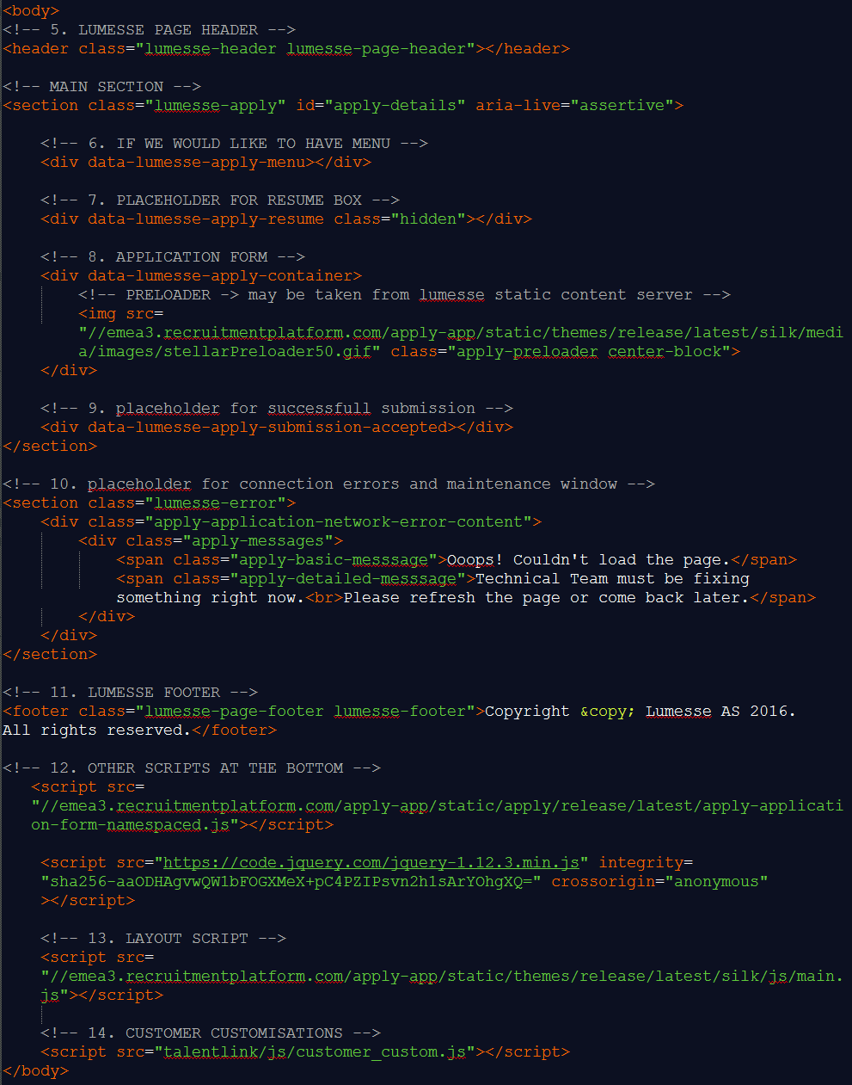

Learn more about Body Tag HTML Mark-up

**5.** The RAC’s body tag starts with the **Lumesse header**. We recommend to not remove this file to be able to benefit from header’s features in the future.

Next few links are nested in a **main section** attributed with class “lumesse-apply”. Its opening tag is also needed to let the delivered layout of RAC display properly.

**6.** **Left side menu** that can lead the user to subsequent parts of the RAC. On mobile devices this menu will appear in the header parts of the application. This web component is optional. You can leave it on the place and style it in your customer_custom.css file. To disable the menu, you can remove this link.

**7. Placeholder for resume box** – please, do not remove this tag if you use Save & Resume functionality.

**8. Application form** – the main RAC form is injected into this div tag. It also contains **preloader gif icon** that is shown to the user when the RAC is loading. The gif may be taken as default from Lumesse static content server or you can replace it with your own custom animation.

**9.** Placeholder that provide the user an information about his **successful submission.**

**10. Placeholder for connection errors and maintenance window**. This section include the error handling massages about temporary problems with loading the page.

**11. Lumesse footer** - the same as Lumesse header, you can change this line under your own customization or leave it on its place if you would like to benefit from footer features in future.

**12. Other scripts at the bottom** - we recommend to not remove these links to let the RAC work properly. It is also needed to leave them in the default order. In this section were added two important JavaScript files:

**a. Core JavaScript file** that run the application.

**b. Link to jQuery** script that is needed to run properly the main.js file added below. This popular and powerful JavaScript library could be also helpful in your further "look and feel" customization. The jQuery link is supplied with the **subresource** **integrity** that secure the appropriate performance of your script and is recommended for most of modern browsers.

**13. Layout script** - the main.js file is crucial for the initialization of the RAC.

**14. Customer customizations** - the customer_custom.js file added on the bottom of the body tag is the place where any additional JavaScript page customization can be added.

# Required information for successful integration

Launching the new RAC on your site

1. When uploading the RAC on your server, **make sure that all its files will stay on its right paths** reflecting the way in which they are indicated in apply.html file. You can upload on your server all the decompressed zip of RAC including all its folders that will stay in default order or you can indicate some new paths to consecutive files during your own customization.
2. Once the component has been integrated into your site you will need to **provide us with its URL** in order to finish up and correctly configure the site. For example RAC URL could be similar to:

[**www.customersitename.com/apply.html**](http://www.customersitename.com/apply.html) **or www.customersitename.com/apply/**

1. When your Lumesse consultant will receive the RAC URL and you will confirm him that you are ready to launch the new Responsive apply component on your site, the Lumesse Client’s Technical Services team will be able to **activate some of ordered additional features** of the RAC such as Save & Resume functionality or LinkedIn and Xing plugins.

# Other useful information

Career Site Technical ID

All TalentLink Career Sites are identified by the Career Site Technical ID. When a job is posted in TalentLink, it is actually posted to a technical site ID. Also other configurationally information (such as data privacy statement, etc) of the career site is identified by its technical ID.

JavaScript Disabled Browsers

Please note that currently there is no fallback for JavaScript Disabled browsers