Lara Haase (Lhaase) – Section C

Management Science I: Homework #3

1.) Shortest Path Problem  
Let:  
 Z = Total Cost ($)  
 xi,j = # of units flowing from node i to node j  
 ci,j = cost to ship one unit from node i to node j, where i = 1-7 and j = 2-8  
Objective:   
 Minimize z= ∑ci,jxi,j OR z = 5.1x1,2 + 3.4x1,3 + 0.5x2,4 + 2x2,5 + x3,2 + 1.6x3,4 + 5x3,7 + 2x4,5 + 3x4,6 + 4.2x4,7 + x5,2 + 3x5,6 +6x5,8 + 1.5x6,5 + 2.2x6,8 + 0.5x6,7 + 2x7,6 + 2.4x7,8Constraints:  
 ∀i,j xi,j ≥0  
 ∑xki - ∑xij = bi  
 Demand Node 1 = -1  
 Demand Node 8 = 1  
 Demand all other nodes = 0

2.) Arcs used in the optimal solution are x1,3 , x2,4 , x3,2 , x4,6 , x6,8  
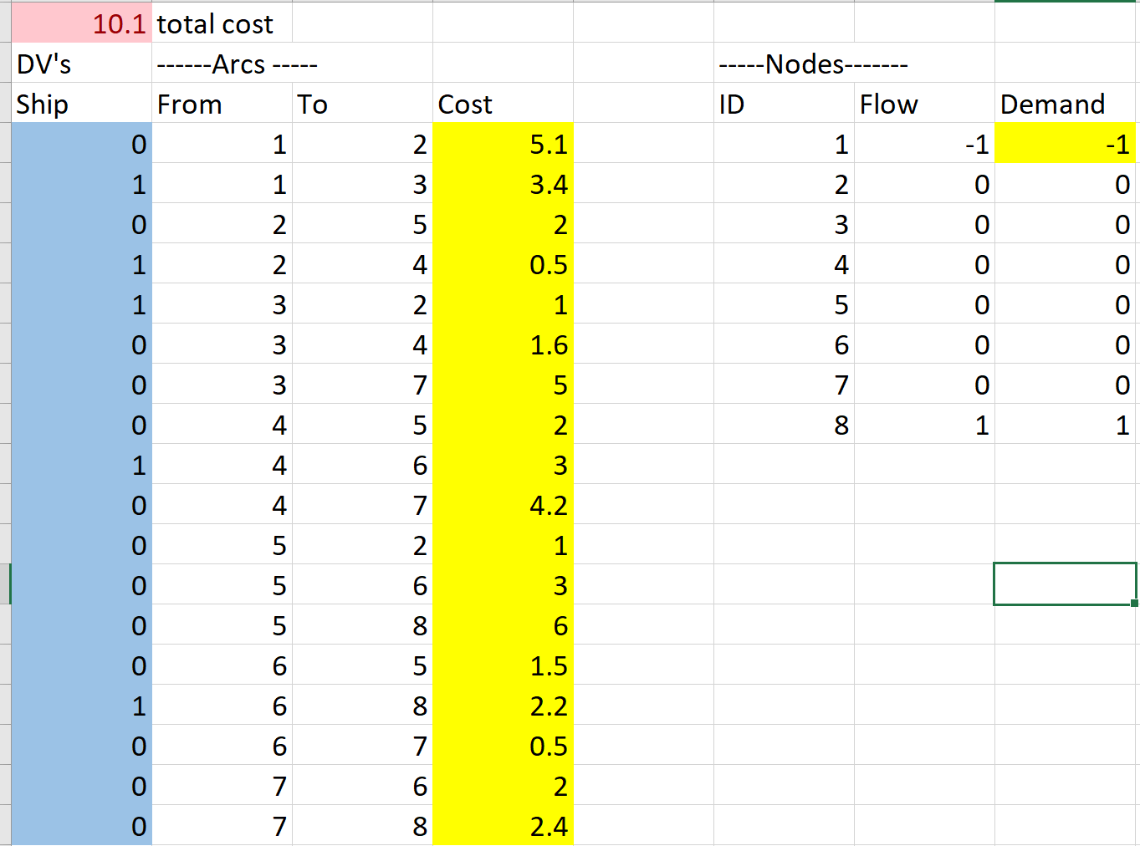  


3.) The optimal solution value is 5.9 units of flow.

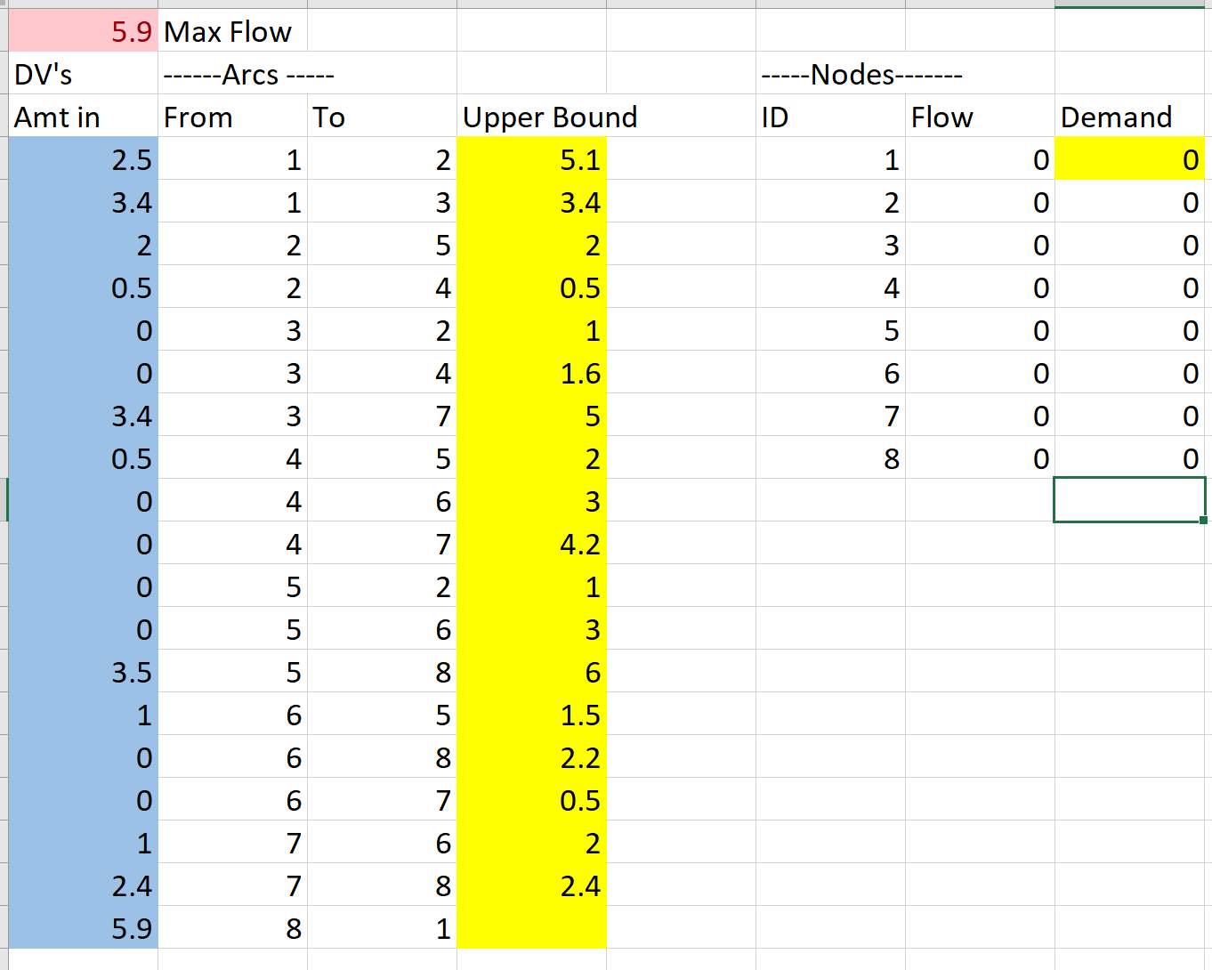

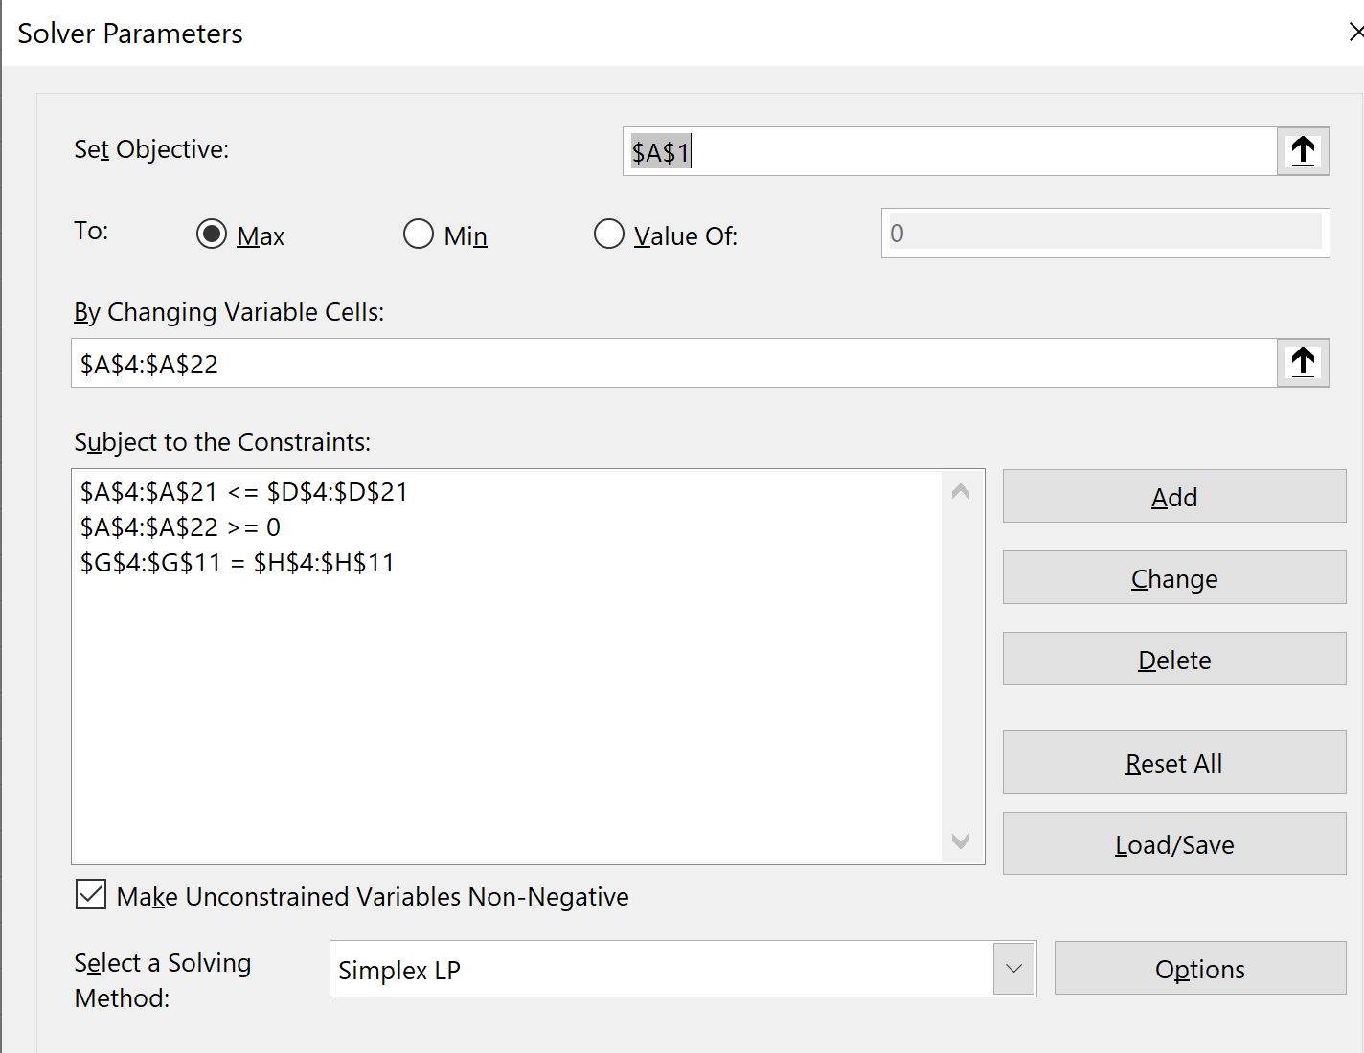

4.) The optimal solution is 4.43

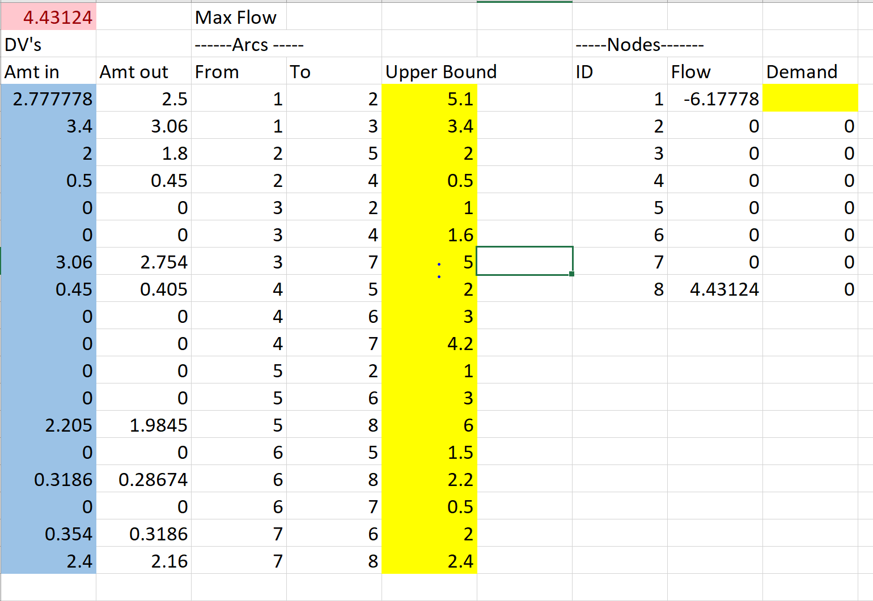

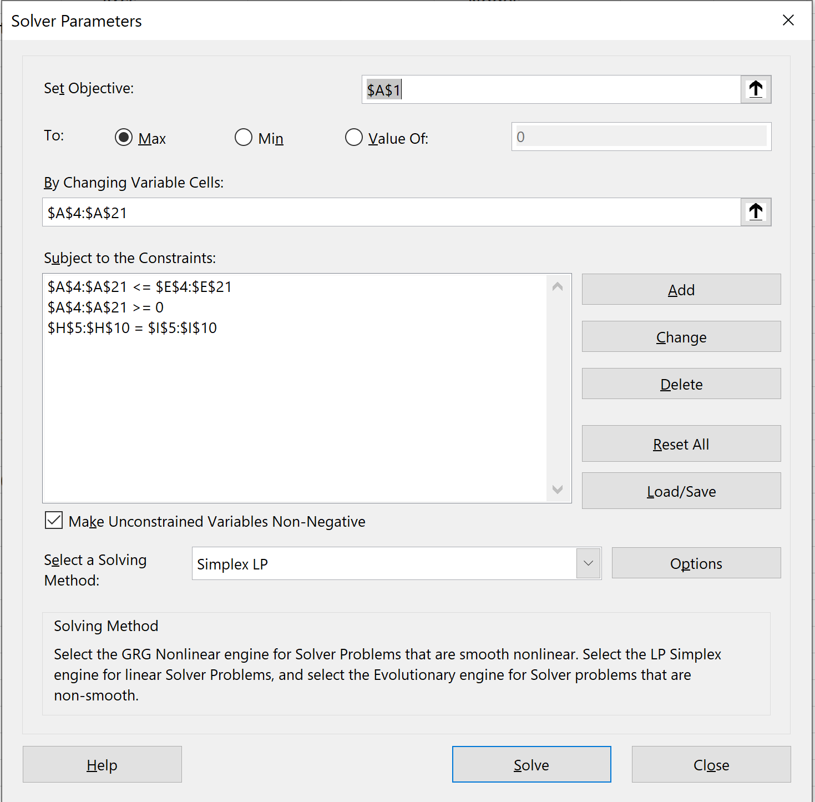

5.) Charleston Constraint:   
 Let Xi,j = # of units shipped from location i to location j  
 XPitt, Char + XStaun, Char + XRoan, Char - XChar, Roan – XChar, Rich – XChar, Norf >= 300  
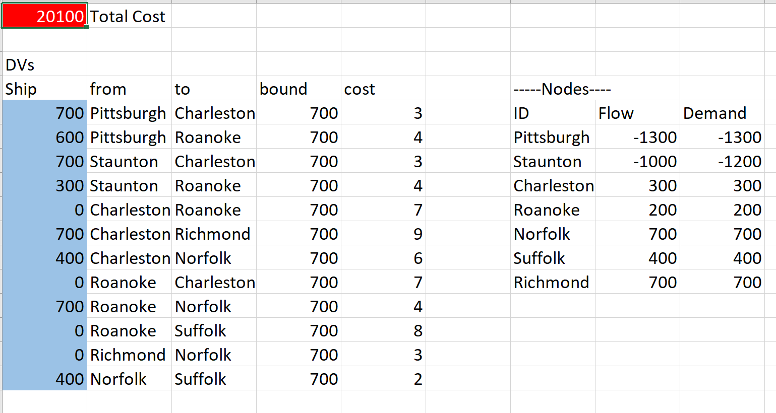

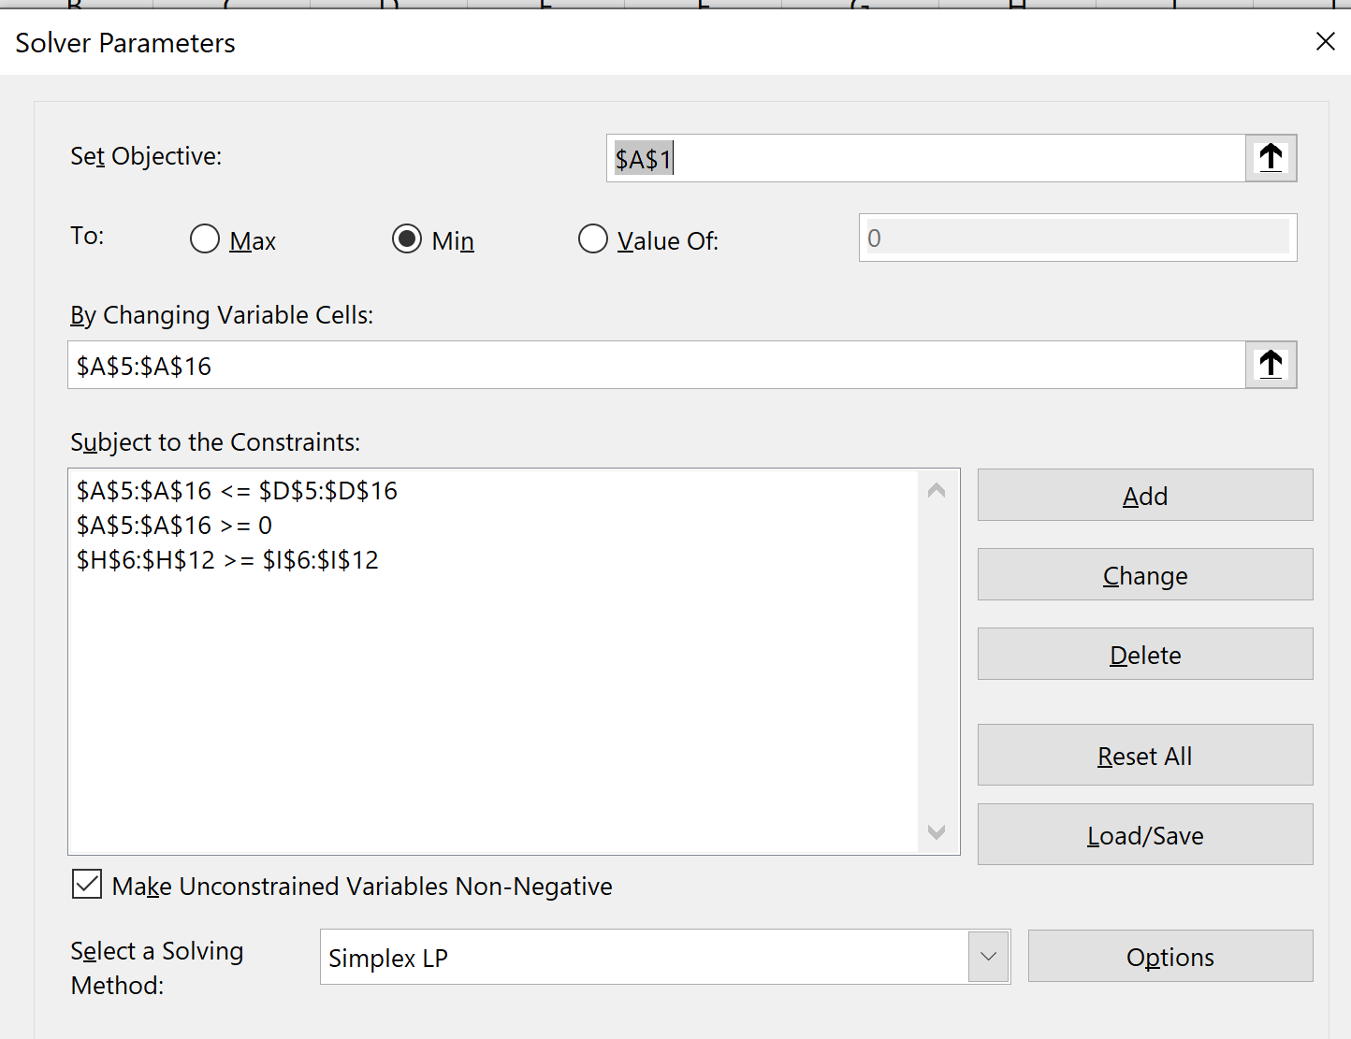

6.) a.) Objective Function Value: 1243  
 b.) Objective Function Value: 1299 (4.5% improvement), unemployed people: 5  
 c.) Objective Function Value: 1315 (5.79% improvement), unemployed people: 6

7.)