Spring, 2020: 90-722 Management Science I:

Homework #1 Due Tuesday January 21st

1) Write out each element of the following sums and their total, where the vector **X** = [x1, x2, x3, x4] = [1, 0, 1, 2] and **Y** = [y1, y2, y3, y4] = [1, 2, 3, 4].

*Note: To produce summation notation in Word, use the Equation Editor: Go to the Insert tab, then click Equation. In the Equation Editor, you can find summation notation under the Large Operators button on the right side. Or you can hand write your solution.*

a) $\sum_{i=1}^{4}{\left(x_{i}+1\right)}$ = 0 + 1 + 2 +3 = 6

b) $\sum_{i=1}^{4}{y_{i}}$ = 1 + 2 +3 +4 = 10

c) $\sum_{i=1}^{4}{{\left(x_{i}+1\right)}^{2}}$ = 0 + 1 + 4 + 9 = 14

d) $\sum_{i=1}^{4}{x_{i} y_{i}}$ = -1 + 0 + 3 + 8 = 10

e) $\sum_{i=1}^{4}{ \frac{x_{i}}{y_{i}}}$ = -1 + 0 + 1/3 + ½ = -1/6

f) $\sum_{i=1}^{4}{{x_{i}}^{y_{i}} }$ = -1 + 0 +1 +16 = 16

g) $\sum_{i=1}^{4}{{i* x}_{i}}$ = -1 + 0 + 3 + 8 = 10

Problems #2-#4 are designed to give you practice with data tables. If you did not catch how to use data tables from the lecture, then Chapter 1B gives step-by-step instructions on how to solve in Excel each of the problems I covered, including the data tables.

**Problem #2:** Consider a firm deciding what price to charge for a product that faces a linear demand curve ( Sales = 110 – 8 * P, where P is the price per unit). Production costs depends on volume with quantity discounts as indicated by the table in Cells A13:B22. The table indicates that the unit price when ordering up to 19 items is $12 per unit, when ordering 20-39 items the unit cost drops to $9 per unit, when ordering 40-59 the unit cost is $7, and so on. Do not worry about how the =VLOOKUP() function in Cell A8 works. We’ll get to that later in the course. For the sake of simplicity, suppose price must be a multiple of $0.50.

For example, if the firm set the price at $9.50 then it would sell 34 items (since 110 – 8 * 9.50 = 34). The unit production cost is $9, so profit of ($9.50  $9.00) * 34 = $17.00.

If you wish, you could build a model that computes the company’s profit as a function of price, but I have already provided such a model in the workbook I provided. Your task is to:

1. Give your best guess of what the optimal price is before doing any analysis, remembering that price should be a multiple of $0.50. (Not graded)  
   $8
2. Build a 1D data table that varies price in the rows of the table from $2.00 to $12.00 in steps of $0.50 with columns showing sales, unit cost, revenue, total cost, and profit.
3. Use conditional formatting to indicate which cells in the profit column offer higher profits (greener cells) and which do worse (red). If you wish, also highlight in yellow the cell giving the greatest profit.
4. Report the optimal price and the corresponding profit.   
   $8.50, $63
5. Report the profit of the guess you made in part a. Was your guess optimal? How far off was it?  
   $46, it was $0.50 off from the optimal price.
6. Create a line graph showing revenue, cost, and profit as a function of the price charged. Is profit a smooth function of price?

No.

**Problem #3:** Now suppose the same firm is setting prices and selling in two regions, not just one, and both have (independent) demand curves that are the same as in Problem #2. The difference is that the (now larger) firm can produce at one facility with pooled production volume allowing it to potentially achieve a lower unit production cost. (Or equivalently, use its bargaining power to drive down the cost its suppliers charge for raw materials and components.)

You can think of this as a model of what happens when two parallel firms serving different geographic markets merge in order to reduce costs.

I have built a model showing how the firm’s total profit (Cell B13) depends on the prices it charges in each region (Cells A4:B4).

Your task is to:

1. Build a 2D data table varying price in Region #1 in the rows of the table from $2.00 to $12.00 in steps of $0.50 and varying the price in Region #2 in columns from $5.00 to $11.50, also in steps of $0.50.
2. Use conditional formatting to indicate which cells offer higher profits (greener cells) and which do worse (red).
3. Report the optimal combination of prices, total profit, and total sales volume. Hint: You can find that best cell using conditional formatting to color the Top 1 cell a particular color, e.g., yellow. Or you can use Excel’s =LARGE() function to find the best value. The syntax would be =LARGE( cell range of table, 1 ). Then you can use conditional formatting to make the cell whose value equals that largest value be a special color.  
   $7.50 for both regions, $350 = total profit, 100 = total sales
4. For this particular set of parameters, compare the performance of two separate firms (two copies of Problem #2) with one larger, merged firm (Problem #3) in terms of total profit derived from serving customers in the two regions, and in terms of price and sales per region? Would consumers like a firm merger in this case? (Note: For different parameter values consumers’ could be affected in the opposite way.) Would shareholders who care about profitability prefer a firm merger in this case?  
   The two smaller firms serving the two regions results in an optimal price of $8.50, with each firm making a profit of $63, or a total profit of $126 with a total sale of 84 units (42 each). The merged larger firm can obtain an optimal price at $7.50 and a total profit of $350 by selling 100 units. Customers would prefer the larger firm because the price would be $1 lower. Shareholders would also prefer a larger firm because the profits would be higher.

**Problem #4:** Make a copy of the spreadsheet and data table from Problem #3. (Right click on the tab at the bottom of the screen, choose “Move or Copy” then click the checkbox for “Make a copy” in the dialog box.)

Modify it so that demand in Region #2 has an intercept of 120 and a slope of -11 (demand in Region #1 stays the same as before). You should see that now the optimal price is asymmetric, with different prices charged in the two different regions.

1. What is the optimal price in each region? Which Region is charged the higher price, the one with the steeper (more elastic) demand curve or the one with the shallower (less elastic) demand curve? Write a sentence stating why that makes sense. (Hint: the answer is not obscure or subtle.)  
   Region 1: $8 and Region 2: $6; The region with the shallower demand curve is charged the higher price. This makes sense because in the region with the steeoer demand curve, as the price increases the number of buyers drops off quicker.
2. What is total sales and how does it compare to total sales in Problem #3?  
   Total sale are 100 units, which is the same as Problem 23In a few words, what happens to profits if price is increased by even $0.50 in either Region relative to the optimal solution? (Don’t use numbers in the answer; just describe the basic trend.)  
   Profits start to drop off significantly as the price increases.
3. State the general, qualitative result or insight that characterizes the optimal solutions for Problems #3 and #4 that relates to your answer to part c.  
   The optimal price is in a sort of middle ground, high enough that there is at least some margin of profit between the cost and the price, but low enough that demand is still robust and doesn’t drop off.

Questions #5 - #6 consider variants on Ragsdale’s Howie Hot tub problem.

**Problem #5:** Ragsdale’s favorite problem is Howie’s Hot tub problem, which we worked in class for the most recent production period. The solution looked like this.

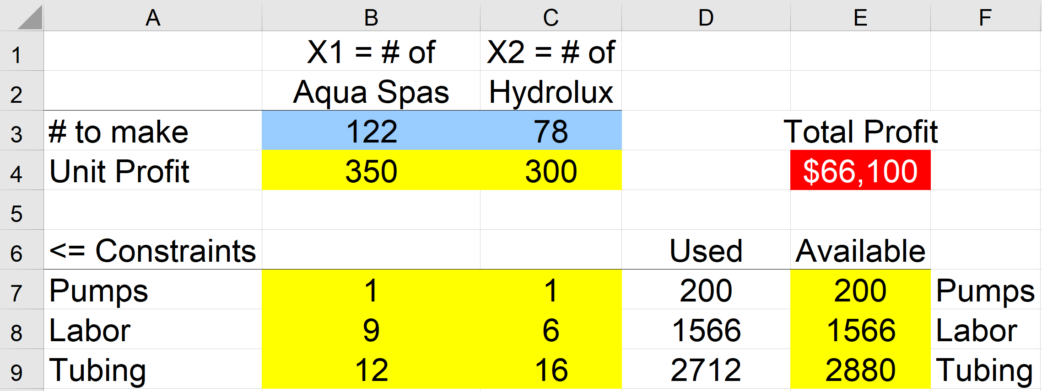

Howie would like to make more money, so he does two things. Since the labor constraint is binding, he obtains 300 more hours of labor, and now has 1866 not just 1566 hours available. He also does some clever negotiating to push the profit margin on Hydroluxes up to $340 per unit. Howie figures that since Hydroluxes are now more profitable and he has more resources, he should make more Hydroluxes. Rerun the optimization with these new parameters and submit a screenshot of your spreadsheet showing the new solution. Write a sentence or two explaining whether (a) Howie makes more money? And (b) Howie makes more Hydroluxes? And (c) Say whether it would have been easy to anticipate this optimal solution intuitively, without doing the optimization.  
(a.)

**Problem #6:** You should see that there are some labor left over in the solution to the previous problem. Howie’s friend Hubert tells Howie he should think about introducing a third type of hot tub to use up that left over labor. This new product, called the “Water King”, has an objective function coefficient of $450, and its production uses 8 hours of labor and 18 feet of tubing, as well as one pump. Solve the model as Hubert suggests.

Submit a screenshot of the new model showing the new optimal solution, and write a short paragraph (no more than 4 sentences) describing how the solution differs from that in Problem #5 and noting how well Hubert’s suggestion uses up left over labor and increases Howie’s profits.

**Problem #7:** A doctor’s practice is trying to figure out what mix of five different appointment types (labelled A – E) would be most profitable on a typical eight-hour work day given the following information about profit per appointment and minutes of resource consumed per appointment for each of five resources.



The office has 1.5 doctors, 2 RN’s, 2 PA’s, 4 exam rooms, and 2 lab techs, so it has 720 minutes of doctors’ time (1.5 MD’s times 8 hours per day times 60 minutes per day), and similarly for the other four resources except that the PA’s have 7.5 hour work shifts, so there is only 900 minutes of PA time available (2 * 7.5 * 60 = 900 minutes).

Provide an algebraic formulation that will allow the office to determine the maximum profit it could hope to achieve on a day. Be sure to define your decision variables clearly. Note: The office likely does not actually have complete control over the mix of appointments, and there is random variation from day to day, so this deterministic optimization problem is an abstraction, but it can nonetheless help them understand an upper bound on the possible profit per day.

**Problem #8:** Implement the model from Problem #7 and solve it to optimality. Provide a screenshot of your solved spreadsheet and also of the Solver dialog box. Which type of appointment seems to be least useful for maximizing profit? What resource seems least constrained with this optimal appointment mix?

**Problem #9:** For Ragsdale’s Chapter 2, Problem #17 (Electrotech Corporation), provide the algebraic formulation and solve to optimality in Excel. (Provide a screen shot of your spreadsheet model and state what is the optimal solution and solution value.) Also report the optimal solution to Problem #16 (same basic problem, but with one fewer constraint), and note whether removing the constraint improves the solution value.