External portals

* They are available publicly
* Audience: external dev & decision makers
* Potential profit centers
* External developer portals

Developer portals

* Internal developer portals
* External developer portals
* They are not available publicly
* Audience : company/team members

Internal portals

* What is a developer portal?
* Doc types on dev-portals
* What API description pages are?
* Writing API description

***API Documentation***

*API Description*

* API’s most important functions and features
* Benefits and requirements
* Common fields of operations
* Helps to decide which API to use
* Audience is heterogeneous
  + Developers
  + Decision makers
* Important to target managers

Reference docs

Supporting docs

*Supporting documentation*

* Concepts
* How-to guides
* Tutorials
* Glossaries
* FQA
* API Description

*Reference documentation*

* Open API/Swagger, RAML, API Blueprint
* Functions
* Classes
* Return types
* Arguments and Parameters

*API Description*

* Category / Tags
* Benefits
* What it is
* Why use it
* (How it works)
* How to use
* API name
* Description
* Version number
* Requirement
* (Pricing)

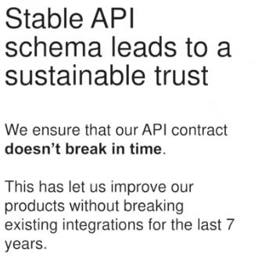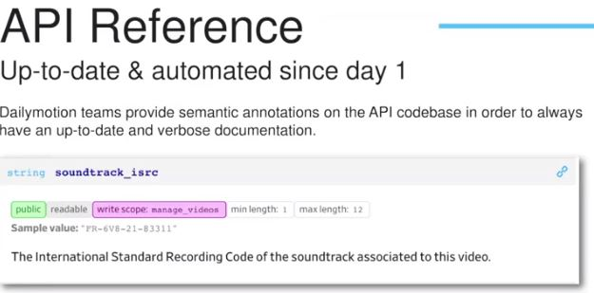

Event-driven for API design

