– Introduction to Linux edx --

Chapter 1 Linux Foundation

Learning Objectives
By the end of this chapter, you should be able to:
    - Discuss the role of The Linux Foundation.
    - Appreciate the learning opportunities provided by The Linux Foundation's training program.
    - Describe the software environment required for this course.
    - Describe the three major Linux distribution families.

About The Linux Foundation
Since its inception in 1991, Linux has grown to become a major force in computing - powering everything from the New York Stock Exchange, to mobile phones, supercomputers, and consumer devices.
The Linux Foundation partners with the world's leading developers and companies to solve the hardest technology problems and accelerate open technology development and commercial adoption. The Linux Foundation makes it its mission to provide experience and expertise to any initiative working to solve complex problems through open source collaboration, providing the tools to scale open source projects: security best practices, governance, operations and ecosystem development, training and certification, licensing, and promotion.
Linux is the world's largest and most pervasive open source software project in history. The Linux Foundation is home to Linux creator Linus Torvalds and lead maintainer Greg Kroah-Hartman, and provides a neutral home where Linux kernel development can be protected and accelerated for years to come. The success of Linux has catalyzed growth in the open source community, demonstrating the commercial efficacy of open source and inspiring countless new projects across all industries and levels of the technology stack.
The Linux Foundation's work today extends far beyond Linux, fostering innovation at every layer of the software stack. The Linux Foundation is the umbrella organization for many critical open source projects that power corporations today, spanning all industry sectors:
    - Big data and analytics: ODPi, R Consortium
    - Networking: OpenDaylight, ONAP, OPNFV
    - Embedded: Dronecode, Zephyr
    - Web tools: JS Foundation, Node.js
    - Cloud computing: Cloud Foundry, Cloud Native Computing Foundation, Open Container Initiative
    - Automotive: Automotive Grade Linux
    - Security: The Core Infrastructure Initiative
    - Blockchain: Hyperledger
    - And many more.
To learn more about The Linux Foundation, visit The Linux Foundation's website.

The Linux Foundation Events
The Linux Foundation hosts conferences and other events throughout the world which bring community members together in person. These events:
    - Provide an open forum for development of the next kernel (the actual operating system) release.
    - Bring together developers and system administrators to solve problems in a real-time environment.
    - Host workgroups and community groups for active discussions.
    - Connect end users, system administrators, and kernel developers in order to grow Linux use in the enterprise.
    - Encourage collaboration among the entire community.
    - Provide an atmosphere that is unmatched in its ability to further the platform.

More About The Linux Foundation Events
The Linux Foundation events include:
    - Open Source Summit North America, Europe, Japan, and China
    - MesosCon North America, Europe, and China
    - Embedded Linux Conference/OpenIoT Summit North America and Europe
    - Open Source Leadership Summit
    - Automotive Linux Summit
    - Apache: Big Data North America & ApacheCon
    - KVM Forum
    - Linux Storage Filesystem and Memory Management Summit
    - Vault
    - Open Networking Summit
    - And many more.

The Linux Foundation Training

Although we believe in individual initiative and creativity, learning Linux and open source technologies need not be intimidating. You can leverage the power of collaboration to jump start your learning. Our classes build the critical skills that individuals and organizations need to get the most out of Linux and open source technologies and continue with self-directed learning.
The Linux Foundation offers several types of training:
    - Classroom
    - Online
    - On-Site
    - Events-based.

Training That Builds Skills

The Linux Foundation training is for the community and is designed by members of the community. The System Administration courses focus on Enterprise Linux environments and target system administrators, technical support, and architects. The Developer courses feature instructors and content straight from the leaders of the open source developer community.
To get more information about specific courses offered by The Linux Foundation visit our catalogue:
    - Enterprise IT & Linux System Administration Courses
    - Linux Programming & Development Courses
    - Open Source Compliance Courses
    - And many more.
The Linux Foundation training is distribution-flexible, technically advanced, and created with the actual leaders of the open source development community themselves. Most courses are more than 50% focused on hands-on labs and activities to build real world skills.

Course Software Requirements
In order to fully benefit from this course, you will need to have at least one Linux distribution installed (if you are not already familiar with the term distribution, as it relates to Linux, you soon will be!).
On the next page, you will learn some more details about the many available Linux distributions and the families they can be considered to belong to. Because there are literally hundreds of distributions, we have not covered them all in this course. Instead, we have decided to focus on the three major distribution families, and we have chosen distributions from within each family to use for illustrations, examples, and exercises. This is not meant to suggest that we endorse these specific distributions; they were simply chosen because they are fairly widely used and each is broadly representative of its respective family.
The families and representative distributions we are using are:
    - Red Hat Family Systems (including CentOS and Fedora)
    - SUSE Family Systems (including openSUSE)
    - Debian Family Systems (including Ubuntu and Linux Mint).

Focus on Three Major Linux Distribution Families
In the next chapter, you will learn about the components that make up a Linux distribution.
For now, what you need to know is that this course focuses on the three major Linux distribution families that currently exist. However, as long as there are talented contributors, the families of distributions and the distributions within these families will continue to change and grow. People see a need, and develop special configurations and utilities to respond to that need. Sometimes that effort creates a whole new distribution of Linux. Sometimes, that effort will leverage an existing distribution to expand the members of an existing family.
For a rather long list of available distributions, see The LWN.net Linux Distribution List.
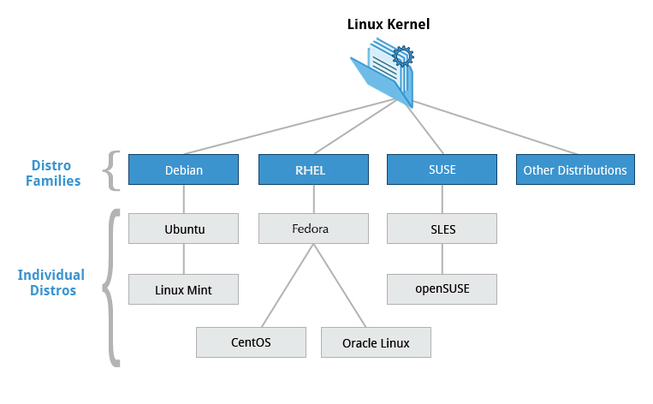

The Red Hat Family
Red Hat Enterprise Linux (RHEL) heads the family that includes CentOS, Fedora and Oracle Linux.
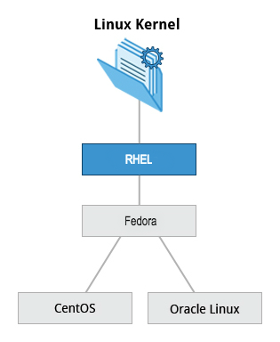
Fedora has a close relationship with RHEL and contains significantly more software than Red Hat's enterprise version. One reason for this is that a diverse community is involved in building Fedora, with many contributors who do not work for Red Hat. Furthermore, it is used as a testing platform for future RHEL releases.
In this course, CentOS is often used for activities, demos, and labs because it is available at no cost to the end user and has a much longer release cycle than Fedora (which releases a new version every six months or so).
The basic version of CentOS is also virtually identical to RHEL, the most popular Linux distribution in enterprise environments.

Key Facts About the Red Hat Family
Some of the key facts about the Red Hat distribution family are:
    - Fedora serves as an upstream testing platform for RHEL.
    - CentOS is a close clone of RHEL, while Oracle Linux is mostly a copy with some changes (in fact, CentOS has been part of Red Hat since 2014).
    - A heavily patched version 3.10 kernel is used in RHEL/CentOS 7, while version 4.18 is used in RHEL/CentOS 8.
    - It supports hardware platforms such as Intel x86, Arm, Itanium, PowerPC, and IBM System z.
    - It uses the yum and dnf RPM-based yum package managers (covered in detail later) to install, update, and remove packages in the system.
    - RHEL is widely used by enterprises which host their own systems.

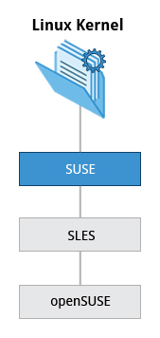
The SUSE Family

The relationship between SUSE (SUSE Linux Enterprise Server (SLES) ) and openSUSE is similar to the one described between RHEL, CentOS, and Fedora.
We use openSUSE as the reference distribution for the SUSE family, as it is available to end users at no cost. Because the two products are extremely similar, the material that covers openSUSE can typically be applied to SLES with few problems.

Key Facts About the SUSE Family
Some of the key facts about the SUSE family are listed below:
    - SUSE Linux Enterprise Server (SLES) is upstream for openSUSE.
    - Kernel version 4.12 is used in openSUSE Leap 15.
    - It uses the RPM-based zypper package manager (we cover it in detail later) to install, update, and remove packages in the system.
    - It includes the YaST (Yet Another Setup Tool) application for system administration purposes.
    - SLES is widely used in retail and many other sectors.

The Debian Family
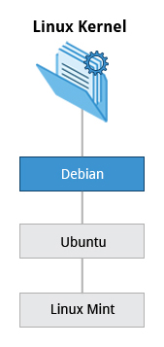
The Debian distribution is upstream for several other distributions, including Ubuntu. In turn, Ubuntu is upstream for Linux Mint and a number of other distributions. It is commonly used on both servers and desktop computers. Debian is a pure open source community project (not owned by any corporation) and has a strong focus on stability.
Debian provides by far the largest and most complete software repository to its users of any Linux distribution.
Ubuntu aims at providing a good compromise between long term stability and ease of use. Since Ubuntu gets most of its packages from Debian’s stable branch, it also has access to a very large software repository. For those reasons, we will use Ubuntu 18.04 and 20.04 LTS (Long Term Support) as the reference Debian family distributions for this course. Ubuntu is a registered trademark of Canonical Ltd. and is used throughout this course with their permission.

Key Facts About the Debian Family
Some key facts about the Debian family are listed below:
    - The Debian family is upstream for Ubuntu, and Ubuntu is upstream for Linux Mint and others.
    - Kernel version 4.15 is used in Ubuntu 18.04 LTS.
    - It uses the DPKG-based APT package manager (using apt, apt-get, apt-cache, etc. which we cover in detail later) to install, update, and remove packages in the system.
    - Ubuntu has been widely used for cloud deployments.
    - While Ubuntu is built on top of Debian and is GNOME-based under the hood, it differs visually from the interface on standard Debian, as well as other distributions.

More About the Software Environment
The material produced by The Linux Foundation is distribution-flexible. This means that technical explanations, labs, and procedures should work on almost all most modern distributions. While choosing between available Linux systems, you will notice that the technical differences are mainly about package management systems, software versions, and file locations. Once you get a grasp of those differences, it becomes relatively painless to switch from one Linux distribution to another.
The desktop environment used for this course is GNOME. As we will note in Chapter 4: Graphical Interface, there are different environments, but we selected GNOME as it is the most widely used.

Learning Objectives (Review)
You should now be able to:
    - Discuss the role of The Linux Foundation.
    - Appreciate the learning opportunities provided by The Linux Foundation's training program.
    - Describe the software environment required for this course.
    - Describe the three major Linux distribution families.

Summary
You have completed Chapter 1. Let’s summarize the key concepts covered:
    - The Linux Foundation is the umbrella organization for many critical open source projects that power corporations, spanning all industry sectors. Its work today extends far beyond Linux, fostering innovation at every layer of the software stack.
    - The Linux Foundation training is for the community and by the community. Linux training is distribution-flexible, technically advanced, and created with the leaders of the Linux development community.
    - There are three major distribution families within Linux: Red Hat, SUSE and Debian. In this course, we will work with representative members of all of these families throughout.


Chapter 2 Linux Phylosophy and Concepts

Three Important Pieces of Context
Please keep in mind the following:
    - Things change in Linux
No matter how hard we have worked to stay current, Linux is constantly evolving, both at the technical level (including kernel features) and at the distribution and interface level. So, please keep in mind we have tried to be as up-to-date as possible at the time this course was released, but there may be changes and new features we have not discussed. This is unavoidable.

    - We have repeated some things in the class material
It is just about impossible in a course this comprehensive to never revisit topics that have previously been covered, and short reviews are helpful so you do not have to go scouring through earlier sections to jog your memory. This is particularly true with system configuration items, like how to use sudo to gain temporary root privileges in as safe a manner as possible. We know we have done this and, at least in most cases, it is by design, not by accident.

    - We have tried to avoid holy wars
There are many areas where there are strong preference disagreements in the Linux (and wider open source) community. Examples include the best editor: emacs vs. vi; the best graphical desktop: GNOME vs. KDE, etc. Usually, we have chosen (when necessary) a particular alternative to emphasize just to keep things clean. For example, we talk much more about GNOME than KDE simply because it has a bigger user base, not because we are taking a position as to which is superior.

Final Thoughts
In order for you to get the most out of this course, we recommend that you have Linux installed on a machine that you can use throughout this course. You do not need to view the course material on a Linux machine (all you need is a browser). However, you will see that there is a lot of follow-along activities and labs that you will benefit from only if you can do them on your own machine. We have prepared a brief installation guide: "Preparing Your Computer for LFS101x.2", that helps you to select a Linux distribution to install, decide on whether you want to do a stand-alone pure Linux machine or a dual-boot one, whether do a physical or virtual install, etc. And then guides through the steps. We will also discuss the installation procedure in detail in a later section.
We have not covered everything in great detail, but keep in mind that most of the documentation in Linux is actually already on your system in the form of man pages, which we will discuss in great detail later. Whenever you do not understand something or want to know more about a command, program, topic, or utility, you can just type man <topic> at the command line. We will assume you are thinking this way and not constantly repeat "For more information, look at the man page for <topic>".
On a related note, throughout the course we use a shorthand that is common in the open source community. When referring to cases where the user has to make a choice of what to enter (e.g. name of a program or file), we use the short hand 'foo' to represent <insert file name here>. So beware, we are not actually suggesting that you manipulate files or install services called 'foo'!

Learning Objectives
By the end of this chapter, you should be able to:
    - Discuss the history and philosophy of Linux.
    - Describe the Linux community.
    - Define the common terms associated with Linux.
    - Discuss the components of a Linux distribution.

Introduction
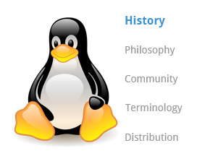
Linux is an open source computer operating system, initially developed on and for Intel x86-based personal computers. It has been subsequently ported to an astoundingly long list of other hardware platforms, from tiny embedded appliances to the world's largest supercomputers.
In this section, we follow the surprising history of how Linux evolved from a project of one Finnish college student, into a massive effort with an enormous impact on today's world.

Linux History
Linus Torvalds was a student in Helsinki, Finland, in 1991, when he started a project: writing his own operating system kernel. He also collected together and/or developed the other essential ingredients required to construct an entire operating system with his kernel at the center. It wasn't long before this became known as the Linux kernel.
In 1992, Linux was re-licensed using the General Public License (GPL) by GNU (a project of the Free Software Foundation or FSF, which promotes freely available software), which made it possible to build a worldwide community of developers. By combining the kernel with other system components from the GNU project, numerous other developers created complete systems called Linux distributions in the mid-90’s.
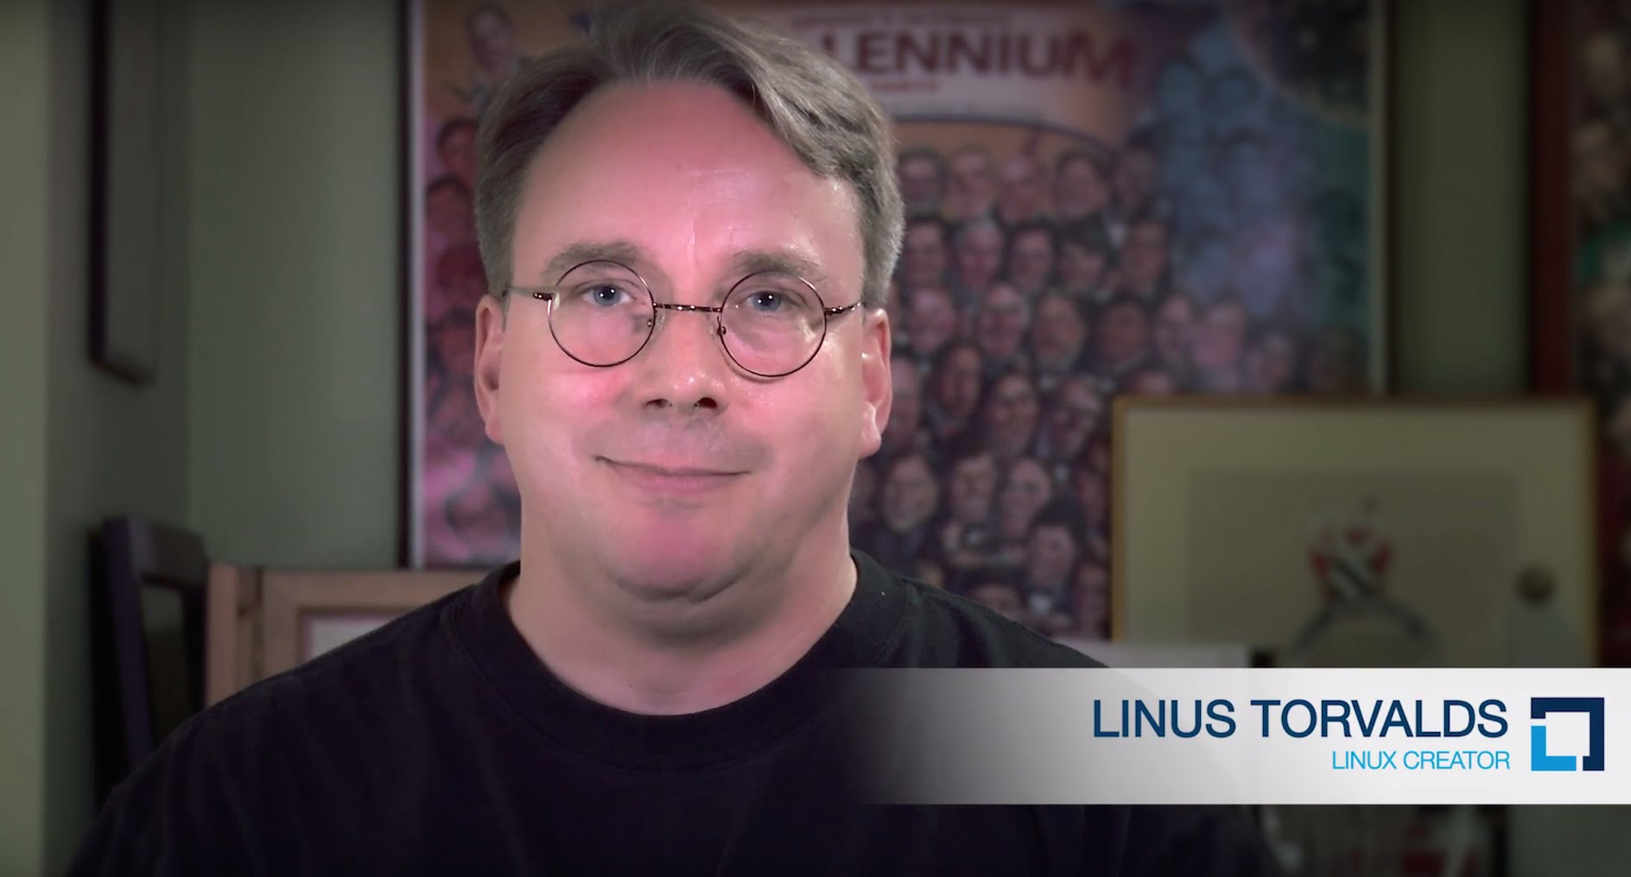

More About Linux History
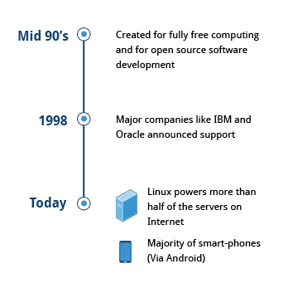
The Linux distributions created in the mid-90s provided the basis for fully free (in the sense of freedom, not zero cost) computing and became a driving force in the open source software movement. In 1998, major companies like IBM and Oracle announced their support for the Linux platform and began major development efforts as well.
Today, Linux powers more than half of the servers on the Internet, the majority of smartphones (via the Android system, which is built on top of Linux), and all of the world’s most powerful supercomputers.

Introduction
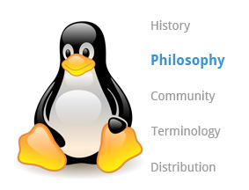
Every successful project or organization needs an implicit or explicit philosophy that frames its objectives and projects its growth path. This section contains a description of the "Linux philosophy" and how it has impacted Linux's amazing evolution.
Linux is constantly enhanced and maintained by a network of developers from all over the world collaborating over the Internet, with Linus Torvalds at the head. Technical skill, a desire to contribute, and the ability to collaborate with others are the only qualifications for participating.

Linux Philosophy
Linux borrows heavily from the well-established UNIX operating system. It was written to be a free and open source system to be used in place of UNIX, which at the time was designed for computers much more powerful than PCs and was quite expensive. Files are stored in a hierarchical filesystem, with the top node of the system being the root or simply "/". Whenever possible, Linux makes its components available via files or objects that look like files. Processes, devices, and network sockets are all represented by file-like objects, and can often be worked with using the same utilities used for regular files. Linux is a fully multitasking (i.e. multiple threads of execution are performed simultaneously), multiuser operating system, with built-in networking and service processes known as daemons in the UNIX world.
Note: Linux was inspired by UNIX, but it is not UNIX.

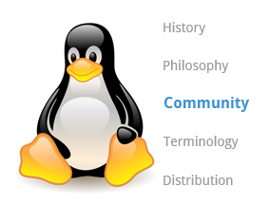
Introduction
Suppose that, as part of your job, you need to configure a Linux file server, and you run into some difficulties. If you are not able to figure out the answer yourself or get help from a co-worker, the Linux community might just save the day!
There are many ways to engage with the Linux community:
    - Post queries on relevant discussion forums.
    - Subscribe to discussion threads.
    - Join local Linux groups that meet in your area.

More About Linux Community
The Linux community is a far-reaching ecosystem consisting of developers, system administrators, users and vendors who use many different forums to connect with one another. Among the most popular are:
    - Internet Relay Chat (IRC) software (such as WeeChat, HexChat, Pidgin and XChat)
    - Online communities and discussion boards including Linux User Groups (both local and online)
    - Many collaborative projects hosted on services such as GitHub
    - Newsgroups and mailing lists, including the Linux Kernel Mailing List
    - Community events, e.g. Hackathons, Install Fests, Open Source Summits and Embedded Linux Conferences.
A portal to one of the most powerful online user communities can be found at linux.com. This site is hosted by The Linux Foundation and serves over one million unique visitors every month. It has active sections on:
    - News
    - Community discussion threads
    - Free tutorials and user tips.
We will refer several times in this course to relevant articles or tutorials on this site.

Introduction

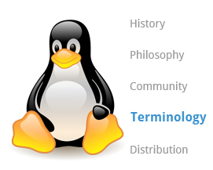
When you start exploring Linux, you will soon come across some terms which may be unfamiliar, such as distribution, boot loader, desktop environment, etc. Before we proceed further, let's stop and take a look at some basic terminology used in Linux to help you get up to speed.

Before you begin using Linux, you need to be aware of some basic terms such as kernel, distribution, boot loader, service, filesystem, X Window system, desktop environment, and command line. These are very commonly used by the Linux community.
The kernel is considered the brain of the Linux operating system. It controls the hardware and makes the hardware interact with the applications. An example of a kernel is the Linux kernel. The most recent Linux kernel, along with past Linux kernels, can be found at the kernel.org web site.
A distribution also known as Distros is a collection of programs combined with the Linux kernel to make up a Linux-based operating system. Some common examples of a distribution are Red Hat Enterprise Linux, Fedora, Ubuntu, and Gentoo.
The boot loader, as the name implies, is a program that boots the operating system. Two examples of a boot loader are GRUB and ISOLINUX.A service is a program that runs as a background process. Some examples of the service are httpd, nfsd, ntpd, ftpd and named.
A filesystem is a method for storing and organizing files in Linux. Some examples of filesystems are ext3, ext4, FAT, XFS and Btrfs.
The X Window System provides the standard toolkit and protocol to build graphical user interfaces on nearly all Linux systems.
The desktop environment is a graphical user interface on top of the operating system. GNOME, KDE, Xfce and Fluxbox are some examples of the desktop environment.
The command line is an interface for typing commands on top of the operating system.
The Shell is the command line interpreter that interprets the command line input and instructs the operating system to perform any necessary tasks and commands. For example, bash, tcsh and zsh.

Introduction
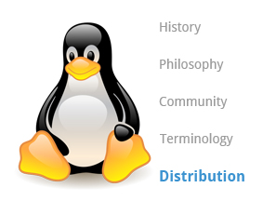
Suppose you have been assigned to a project building a product for a Linux platform. Project requirements include making sure the project works properly on the most widely used Linux distributions. To accomplish this, you need to learn about the different components, services, and configurations associated with each distribution. We are about to look at how you would go about doing exactly that.

Linux Distributions
So, what is a Linux distribution and how does it relate to the Linux kernel?
The Linux kernel is the core of the operating system. A full Linux distribution consists of the kernel plus a number of other software tools for file-related operations, user management, and software package management. Each of these tools provides a part of the complete system. Each tool is often its own separate project, with its own developers working to perfect that piece of the system.
While the most recent Linux kernel (and earlier versions) can always be found in The Linux Kernel Archives, Linux distributions may be based on different kernel versions. For example, the very popular RHEL 7 distribution is based on the 3.10 kernel, which is not new, but is extremely stable. Other distributions may move more quickly in adopting the latest kernel releases. It is important to note that the kernel is not an all or nothing proposition, for example, RHEL 7/CentOS 7 have incorporated many of the more recent kernel improvements into their older versions, as have Ubuntu, openSUSE, SLES, etc.
Examples of other essential tools and ingredients provided by distributions include the C/C++ compiler, the gdb debugger, the core system libraries applications need to link with in order to run, the low-level interface for drawing graphics on the screen, as well as the higher-level desktop environment, and the system for installing and updating the various components, including the kernel itself. And all distributions come with a rather complete suite of applications already installed.
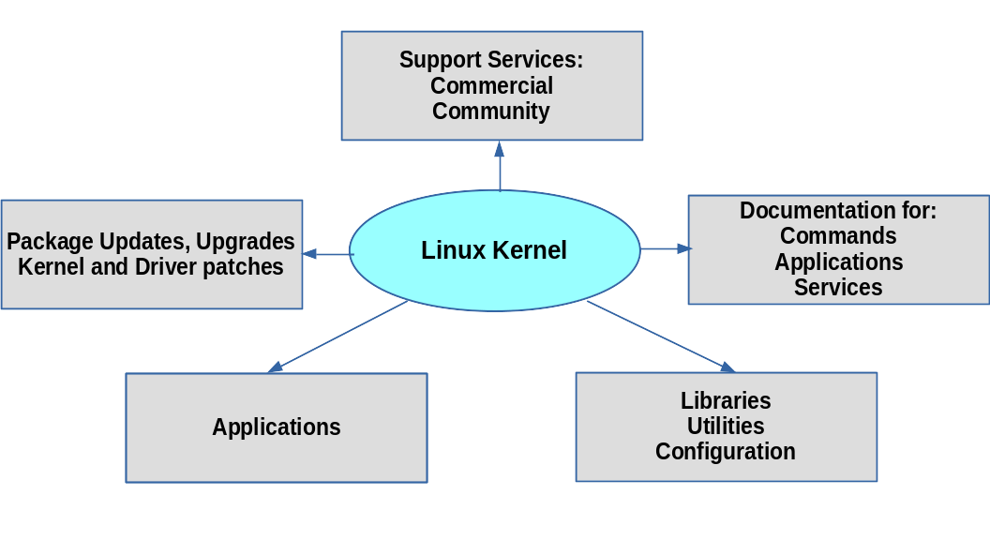

Services Associated with Distributions
The vast variety of Linux distributions are designed to cater to many different audiences and organizations, according to their specific needs and tastes. However, large organizations, such as companies and governmental institutions and other entities, tend to choose the major commercially-supported distributions from Red Hat, SUSE, and Canonical (Ubuntu).
CentOS is a popular free alternative to Red Hat Enterprise Linux (RHEL) and is often used by organizations that are comfortable operating without paid technical support. Ubuntu and Fedora are widely used by developers and are also popular in the educational realm. Scientific Linux is favored by the scientific research community for its compatibility with scientific and mathematical software packages. Both CentOS and Scientific Linux are binary-compatible with RHEL; i.e. in most cases, binary software packages will install properly across the distributions.
Many commercial distributors, including Red Hat, Ubuntu, SUSE, and Oracle, provide long term fee-based support for their distributions, as well as hardware and software certification. All major distributors provide update services for keeping your system primed with the latest security and bug fixes, and performance enhancements, as well as provide online support resources.
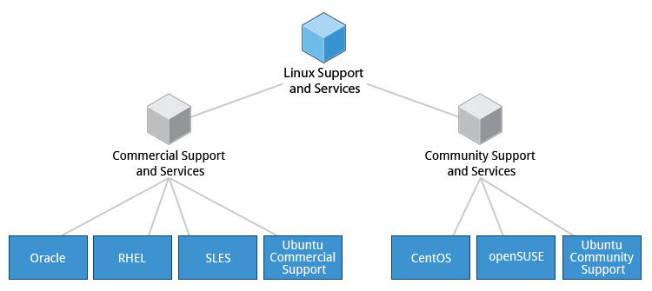

Learning Objectives (Review)
You should now be able to:
    - Discuss the history and philosophy of Linux.
    - Describe the Linux community.
    - Define the common terms associated with Linux.
    - Discuss the components of a Linux distribution.

Summary
You have completed Chapter 2. Let’s summarize the key concepts covered:
      - Linux borrows heavily from the UNIX operating system, with which its creators were well-versed.
      - Linux accesses many features and services through files and file-like objects.
      - Linux is a fully multi-tasking, multi-user operating system, with built-in networking and service processes known as daemons.
      - Linux is developed by a loose confederation of developers from all over the world, collaborating over the Internet, with Linus Torvalds at the head. Technical skill and a desire to contribute are the only qualifications for participating.
      - The Linux community is a far reaching ecosystem of developers, vendors, and users that supports and advances the Linux operating system.
      - Some of the common terms used in Linux are: kernel, distribution, boot loader, service, filesystem, X Window system, desktop environment, and command line.
      - A full Linux distribution consists of the kernel plus a number of other software tools for file-related operations, user management, and software package management.

Chapter 1

