FUNDAMENTALS OF DIGITAL SIGNAL PROCESSING

HOMEWORK 2: FOURIER TRANSFORM OF DISCRETE - TIME SIGNALS

---------------------------------------------
NAME AND SURNAME

1. Given the following unit-sample response sequences compute the Fourier transform and sketch the magnitude and phase functions:
a. h(-1)=1; h(1)=1; h(n)=0 otherwise.
b. h(0)=1; h(1)=-1; h(n)=0 otherwise
c. h(-1)=1; h(0)=-2; h(1)=1; h(n)=0 otherwise.

2. Determine whether the following sequences have Fourier transforms and compute the Fourier transform if it exist.
a. h(n)=1 for n>=0; h(n)=0 otherwise.
b. h(n)=1 0<=n<=N, h(n)=0 otherwise.
c. h(n)=1 for -N<=n<=N, h(n)=0 otherwise.

3. Determine and plot magnitude and phase response of the first order recursive filter which unit sample response is given by:
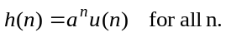
Consider two values of a: a=.5 and a=.9.

4 Determine the convolution of the sequences x₁(n) and x₂(n) by using their Fourier transform.
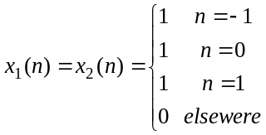
5 Which system has a linear phase and why:

a. h(n)=0.4^{n}u(n);
b. h(n)=2^{n} u(n);
c. h(n)=1, for n=1,2,3,4; otherwise h(n)=0.
d. h(1)=4;h(2)=2=h(3);
e. h(1)=0.5 h(2)=0, h(3)=-0.5
f. h(n)=1, for n>0;
h(n)=1 for n=0
h(n)=0 for n<0

