Title of my file
Table of Contents
H1 1 1
H2 1 1 1
H2 1 2 1
H1 2 1
H2 2 1 1
H2 2 2 1

H1 1

H2 1 1

H2 1 2
First very important paragraph.
And now a very very very very very very very very very very very very very very very very very very very very very very very very long paragraph that gets split across two lines.
Reference to H1 1 on page: 1
https://commons.wikimedia.org/wiki/File:Fractal_Broccoli.jpg
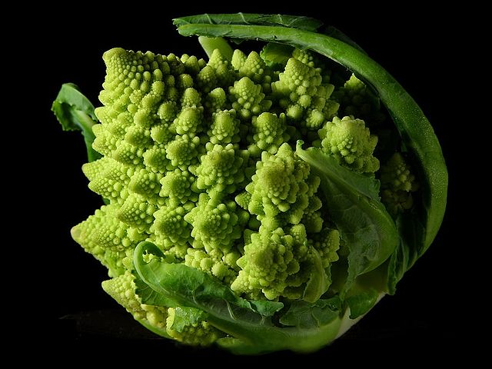

H1 2

H2 2 1

H2 2 2

