# Title of my file

**Table of Contents**

Title of my file 1

H2 1 1

H3 1 1 1

H3 1 2 1

H2 2 2

H3 2 1 2

H3 2 2 2

## H2 1

### H3 1 1

### H3 1 2

First very important paragraph.

And now a very very very very very very very very very very very very very very very very very very very very very very very very long paragraph that gets split across two lines.

Reference to section H2 1 on page: 1

Reference to figure: Figure 1: Fractal broccoli

Reference to table: Table 1: My sample table

An [external link](http://example.com/) with custom text.

Raw external link: <https://commons.wikimedia.org/wiki/File:Fractal_Broccoli.jpg>

Mathematical equation:

$$\frac{x=\sqrt{1+1}}{2}$$

Code block: there is no built-in way. One option is to create your own style:

int main() {

puts(“hello world”);

}

And another:

def main:

print(‘hello world’);

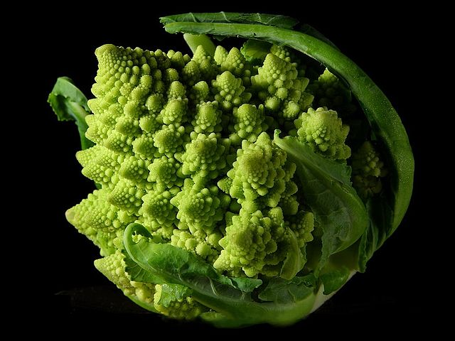Figure 1: Fractal broccoli

I like broccoli. And I **love** fractals.

A list:

* item 1
* item 2
* item 3

A table:

Table 1: My sample table

This is a **very nice** sample table.

|  |  |  |
| --- | --- | --- |
| Header 1 | Header 2 | Header 3 |
| Item 1 1 | Item 1 2 | Item 1 3 |
| Item 2 1 | Item 2 2 | Item 2 3 |

## H2 2

### H3 2 1

### H3 2 2