Brief

I'll build a software to track basketball scores. Currently, in local tournaments, a sheet of paper with a template is used to record basketball games scores.
The use of the software will require people to change the way they capture the scores. Also, it will enable the elaboration of reports based on the information captured. This could potentially change referee assignment based on statistics, like team with most fouls given or players with most technical fouls. This will also allow to detect the players performance.

Observation

Needs/Goals

Inspiration

http://dakstats.daktronics.com/Pages/TwoClickTutorial.aspx

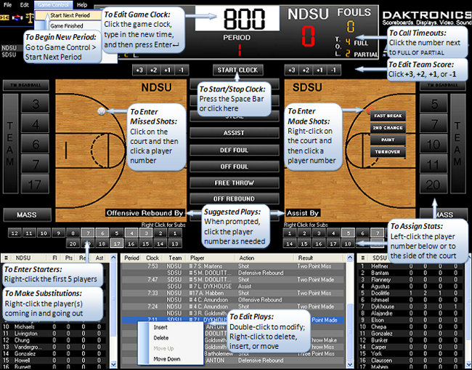
This software condense all the information in one screen without cluttering the view. It allows rapid and easy way of capturing data. It also permits the user to correct mistakes and capture all the information. Its main drawback is the use of right click to perform some actions.
http://basketball-statistics.net/

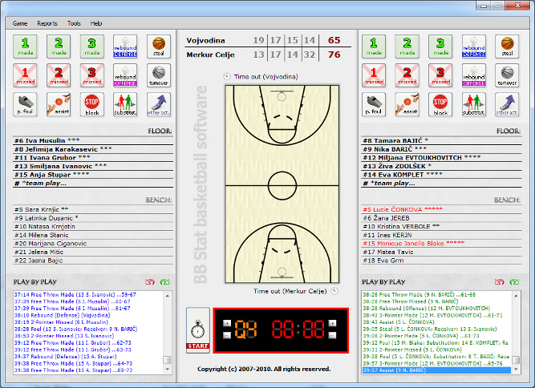

http://www.pointstreaksolutions.com/sports-software/basketball-statistics/easy-to-use-basketball-scoring-software/

