Gift Me Five

Team 2 - Darmstadt

Created on January 15 2020

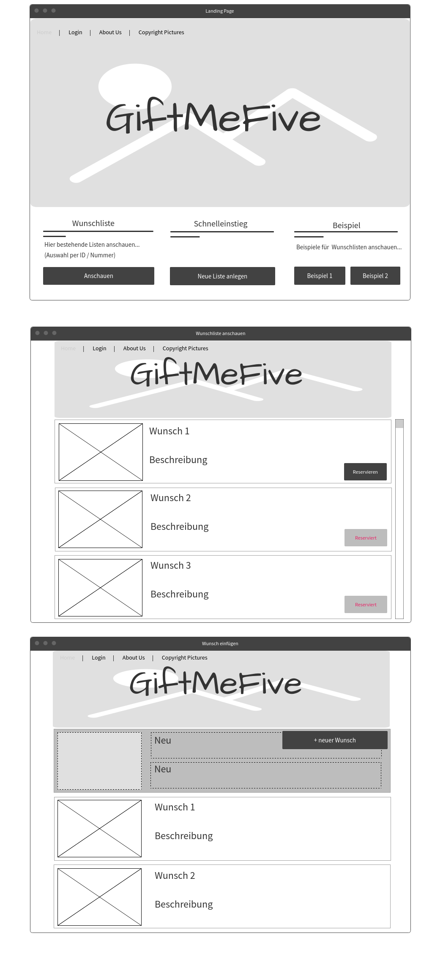
1.0. Page 1

