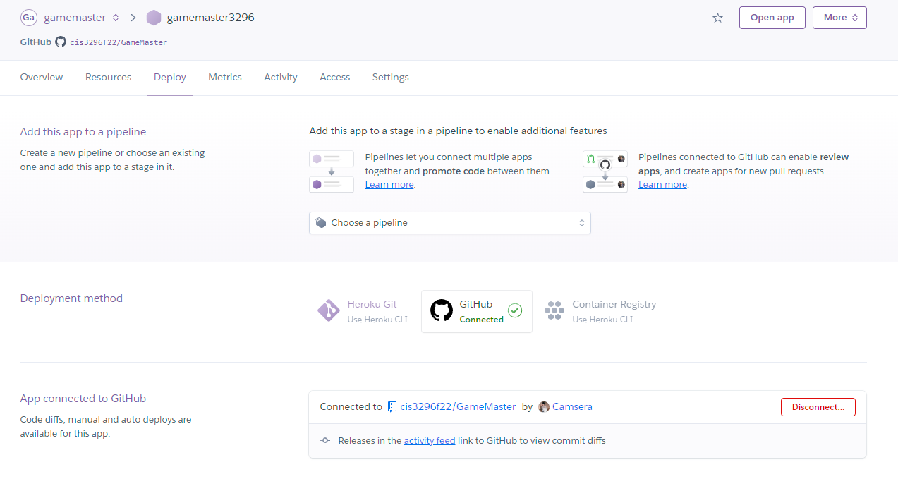

Go to Deploy page, scroll down to Manual deploy. Choose the branch you have provided the Procfile to and the main bot token. Click Deploy Branch

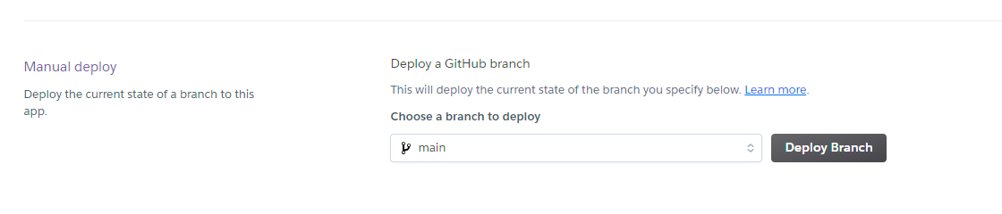

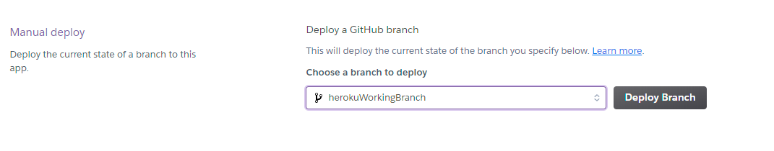

After you deployed go to resources, click the edit button and turn on Worker node ./index.js.

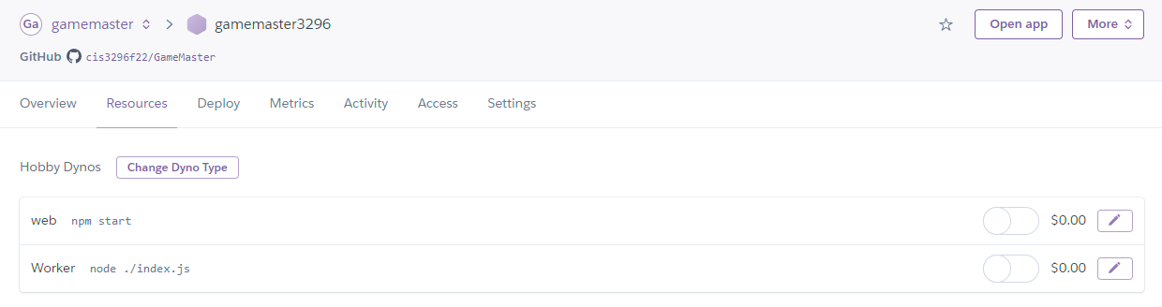

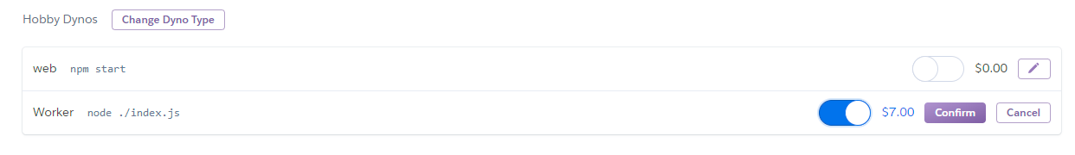

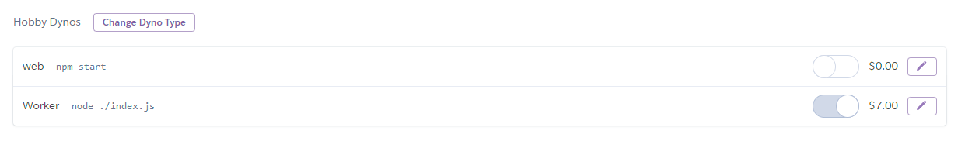

Click More in the top right and View Logs. Build should have deployed successfully. Bot should be running. If build failed or bot isn’t running, go back into resources and shut off the Worker resource.



